JAMES KAJDASZ 12 June 2013
Dr. James Kajdasz is a Lieutenant Colonel in the United States Air Force and a faculty member at the National Intelligence University. His research interests focus on using empirical methods to evaluate and improve intelligence analysis.
A Demonstration of the Benefits of Aggregation in an Analytic Task
The goal of this article is to describe an easily done exercise that demonstrates the benefits of aggregate analysis. It is hoped this might be useful for instructors of intelligence analysis who are interested in an exercise they can use in the classroom, or for the intelligence practitioner who might like some “hands on” experience with something they have heard of, but have not personally worked with.
By aggregate analysis, I am referring to the taking of a large number of independently made assessments and then mathematically aggregating the assessments together to form one single assessment. I am not referring to things like brainstorming, for example, where individuals are actively interacting with each other while forming the group assessment.
It’s been noted that the average assessment derived from a large number of independent estimates tends to be quite accurate. Some of the research on this topic was popularized by James Surowiecki in his book The Wisdom of Crowds. The archetypal story on this topic is told about Sir Francis Galton. While attending the West of England Fat Stock and Poultry Exhibition, Galton noted a contest where competitors guessed the weight after butchering of a fat ox. Galton collected the almost 800 guesses transcribed on cards and discovered that the mean estimate (1,197 lbs.) was remarkably close to the actual weight (1,198 lbs.) of the butchered ox.
Researchers have examined the aggregation question more rigorously over the years. Aggregating the independent assessments of a large number of individuals has been observed to provide benefits in a wide variety of disciplines. A sampling: executives at Time Magazine made forecasts on the amount of advertising space they would sell in future issues. Being a primary source of revenue, such forecasts receive a lot of attention and are given great importance. Individual forecasters had a forecasting error of 10.5%. If two individual forecasters had their forecasts averaged together, the subsequent error rate fell to 8.9%. Error rates continued to fall as the assessments of additional forecasters were added to the mix. A group of thirteen forecasters had a reduced average error rate of 7.2%. In another example, airlines attempted to forecast how many passengers would fly in the upcoming months. Such forecasts are important so airlines can have enough aircraft and other resources where needed. Two separate sets of forecasts, when combined, formed more accurate estimates than either set did alone. One way to efficiently aggregate a large number of independent forecasts is to utilize a stock market mechanism. Futures markets use this principle to evaluate the likelihood of future events. Forecasts based on futures markets have been found highly accurate in assessments as diverse as movie box-office earnings, mobile phone usage, and even pop-music chart positions.
Efforts to apply the methodology continue. There’s the Intelligence Advanced Research Projects Activity’s (IARPA) Aggregate Contingent Estimation (ACE) program, whose purpose is to “dramatically enhance the accuracy, precision, and timeliness of intelligence forecasts for a broad range of event types, through the development of advanced techniques that elicit, weight, and combine the judgments of many intelligence analysts”. In addition to IC efforts, futures markets that are open to the public (InTrade, HSX, and the Iowa Electronics Market) continue to estimate the likelihood of various events, and are shown to be more accurate than other benchmarks of performance.
And yet, to most in the intelligence community, talk of these topics is esoteric. Few are likely anticipating the start of their own complicated Bayesian aggregation algorithms to combine forecasts (as is done in the IARPA program) or set up their own political prediction market. The advantages of crowd-based analysis seem merely an academic discussion. What is needed is a more accessible, easily demonstrable example of the crowd tackling an analytic task. Such an example can serve as an introduction to students on the benefits of aggregate analysis as well as a demonstration to skeptical intelligence professionals who want to evaluate a technique first-hand before making up their own mind.
IN SEARCH OF AN ANLAYTIC TASK
The most suitable intelligence demonstration for an analytic task is an assessment of some issue that is relevant to national security. Will Iran develop a nuclear weapon in 2013? Will Israel conduct an air strike against Iran in the next six months? Will north Korea conduct another test of a nuclear weapon in the next three months? Will Assad retain power in Syria until the end of the year? Questions such as these are asked in IARPA’s ACE program, as well as prediction markets such as InTrade. However, such questions unfold over a matter of months, or even years, and are less suitable to serve as a quick introductory demonstration on the effectiveness of aggregate analysis. Students are in the classroom for a limited time, and intelligence professionals may be too busy to invest such a long evaluation period to acquire first-hand experience with a method. What is needed is a short, quick, and easily demonstrable analytic task.
Attempting to fill this void, I offer the following admittedly overly simplistic analogy of an analytic task to serve as a suitable demonstration. It lacks some of the complexity of a more realistic intelligence analytic task, but it also offers some similarities and is brief enough that it can be demonstrated from start to finish in less than an hour. Imagine that you are watching a video clip of a person’s face. The person is looking at you, and smiles. The smile might be a genuine reaction to seeing something funny, or it may be a forced smile. Can you tell the difference? I like to exaggerate the importance of the test to my students by kidding that if they ever hoped to be quality HUMINT officers, they’ll need to judge the character of a potential source by looking him/her in the eye and determining their authenticity immediately. The “analyst” in this case must make a subjective judgment. The analyst looks for any number of cues to indicate the smile’s validity. But, as in intelligence analysis, it may be difficult to describe all those cues, or describe the overall certainty surrounding the assessment. Readers can try this test for themselves by going to the footnoted web address. Can the benefits of aggregate analysis be demonstrated in such a task?
I asked 217 people to take this test. Each person assessed a total of 20 separate videos of individuals smiling. On average, most people didn’t do particularly well. The average individual performance was 13.6 out of 20 smiles judged correctly. I also attempted to find individual characteristics that would identify those people who would do best at this task. I examined gender, age, number of children (what better training to detect deception than to have a child!), as well as years one was in a profession where one was required to “read” people, such as investigator, market researcher, survey administrator, polygrapher, or other similar position. None of these characteristics were significant predictors of performance. The best performance was achieved by three individuals who were correct in 19 out of 20 of their assessments. The video judged incorrectly was unique for each of these top performing individuals. All got one judgment incorrect, but they did not get the same one incorrect.
<<Insert Figure 1>>
The data shows something else too. Looking at just the first smile video by itself, most students (52%) thought the smile was genuine. Most students were correct. The smile was genuine. Most students (87%) thought the second smile was forced. This was also correct. In fact, if you go through each of the 20 videos in this manner, the prevailing opinion was correct in 19 out of 20 smile videos, for an impressive accuracy rate of 95%. This is in spite of the fact that individual performance averaged only 68%. The group performance succeeded grandly where individual performance was mediocre. No individual did better than the group performance.
TASK PERFORMANCE FOR DIFFERENT SIZED GROUPS
A group of 217 is a lot of people. It is certainly larger than the typical academic class size where one might hope to demonstrate aggregate analysis. How would the performance level of a typical class of around 21 students perform? To simulate how a hypothetical group of 21 would perform on the smile video task, 21 individuals were selected at random from the 217 that had previously performed the task. A virtual vote was held for this hypothetical class to determine the class assessment for each of the twenty smile videos. For example: on the first smile video, if 11 class members deemed the smile video was genuine, and 10 assessed the smile as forced, then the class’ assessment for the first video would be that it was a genuine smile. This was done for each of the twenty smile videos. Finally, the group’s assessments were graded to see how many videos the group got correct.
The individuals making up the first hypothetical class of 21 were then returned to the larger pool of individuals, and the whole procedure was repeated again to create a second hypothetical class of 21. By repeating this procedure multiple times, and obtaining a large number of hypothetical classes, a more accurate estimate of what constitutes “typical” performance by a group of 21 is obtained. In all, 217 hypothetical classes of 21 individuals were created and graded. On average, a group of 21 individuals scored 86% (17.2 out of 20 correct) on the smile video task, a significant increase over the typical individual performance of 68% (13.6 out of 20 correct).
<<Insert Figure 2>>

What results can you expect if you repeat this exercise in your class? Assuming a hypothetical class size of 21 individuals, and based on the results I have observed, I can make some predictions. Most individuals (90%) will obtain an individual accuracy rate of between 46% (9.2 of 20 judged correctly) and 90% (18 of 20 correct). When you average all of the individual performance scores in a class of 21 students together, the average individual performance for the class should (90% of the time) fall between 63% accuracy (12.6 of 20) and 73% accuracy (14.6 of 20). Note that this isn’t aggregate analysis; it is simply the average individual performance in a class of 21 persons. And how about aggregate analysis? When the entire class independently assesses each smile video, and the assessments are used to create a single class judgment through a voting procedure, as is described in the “virtual vote” procedure above, most classes (90%) who perform this exercise should have an aggregate analytical performance of between 74% (14.8 of 20) and 98% (19.6 of 20). This is significantly better than typical average individual performance of between 63% and 73%.
The results described above are for a group of 21 persons. What about groups of different sizes? I tested different sized groups, starting with a 3-person group and extending all the way up to a 31-person group. For each test of a particular group size, I repeated the same procedures described above. I randomly selected participants from my pool of individual performers and formed them into a notional group. I conducted a “virtual vote” to see what the group’s assessment would be for each video, and then I graded the group’s performance. I collected 217 “virtual groups” for each group size tested. As group size increased, the performance of the aggregate analysis continued to improve. For a group-of-three, average performance was 75% accuracy. For a group of 31, average performance was 87%.
<< Insert Figure 3 >>
WHAT DO WE MAKE OF HIGH-PERFORMING INDIVIDUALS?
On occasion, a single individual will equal or do better than the aggregate performance of the group. What should we conclude from this? There are at least two possibilities: skill and luck. The person may have special experience or ability in this task. If this is the case, then the individual should be able to deliver predictably higher performance. We can test this hypothesis by dividing our smile video test in to two parts. Part one consists of the first 10 videos, part two consists of the second 10 videos. A person who does extremely well on the first 10 videos, if they are truly highly skilled, should also do well on the second set of 10 videos. Is there evidence for this? Looking at my results of 217 individuals, performance on the first 10 videos was significantly correlated to performance on the second ten videos. This is consistent with the explanation that there is an element of skill at this task, and high performers are not just lucky.
Does this mean higher skilled performers can ignore the benefits of aggregate analysis? Readers would be cautioned from making such a conclusion. The aggregate analysis of a group of experts will still outdo the performance of a single expert. In fact, the benefits of aggregate analysis are significant enough that it can be shown mathematically that a large number of laymen can beat a smaller number of experts. For example, if hypothetical laymen make 4 times as many errors as an expert does, it can be shown that you need the combined independent assessment of 16 laymen to equal the performance of your one expert. A group of 64 laymen can beat the expert by a factor of two. This is not to say that expertise is not valued in this context. A large number of experts will outperform an equally large number of laymen. However, it’s often hard to find a large number of experts.
Then there is the matter of consistency. A highly skilled individual should, on average, perform better. However, there will be some good days and some bad days. On the bad days, even the expert may return a dismal performance. Performance from an aggregated group tends to be more consistent. The highs are not quite as high and the lows are not quite as low. The performance range of an aggregated group is more boring and predictable. This can be demonstrated with the data collected in our smile video task. For example: when looking at the typical performance of individuals on the smile video task, most had an accuracy rate of between 46% and 90% -- a spread of 44 percentage points. An aggregated group of 21 persons returns a typical accuracy rate of between 74% and 98%; a noticeably smaller spread of 24 percentage points. The spread for a group of 31 aggregated individuals is even smaller: only 20 percentage points (typically ranging between 77% and 97%). The range of performance can be more appropriately quantified by calculating the standard deviation. A higher standard deviation indicates a larger “spread” in performance scores. Calculating the standard deviation for groups of different sizes, it can be seen in Figure 4 that the “spread” in performance continued to decrease as the group size grew larger.
<<Insert Figure 4>>
The results of improved, more predictable performance observed in the smile video task are nothing new. They have been demonstrated and repeated in a host of other studies. But how to explain these results…
WHY DOES AGGREGATE ANALYSIS DO BETTER?
When I explain these results to students, I highlight a few reasons for superior performance of aggregated independent assessments. The first reason has to do with a mathematical trick related to the central limit theorem. To illustrate, imagine that you have a tape measure and you are measuring the height of your desk to the nearest millimeter. Then you ask another person to do it. And another. And another... At the end of this process, you would have a range of reported measures that are similar, but slightly different from each other. Of course, the size of the desk isn’t changing. The desk does have a “true” height. But, every time someone measures the desk, there is a little bit of random error mixed into their estimate. Most of these errors would be quite small. Occasionally an error would be larger. This random error could cause you to overestimate the height of the desk or, equally likely, underestimate it. If the error component is truly random, the chance of you overestimating the height is equal to the chance of you underestimating the height. Much like flipping a coin, half the coin tosses will be “heads’ and half will be “tails”. You might not observe an even split for a small number of coin tosses, but as the number of coin tosses grows, the ratio of “heads” and “tails” will be very close to 50/50. Similarly, for a large number of assessments, the random error will be equally spread around the true value. This is an important point because it means if you take a large number of measures, approximately half the measures will be overestimates and half the measures will be underestimates. The positive errors and negative errors will occur in approximately equal frequency and will cancel each other out when all the measures are aggregated together. The average of all the measures is thus likely closer to the true height of the desk because the random error component has been removed as a result of mutually cancelling errors! I get more excited about this fact than my students typically do.
What about non-random error? Systematic error, or bias, is predictable error. If the tape measure that is used to measure the height of the desk is stretched out, then the measures that are taken will consistently underestimate the true height of the desk. Aggregating a large number of measures will not eliminate bias. These concepts are illustrated in Figure 5.
<<Insert Figure 5>>
I use simplistic examples of measuring a desk, or flipping a coin to explain the concepts to students, but then emphasize that the same concepts apply to more complicated analytic tasks as well. There are other reasons cited for why aggregated analyses do well. In this article, I have focused on the elimination of random error.
AGGREGATING OPINIONS IS NOT NATURAL
In situations where multiple forecasting opinions have been made available on a given topic, it seems natural to go about identifying which individual forecaster is best and most accurate. Once the determination is made, one can then rely more heavily on that forecaster in the future and discard the rest. Similarly, for intelligence problems, it seems natural to put the best or most experienced analyst on the topic to head the IC assessment. Aggregation suggests something different. Rather than discarding or ignoring the majority of information, a large body of research spanning over the past 100 years has indicated better accuracy can be achieved through aggregation of a large number of opinions.
In the examples above, opinions were aggregated simply by averaging. In this approach, the opinion of each individual counts equally. But should this be the case? Some individuals may have demonstrated better accuracy in the past, or have more experience and should therefore have their opinions weighted more heavily. In the smile video task, for example, I found one variable that did predict performance. I asked participants, before they tried the task, to estimate how many videos they thought they would get correct. Participants’ estimates were significantly positively correlated to the number of videos they actually did get correct. People may have some intuition of how well they can do on the task. It might be possible to use one’s estimate of performance as a way to weight some opinions more heavily while forming the aggregate assessment. What is the optimal way to weigh the opinions? IARPA’s ACE project is exploring such possibilities.

BIBLIOGRAPHY
Arrow, K. J, R. Forsythe, M. Gorham, R. Hahn, R. Hanson, J. O Ledyard, S. Levmore, et al. “The Promise of Prediction Markets.” Science 320, no. 5878 (2008): 877.
Ashton, Alison Hubbard. “An Empirical Study of Budget-Related Predictions of Corporate Executives.” Journal of Accounting Research 20, no. 2 (1982): 440–449.
Ashton, Alison Hubbard, and Robert H. Ashton. “Aggregating Subjective Forecasts: Some Empirical Results.” Management Science 31 (1985): 1499–1508.
Bates, J.M., and C.W.J. Granger. “The Combination of Forecasts.” OR (1969): 451–468.
“BBC - Science & Nature - Human Body and Mind - Spot The Fake Smile.” Accessed May 13, 2013. http://www.bbc.co.uk/science/humanbody/mind/surveys/smiles/.
Galton, Francis. “The Ballot-box.” Nature 75, no. 1952 (1907): 509.
———. “Vox Populi.” Nature 75, no. 1949 (1907): 450–451.
Ho, T. H., and K. Y. Chen. “Discovering and Managing New Product Blockbusters: The Magic and Science of Prediction Markets.” California Management Review 50 (2007): 144–58.
Hogarth, Robin M. “A Note on Aggregating Opinions.” Organizational Behavior and Human Decision Processes 21, no. 1 (1978): 40–46.
“IARPA - ACE Program.” Accessed January 31, 2013. http://www.iarpa.gov/Programs/ia/ACE/ace.html.
Kajdasz, James E. “Spot the Fake Smile.” Accessed May 13, 2013. http://www.surveymonkey.com/s/SmileRead.
Mullen, Brian, Craig Johnson, and Eduardo Salas. “Productivity Loss in Brainstorming Groups: A Meta-analytic Integration.” Basic and Applied Social Psychology 12, no. 1 (1991): 3–23.
Russolillo, Steven. “Intrade Shuts Down Months After Federal Scrutiny - MarketBeat - WSJ.” Wall Street Journal, March 11, 2013. http://blogs.wsj.com/marketbeat/2013/03/11/intrade-shuts-down-months-after-federal-scrutiny/.
S., Louise. “The Swarm Is Greater Than the Parts: Cultivating the Wisdom of Crowds in the Intelligence Community.” 2006 Galileo Paper (2006).
Spann, Martin, and Bernd Skiera. “Internet-based Virtual Stock Markets for Business Forecasting.” Management Science 49, no. 10 (2003): 1310–1326.
Surowiecki, James. The Wisdom of Crowds. New York: Anchor Books, 2005.
Tziralis, G., and I. Tatsiopoulos. “Prediction Markets: An Extended Literature Review.” The Journal of Prediction Markets 1, no. 1 (2007): 75–91.
Wolfers, Justin, and Eric Zitzewitz. “Prediction Markets.” The Journal of Economic Perspectives 18, no. 2 (Spring 2004): 107–126.
Yeh, Puong Fei. “Using Prediction Markets to Enhance US Intelligence Capabilities.” Studies in Intelligence 50, no. 4 (2006): 37–49.

Figure 1: Histogram showing Individual Performance on the Smile Video Task.
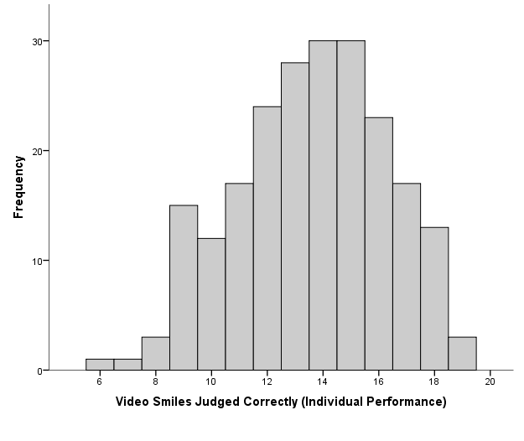

Figure 2. Histogram showing aggregate analysis of notional group of 21 performance.

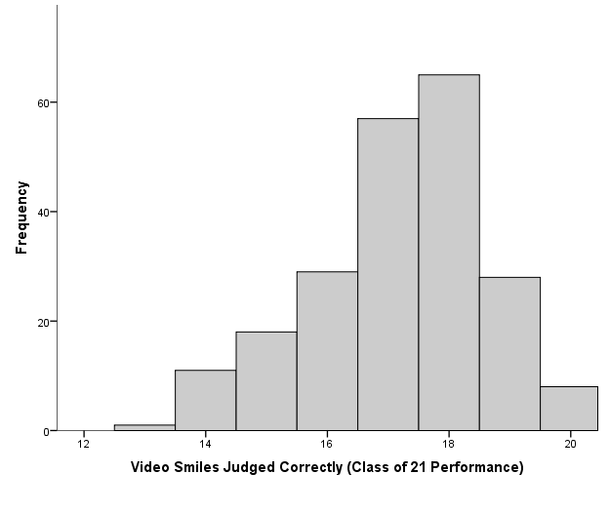

Figure 3. Aggregate analytical performance for groups of various sizes on “Smile Video Task”.

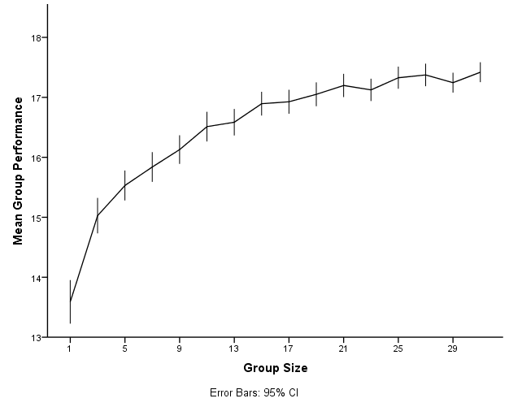

Figure 4. Typical spread of performance for Groups of various sizes on “Smile Video Task”.

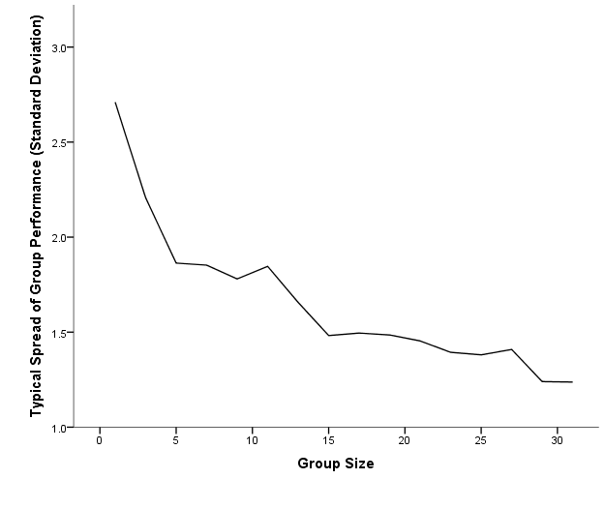

Figure 5. Illustration of random error and errors due to bias.
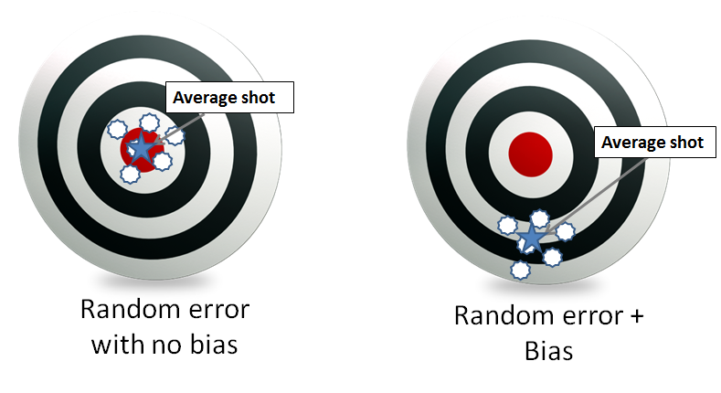

REFERENCES

The views expressed in the article are those of the author and do not reflect the official policy or position of the U.S. Government, the Department of Defense, or any of its components.
For a review of the brainstorming literature, see Mullen, Brian, Craig Johnson, and Eduardo Salas. “Productivity Loss in Brainstorming Groups: A Meta-analytic Integration.” Basic and Applied Social Psychology 12, no. 1 (1991): 3–23.
Surowiecki, James. The Wisdom of Crowds. New York: Anchor Books, 2005. Also see: S., Louise. “The Swarm Is Greater Than the Parts: Cultivating the Wisdom of Crowds in the Intelligence Community.” 2006 Galileo Paper (2006).
Galton, Francis. “The Ballot-box.” Nature 75, no. 1952 (1907): 509. Galton, Rancis. “Vox Populi.” Nature 75, no. 1949 (1907): 450–451.
Ashton, Alison Hubbard. “An Empirical Study of Budget-Related Predictions of Corporate Executives.” Journal of Accounting Research 20, no. 2 (1982): 440–449. Ashton, Alison Hubbard, and Robert H. Ashton. “Aggregating Subjective Forecasts: Some Empirical Results.” Management Science 31 (1985): 1499–1508.
Bates, J.M., and C.W.J. Granger. “The Combination of Forecasts.” OR (1969): 451–468.
Spann, Martin, and Bernd Skiera. “Internet-based Virtual Stock Markets for Business Forecasting.” Management Science 49, no. 10 (2003): 1310–1326.
“IARPA - ACE Program.” Accessed January 31, 2013. http://www.iarpa.gov/Programs/ia/ACE/ace.html.
Arrow, K. J, R. Forsythe, M. Gorham, R. Hahn, R. Hanson, J. O Ledyard, S. Levmore, et al. “The Promise of Prediction Markets.” Science 320, no. 5878 (2008): 877.
InTrade recently had to cease trading due to U.S. internet gambling laws. Russolillo, Steven. “Intrade Shuts Down Months After Federal Scrutiny - MarketBeat - WSJ.” Wall Street Journal, March 11, 2013. http://blogs.wsj.com/marketbeat/2013/03/11/intrade-shuts-down-months-after-federal-scrutiny/.
Kajdasz, James E. “Spot the Fake Smile.” Accessed May 13, 2013. http://www.surveymonkey.com/s/SmileRead. The test was modified from the original: “BBC - Science & Nature - Human Body and Mind - Spot The Fake Smile.” Accessed May 13, 2013. http://www.bbc.co.uk/science/humanbody/mind/surveys/smiles/.
One-Sample t(216)=19.62, p<.001
M = 13.59, SD = 2.71, CI_{.90}: 9.15 to 18.03
M = 13.59, SE = 0.59, CI_{.90}: 12.62 to 14.56
M = 17.2, SD = 1.45, CI_{.90}: 14.81 to 19.58
Independent Samples t(273.47)=34.06, p<.001 (adjusted for unequal variances, according to Levine’s test)
M = 15.03, SD = 2.21
M = 17.42, SD = 1.24
Pearson’s r = .37, p < .001
Ho, T. H., and K. Y. Chen. “Discovering and Managing New Product Blockbusters: The Magic and Science of Prediction Markets.” California Management Review 50 (2007): 144–58.
M = 13.59, SD = 2.71, CI_{.90}: 9.15 to 18.03
M = 17.2, SD = 1.45, CI_{.90}: 14.81 to 19.58
M = 17.42, SD = 1.24, CI_{.90}: 15.39 to 19.45
Arrow, K. J, R. Forsythe, M. Gorham, R. Hahn, R. Hanson, J. O Ledyard, S. Levmore, et al. “The Promise of Prediction Markets.” Science 320, no. 5878 (2008): 877. Ashton, Alison Hubbard, and Robert H. Ashton. “Aggregating Subjective Forecasts: Some Empirical Results.” Management Science 31 (1985): 1499–1508. Bates, J.M., and C.W.J. Granger. “The Combination of Forecasts.” OR (1969): 451–468. Hogarth, Robin M. “A Note on Aggregating Opinions.” Organizational Behavior and Human Decision Processes 21, no. 1 (1978): 40–46. Spann, Martin, and Bernd Skiera. “Internet-based Virtual Stock Markets for Business Forecasting.” Management Science 49, no. 10 (2003): 1310–1326. Tziralis, G., and I. Tatsiopoulos. “Prediction Markets: An Extended Literature Review.” The Journal of Prediction Markets 1, no. 1 (2007): 75–91. Wolfers, Justin, and Eric Zitzewitz. “Prediction Markets.” The Journal of Economic Perspectives 18, no. 2 (Spring 2004): 107–126. Yeh, Puong Fei. “Using Prediction Markets to Enhance US Intelligence Capabilities.” Studies in Intelligence 50, no. 4 (2006): 37–49.
Surowiecki notes for example: it increases the diversity of opinions, estimates cannot be dominated by “bossy” group members, and forecaster specialization allows members to bring unique knowledge to the problem.
Bates, J.M., and C.W.J. Granger. “The Combination of Forecasts.” OR (1969): 451–468.
Pearson’s r = .21, p = .002

