GROUP 3 (WIND GROUP)

**Architectural Design and Analysis.**

The team agreed on a service oriented architecture and the technologies below are of the team’s choice.

* Spring Boot
* Spring Data JPA
* Spring Security
* JSON Web Token
* MySQL

**How do we secure the application?**

We intend to secure the application with Spring Security and Json Web Token (JWT). We intend to secure our application by the following ways.

* Authenticate the user and return the JWT token.
* User makes request to our resource server by adding the bearer token as part of the header.
* FilterChainProxy (Spring Security Filter) will delegate request to the BasicAuthenticationFilter for authorization before consuming any resource.

**UML CLASS Diagram**

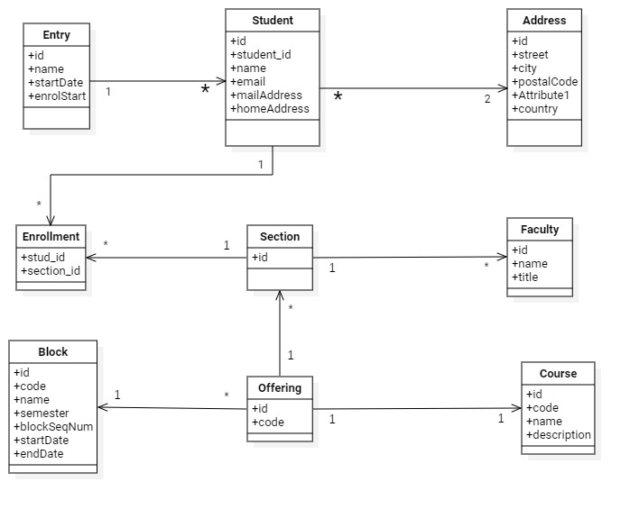

**USE CASE DIAGRAM**

