**Tumor-Normal Analysis**

The data table contains deletions found in tumor samples. When a deletion is selected in the data table for a tumor-normal sample, 2 or 4 windows open. Tumor reads are in the top window or windows, normal in the bottom window or windows. Deletions of size > 5000 only open in 4 windows. Smaller deletions are best viewed in 2 windows. The regions visualized in the normal sample are the same regions shown in the tumor sample allowing for easy comparison.

Fig. 1 – Sample 5768, 2 window display (top) for deletion of size 646, 4 window display (bottom) for deletion of size 16941.

You may need to drag the normal sample windows down to analyze the tumor sample windows.

Entries of 0, 1, and 2 should be used for deletions where 2 = homozygous (deletion on both alleles), 1 = heterozygous (1 allele), and 0 means GROM called a deletion but there is no evidence for a deletion based on RP, RD, or SR (soft-clips and non-primary alignments) analysis. We normally look for differences between the tumor and normal samples. We have also found some deletions that are present in a high percentage of tumor and normal samples. These are also of interest (see Fig. 5, Table 1).

**A scale to rate deletions:**

score 4 = direct evidence on both ends, either soft-clips, non-primary alignments (NPAs), or both + RP and RD

score 3 = direct evidence on one end, either soft-clips, non-primary alignments, or both + RP and RD

score 2 = RP and RD

score 1 = RP or RD

Direct evidence means that the soft-clip lines up with the drop in read depth.

For scores 3 and 4 we are giving counts of soft-clips on each end of the deletion, but you just need to report 1 for 1 soft-clip or 2 if count >= 2. If the coordinate of the soft-clip breakpoint doesn't match the GROM call, please give the coordinate of the soft-clip breakpoint.

Fig. 3 – Sample 5768 deletion of size 16941. This deletion would have a score of 4 since it has RP evidence (pink bars in both windows showing abnormally large insert sizes), RD evidence (no read depth in region of deletion), and soft-clips on both ends where the read depth drops to 0. On the left only 1 soft-clip aligns; on the right 2 soft-clips align.

Fig. 4 - Sample 7983 deletion of size 189994. This deletion would have a score of 3 since there is RP and RD evidence and 1 soft-clip on the left that aligns with the deletion call (blue arrow). There are 2 reads on the right (red arrow) that end near the deletion calls, but they don’t have soft-clips so they are not counted as direct evidence. The absence of pink bars in the left window should be noted since it makes the RP evidence questionable. This deletion appears to be heterozygous, but the variable read depth makes this conclusion questionable.

Fig. 4 - Sample 7983 deletion of size 441. This deletion has a score of 3. The soft-clip is not visible at default magnification (top) but becomes apparent when one zooms in (arrow). The right end of the soft-clip aligns with the right breakpoint of this heterozygous deletion.

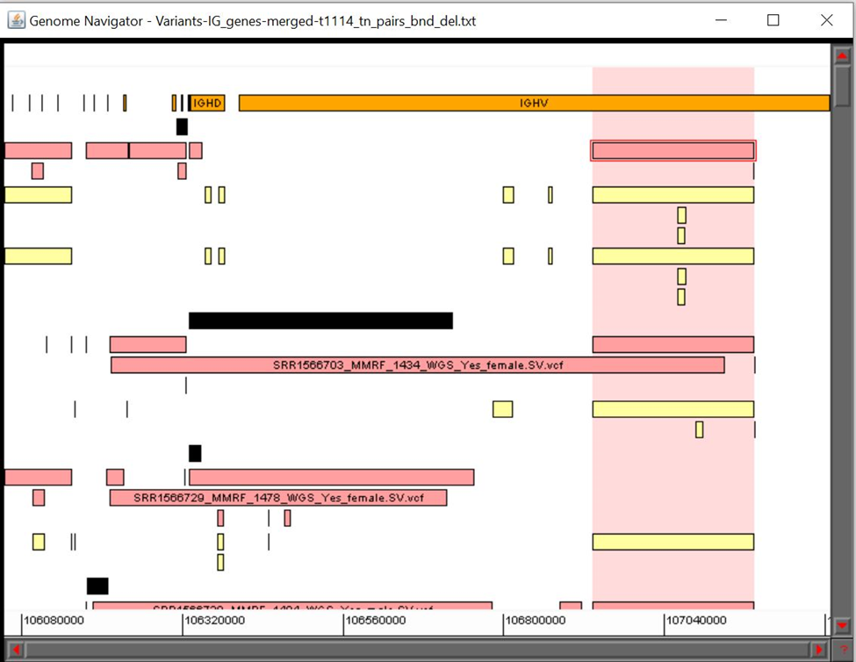

Fig. 5 – Variant Navigator (VN) multi-sample display. IG gene regions in orange at top (arrow). Deletion calls by GROM for tumor samples in red and normal samples in yellow. Deletions of size ~242000 highlighted by pink background. Translocation calls are shown as black boxes.

IG genes are in the region 106053274 - 107288051. IG genes of most interest are IGHV, IGHD, IGHJ genes. These genes are in the coordinate range of 106329406| - 107288051.

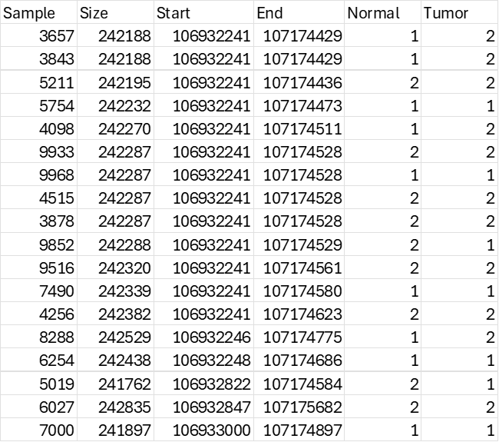

Table 1 – Excerpt of table of deletions of size ~242000 bp. Most start at 106932241 (61 out of 78) with differing endpoints. In Normal and Tumor columns heterozygous = 1, homozygous = 2.

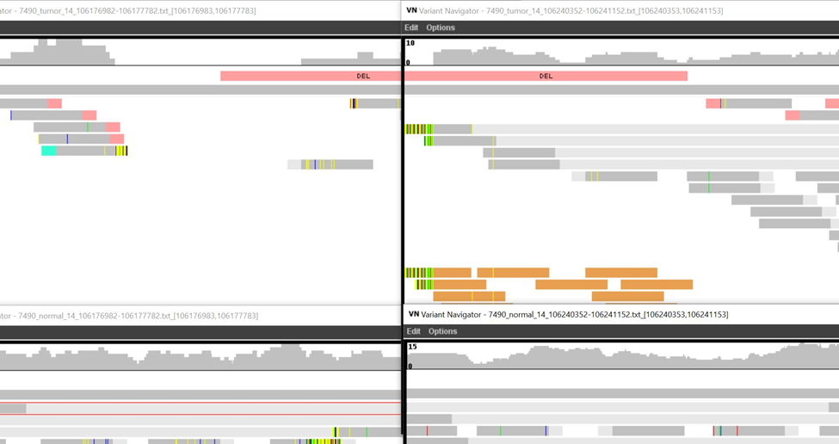

Fig. 6 – Sample 7490 deletion of size 63370. Orange reads indicated by blue arrow provide evidence of translocation. Mates of all of these reads are on chr 11. When reads are selected by a mouse click, the mate chromosome is shown in the SELECTED OBJECT box at the bottom right of the VN window.