Solar Array Pointing Algorithm
Sun vector, reference frames, gimbal kinematics, and user-configurable travel limits
Satellite Energy Balance simulator · energy_balance/solar_array.py, attitude.py, sun.py, orbit.py

1. Scope and summary
This document describes how the simulator decides where each solar array points at every time step, and how that decision is constrained by the gimbal travel limits and slew rate the user enters in the sidebar. It covers the full chain: locating the Sun in inertial space, establishing the orbit and body reference frames, expressing the Sun direction in body coordinates, solving for the ideal gimbal angles, applying travel limits and rate limits to produce the achievable angles, and converting the resulting array orientation into a cosine-of-incidence factor for the power model.
Every numerical example in this document uses the simulator's default values — the opening preset “LEO 1000 km, 80 deg” with the sidebar's default gimbal limits (primary axis ±180°, secondary axis ±60°, 1.0 °/s slew). Section 9 works that case end to end.
The algorithm is deliberately kinematic, not dynamic. It computes the orientation a perfectly behaved drive would reach subject to its hard stops and maximum rate; it does not model motor torque, structural flexibility, controller bandwidth, or pointing jitter.

1.1 The pointing chain in one table
Step | Module / function | Produces
1. Propagate the orbit | orbit.py → propagate_orbit | r_eci(t), v_eci(t) in km and km/s
2. Locate the Sun | sun.py → sun_vector_eci | u_sun_eci(t) unit vector, distance in AU
3. Illumination | eclipse.py → illumination_fraction_conical | illumination fraction 0…1
4. Build the attitude | attitude.py → body_to_eci | R(t), the 3×3 body→ECI rotation
5. Sun in body frame | solar_array.py → panel_frames_eci | u_sun_body = Rᵀ u_sun_eci
6. Ideal gimbal angles | solar_array.py → panel_frames_eci | θ₁, θ₂ that aim the normal at the Sun
7. Apply travel limits | solar_array.py → _limited_axis_angles | achievable angles after stops and rate cap
8. Actual normal and power | solar_array.py → array_power_watts | n̂_eci, cos(incidence), panel watts

Steps 6 and 7 are the pointing algorithm proper. Steps 1–5 supply its inputs and step 8 consumes its output. All of the geometry is vectorised over the time grid: the rotation stack R has shape (N, 3, 3) and every angle series has shape (N,).

2. Notation and conventions
Symbol | Meaning | Where it comes from
r_eci, v_eci | Satellite position and velocity in ECI (km, km/s) | propagate_orbit
û_sun | Unit vector from Earth's centre toward the Sun, in ECI | sun_vector_eci
R | Rotation matrix body → ECI, so that r_eci = R r_body | body_to_eci
ŝ | Sun direction in body coordinates, ŝ = Rᵀ û_sun | panel_frames_eci
n̂₀ | Panel rest normal in body coordinates (normal_body) | PanelConfig
â₁ | Primary gimbal axis in body coordinates (rotation_axis_body) | PanelConfig
â₂ | Secondary gimbal axis, â₂ = â₁ × n̂₀ | derived
θ₁, θ₂ | Primary (azimuth) and secondary (elevation) gimbal angles | solved per time step
n̂ | Actual panel normal after the gimbals have moved | normal_eci
β | Beta angle: elevation of the Sun above the orbit plane | beta_angle_deg

- Rotation convention — a rotation matrix maps body coordinates into ECI coordinates: r_eci = R r_body. The inverse mapping is therefore the transpose, r_body = Rᵀ r_eci, which is how the Sun direction is brought into the body frame (the code writes this as an einsum with the index order reversed).
- Angle sign convention — all gimbal angles follow the right-hand rule about their rotation axis. A positive θ₁ rotates the rest normal toward +â₂ when viewed down +â₁.
- Units — lengths in km, angles in degrees at every interface the user or the charts touch, radians only inside the trigonometry. Time is seconds from epoch.
- Frames are right-handed and orthonormal — every basis the code builds is explicitly Gram–Schmidt orthogonalised, so no frame is ever slightly skewed by an input that was not quite perpendicular.

3. Reference frames
Four frames appear in the pointing calculation. Two of them — the orbit frame and the body frame — are the ones the user needs to reason about when choosing a mounting face and a gimbal axis, so they are defined in full below.

3.1 Earth-centred inertial (ECI)
ECI is the common frame in which everything is finally compared. Its origin is the centre of the Earth; +X points toward the vernal equinox; +Z points along the Earth's rotation axis toward the north pole; +Y completes the right-handed set in the equatorial plane. The frame does not rotate with the Earth, so the Sun vector and the satellite state can be differenced directly without any sidereal bookkeeping.
The simulator treats the mean-equinox-of-date frame produced by the low-precision solar ephemeris as if it were the same ECI frame used by the orbit propagator. Over the few decades around J2000 for which the ephemeris is valid, the resulting Sun-direction error is on the order of 0.01°, which is negligible against the cosine losses and gimbal limits this document is about.

3.2 Perifocal frame (PQW)
The propagator first solves Kepler's equation in the orbit's own plane. The perifocal frame has +P toward perigee, +Q 90° ahead of perigee in the direction of motion, and +W along the orbital angular momentum. Position and velocity are formed there and then rotated into ECI by the standard three-angle sequence:
R_eci<-pqw = Rz(RAAN) . Rx(inclination) . Rz(argument of perigee)
The propagator advances RAAN and argument of perigee with their secular J2 rates and advances the mean anomaly with the J2-corrected mean motion, so this rotation changes slowly over the run. For the default orbit the node regresses at −1.0392° per day.

3.3 The orbit frame (R, S, W)
The orbit frame — also called the local-vertical / local-horizontal or RSW frame — is the frame that rides with the satellite and is the reference for nadir-pointing attitude. It is defined at each instant directly from the position and velocity:
Axis | Definition | Physical meaning
R̂ | r_eci / |r_eci| | Radial, pointing away from Earth (zenith). Its negative is nadir.
Ŵ | (r × v) / |r × v| | Orbit normal, along the angular momentum vector.
Ŝ | Ŵ × R̂ | In-plane and transverse; equals the velocity direction for a circular orbit.

Two quantities derived from this frame drive the whole pointing problem. The first is the nadir direction −R̂, which the attitude model aims a chosen body face at. The second is the beta angle, the elevation of the Sun above the orbit plane:
beta = 90 deg - angle( W_hat , u_sun )
Beta sets how far the Sun ever moves out of the orbit plane, and therefore how much angular travel the gimbals have to cover. At β = 0 the Sun lies in the orbit plane and sweeps a full 360° around the satellite every revolution; at β = 90° it sits on the orbit normal and barely moves in the body frame. The default epoch is a near-equinox case with β ≈ 0.09°, which is the hardest case for a gimbal with limited travel — see section 9.
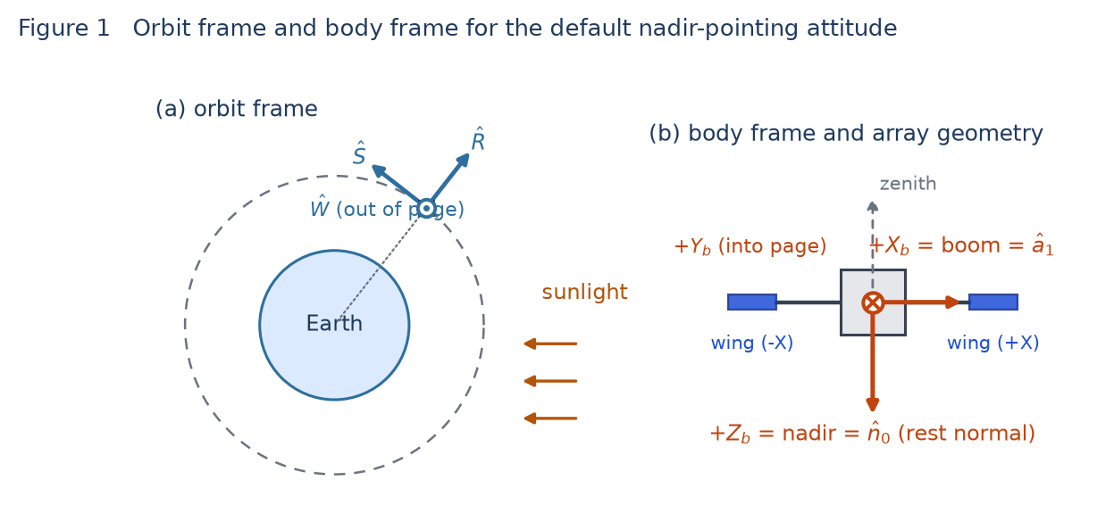
Figure 1. Left: the orbit frame at an instant, with the radial, along-track and orbit-normal directions. Right: the default body frame seen from the orbit normal, with the two wings on the ±X booms. The panel rest normal +Zᵇ is the nadir face, so at zero gimbal angle the arrays face the Earth, not the Sun.

3.4 The body frame
The body frame is fixed to the spacecraft structure. Panel normals and gimbal axes are entered in this frame, and the user names its six faces by the labels +X, −X, +Y, −Y, +Z and −Z, which map to the obvious unit vectors (BODY_FACES in config.py). How the body frame sits relative to the orbit is decided entirely by the attitude mode:
Attitude mode | How the body frame is built | Resulting orientation
Nadir pointing (default) | +Zᵇ is driven to nadir (−R̂); the chosen yaw axis (default +Xᵇ) is driven to the velocity direction, orthogonalised against nadir; the third axis completes the right-handed set. | +Zᵇ = nadir, +Xᵇ ≈ along-track, +Yᵇ = −Ŵ. The body frame rotates once per orbit in inertial space.
Sun pointing | A chosen body axis (default +Zᵇ) is driven onto the Sun line; the remaining phase about that line is fixed by an arbitrary ECI +Z hint vector. | The commanded axis holds the Sun. The Sun direction in body coordinates is constant, so an array whose rest normal is that axis needs no gimbal motion at all.
Inertial | R is the identity matrix. | Body axes coincide with ECI axes; the Sun sweeps through the body frame once per year.

The default attitude is nadir pointing with the +X yaw axis, so for the default circular orbit the body axes line up with the orbit frame as follows. This is worth internalising, because it explains the gimbal behaviour in section 9:
+X_body -> +S_hat (along-track / velocity)
+Y_body -> -W_hat (negative orbit normal)
+Z_body -> -R_hat (nadir, toward the Earth)
Note that for an eccentric orbit the velocity is not exactly perpendicular to the radius, so the yaw axis is placed along the component of velocity perpendicular to nadir rather than along velocity itself. Nadir always wins; the yaw axis only resolves the remaining rotation about it.

3.5 The panel (gimbal) frame
Each panel carries its own orthonormal triad, built from two user inputs and one derived vector:
- n̂₀ — the rest normal (normal_body). The direction the panel faces when both gimbal angles are zero. The user picks a body face or enters a custom vector; the code normalises it.
- â₁ — the primary gimbal axis (rotation_axis_body). Physically the boom or drive shaft the panel rotates about. For a two-wing array the sidebar sets this from the chosen mounting sides (±X or ±Y) and both wings share it.
- â₂ = â₁ × n̂₀ — the secondary gimbal axis, derived, not entered. It is perpendicular to both the boom and the rest normal.
The convention assumes the rest normal is perpendicular to the primary axis, which is what a real boom-mounted wing looks like, and which the defaults satisfy (n̂₀ = +Zᵇ, â₁ = +Xᵇ, so â₂ = −Yᵇ). Then (n̂₀, â₂, â₁) is an orthonormal right-handed triad and the gimbal angles below have a clean interpretation. If a user enters a rest normal that is not perpendicular to the axis, the one-axis model still behaves correctly — it keeps the component of the normal that lies along the axis fixed and rotates only the perpendicular part — but the two-axis angles lose their azimuth/elevation meaning.

3.6 Frame chain summary
PQW --Rz(RAAN) Rx(i) Rz(argp)--> ECI <--R-- BODY <--gimbals-- PANEL

u_sun_body = R^T u_sun_eci (Sun into the body frame)
n_eci = R n_body (panel normal back out to ECI)
cos(inc) = clip( n_eci . u_sun_eci , 0 , 1 )

4. Locating the Sun
The Sun direction comes from the Astronomical Almanac / Vallado low-precision series, evaluated at each time step. Working in Julian centuries T from J2000, the code forms the mean longitude and mean anomaly of the Sun, applies the equation-of-centre correction to get the ecliptic longitude, computes the Earth–Sun distance, and rotates from the ecliptic into the equatorial frame by the obliquity:
lambda_M = 280.460 + 36000.771 T (deg)
M = 357.5277233 + 35999.05034 T (deg)
lambda = lambda_M + 1.914666471 sin M + 0.019994643 sin 2M
r_AU = 1.000140612 - 0.016708617 cos M - 0.000139589 cos 2M
eps = 23.439291 - 0.0130042 T (deg)

r_sun_eci = r_AU * [ cos(lambda), cos(eps) sin(lambda), sin(eps) sin(lambda) ] * AU_KM
u_sun_eci = r_sun_eci / |r_sun_eci|
Two products come out of this. The unit vector û_sun drives all of the pointing geometry. The distance r_AU drives the solar flux through an inverse-square scaling, so a run near perihelion sees a few percent more flux than one near aphelion:
flux(t) = solar_constant / r_AU(t)^2 (W/m^2)
At the default epoch of 2026-03-20 12:00 UTC the Sun is at 0.995838 AU, so the 1361 W/m² solar constant becomes 1372.40 W/m² at the spacecraft, and the Sun direction is û_sun = (0.999998, −0.001756, −0.000761) — essentially along the ECI +X axis, as expected three days after the March equinox.

5. The ideal pointing solution
With the Sun direction expressed in body coordinates as ŝ = Rᵀ û_sun, each panel solves for the orientation that maximises the cosine of incidence, subject to whatever degrees of freedom its mounting gives it. This is the “ideal” or “commanded” solution; limits are applied afterwards in section 6.

5.1 Fixed panels
There is nothing to solve. The normal is the rest normal carried into ECI, n̂ = R n̂₀, both gimbal angles are reported as zero, and the cosine of incidence is whatever the attitude happens to deliver.

5.2 One-axis tracking
A one-axis panel can rotate only about â₁, so its normal is confined to the plane perpendicular to that axis. The best achievable normal is therefore the Sun direction projected into that plane and renormalised:
s_par = (s_hat . a1_hat) a1_hat component along the axis
s_perp = s_hat - s_par component in the rotation plane
n_best = s_perp / |s_perp| (falls back to n0 if |s_perp| ~ 0)
The resulting cosine of incidence has a closed form that is useful for sizing: cos(incidence) = |s_perp| = √(1 − (ŝ·â₁)²). The only loss is the Sun's angle out of the rotation plane; a one-axis array can never do better than that, no matter how it is driven. The commanded angle reported to the user is the signed rotation about the axis from the rest normal to this tracked normal, formed with a four-quadrant arctangent so it is continuous through ±180°:
sin_part = ( n0_hat x n_best ) . a1_hat
cos_part = n0_hat . n_best
theta = atan2( sin_part , cos_part ) (deg, in -180 .. +180)

5.3 Two-axis tracking
A two-axis gimbal is modelled as a classic azimuth-over-elevation mount. The outer (primary) gimbal rotates the yoke by θ₁ about the body-fixed boom axis â₁; the inner (secondary) gimbal then tips the panel by θ₂ about the secondary axis, which rides on the yoke. Composed, the actual normal is:
n_body(theta1, theta2) =
cos(theta2) cos(theta1) * n0_hat
+ cos(theta2) sin(theta1) * a2_hat
- sin(theta2) * a1_hat
Because (n̂₀, â₂, â₁) is an orthonormal triad, this is nothing more than a spherical coordinate parameterisation of the unit sphere in that triad, which means the ideal angles can be read off directly by projecting the Sun direction onto the three axes:
p = s_hat . n0_hat q = s_hat . a2_hat r = s_hat . a1_hat

theta1_ideal = atan2( q , p ) azimuth about the boom, -180 .. +180 deg
theta2_ideal = -asin( r ) elevation toward the boom, -90 .. +90 deg
Substituting these back into the kinematics gives n_body = p n̂₀ + q â₂ + r â₁ = ŝ exactly, so an unconstrained two-axis array always achieves cos(incidence) = 1 while the satellite is in sunlight. The code exploits this: when no limits are configured it skips the kinematics entirely and sets the ECI normal equal to the Sun vector, which keeps the unlimited case bit-for-bit exact and cheap. The angle solution is still reported so the charts can show what the drives are doing.
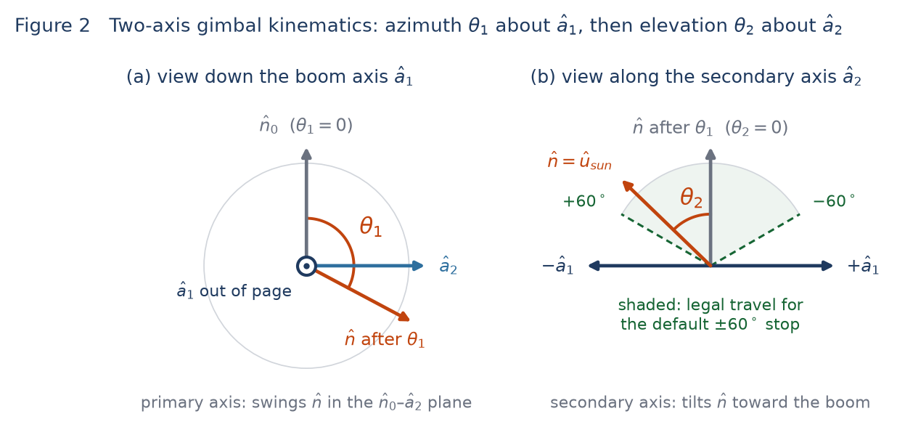
Figure 2. The two gimbal rotations. (a) Looking down the boom axis, the primary gimbal swings the normal through θ₁ in the plane spanned by the rest normal and the secondary axis. (b) In the perpendicular view, the secondary gimbal tips the normal through θ₂ toward the boom; the shaded sector is the legal travel left by the default ±60° stop.

5.4 The elevation singularity
An azimuth-over-elevation mount has a singularity where the inner axis points along the line of sight. Setting θ₂ = ±90° in the kinematics collapses the first two terms and leaves n_body = ∓â₁ regardless of θ₁: when the Sun lies exactly along the boom, the azimuth angle has no effect on where the panel points.
Near that configuration the azimuth command becomes ill-conditioned — a small motion of the Sun demands a large and fast change in θ₁. The simulator does not regularise this; it solves the exact inverse kinematics and lets the slew-rate limit absorb the excursion. The practical consequence is a brief azimuth “flip” whenever the Sun crosses the boom axis, visible in Figure 3. The energy cost is small, because near the singularity the elevation angle is close to ±90° and, as section 7.2 shows, an azimuth error there barely moves the normal.

6. Gimbal travel limits
Real solar array drives are not free to rotate forever. Cable harnesses and slip-ring designs impose an accumulated-travel budget, and simple mounts have hard mechanical stops. The simulator models both, and which one applies is inferred from the width of the interval the user enters rather than from a separate switch.

6.1 What the user enters
Field (PanelConfig) | Sidebar control | Default | Applies to
gimbal_min_deg / gimbal_max_deg | “Limit gimbal travel” / “Limit primary axis travel”, minimum and maximum angle | checked, −180° / +180° | 1-axis and 2-axis
gimbal2_min_deg / gimbal2_max_deg | “Limit secondary axis travel”, secondary minimum and maximum | checked, −60° / +60° | 2-axis only
max_slew_rate_deg_s | “Max slew (deg/s)” | 1.0 °/s | every limited axis

Note the distinction between the two kinds of default. PanelConfig leaves all four limit fields unset (None), which means unlimited travel; the sidebar, however, presents both limit checkboxes already ticked with ±180° and ±60°. A default run of the app is therefore a gimbal-limited run, and that is the case documented in section 9.
Validation happens in the PanelConfig model and rejects the combinations that have no physical meaning:
- A minimum and a maximum must be supplied together.
- The interval must contain the 0° rest position, and the maximum must exceed the minimum. This guarantees the drive can always sit at rest and that the interval is non-degenerate.
- Primary-axis limits are accepted only for one-axis and two-axis panels; a fixed panel has no drive to limit.
- Secondary-axis limits are accepted only for two-axis panels and must lie within ±90°, because the elevation angle is an arcsine and can never exceed that range.

6.2 Step one: unwrap the command into a continuous trajectory
The ideal angles come out of an arctangent and therefore live on (−180°, +180°]. A drive does not see it that way: a command that walks from +179° to −179° is a 2° motion, not a 358° one. Before any limit is applied the series is unwrapped into a continuous trajectory (numpy.unwrap on the radian series), which is also what makes accumulated travel a meaningful quantity. The time grid must be strictly increasing and must have one sample per geometry sample; both are checked.

6.3 Step two: cable wrap or hard stop
The span of the interval decides which of two very different behaviours applies:
if (maximum - minimum) >= 360 deg : cable-wrap limit, the drive can rewind
else : hard mechanical stop, the drive simply clamps
The reasoning is geometric. If the legal interval is at least a full turn wide then for any commanded angle θ there is always some equivalent angle θ + 360k inside the interval, which points the panel in exactly the same direction. The drive can therefore always keep tracking the Sun perfectly; the limit costs travel time, not incidence. If the interval is narrower than a full turn, no such equivalent angle need exist, and once the Sun leaves the reachable sector the panel has no choice but to sit at the stop and accept the cosine loss.

6.4 Cable-wrap mode: branch tracking and rewind
In cable-wrap mode (_rewind_branch_angles) the controller holds a branch index k and follows the target θ_ideal + 360k. The branch is kept as long as it stays legal, so the drive does not thrash between equivalent angles. When continuing on the current branch would leave the interval, a new legal branch is chosen — the one nearest the drive's current position, so the unwind is as short as possible — and the panel is flagged as rewinding until it arrives:
branch = nearest legal k to the current position
for each step i:
target = ideal_unwrapped[i] + 360 * branch
if target outside [minimum, maximum]:
branch = nearest legal k to actual[i-1] # pick a 360-deg-equivalent angle
target = ideal_unwrapped[i] + 360 * branch
rewinding = True
step = max_slew_rate * (t[i] - t[i-1])
actual[i] = clip( actual[i-1] + clip(target - actual[i-1], -step, +step),
minimum, maximum )
if actual[i] has reached target: rewinding = False
The rewind is not free. The drive turns through most of a revolution at its maximum slew rate, and the power model uses the array's actual orientation throughout, so generated power dips while the panel sweeps away from the Sun and back. The rewinding flag is carried through to the UI so those intervals can be marked on the angle chart. The model does not schedule rewinds opportunistically; a rewind begins at the moment continued tracking would cross a limit, even if waiting for the next eclipse would have been free.

6.5 Hard-stop mode: clamping
A hard stop (_hard_stop_angles) has no equivalent branch to escape to, so the logic collapses to a clamp of the unwrapped command followed by the same rate limit:
target = clip( ideal_unwrapped, minimum, maximum )
for each step i:
step = max_slew_rate * (t[i] - t[i-1])
actual[i] = clip( actual[i-1] + clip(target[i] - actual[i-1], -step, +step),
minimum, maximum )
rewinding = False everywhere
When the Sun goes out of reach the panel parks at the nearer stop and the incidence angle degrades smoothly — there is no discontinuity and no attempt to give up and return to rest. The reported target angle for a hard-stop axis is the clamped (legal) command, not the unreachable ideal one; the charts therefore show the target lying on the limit line while the drive is pinned.
The secondary axis of a two-axis panel is always treated as a hard stop. Its angle is an arcsine bounded to ±90°, so a 360°-wide interval cannot exist and a rewind is physically meaningless.

6.6 Rate limiting and the initial condition
Every limited axis is rate limited. At each step the drive may move at most max_slew_rate_deg_s multiplied by the actual time step, so a coarse time grid implicitly allows a larger per-step motion — the limit is a rate, not a per-sample cap. The move is then clamped into the legal interval a second time, which guarantees the reported angle never leaves the user's limits even transiently.
Both limited modes start the simulation with the drive already on its command rather than at the 0° rest position: actual[0] is set to target[0], which the branch selection and the clamp both guarantee lies inside the legal interval. Epoch is therefore a spacecraft that has been tracking all along, not one that has just deployed. Starting from rest instead would open every run with a slew of up to a full revolution — 180° taking three minutes in the default configuration — that belongs to the initial condition rather than to the orbit, and that shows up as the array visibly flipping in the first seconds of the Frames animation.
Two details follow from this. For a cable-wrap axis the starting branch is still the legal one nearest rest, so the drive begins unwound and the first rewind, if any, is driven by the orbit rather than by where the simulation happened to start. For a hard-stop axis whose Sun is already out of reach at epoch, the command is the clamped one, so the drive starts pinned at the nearer stop — that is a limit being hit, not a transient. Section 9.3 shows the first samples of the default case.

6.7 Recombining the two axes
For a limited two-axis panel the two axes are processed independently — each gets its own unwrap, limit mode, clamp and rate cap — and the achievable angles are then substituted back into the same kinematics used to derive them:
n_body = cos(th2_act) cos(th1_act) n0_hat
+ cos(th2_act) sin(th1_act) a2_hat
- sin(th2_act) a1_hat
n_eci = R n_body
This is a per-axis clamp, not a joint-workspace optimisation. When one axis saturates, the model does not re-solve the other axis to recover as much cosine as the remaining freedom would allow; it keeps commanding the unconstrained ideal on the free axis. For an azimuth-over-elevation mount that is both the honest representation of how a simple drive controller behaves and close to optimal in practice, but it is a modelling choice worth knowing about when interpreting a heavily saturated case.
The same substitution is applied to a limited one-axis panel, using its single angle to rebuild the normal about the boom axis. Because this recombination is exact, the drawn geometry and the computed power can never disagree — the normal used for the cosine is the same vector the Frames tab renders.

7. From orientation to power

7.1 The incidence factor
Once the actual normal is in ECI, the incidence factor is a clipped dot product, and the per-panel power follows:
cos_inc = clip( n_eci . u_sun_eci , 0 , 1 )

P = flux * area * cell_eff * packing * inherent * degradation
* (1 - temperature_loss) * cos_inc * illumination
The clip at zero is what makes a back-lit panel produce nothing rather than negative power. The illumination factor from the conical eclipse model multiplies in separately, so a panel that is perfectly pointed but in umbra produces nothing, and the gimbals keep tracking through eclipse rather than parking.

7.2 What a limit actually costs
Writing the ideal angles as (θ₁, θ₂) and the achieved angles as (θ₁', θ₂'), the dot product of the actual normal with the Sun reduces to the spherical law of cosines:
cos_inc = cos(th2') cos(th2) cos(th1' - th1) + sin(th2') sin(th2)
Two special cases make the behaviour easy to reason about, and both are worth keeping in mind when choosing limits:
- Elevation-only error — if the azimuth is on target, cos_inc = cos(θ₂ − θ₂'). The loss depends only on how many degrees the secondary axis fell short. A 30° shortfall costs 13%; a 10° shortfall costs 1.5%.
- Azimuth-only error — if the elevation is on target, cos_inc = 1 − cos²(θ₂)·(1 − cos Δθ₁). The penalty is scaled by cos² of the elevation angle, so azimuth errors are harmless near the singularity (θ₂ ≈ ±90°) and most expensive at θ₂ = 0. This is why the azimuth flip in Figure 3 costs so little.
Both identities were checked against the simulator over a full day of the default configuration and agree with the computed cos_inc to within 8×10⁻¹⁵, which is floating-point noise.

8. What the algorithm reports
panel_frames_eci returns a dictionary per panel, and array_power_watts stacks it across panels onto the results DataFrame. These are the series the Frames tab plots and the “Inspect frame” table reads:
Key | Shape | Meaning
normal_eci | (N, 3) | Actual panel normal in ECI, after all limits.
edge_eci | (N, 3) | In-plane direction used to draw the plate.
angle_deg | (N,) | 1-axis: the signed gimbal angle. 2-axis: the total slew angle from the rest normal to the actual normal.
target_angle_deg | (N,) | The legal commanded angle (1-axis), or the total slew angle to the Sun (2-axis).
angle1_deg / angle2_deg | (N,) | Actual primary and secondary axis angles. A 1-axis panel reports its angle as angle1 and zero for angle2.
target_angle1_deg / target_angle2_deg | (N,) | The corresponding commanded angles, after branch selection or clamping.
rewinding | (N,) | True while a cable-wrap axis is unwinding. Always False for hard stops.
cos_incidence | (N,) | The clipped cosine factor fed to the power model.

The difference between an angle series and its target series is exactly the pointing error introduced by the limits: they coincide whenever the drive is tracking freely and separate while it is slewing, rewinding or pinned at a stop.

9. Worked example with the default values
This section runs the algorithm end to end on the simulator's opening configuration, with the sidebar's default gimbal limits in force.

9.1 Inputs
Group | Setting | Default value
Mission | Epoch / duration / step | 2026-03-20 12:00:00 UTC / 1.0 day / 30 s (2881 samples)
Orbit | Perigee and apogee altitude | 1000 km circular (a = 7378.137 km, e = 0)
 | Inclination / RAAN / argument of perigee / true anomaly | 80° / 0° / 0° / 0°
Attitude | Mode / yaw axis | Nadir pointing / +X
Array | Number of wings, area | 2 wings on the ±X booms, 4.0 m² each
 | Rest normal / mounting / primary axis | +Z body / 2-axis tracking / (1, 0, 0) body
 | Primary limit / secondary limit / max slew | −180°…+180° / −60°…+60° / 1.0 °/s
 | Cell efficiency, packing, inherent, temp loss | 0.30, 0.85, 0.77, 0.10
 | Degradation / mission year / solar constant | 2.5 %/yr / year 0 / 1361 W/m²

Two consequences of these defaults set up everything that follows. First, both wings share one boom axis and one rest normal, so they are kinematically identical and generate identical power; the ±X naming only affects how they are drawn. Second, the effective per-panel factor — efficiency × packing × inherent degradation × (1 − temperature loss) — is 0.176715, so at the epoch flux of 1372.40 W/m² a perfectly pointed 4 m² wing makes 970.09 W and the array peaks at 1940.19 W.

9.2 Geometry at epoch
At t = 0 the satellite sits on the ECI +X axis at the ascending node. The propagator, ephemeris and attitude builder give:
r_eci = (7378.137, 0, 0) km v_eci = (0, 1.276338, 7.238474) km/s
R_hat = (1, 0, 0) W_hat = (0, -0.984808, 0.173648)
u_sun_eci = (0.999998, -0.001756, -0.000761) distance = 0.995838 AU
beta = +0.0915 deg (range over the day: -1.761 .. +0.091 deg)

R (body -> ECI) = [ 0 0 -1 ]
[ 0.173648 0.984808 0 ]
[ 0.984808 -0.173648 0 ]

+X_body -> (0, 0.173648, 0.984808) = velocity direction
+Y_body -> (0, 0.984808, -0.173648) = -W_hat
+Z_body -> (-1, 0, 0) = nadir
Rotating the Sun into the body frame gives ŝ = (−0.001054, −0.001597, −0.999998) — the Sun is almost exactly along −Zᵇ, which is zenith. That is the crux of the default geometry: the panel rest normal is +Zᵇ, the nadir face, so the Sun starts out behind the panels and the gimbals must swing nearly a half turn to see it. Projecting onto the triad:
p = s . n0_hat = -0.999998 q = s . a2_hat = +0.001597 r = s . a1_hat = -0.001054
theta1_ideal = atan2(q, p) = +179.9085 deg
theta2_ideal = -asin(r) = +0.0604 deg
The beta angle of 0.09° is the second decisive fact. The Sun lies essentially in the orbit plane, and the boom axis +Xᵇ is the along-track direction, which rotates through the orbit plane once per revolution. The Sun therefore sweeps past the boom axis twice per orbit — straight through the elevation singularity of section 5.4.

9.3 The first samples
Both drives begin on command. The azimuth command is already at +179.9° at epoch and the drive is there too, so nothing has to catch up: both axes track exactly from the first sample and the incidence factor is 1.0000 throughout. The elevation command walks away from rest at about 0.057 °/s, far inside the 1 °/s cap, so it is never rate limited either:
t (s) | θ₁ command | θ₁ actual | θ₂ command | θ₂ actual | cos(inc)
0 | +179.909° | +179.909° | +0.060° | +0.060° | 1.0000
30 | +179.909° | +179.909° | +1.771° | +1.771° | 1.0000
60 | +179.910° | +179.910° | +3.481° | +3.481° | 1.0000
90 | +179.910° | +179.910° | +5.191° | +5.191° | 1.0000
120 | +179.910° | +179.910° | +6.901° | +6.901° | 1.0000
150 | +179.911° | +179.911° | +8.612° | +8.612° | 1.0000
180 | +179.911° | +179.911° | +10.322° | +10.322° | 1.0000

It is worth seeing what the alternative would have cost. Had the drives started at the 0° rest position, the primary axis would have needed its full 180° of travel at 1 °/s — exactly 180 s, six samples — before the incidence factor first reached 1.0000, and the array would have been nearly edge-on to the Sun for the first two minutes of every run. Those six partly wasted samples are worth roughly 75 Wh over the day, which is essentially the whole difference between the “primary limit only” and “no limits” rows of the sensitivity table in section 9.6. The arithmetic is real, but it measures where the simulation happens to begin rather than anything about the orbit or the limits, which is why the model starts the drive on command instead.

9.4 One orbit in steady state
Sampled every ten minutes through the second revolution, the pattern is clear: the elevation axis does nearly all of the work, sweeping ±90° once per orbit and spending the extremes pinned at its ±60° stops, while the azimuth axis sits near 0° or ±180° and flips between them as the Sun crosses the boom.
t (s) | Sun in body frame (ŝ) | θ₁ ideal | θ₁ actual | θ₂ ideal | θ₂ actual | cos(inc)
6330 | (−0.016, +0.001, −1.000) | −179.96° | −179.96° | +0.93° | +0.93° | 1.0000
6930 | (−0.576, +0.001, −0.818) | −179.93° | −179.93° | +35.13° | +35.13° | 1.0000
7530 | (−0.936, +0.001, −0.353) | −179.80° | −179.80° | +69.34° | +60.00° | 0.9867
8130 | (−0.972, +0.001, +0.234) | −0.35° | −0.35° | +76.46° | +60.00° | 0.9590
8730 | (−0.672, +0.002, +0.740) | −0.13° | −0.13° | +42.25° | +42.25° | 1.0000 (eclipse)
9930 | (+0.441, +0.002, +0.898) | −0.14° | −0.14° | −26.16° | −26.16° | 1.0000 (eclipse)
10530 | (+0.869, +0.002, +0.495) | −0.27° | −0.27° | −60.37° | −60.00° | 1.0000
11130 | (+0.997, +0.003, −0.080) | −178.15° | −104.54° | −85.43° | −60.00° | 0.8745
11730 | (+0.780, +0.003, −0.626) | −179.74° | −179.74° | −51.22° | −51.22° | 1.0000
12330 | (+0.293, +0.003, −0.956) | −179.82° | −179.82° | −17.02° | −17.02° | 1.0000

The sample at t = 11130 s shows both mechanisms at once. The elevation command of −85.4° is beyond the −60° stop, and the azimuth is mid-flip at −104.5° against a command of −178.2° — a 73.6° lag imposed by the slew rate. Feeding those four angles into the spherical law of cosines from section 7.2 gives 0.500 × 0.0798 × cos 73.6° + 0.866 × 0.9968 = 0.8745, matching the simulator exactly. Note how little the 73.6° azimuth lag costs: because the elevation is at 60°, the azimuth penalty is scaled by cos²(60°) = 0.25.
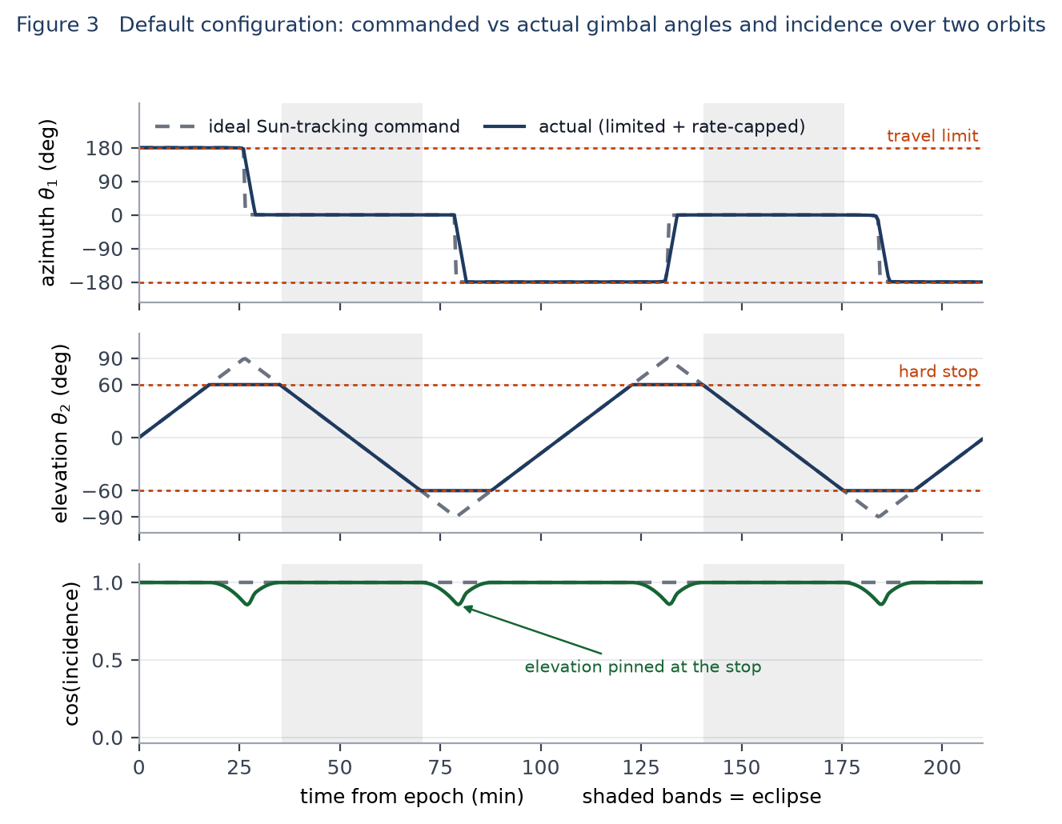
Figure 3. Two orbits of the default configuration. Top: the azimuth axis librates between 0° and ±180°, flipping as the Sun crosses the boom; the rate cap rounds each flip. Middle: the elevation command is a near-triangular sweep whose peaks are cut off by the ±60° stops. Bottom: the resulting incidence factor, which holds at 1.0 from epoch and dips shallowly at each saturation.

9.5 Statistics over the day
Quantity | Value
Orbital period / eclipse | 105.18 min; about 35 min of eclipse per orbit (sunlit 66.1% of the day)
Samples in sunlight | 1904 of 2881
Secondary axis pinned at a ±60° stop | 50.5% of sunlit samples
Largest secondary-axis shortfall | 29.84° (command reaches 89.84°)
Azimuth rate the ideal command demands | up to 5.92 °/s; exceeds the 1 °/s cap on 45 samples per day
Elevation rate demanded | at most 0.057 °/s — never rate limited
Mean cos(incidence) in sunlight | 0.9773 (minimum 0.8562)
Mean / 95th percentile / worst off-Sun angle | 7.50° / 27.53° / 31.10°
Cable-wrap rewinds | none — the azimuth command never leaves ±180°

That last line deserves emphasis. The default ±180° interval spans exactly 360°, so it is a cable-wrap limit and rewinds are available — but the azimuth librates rather than winding up, so the unwrapped command never leaves the interval and no rewind is ever triggered. Changing the primary limit to ±270° produces the same energy for the same reason. To see the rewind machinery exercised on this orbit the interval has to be offset rather than widened: −360°…0° is also a legal cable-wrap limit and triggers 12 rewind samples per day.

9.6 What the limits cost
Re-running the same default mission while changing only the limits isolates their effect on a day of generated energy:
Configuration | Energy (Wh/day) | vs unlimited | Mean cos(inc), sunlit
2-axis, no limits | 30 731.4 | — | 1.0000
2-axis, ±180° primary only | 30 729.5 | −0.01% | 0.9999
2-axis, ±180° and ±90° | 30 729.5 | −0.01% | 0.9999
2-axis, ±180° and ±60° (sidebar default) | 30 032.5 | −2.27% | 0.9773
2-axis, ±60° secondary only | 30 048.4 | −2.22% | 0.9778
2-axis, ±90° primary and ±60° secondary | 18 471.5 | −39.89% | 0.6016
1-axis about the same boom, unlimited | 16 654.3 | −45.8% | 0.5419
1-axis, ±180° (cable wrap) | 16 624.2 | −45.9% | 0.5409
1-axis, ±90° (hard stop) | 2 345.5 | −92.4% | 0.0769
Fixed panel on the +Z face | 2 006.7 | −93.5% | 0.0659

The ordering is instructive. A ±90° secondary stop costs almost nothing here because the elevation command peaks at 89.84° and barely clips it; tightening that same stop to ±60° costs 2.3%. Turning the primary axis from a cable wrap into a ±90° hard stop costs 40%, because the azimuth needs to reach ±180° and simply cannot. The one-axis rows show the geometric ceiling of section 5.2: with the Sun this close to the boom axis, |ŝ·â₁| averages 0.72 and no one-axis drive can average better than 0.54 on the cosine. The ±90° one-axis case collapses further still, because the rest normal faces nadir and the ideal command sits near ±180° — the exact opposite end of a ±90° travel range.
The slew rate matters much less than the travel limits, because only the brief azimuth flips are rate limited at all:
Max slew rate | 0.2 °/s | 0.5 °/s | 1.0 °/s (default) | 2.0 °/s | 10 °/s
Energy (Wh/day) | 29 103.9 | 29 938.8 | 30 032.5 | 30 046.7 | 30 048.4

Going from 1 °/s to effectively infinite rate recovers only 16 Wh of the 699 Wh the default limits cost; the rest is the ±60° elevation stop, which no amount of slew rate can fix. Dropping to 0.2 °/s, on the other hand, costs a further 929 Wh, because each azimuth flip then takes minutes. Note how much smaller the top-end recovery is than it looks in a model that starts from rest: with no start-up slew to pay for, a faster drive has only the flips left to improve.
For completeness, the default mission as a whole generates 30 032.5 Wh against 19 206.7 Wh of load, shunting 7088.3 Wh and reaching a minimum state of charge of 42.1%. That is a positive power budget, though it fails the configured 30% depth-of-discharge limit — a battery sizing question rather than a pointing one.

10. Assumptions, edge cases and limitations
- Kinematic, not dynamic — travel limits and a maximum rate are modelled; torque, inertia, controller lag, flexible-mode ringing and pointing jitter are not.
- Per-axis clamping — when a two-axis gimbal saturates on one axis, the other axis keeps following its unconstrained command rather than re-solving for the best reachable normal.
- Rewind scheduling — a cable-wrap rewind starts the moment continued tracking would cross a limit, with no attempt to defer it into an eclipse where it would be free.
- Already-tracking initial condition — limited drives start on their command rather than at 0°, so no run opens with a start-up slew. Acquisition and deployment sequences, and the energy they cost, are outside the model.
- No self-shadowing or structural blockage — a panel is lit whenever the spacecraft is lit and the cosine is positive; the bus, antennas and the opposite wing never cast shadows.
- No articulation feedback — the gimbal motion does not disturb the attitude, and the attitude solution never reacts to where the arrays are pointing.
- Sun-pointing attitude has a free phase — the rotation about the commanded Sun-pointing axis is resolved with a fixed ECI +Z hint vector. With the default panel normal this is harmless (the gimbals sit at rest), but for an off-axis panel with tight limits that arbitrary phase does influence the gimbal angles.
- Degenerate inputs are handled, not rejected — if the Sun lies parallel to a one-axis panel's rotation axis the projection vanishes and the code falls back to the rest normal; if a rotation axis is entered as the zero vector it is replaced by +Y body.
- Ephemeris accuracy — the low-precision solar series is good to roughly 0.01° for dates within a few decades of J2000, far finer than any pointing effect discussed here.
- Orbit model — secular J2 only. Over a single-day default run the node moves about one degree; over month-long runs the beta angle history, and hence the gimbal duty cycle, follows that precession.

11. Reproducing these results
Every number in section 9 comes from the package itself. The following script reproduces the geometry series for the default configuration with the sidebar's default limits:
import numpy as np
from energy_balance.attitude import body_to_eci
from energy_balance.config import SimulationConfig, SolarArrayConfig
from energy_balance.orbit import OrbitState, propagate_orbit
from energy_balance.solar_array import panel_frames_eci
from energy_balance.sun import sun_vector_eci

base = SimulationConfig() # the opening preset
panels = [p.model_copy(update={"gimbal_min_deg": -180.0, "gimbal_max_deg": 180.0,
"gimbal2_min_deg": -60.0, "gimbal2_max_deg": 60.0})
for p in base.solar_array.panels] # the sidebar defaults
cfg = base.model_copy(update={"solar_array": SolarArrayConfig(panels=panels)})

times = np.arange(0.0, 86400.0 + 1e-9, cfg.mission.time_step_s)
state = OrbitState(cfg.orbit, cfg.mission.epoch)
orbit = propagate_orbit(state, times)
sun = sun_vector_eci(cfg.mission.epoch, times)
R = body_to_eci(cfg.attitude, orbit["r_eci_km"], orbit["v_eci_km_s"],
sun["u_sun_eci"])

frames = panel_frames_eci(cfg.solar_array.panels[0], R, sun["u_sun_eci"], times)
print(frames["angle1_deg"][:8], frames["angle2_deg"][:8], frames["cos_incidence"][:8])
For the energy figures, run the whole simulation with run_simulation(cfg) and integrate the gen_w column over the time step. The per-panel geometry series are attached to the returned DataFrame as attributes (panel_angle1_deg, panel_angle2_deg, panel_cos_incidence, panel_rewinding, and the matching target series).

