How data was really acquired, any problems, lessons learned, etc., converted.
Originally use: Population Estimates Program (aka PEP), but resulting this:
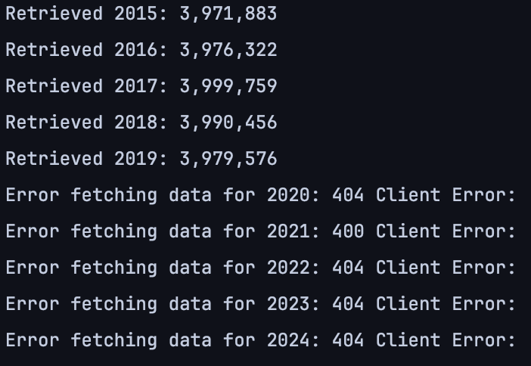
Reason:
2020: no release data in 2020 due to covid.
2021: the format has changed. (from a DATE_CODE parameter (7=2014, 8=2015, 9=2016, 10=2017, 11=2018, 12=2019) to (POP_2020, POP_2021...)
2022+: not available via API

Result: switch to ACS (American Community Survey) 1-Year Estimates

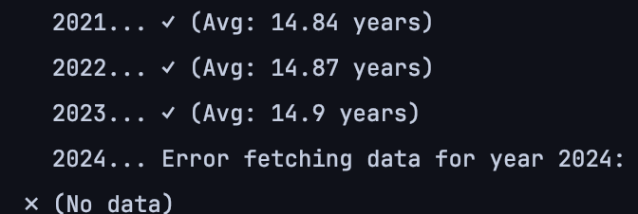
No data for education in ACS. (usually publish in December 2025 for the data in 2024)

During data combination step:
Combine the city image hard to see the trend line, even with an adaptive y-axis scale.
