Here are descriptive statistics for the analysis.

Departure from normal temperature (DNPT)

Min. 1st Qu. Median Mean 3rd Qu. Max. NA's

-184.00 -32.00 -2.00 -12.39 17.25 74.00 228

Monthly Mean by parameter value

analysis$Parameter.Name: Carbon monoxide

Min. 1st Qu. Median Mean 3rd Qu. Max.

0.2862 0.3302 0.4636 0.4132 0.4855 0.5084

analysis$Parameter.Name: Nitrogen dioxide (NO2)

Min. 1st Qu. Median Mean 3rd Qu. Max.

2.220 5.985 12.460 14.270 18.950 35.360

analysis$Parameter.Name: Sulfur dioxide

Min. 1st Qu. Median Mean 3rd Qu. Max.

-0.1735 -0.1708 0.1303 0.4622 1.0670 2.5120

summary(as.numeric(Climate.data.Utah.2013$ELEVATION))

Min. 1st Qu. Median Mean 3rd Qu. Max.

1.00 32.00 65.00 64.48 95.00 129.00

**The First model I ran for the pollutants and departure from normal temperature can be seen below. There was no effect of pollutants but there was for elevation. Only cases from the air quality data set and the climate data set are included.**

Linear mixed model fit by REML ['lmerMod']

Formula: DPNT ~ Parameter.Name * Arithmetic.Mean + as.numeric(ELEVATION) +

(1 | City.Name/DATE)

Data: analysis

REML criterion at convergence: 2535

Scaled residuals:

Min 1Q Median 3Q Max

-5.0173 -0.0051 0.0013 0.0057 4.4650

Random effects:

Groups Name Variance Std.Dev.

DATE:City.Name (Intercept) 2.815e+03 5.305e+01

City.Name (Intercept) 9.607e-13 9.801e-07

Residual 8.541e+00 2.922e+00

Number of obs: 420, groups: DATE:City.Name, 60; City.Name, 5

Fixed effects:

Estimate Std. Error t value

(Intercept) -23.71866 7.47753 -3.172

Parameter.NameNitrogen dioxide (NO2) 0.04887 2.43527 0.020

Parameter.NameSulfur dioxide 0.05753 2.48988 0.023

Arithmetic.Mean 0.17753 6.77463 0.026

**as.numeric(ELEVATION) 0.12775 0.03929 3.251**

Parameter.NameNitrogen dioxide (NO2):Arithmetic.Mean -0.17677 6.76536 -0.026

Parameter.NameSulfur dioxide:Arithmetic.Mean -0.16860 6.72119 -0.025

Correlation of Fixed Effects:

(Intr) Pr.NNd(NO2) Pr.NSd Arth.M a.(ELE P.NNd(NO2):

Pr.NNd(NO2) -0.343

Prmtr.NmSld -0.344 0.977

Arithmtc.Mn -0.343 0.965 0.968

a.(ELEVATIO -0.198 0.001 0.001 0.001

P.NNd(NO2): 0.343 -0.966 -0.968 -1.000 -0.001

Prm.NSd:A.M 0.342 -0.964 -0.970 -0.998 -0.001 0.998

**A second model was run on the all the climate data looking at the association between elevation, date and departures from normal temps. There was a positive association between elevation and DNPT and a significant variance component for date. The scatterplot at the bottom of this page suggests that this relationship is weak.**

Linear mixed model fit by REML ['lmerMod']

Formula: DPNT ~ as.numeric(ELEVATION) + (1 | City.Name/DATE)

Data: Climate.data.Utah.2013

REML criterion at convergence: 13378.8

Scaled residuals:

Min 1Q Median 3Q Max

-1.68058 -0.15650 0.07692 0.23403 2.06392

Random effects:

Groups Name Variance Std.Dev.

**DATE:City.Name (Intercept) 1652.0 40.64**

City.Name (Intercept) 0.0 0.00

Residual 210.8 14.52

Number of obs: 1296, groups: DATE:City.Name, 1260; City.Name, 111

Fixed effects:

Estimate Std. Error t value

(Intercept) -17.16465 2.37112 -7.239

**as.numeric(ELEVATION) 0.07278 0.03149 2.311**

Correlation of Fixed Effects:

(Intr)

a.(ELEVATIO -0.859

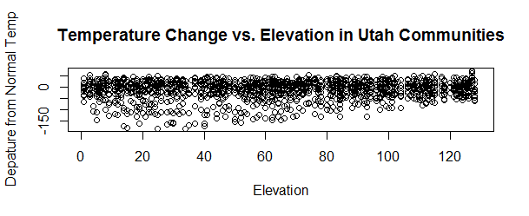

Climate.data.Utah.2013$DATE: 201301 – **January 2013**

**A significant positive correlation between elevation and departure from normal monthly temperatures in tenths of degrees Fahrenheit was found accounting for 32.4% of the variance (found by squaring the correlation coefficient). This effect was strongest for any month.**

Pearson's product-moment correlation

data: as.numeric(Climate.data.Utah.2013$ELEVATION) and Climate.data.Utah.2013$DPNT

t = 7.2287, df = 109, p-value = **7.073e-11**

alternative hypothesis: true correlation is not equal to 0

95 percent confidence interval:

0.4283024 0.6831575

sample estimates:

cor

**0.5692506**

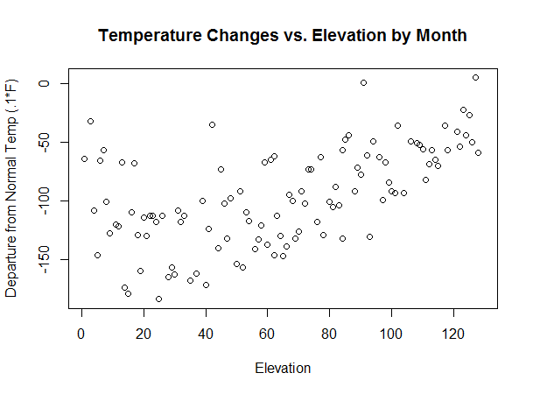

--------------------------------------------------------------------------

Climate.data.Utah.2013$DATE: 201302 – **February 2013**

**A significant positive association was found for February but it accounted for**

**16.1% of the variance.**

Pearson's product-moment correlation

data: as.numeric(Climate.data.Utah.2013$ELEVATION) and Climate.data.Utah.2013$DPNT

t = 4.5359, df = 107, p-value = **1.505e-05**

alternative hypothesis: true correlation is not equal to 0

95 percent confidence interval:

0.2309296 0.5482727

sample estimates:

cor

**0.4015871**

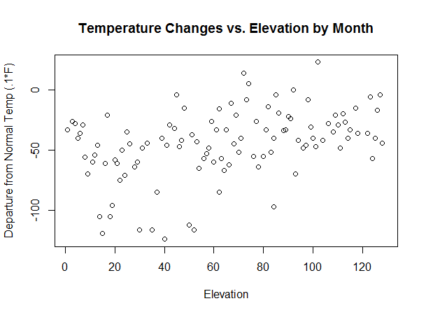

--------------------------------------------------------------------------

Climate.data.Utah.2013$DATE: 201303 – **March 2013**

**A significant association was found for elevation and temperature changes for March. This relationship accounted for 14.2% of the variance. All winter months showed a significant positive association with changes from normal temp.**

Pearson's product-moment correlation

data: as.numeric(Climate.data.Utah.2013$ELEVATION) and Climate.data.Utah.2013$DPNT

t = 4.2077, df = 107, p-value = **5.382e-05**

alternative hypothesis: true correlation is not equal to 0

95 percent confidence interval:

0.2030867 0.5275087

sample estimates:

cor

**0.3767945**

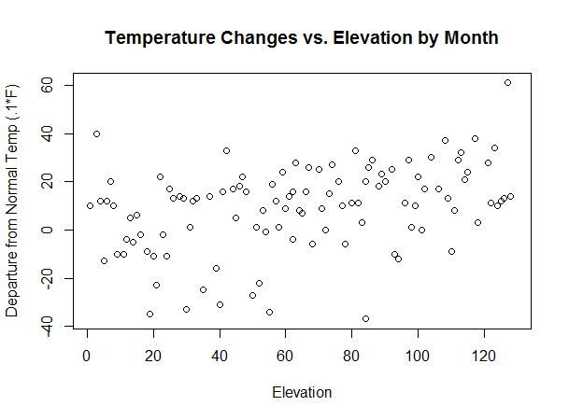

--------------------------------------------------------------------------

Climate.data.Utah.2013$DATE: 201304 - **April 2013**

**No significant relationship was found.**

Pearson's product-moment correlation

data: as.numeric(Climate.data.Utah.2013$ELEVATION) and Climate.data.Utah.2013$DPNT

t = 0.33499, df = 107, p-value = **0.7383**

alternative hypothesis: true correlation is not equal to 0

95 percent confidence interval:

-0.1566884 0.2191349

sample estimates:

cor

**0.03236731**

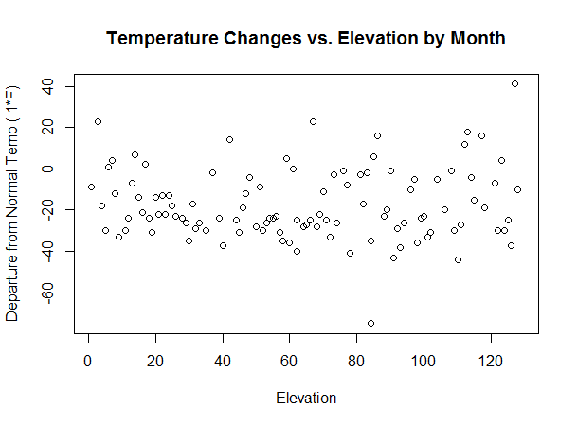

--------------------------------------------------------------------------

Climate.data.Utah.2013$DATE: 201305 – **May 2013**

**No significant relationship was found.**

Pearson's product-moment correlation

data: as.numeric(Climate.data.Utah.2013$ELEVATION) and Climate.data.Utah.2013$DPNT

t = -1.1199, df = 106, p-value = 0.2653

alternative hypothesis: true correlation is not equal to 0

95 percent confidence interval:

-0.29116167 0.08252263

sample estimates:

cor

-0.1081377

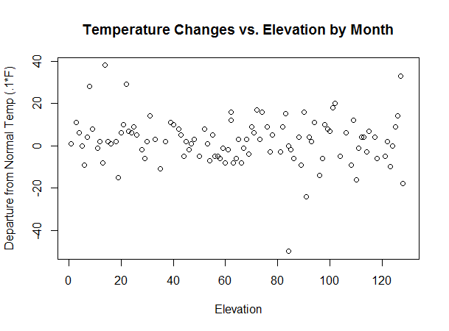

--------------------------------------------------------------------------

Climate.data.Utah.2013$DATE: 201306 – **June 2013**

**No significant relationship was found.**

Pearson's product-moment correlation

data: as.numeric(Climate.data.Utah.2013$ELEVATION) and Climate.data.Utah.2013$DPNT

t = 1.5214, df = 108, p-value = 0.1311

alternative hypothesis: true correlation is not equal to 0

95 percent confidence interval:

-0.04356991 0.32332534

sample estimates:

cor

0.1448533

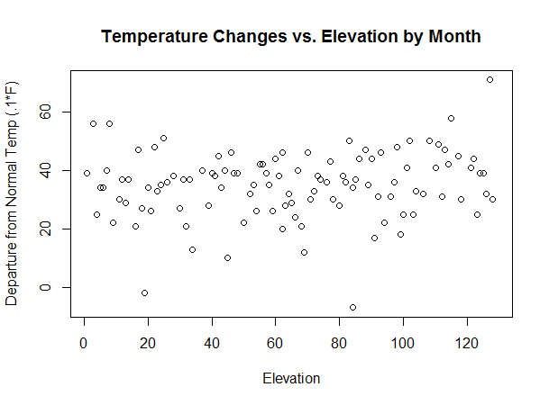

--------------------------------------------------------------------------

Climate.data.Utah.2013$DATE: 201307 **– July 2013**

**No significant relationship was found for July though it was close.**

Pearson's product-moment correlation

data: as.numeric(Climate.data.Utah.2013$ELEVATION) and Climate.data.Utah.2013$DPNT

t = -1.856, df = 105, p-value = **0.06625**

alternative hypothesis: true correlation is not equal to 0

95 percent confidence interval:

-0.35604028 0.01203598

sample estimates:

cor

**-0.1782297**

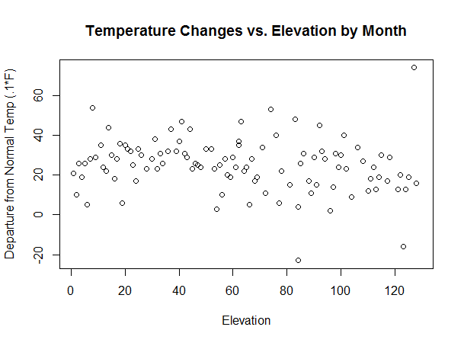

--------------------------------------------------------------------------

Climate.data.Utah.2013$DATE: 201308 – **August 2013**

**There was a significant negative correlation for August accounting for 8.1% of the variability in departures from normal temperature.**

Pearson's product-moment correlation

data: as.numeric(Climate.data.Utah.2013$ELEVATION) and Climate.data.Utah.2013$DPNT

t = -3.0996, df = 109, p-value = 0.002466

alternative hypothesis: true correlation is not equal to 0

95 percent confidence interval:

-0.4472774 -0.1037219

sample estimates:

cor

-0.2846124

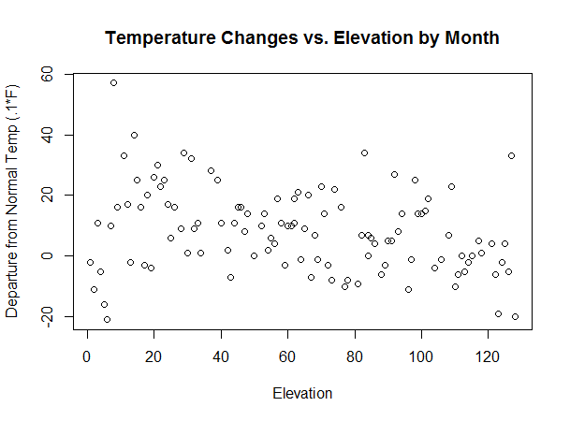

--------------------------------------------------------------------------

Climate.data.Utah.2013$DATE: 201309 – **September 2013**

**Like August, there was a significant negative correlation for September accounting for 8.9% of the variability. These two months had the only significant negative correlations.**

Pearson's product-moment correlation

data: as.numeric(Climate.data.Utah.2013$ELEVATION) and Climate.data.Utah.2013$DPNT

t = -3.2448, df = 107, p-value = 0.001569

alternative hypothesis: true correlation is not equal to 0

95 percent confidence interval:

-0.4614327 -0.1178429

sample estimates:

cor

-0.29931

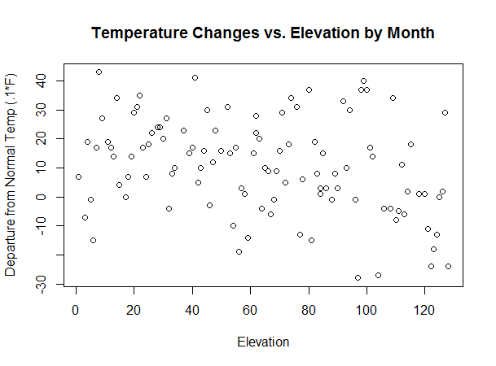

--------------------------------------------------------------------------

Climate.data.Utah.2013$DATE: 201310 – **October 2013**

**No significant relationship was found.**

Pearson's product-moment correlation

data: as.numeric(Climate.data.Utah.2013$ELEVATION) and Climate.data.Utah.2013$DPNT

t = -0.21298, df = 102, p-value = 0.8318

alternative hypothesis: true correlation is not equal to 0

95 percent confidence interval:

-0.2128074 0.1722041

sample estimates:

cor

-0.02108329

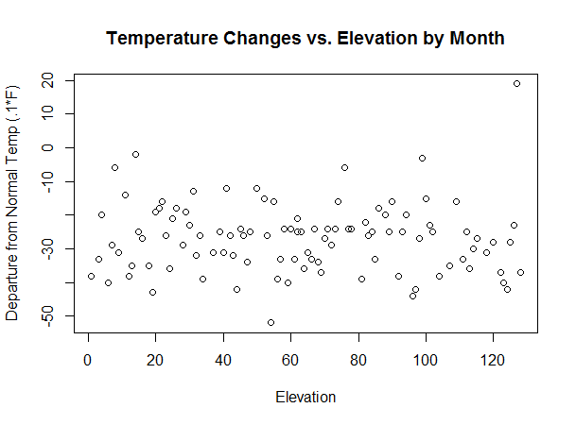

--------------------------------------------------------------------------

Climate.data.Utah.2013$DATE: 201311 – **November 2013**

**No significant relationship was found.**

Pearson's product-moment correlation

data: as.numeric(Climate.data.Utah.2013$ELEVATION) and Climate.data.Utah.2013$DPNT

t = -0.092593, df = 103, p-value = 0.9264

alternative hypothesis: true correlation is not equal to 0

95 percent confidence interval:

-0.2004379 0.1828619

sample estimates:

cor

-0.009123125

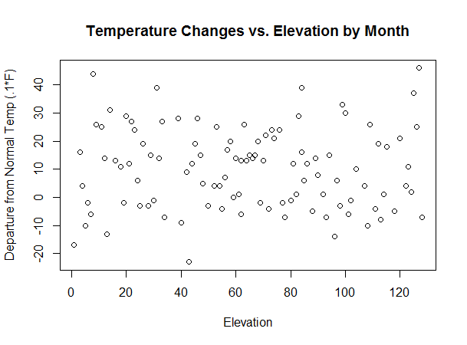

--------------------------------------------------------------------------

Climate.data.Utah.2013$DATE: 201312 – **December 2013**

**December had the second highest positive association between elevation and departure from normal temps a 27.8% of the variance.**

Pearson's product-moment correlation

data: as.numeric(Climate.data.Utah.2013$ELEVATION) and Climate.data.Utah.2013$DPNT

t = 6.2684, df = 102, p-value = **8.844e-09**

alternative hypothesis: true correlation is not equal to 0

95 percent confidence interval:

0.3726024 0.6535605

sample estimates:

cor

**0.5273487**

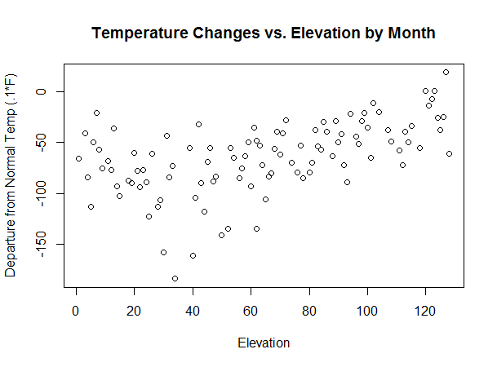

**Summary**

**There were no significant associations between air pollutants and departures from monthly normal temperatures (DPNT) for Utah. There were significant positive associations between elevation of the climate station and DPNT in the winter months of December thru March in 2013. This indicates that higher elevations have increased temperatures above their normal temps in winter months in Utah in 2013.**

**There were weaker significant negative correlations in the summer/fall months of August and September of the same year. This suggests that the higher elevations have somewhat lower temps than their normal temps in these months in 2013.**

**One should always be careful about concluding cause and effect relationships between variables from correlational data. If these results are found in other years and places, it does suggest that higher temperatures at higher elevations in the winter months have negative consequences for the snow pack in the mountains and thus the water runoff in the spring.**