TUGAS KECIL

Penyelesaian Cyberpunk 2077 Breach Protocol dengan Algoritma Brute Force



OLEH

JIMLY NUR ARIF

13522123

Dalam rangka memenuhi Tugas Kecil mata kuliah Strategi Algoritma

Teknik Informatika

STEI ITB

# Table of Contents

CheckList 2

Algoritma brute force 2

Source Program bf.py 2

Tangkapan layar 15

Pranala Repository 18

# CheckList

|  |  |  |
| --- | --- | --- |
| **Poin** | **Ya** | **Tidak** |
| 1. Program berhasil dikompilasi tanpa kesalahan | V |  |
| 2. Program berhasil dijalankan | V |  |
| 3. Program dapat membaca masukan berkas .txt | V |  |
| 4. Program dapat menghasilkan masukan secara acak | V |  |
| 5. Solusi yang diberikan program optimal | V |  |
| 6. Program dapat menyimpan solusi dalam berkas .txt | V |  |
| 7. Program memiliki GUI |  | V |

# Algoritma brute force

1. Deteksi ukuran matriks
2. Untuk setiap kolom pada baris pertama digunakan sebagai pangkal path
3. Setiap pangkal path dihasilkan segala kemungkinan dengan fungsi generate_pattern
4. Fungsi generate_pattern akan secara masif mencari pattern, misal belok kanan, maka langkah berikutnya ke atas, ke kanan lagi, dan ke bawah
5. Bila sudah mengenai dinding matriks harus belok
6. Untuk meningkat efisiensi, maka pembuatan pola akan terhenti bila perubahan arah pada pattern sudah melebihi jumlah buffer

# Source Program bf.py

import time

import random

def generate_patterns(n, m, max_len, buffer_size):

directions = [(0, 1), (0, -1), (1, 0), (-1, 0)] # Right, left, down, up directions

patterns = []

def search(x, y, path, change_dir, preddx, preddy):

if len(path) > max_len:

return

patterns.append(path[:])

for i in range(4):

dx, dy = directions[i]

nx, ny = x + dx, y + dy

if (len(path) > 1 or (dx, dy) == (1, 0)) and 0 <= nx < n and 0 <= ny < m and (nx, ny) not in path and change_dir < buffer_size:

if (preddx == dx or preddy == dy):

path.append((nx, ny))

search(nx, ny, path, change_dir, dx, dy)

else:

path.append((nx, ny))

search(nx, ny, path, change_dir + 1, dx, dy)

path.pop()

for i in range(m):

search(0, i, [(0, i)], 1, 0, 0)

return patterns

def deletePath(patterns):

for i in range(len(patterns)):

coordinates = patterns[i]

j = 1

while j < len(coordinates) - 1:

if coordinates[j][1] == coordinates[j - 1][1] and coordinates[j][1] == coordinates[j + 1][1]:

del coordinates[j]

elif coordinates[j][0] == coordinates[j - 1][0] and coordinates[j][0] == coordinates[j + 1][0]:

del coordinates[j]

else:

j += 1

return patterns

def developer_sequences_build():

sequences = [

['BD', 'E9', '1C'],

['BD', '7A', 'BD'],

['BD', '1C', 'BD', '55']

]

sequences_rewards = [10, 20, 30]

return sequences, sequences_rewards

def count_point(all_path, sequences, sequences_rewards):

path_reward = [0] * len(all_path)

for i, path in enumerate(all_path):

used_index = []

for j in range(len(path) - 1):

for k in range(j + 1, len(path)):

sequence = path[j:k + 1]

if sequence in sequences:

# Dapatkan indeks dari sequence dalam sequences

index = sequences.index(sequence)

# Jika indeks belum ada dalam used_index, tambahkan nilai dari sequences_rewards

if index not in used_index:

path_reward[i] += sequences_rewards[index]

# Tambahkan indeks ke used_index

used_index.append(index)

return path_reward

def path_biggest_point(path_reward, all_path):

biggest = max(path_reward)

if biggest == 0:

return "none","none"

index = path_reward.index(biggest)

path = all_path[index]

return path, biggest, index

def sequences_build():

number_of_sequences = int(input("Enter the number of sequences: "))

sequences = []

sequences_rewards = []

for i in range(number_of_sequences):

sequence = input("Enter the sequence {}: ".format(i + 1)).strip().split()

while len(sequence) < 2:

print("Sequence harus terdiri dari minimal dua elemen. Coba lagi.")

sequence = input("Enter the sequence {}: ".format(i + 1)).strip().split()

sequences.append(sequence)

sequences_reward = int(input("Enter the reward for sequence {}: ".format(i + 1)))

sequences_rewards.append(sequences_reward)

return sequences, sequences_rewards

def extractPath(results, matrix):

all_path = []

for i in range(len(results)):

coordinates = results[i]

values = [matrix[row][col] for row, col in coordinates]

all_path.append(values)

return all_path

def matrix_build():

matrix_dimensions = input("matrix_width matrix_height: ").split()

matrix_width = int(matrix_dimensions[1])

matrix_height = int(matrix_dimensions[0])

matrix = [[0 for i in range(matrix_width)] for j in range(matrix_height)]

matrix = []

print("Masukkan matriks (pisahkan elemen dengan spasi, baris baru untuk setiap baris):")

for _ in range(matrix_height):

row = input().strip().split()

while len(row) != matrix_width:

print("Error: Jumlah elemen harus sama jumlah kolom!!!")

print("Ulangi input baris terkini: ")

row = input().strip().split()

matrix.append(row)

return matrix_width, matrix_height, matrix

def matrix_build_txt(matrix_height, matrix_width):

matrix = [[0 for i in range(matrix_width)] for j in range(matrix_height)]

matrix = []

print("Masukkan matriks (pisahkan elemen dengan spasi, baris baru untuk setiap baris):")

for _ in range(matrix_height):

row = input().strip().split()

while len(row) != matrix_width:

print("Error: Jumlah elemen harus sama jumlah kolom!!!")

print("Ulangi input baris terkini: ")

row = input().strip().split()

matrix.append(row)

return matrix

def generate_random_sequences(token):

sequences = []

sequences_rewards = []

jumlah_sekuens = int(input("jumlah sekuens: "))

ukuran_maksimal_sekuens = int(input("ukuran maksimal sekuens: "))

for _ in range(jumlah_sekuens):

sequence_length = random.randint(2, ukuran_maksimal_sekuens)

sequence = [random.choice(token) for _ in range(sequence_length)]

sequences.append(sequence)

sequences_rewards.append(random.randint(1, 30))

return sequences, sequences_rewards

def matrix_generator(token, n, m):

matrix = []

for i in range(n):

row = []

for j in range(m):

row.append(random.choice(token))

matrix.append(row)

return matrix

def generate_random_sequence_txt(token, jumlah_sekuens, ukuran_maksimal_sekuens):

sequences = []

sequences_rewards = []

for _ in range(jumlah_sekuens):

sequence_length = random.randint(2, ukuran_maksimal_sekuens)

sequence = [random.choice(token) for _ in range(sequence_length)]

sequences.append(sequence)

sequences_rewards.append(random.randint(1, 30))

return sequences, sequences_rewards

def main():

file_name = "input.txt"

try:

with open(file_name, "r") as file:

# Inisialisasi counter baris

counter = 0

# Loop melalui setiap baris dalam file

for baris in file:

# Tambahkan 1 ke counter setiap kali loop

counter += 1

# Jika counter adalah 2, ini adalah baris kedua

if counter == 2:

# Split baris menjadi dua bagian

angka = baris.split()

# Pastikan terdapat dua angka

if len(angka) == 2:

# Periksa apakah keduanya bilangan angka

if angka[0].isdigit() and angka[1].isdigit():

method = "manual"

else:

method = "auto"

else:

method = "auto"

break

with open(file_name, "r") as file:

# method = file.readline().strip()

if method == "manual":

buffer_size = int(file.readline().strip())

matrix_width, matrix_height = map(int, file.readline().split())

matrix = [file.readline().split() for _ in range(matrix_height)]

max_len = matrix_width * matrix_height

sequences, sequences_rewards = [], []

number_of_sequences = int(file.readline().strip())

for _ in range(number_of_sequences):

sequence = file.readline().strip().split() # Membaca sequence

sequences.append(sequence)

sequence_reward = int(file.readline().strip()) # Membaca reward untuk sequence

sequences_rewards.append(sequence_reward)

print("loading... too big buffer_size can take a long time, please sabar \n")

start_time = time.time()

patterns = generate_patterns(matrix_height, matrix_width, max_len, buffer_size)

patterns = deletePath(patterns)

results = extractPath(patterns, matrix)

end_time = time.time()

path_reward = count_point(results, sequences, sequences_rewards)

path, biggest, path_biggest_index = path_biggest_point(path_reward, results)

biggest_path_Windexes = patterns[path_biggest_index]

runtime = round((end_time - start_time) * 1000)

print("biggest score = ", biggest)

# print(path)

print("path: ", end="")

for i in range(len(path)):

print(path[i], end=" ")

print("")

for point in biggest_path_Windexes:

print(f"{point[1]+1}, {point[0]+1}")

print("\n" + str(runtime) + " ms")

is_save = input("Apakah ingin menyimpan hasil ke file? (y/n): ")

# simpan tanpa prompt

if is_save == "y":

with open("../test/result.txt", "w") as file:

file.write(str(biggest) + "\n")

for i in range(len(path)):

file.write(str(path[i]) + " ")

file.write("\n")

for point in biggest_path_Windexes:

file.write(f"{point[1]+1}, {point[0]+1}\n")

file.write("\n" + str(runtime) + " ms")

print("Berhasil disimpan di result.txt")

elif method == "auto":

jumlah_token_unik = int(file.readline().strip())

token = file.readline().split() # misal bentuknya kek gini ['E9', 'B7', '8M']

while len(token) != jumlah_token_unik:

print("Error: Jumlah token harus", jumlah_token_unik, "!!!")

print("Ulangi input baris terkini: ")

token = input().strip().split()

buffer_size = int(file.readline().strip())

matrix_width, matrix_height = map(int, file.readline().split())

print("loading... too big buffer_size can take a long time, please sabar \n")

max_len = matrix_width * matrix_height

jumlah_sekuens = int(file.readline().strip())

ukuran_maksimal_sekuens = int(file.readline().strip())

sequences, sequences_rewards = generate_random_sequence_txt(token, jumlah_sekuens, ukuran_maksimal_sekuens)

matrix = matrix_generator(token, matrix_height, matrix_width)

for _ in range(len(matrix)):

print(matrix[_])

print("sequences: ", sequences)

print("sequences_rewards: ", sequences_rewards)

start_time = time.time()

patterns = generate_patterns(matrix_height, matrix_width, max_len, buffer_size)

patterns = deletePath(patterns)

results = extractPath(patterns, matrix)

end_time = time.time()

path_reward = count_point(results, sequences, sequences_rewards)

# print("path_reward:", path_reward)

path, biggest, path_biggest_index = path_biggest_point(path_reward, results)

biggest_path_Windexes = patterns[path_biggest_index]

runtime = round((end_time - start_time) * 1000)

print("biggest score = ", biggest)

# print(path)

print("path: ", end="")

for i in range(len(path)):

print(path[i], end=" ")

print("")

for point in biggest_path_Windexes:

print(f"{point[1]+1}, {point[0]+1}")

print("\n" + str(runtime) + " ms")

is_save = input("Apakah ingin menyimpan hasil ke file? (y/n): ")

if is_save == "y":

with open("../test/result.txt", "w") as file:

file.write(str(biggest) + "\n")

for i in range(len(path)):

file.write(str(path[i]) + " ")

file.write("\n")

for point in biggest_path_Windexes:

file.write(f"{point[1]+1}, {point[0]+1}\n")

file.write("\n" + str(runtime) + " ms")

print("Berhasil disimpan di result.txt")

else:

print("Invalid method input")

main()

except FileNotFoundError:

print(f"File '{file_name}' tidak ditemukan.")

if __name__ == "__main__":

main()

# Tangkapan layar

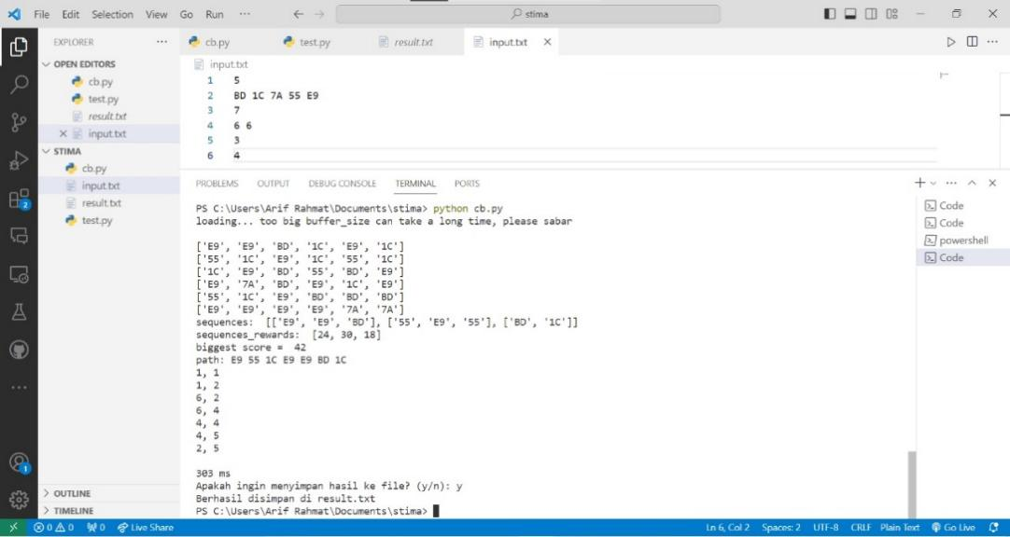

# Pranala Repository

<https://github.com/jimlynurarif/Tucil1_13522123>