**caTissue Suite v1.2**

***Integrated Biospecimen Banking***

***Information System***

**Building caTissue from source code**

Copyright and License page

**Copyright Notice.** Copyright 2010 Washington University in St. Louis (“caBIG® Participant”). caTissue was created with NCI funding and is part of the caBIG® initiative. The software subject to this notice and license includes both human readable source code form and machine readable, binary, object code form (the “caBIG® Software”).

This caBIG® Software License (the “License”) is between caBIG® Participant and You. “You (or “Your”) shall mean a person or an entity, and all other entities that control, are controlled by, or are under common control with the entity. “Control” for purposes of this definition means (i) the direct or indirect power to cause the direction or management of such entity, whether by contract or otherwise, or (ii) ownership of fifty percent (50%) or more of the outstanding shares, or (iii) beneficial ownership of such entity.

**License.** Provided that You agree to the conditions described below, caBIG® Participant grants You a non-exclusive, worldwide, perpetual, fully-paid-up, no-charge, irrevocable, transferable and royalty-free right and license in its rights in the caBIG® Software, including any copyright or patent rights therein, to (i) use, install, disclose, access, operate, execute, reproduce, copy, modify, translate, market, publicly display, publicly perform, and prepare derivative works of the caBIG® Software in any manner and for any purpose, and to have or permit others to do so; (ii) make, have made, use, practice, sell, and offer for sale, import, and/or otherwise dispose of caBIG® Software (or portions thereof); (iii) distribute and have distributed to and by third parties the caBIG® Software and any modifications and derivative works thereof; and (iv) sublicense the foregoing rights set out in (i), (ii) and (iii) to third parties, including the right to license such rights to further third parties. For sake of clarity, and not by way of limitation, caBIG® Participant shall have no right of accounting or right of payment from You or Your sublicensees for the rights granted under this License. This License is granted at no charge to You. Your downloading, copying, modifying, displaying, distributing or use of caBIG® Software constitutes acceptance of all of the terms and conditions of this Agreement. If you do not agree to such terms and conditions, you have no right to download, copy, modify, display, distribute or use the caBIG® Software.

1. Your redistributions of the source code for the caBIG® Software must retain the above copyright notice, this list of conditions and the disclaimer and limitation of liability of Article 6 below. Your redistributions in object code form must reproduce the above copyright notice, this list of conditions and the disclaimer of Article 6 in the documentation and/or other materials provided with the distribution, if any.
2. Your end-user documentation included with the redistribution, if any, must include the following acknowledgment: “This product includes software developed by Washington University in St. Louis.” If You do not include such end-user documentation, You shall include this acknowledgment in the caBIG® Software itself, wherever such third-party acknowledgments normally appear.
3. You may not use the names ”Washington University in St. Louis”, “The National Cancer Institute”, “NCI”, “Cancer Bioinformatics Grid” or “caBIG®” to endorse or promote products derived from this caBIG® Software. This License does not authorize You to use any trademarks, service marks, trade names, logos or product names of either caBIG® Participant, NCI or caBIG®, except as required to comply with the terms of this License.
4. For sake of clarity, and not by way of limitation, You may incorporate this caBIG® Software into Your proprietary programs and into any third party proprietary programs. However, if You incorporate the caBIG® Software into third party proprietary programs, You agree that You are solely responsible for obtaining any permission from such third parties required to incorporate the caBIG® Software into such third party proprietary programs and for informing Your sublicensees, including without limitation Your end-users, of their obligation to secure any required permissions from such third parties before incorporating the caBIG® Software into such third party proprietary software programs. In the event that You fail to obtain such permissions, You agree to indemnify caBIG® Participant for any claims against caBIG® Participant by such third parties, except to the extent prohibited by law, resulting from Your failure to obtain such permissions.
5. For sake of clarity, and not by way of limitation, You may add Your own copyright statement to Your modifications and to the derivative works, and You may provide additional or different license terms and conditions in Your sublicenses of modifications of the caBIG® Software, or any derivative works of the caBIG® Software as a whole, provided Your use, reproduction, and distribution of the Work otherwise complies with the conditions stated in this License.
6. THIS caBIG® SOFTWARE IS PROVIDED "AS IS" AND ANY EXPRESSED OR IMPLIED WARRANTIES (INCLUDING, BUT NOT LIMITED TO, THE IMPLIED WARRANTIES OF MERCHANTABILITY, NON-INFRINGEMENT AND FITNESS FOR A PARTICULAR PURPOSE) ARE DISCLAIMED. IN NO EVENT SHALL WASHINGTON UNIVERSITY IN ST. LOUIS OR ITS AFFILIATES BE LIABLE FOR ANY DIRECT, INDIRECT, INCIDENTAL, SPECIAL, EXEMPLARY, OR CONSEQUENTIAL DAMAGES (INCLUDING, BUT NOT LIMITED TO, PROCUREMENT OF SUBSTITUTE GOODS OR SERVICES; LOSS OF USE, DATA, OR PROFITS; OR BUSINESS INTERRUPTION) HOWEVER CAUSED AND ON ANY THEORY OF LIABILITY, WHETHER IN CONTRACT, STRICT LIABILITY, OR TORT (INCLUDING NEGLIGENCE OR OTHERWISE) ARISING IN ANY WAY OUT OF THE USE OF THIS caBIG® SOFTWARE, EVEN IF ADVISED OF THE POSSIBILITY OF SUCH DAMAGE.

Document Change History

|  |  |  |  |
| --- | --- | --- | --- |
| Version Number | Date | Description | Contributor |
| 1.0 | 3/15/2011 | Updates for caTissue Suite 1.2 deployment | caTissue Release 1.2 Development Team , Dave Mulvihill |
| 1.1 | 3/18/2011 | Various grammatical updates | Dave Mulvihill/Brent Lander |

ng

|  |  |
| --- | --- |
| **Contacts and Support** | |
| Knowledge Center Main Page | <https://cabig-kc.nci.nih.gov/Biospecimen/KC/index.php/Main_Page> |
| Knowledge Center Discussion Forum | <https://cabig-kc.nci.nih.gov/Biospecimen/forums/> |
| Knowledge Center Contact | [tbpt_kc_support@mga.wustl.edu](mailto:tbpt_kc_support@mga.wustl.edu) |

**Table of Content**

Contents

1. Introduction 6

2. Prerequisites 6

Set up Development Environment (Eclipse IDE) 7

3. Get the Source 10

4. Setup caTissue Code in Eclipse IDE 12

5. Building dependent jar files 20

6. Compile, build and deploy 22

7. Generating caCORE API 23

# Introduction

This document describes the steps to build caTissue from source code and setting up the development environment for caTissue Suite source code. Following are the high level steps of building caTissue code:

1. Install/Setup pre-requisite software.
2. Setup Eclipse IDE.
3. Checkout the code from CVS or download the source code archive
4. Setup the build path of source code in Eclipse IDE.
5. Run Ant commands to build application, deploy application, and create database schemas.

# Prerequisites

Before tring to build, have the correct tools, and configure these tools correctly. Information on pre-requisite configuration (such as memory size) can be found in the deployment guide for a specific caTissue version.

***JDK 1.5***

Download the JDK 1.5 and install it to a desired location e.g. C:\JDK 1.5.

***Eclipse*** <http://www.eclipse.org/downloads/>

Download the Eclipse 3.2.2 or higher version and install it to a desired location e.g. C:\ECLIPSE.

***ANT*** <http://ant.apache.org/>

Download the ANT version (as supported by specific version of caTissue) and install it to a desired location e.g. C:\ANT.

***MySQL/Oracle***

Install the MYSQL/Oracle database version (as supported by specific version of caTissue) and install it to a desired location

***JBoss***

Download the JBoss version (as supported by specific version of caTissue) and install it to a desired location e.g. C:\JBOSS.

Following table list the supported version of pre-requisite of specific caTissue version.

|  |  |
| --- | --- |
| **Pre-requisites** | **caTissueSuite v1.1** |
| JDK | 1.5 |
| JBoss | 4.2.2 GA |
| MySQL | 5.0.45 |
| Oracle | 10.2.0.2 |
| Ant | 1.7 |

Table - Required Software and Versions

Please refer to the following notations used throughout the document

|  |  |
| --- | --- |
| **Keyword** | **Comment** |
| ECLIPSE_HOME | The folder location where Eclipse is installed e.g. F:\Eclipse |
| WORKSPACE | The folder location which is a eclipse workspace where you placed a source code. e.g. F:\Workspace |
| CATISSUE_HOME | The folder location where the caTissue placed source code is copied inside WORKSPACE e.g. F:\Workspace\Catissuecore |
| JAVA_HOME | The folder location where JDK is installed  e.g. C:\JDK1.5 |
| JBOSS_HOME | The folder location where Jboss is installed  e.g. F:\Jboss 4.2.2.GA |
| ANT_HOME | The folder location where Ant is installed  e.g. C:\Ant |
| MYSQL_HOME | The folder location where MySQL client is installed  e.g. C:\MySQL |
| ORACLE_HOME | The folder location where Oracle client is installed  e.g. C:\Oracle |

Table - Required Environment Variables for Locations

### Set up Development Environment (Eclipse IDE)

In this document, Eclipse 3.2.2 IDE (on Windows platform) is used for demonstration. IDE setup includes configuring correct version of tools like JDK, Ant version.

1. Open the Eclipse IDE
2. Select the folder where you wish to check out the code i.e. ”WORKSPACE_HOME”

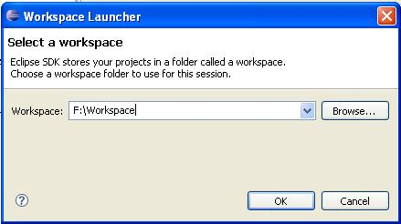

1. Open Java Perspective from Windows -> Open Perspective -> Java

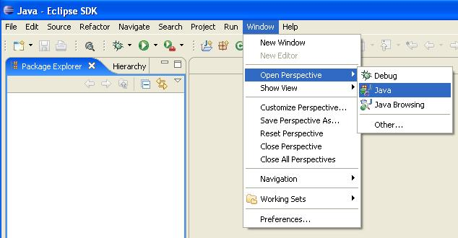

1. Open Eclipse environment preferences window from menu Windows -> Preferences
2. In Preference window from left hand side tree select Java -> Installed JREs and select JDK 1.5 or ”JAVA_HOME”

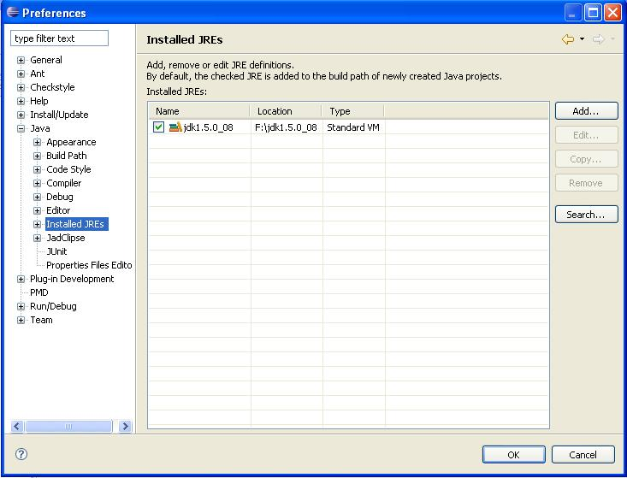

1. Select Java -> Compiler and set Java Compiler to 5.0 in preference Window

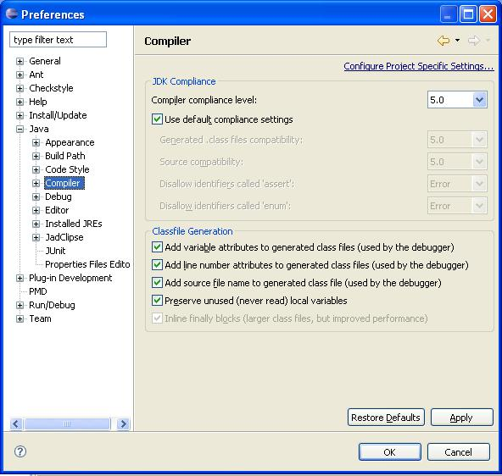

1. Set “ANT_HOME” in Preference Window -> Ant -> Runtime

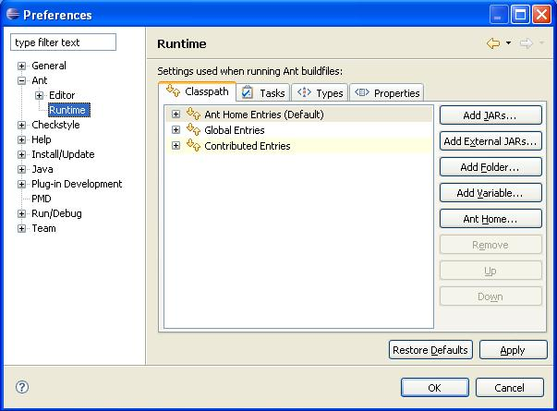

1. Click Ant Home button and select the “ANT_HOME” folder

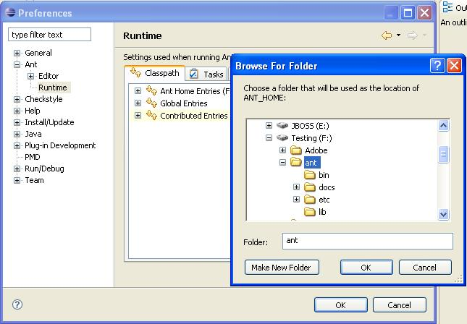

1. Click OK and save the preferences.

# Get the Source

Download the code from <https://ncisvn.nci.nih.gov/svn/catissue_persistent/catissuecore/tags/caTissue_v1.2_RC6_15MAR2011_TAG> under desired release package (for example, caTissue Suite v1.2 – RC6 Release).

After downloading the source code, unzip it to desired location i.e. “CATISSUE_HOME”.

The complete list of project dependencies is listed in the following table.

| **Project** | **Branch** | **Tag** |
| --- | --- | --- |
| catissue_persistent | <https://ncisvn.nci.nih.gov/svn/catissue_persistent/catissuecore/branches/caTISSUE_SUITE_v12_BRANCH/> | <https://ncisvn.nci.nih.gov/svn/catissue_persistent/catissuecore/tags/caTissue_v1.2_RC6_15MAR2011_TAG> |
| dynamic_extensions | <https://ncisvn.nci.nih.gov/svn/dynamic_extensions/branches/branches_DynamicExtensions/DynamicExtension_1.4.2_Catissue1.2_15_July_2010/> | <https://ncisvn.nci.nih.gov/svn/dynamic_extensions/tags/DYN_EXTN_v1.4.2.1.RC2_15OCT10_TAG/> |
| catissue_advanced_query | <https://ncisvn.nci.nih.gov/svn/catissue_advanced_query/branches/branches_AdvancedQuery/AQ_V121FC_Branch_28_Jan_2010/> | <https://ncisvn.nci.nih.gov/svn/catissue_advanced_query/tags/legacy_tags_AdvancedQuery/AQ_V124_RC2_15OCT10_TAG/> |
| metadata_based_query | <https://ncisvn.nci.nih.gov/svn/metadata_based_query/query/branches/autoRoundCF> | <https://ncisvn.nci.nih.gov/svn/metadata_based_query/query/tags/QUERY_v1_RC3_21OCT10_TAG> |
| catissue_cacore_sdk | <https://ncisvn.nci.nih.gov/svn/catissue_cacore_sdk/branches/CACORE_SDK_321_BRANCH> | <https://ncisvn.nci.nih.gov/svn/catissue_cacore_sdk/tags/CaCoreSDK_RC2_15OCT10_TAG> |
| caGRIDSDKQuery32 | <https://ncisvn.nci.nih.gov/svn/catissue_persistent/caGRIDSDKQuery32/branches/CAGRIDSDKQUERY32_BRANCH> | <https://ncisvn.nci.nih.gov/svn/catissue_persistent/caGRIDSDKQuery32/tags/caTISSUE_CaGRIDSDKQUERY_RC2_18OCT10_TAG> |
| keyword_search | <https://ncisvn.nci.nih.gov/svn/keyword_search/TiTLi/branches/TiTLi_WashU> | <https://ncisvn.nci.nih.gov/svn/keyword_search/TiTLi/tags/TiTLi_WashU_V10_RC2_15OCT10_TAG> |
| catissue_idp_authentication_manager | <https://ncisvn.nci.nih.gov/svn/catissue_idp_authentication_manager/trunk> | <https://ncisvn.nci.nih.gov/svn/catissue_idp_authentication_manager/tags/IDP_v10_RC2_15OCT10_TAG> |
| catissue_participant_manager | <https://ncisvn.nci.nih.gov/svn/catissue_participant_manager/branches/ParticipantManager_Branch_For_caTissue_Without_EMPI> | <https://ncisvn.nci.nih.gov/svn/catissue_participant_manager/tags/ParticipantManager_RC2_15OCT10_TAG> |
| catissue_migration_tool | <https://ncisvn.nci.nih.gov/svn/catissue_migration_tool/MigrationTool/branches/BULK_OPERATION_FOR_CATISSUE_V12_RELEASE> | <https://ncisvn.nci.nih.gov/svn/catissue_migration_tool/MigrationTool/tags/BulkOperation_RC2_15OCT10_TAG> |
| wustl_common_package | <https://ncisvn.nci.nih.gov/svn/wustl_common_package/CommonPackage/branches/CP_Branch_For_KeySequenceGen_26_APR_2010> | <https://ncisvn.nci.nih.gov/svn/wustl_common_package/CommonPackage/tags/CommonPackage_v11837_RC5_29NOV10_TAG> |
| catissue_dao | <https://ncisvn.nci.nih.gov/svn/catissue_dao/DAO/branches/DAO/> | <https://ncisvn.nci.nih.gov/svn/catissue_dao/DAO/tags/DAO_v1195_30March10_TAG> |
| wustl_common_utilities | <https://ncisvn.nci.nih.gov/svn/wustl_common_utilities/washu-commons/branches/dev_branch/> | <https://ncisvn.nci.nih.gov/svn/wustl_common_utilities/washu-commons/tags/WashuCommons_V117_RC2_15OCT10_TAG> |
| catissue_simple_query | <https://ncisvn.nci.nih.gov/svn/catissue_simple_query/SimpleQuery/branches/SimpleQuery_V11921_27MAY_2010_BRANCH/> | <https://ncisvn.nci.nih.gov/svn/catissue_simple_query/SimpleQuery/tags/SimpleQuery_v11922_RC2_15OCT10_TAG> |
| catissue_security_manager | <https://ncisvn.nci.nih.gov/svn/catissue_security_manager/SecurityManager/branches/SecurityManager/> | <https://ncisvn.nci.nih.gov/svn/catissue_security_manager/SecurityManager/tags/SecurityManager_V1172_10Feb10_TAG> |
| catissue_CAS | <https://ncisvn.nci.nih.gov/svn/catissue_CAS/trunk> | <https://ncisvn.nci.nih.gov/svn/catissue_CAS/tags/CAS_v10_RC2_19OCT10_TAG> |

Table - Software Dependencies Mapped to SVN

# Setup caTissue Code in Eclipse IDE

**Note**: The user can build caTissue without going through IDE by running ant commands from the command prompt. Section 6 has details on using ant this way.

For users who wish to use the Eclipse IDE, follow the below steps:

Setup the build path required for caTissue source code. This includes verifying the JRE/JDK version, configure the source code folder and add required libraries.

1. Before any step, verify the JRE version used by Eclipse for caTissue project. Right click caTissue project and select Project properties

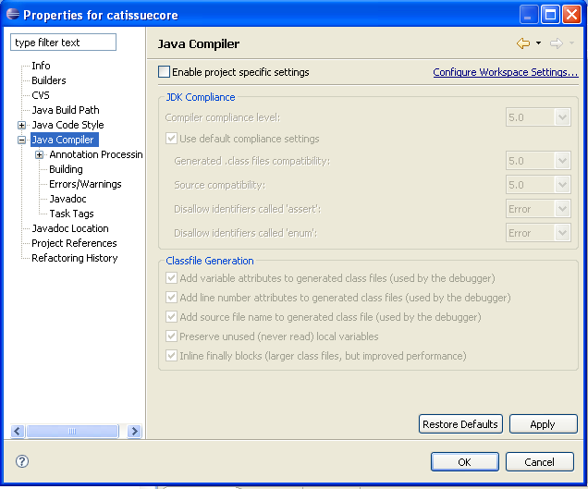

1. Ensure the “Source folder on build path:” points to the correct source code location. Select Java Build Path from the left hand side tree of the Properties window. In Source tab, make sure the source folder points to CATISSUE_HOME/WEB-INF/src folder

and default output folder points to

CATISSUE_HOME/WEB-INF/classes

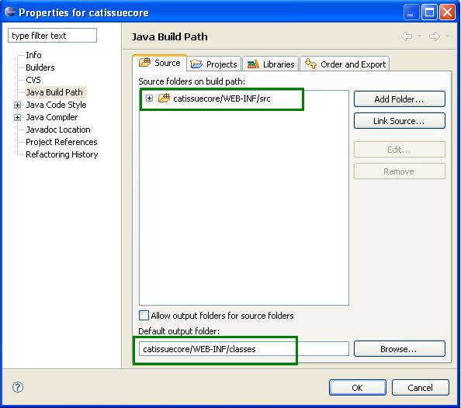

1. Select the Libraries Tab. In Libraries Tab, remove the entries (if present) as shown below by selecting the entries and clicking the Remove button.

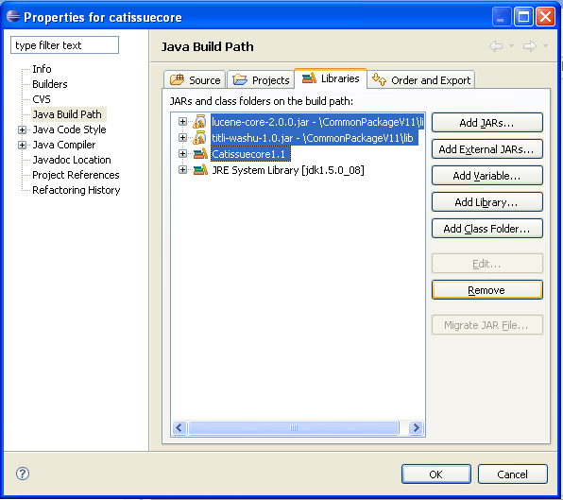

1. From the Libraries Tab, create new User Libraries as follows
   1. Click Add Library
   2. In Add Library window select User Library and click Next

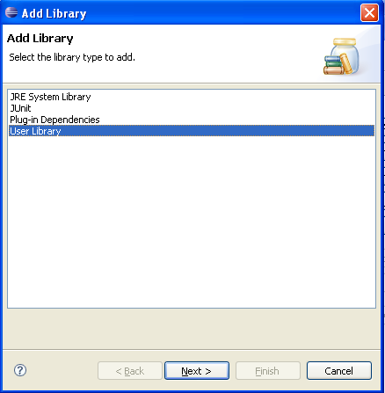

* 1. In the User Library window, click User Libraries button

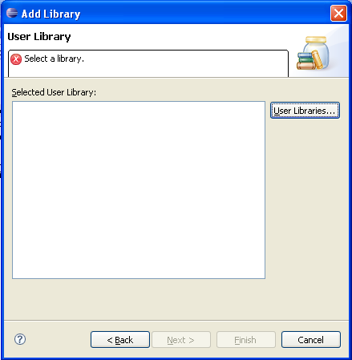

* 1. In the Create User Libraries window, click New

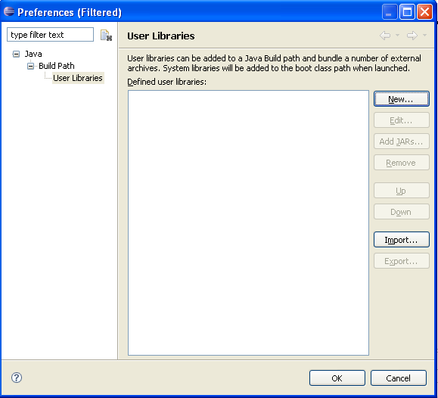

* 1. Enter the User library name and click OK.

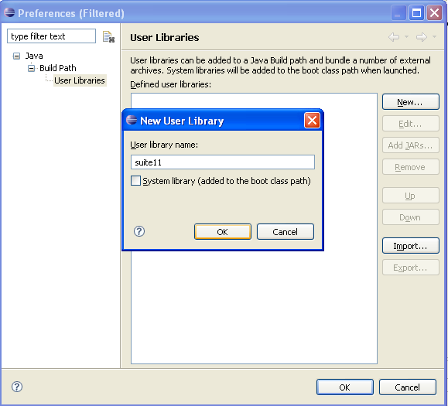

* 1. From User libraries window click Add JARS… button. In the JAR Selection window, select all *.jar files from CATISSUE_HOME/WEB-INF/lib folder and click Open.

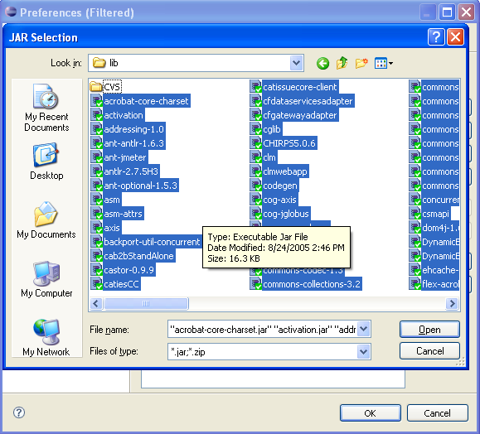

* 1. Click OK on the User Libraries Window

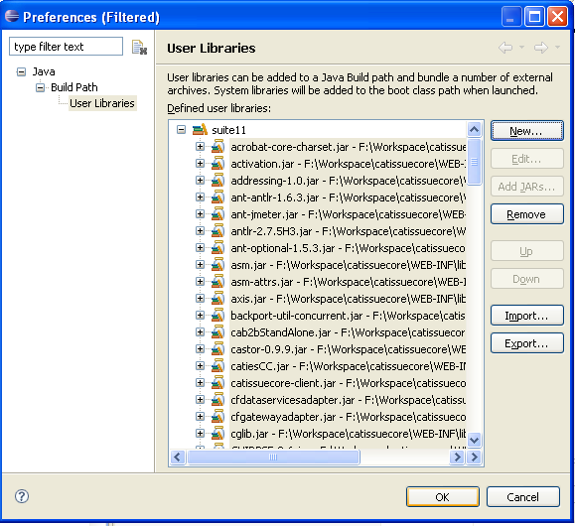

* 1. Ensure the created library is checked and click the Finish button

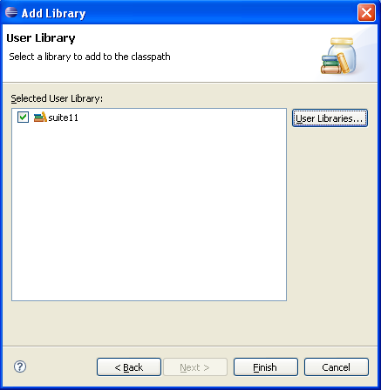

* 1. Make sure the created user library is added in Build Path and click OK on properties window

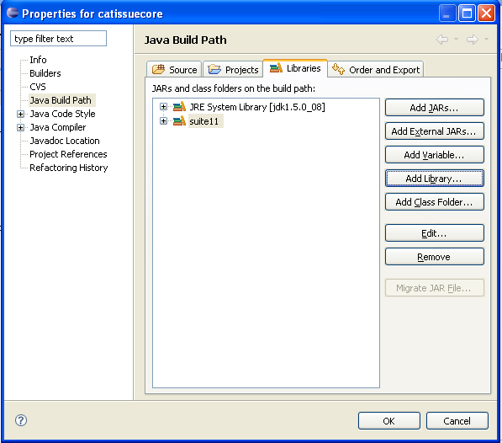

1. Now Eclipse should able to compile the source code
2. To build and deploy the caTissue web application archive use Ant targets available in CATISSUE_HOME/build.xml and CATISSUE_HOME/deploy.xml

# Building dependent jar files

*Figure 1: caTissue Architecture*

As seen in the above architecture diagram, caTissue is modular, with different modules for capabilities like query, dynamic extensions. The modules design is generic; they can be reused in multiple projects easily. Due to this, source code of such modules is not part of the main code base (e.g., SVN repository) of caTissue but exist as separate SVN projects. Only the jar files are included in the lib of caTissue. This section describes the process to generate the jars if one wishes to change the source code in any of these modules.

1. Building dynamic extensions code – Execute the following ant targets from the root folder of dynamic extensions source code.
2. Compile the code:

>ant compile

1. Create dynamic extensions jar

>ant create_dyn_ext_interface_jar

This creates the jar in DynamicExtensionsInterface folder within dynamic extensions source code. Copy this and replace in <caTissue-SourceCodeFolder>/WEB-INF/lib

1. Create DynamicExtensionsCommunication.jar

>ant create_dyn_ext_communication_jar

This creates the file DynamicExtensionsCommunication.jar in the root folder of dynamic extensions source code. Copy this file and replace in   
<caTissue-SourceCodeFolder>/WEB-INF/lib

1. Finally create the dynamic extensions war

>ant build_app_war

This creates war file in root folder of dynamic extensions source code. Copy this file and place in <caTissue-SourceCodeFolder>

1. Building caB2B code - Execute the following ant target from the build folder of caB2B source code:

>ant build.standalone.jar

This compiles the code and creates the cab2bStandAlone.jar in the workarea folder of the caB2B source code. Replace this jar in <caTissue-SourceCodeFolder>/WEB-INF/lib

1. Building common package code - Execute the following ant target from the common package source code folder:

>ant build_jar

This compiles the code and creates the commonpackage.jar in the build folder of the caB2B source code. Replace this jar in <caTissue-SourceCodeFolder>/WEB-INF/lib

1. Building Advance Query code – Execute the following ant target from the advance query source code folder:

>ant build.jar

This compiles the code and creates the query.jar in the workarea folder of the Advance_Query source code. Replace this jar in <caTissue-SourceCodeFolder>/WEB-INF/lib

1. Building Metadata code - Execute the following ant target from the metadata source code folder:

>ant build.jar

This compiles the code and creates the metadata.jar in the workarea folder of the Metadata source code. Replace this jar in <caTissue-SourceCodeFolder>/WEB-INF/lib

1. Building Washu-Commons code - Execute the following ant target from the Washu-Commons source code folder:

>ant build.jar

This compiles the code and creates the washu-commons.jar in the workarea folder of the Washu-Commons source code. Replace this jar in <caTissue-SourceCodeFolder>/WEB-INF/lib

1. Building ShippingTracking code –
   1. Create the following folders
      1. tempShippingTracking in base directory
      2. classes folder in WEB-INF directory
   2. Execute the following ant targets from the ShippingTracking source code folder:
      1. >ant clean
      2. ant st_build_jar

This compiles the code and creates the shippingtracking.jar in the tempShippingTracking folder of the ShippingTracking source code. Place this jar in <caTissue-SourceCodeFolder>/WEB-INF/lib

* + 1. >ant st_create_zip

This compiles the code and creates the shippingtracking.zip in the tempShippingTracking folder of the ShippingTracking source code. Place this zip in <caTissue-SourceCodeFolder>

iv. > Shipping Tracking requires *catissuecore.jar* at compile time that is created from catissueSuitev12RC6 code base and copied into <ShippingTracking-SourceCodeFolder>/WEB-INF/lib

* + 1. Go to caTissue-SourceCodeFolder
    2. ant compile
    3. ant build_client_jar_for_st
    4. It creates *catissuecore.jar* in tempCatissuecore folder present in caTissue-SourceCodeFolder
    5. Copy *catissuecore.jar* and paste it in <ShippingTracking-SourceCodeFolder>/WEB-INF/lib

# Compile, build and deploy

The caTissue build systems uses Ant scripts in managing code compilation, building web application archive, deploy, and DB schema creation. These ant targets are available in build.xml and deploy.xml located at root directory of “CATISSUE_HOME”.

1. Open a command prompt. Change your current directory to the one where you checked out the code.
2. In this directory there is a file names build.xml. Use the following syntax to run any ANT command:

>ant <target_name>

The ANT targets that are most frequently used are:

1. To compile code:

>ant compile

1. To create the installable zip file:

>ant create_zip

***build.xml***

Contains targets to build and prepare the web application archive:

|  |  |
| --- | --- |
| **Target** | **Description** |
| init | Initializes the build process by creating required directories |
| clean | Clears the classes folder |
| compile | Compiles the java source code available at CATISSUE_HOME/WEB-INF/src folder |
| build_war | Build the catissuecore.war from the compiled source code. By default the war is configured for MySQL database. |
| deploy | Deploy the application to the specified JBoss location in caTissueInstall.properties. This deploys only web application archive (catissuecore.war, caTissuePrintwebservice.war and dynamicextension.war). One should use deploy_app of deploy.xml to do complete deployment including deploying required properties file should |
| installable_build_war | Build the catissuecore.war from the compiled source code. There is no database specific configuration. After this target one must use deploy_app to deploy the application. |
| create_zip | This is a major target used for creating caTissue Installable package. Create the installable zip file of the caTissue application which will be used for deploying the application. |

***deploy.xml***

Contains ant targets to deploy the application, create DB schemas, upgrade from Suite 1.1.2 To Suite 1.2

|  |  |
| --- | --- |
| **Target** | **Description** |
| deploy_all | Deploy the application to Jboss and also creates caTissue database schema |
| deploy_app | Deploy the application to Jboss |
| deploy_db | Create caTissue database schema |
| upgrade_all | Deploy the application to Jboss and also upgrade the caTissue database schema from previous caTissueSuite v1.0 |
| upgrade_db | Upgrade the caTissue database schema from previous caTissueSuite v1.0 |

# Generating caCORE API

If there are changes to the caTissue UML model, corresponding modified caCORE APIs have to be generated. Below are the steps to generate caCORE SDK.

1. Copy the UML model in XMI format in CaCoreSDK_3_2_1\models\xmi
2. Configure deploy.properties in CaCoreSDK_3_2_1\conf folder

* Set JBoss, mysql and Java parameters
* project_name= catissuecorecsm
* default_security_level=1
* disable_writable_api_generation=no
* model_filename = <XMI file name>
* fixed_filename = <Fixed_XMI file name>

An example file is provided in CaCoreSDK_3_2_1\conf.

1. Uncomment following lines in the file build-custom.properties present in CaCoreSDK_3_2_1 folder:

#generate-beans.main.ignore=yes

#generate-junit.main.ignore=yes

#generate-OR-mapping.main.ignore=yes

1. Run target build-system from command prompt

>ant build-system

1. After successful build go to CaCoreSDK_3_2_1\output\catissuecorecsm\package and open catissuecorecsm.war and delete the following files from catissuecorecsm.war /WEB-INF/classes
2. catissuecore.csm.new.hibernate.cfg.xml
3. server-config.wsdd
4. deploy.wsdd
5. hibernate.properties
6. edu.wustl.catissuecore.domain.pathology.xsd
7. edu.wustl.catissuecore.domain.shippingtracking.xsd
8. edu.wustl.catissuecore.domain.xsd
9. catissuecorecsm.war /WEB-INF/lib/mysql-connector-java-3.1.13-bin.jar
10. Copy Web-INF/src/hibernate.cfg.xml from caTissue code base. Paste it to catissuecorecsm.war/WEB-INF/classes as orm1.cfg.xml.
11. After successful run, go to CaCoreSDK_3_2_1\output\catissuecorecsm\package, copy the war (i.e catissuecorecsm.war) into caTissue source code.
12. Copy catissuecorecsm-client.jar from CaCoreSDK_3_2_1\output\catissuecorecsm\package\client\lib to caTissueSuite_Client\lib in caTissue source code and rename it to catissuecore-client.jar. Copy the same jar under WEB-INF/lib of caTissue also.
13. Change in catissuecore/Web-INF/web.xml to replace servlet name and servlet class

**New Entry:**

*<servlet>*

*<servlet-name>sdkstartup</servlet-name>*

*<servlet-class>*

*gov.nih.nci.common.util.WebStartupUtil*

*</servlet-class>*

*<load-on-startup>1</load-on-startup>*

*</servlet>*

*<servlet-mapping>*

*<servlet-name>sdkstartup</servlet-name>*

*<url-pattern>/server/HTTPServer</url-pattern>*

*</servlet-mapping>*

**Old Entry:**

*<servlet>*

*<servlet-name>HTTPServer</servlet-name>*

*<servlet-class>gov.nih.nci.system.proxy.HTTPServer</servlet-class>*

*<load-on-startup>1</load-on-startup>*

*</servlet>*

*<servlet-mapping>*

*<servlet-name>HTTPServer</servlet-name>*

*<url-pattern>/server/HTTPServer</url-pattern>*

*</servlet-mapping>*

1. Copy SDKSpringBeanConfig.xml from CaCoreSDK_3_2_1\output\catissuecorecsm\src to /WEB-INf/src of caTissue.
2. Open catissuecorecsm.war /WEB-INF/classes/DAOConfig.xml and add entry for ReportLoaderQueue, ReportLoaderQueue is a part of caTIES that is not in caTissueSuite Model so user need to make manual entry of ReportLoaderQueue in DAOConfig.xml

Following is the ReportLoaderQueue entry:

*edu.wustl.catissuecore.domain.pathology.ReportLoaderQueue,edu.wustl.catissuecore.domain.pathology.impl.ReportLoaderQueueImpl*

1. Copy CaCoreSDK_3_2_1\output\catissuecorecsm\package\client\lib\ catissuecorecsm-client.jar into *caTissueSuite_Client\lib, CaTissueSuite_caGrid_Service\lib, catissue_de_integration_client\lib, private_public_migrator\lib* in caTissue code base as *catissuecore-client.jar*