Rapid parser development: a machine learning approach for Korean
2000 · Hermjakob, U.
Proceedings of the 1st North American chapter of the Association for Computational Linguistics conference
■ Page 1:

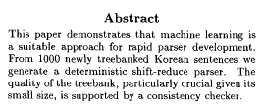

Abstract This paper demonstrates that machine learning is a suitable approach for rapid parser development. From 1000 newly treebanked Korean sentences we generate a deterministic shift-reduce parser. The quality of the treebank, particularly crucial given its small size, is supported by a consistency checker.

■ Page 2:

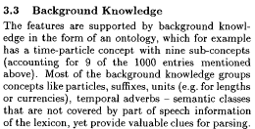

3.3 Background Knowledge The features are supported by background knowl- edge in the form of an ontology, which for example has a time-particle concept with nine sub-concepts (accounting for 9 of the 1000 entries mentioned above). Most of the background knowledge groups concepts like particles, suffixes, units (e.g. for lengths or currencies), temporal adverbs - semantic classes that are not covered by part of speech information of the lexicon, yet provide valuable clues for parsing.

■ Page 2:

The features are edge in the form

■ Page 3: [*Highlights*]

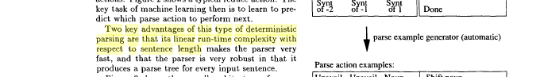

actions. Figure 2 shows a typical reduce action. The key task of machine learning then is to learn to pre- dict which parse action to perform next. Two key advantages of this type of deterministic parsing are that its linear run-time complexity with respect to sentence length makes the parser very fast, and that the parser is very robust in that it produces a parse tree for every input sentence. Figure 3 shows the overall architecture of parser l Svnt Svnt of-2 of- 1 S~n~ Done ~ parse example generator (automatic) Parse action examples: [Unavail Unavail Noun [ Shift noun [

Using corpus-derived name lists for named entity recognition
2000 · Stevenson, M. and Gaizauskas, R.
Proceedings of the sixth conference on Applied natural language processing
■ Page 1:

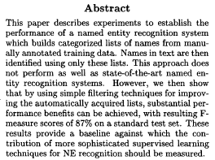

Abstract This paper describes experiments to establish the performance of a named entity recognition system which builds categorized lists of names from manu- ally annotated training data. Names in text are then identified using only these lists. This approach does not perform as well as state-of-the-art named en- tity recognition systems. However, we then show that by using simple filtering techniques for improv- ing the automatically acquired lists, substantial per- formance benefits can be achieved, with resulting F- measure scores of 87% on a standard test set. These results provide a baseline against which the con- tribution of more sophisticated supervised learning techniques for NE recognition should be measured.

■ Page 6: [*Highlights*]

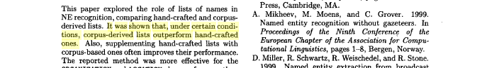

6 Conclusion This paper explored the role of lists of names in NE recognition, comparing hand-crafted and corpus- derived lists. It was shown that, under certain condi- tions, corpus-derived lists outperform hand-crafted ones. Also, supplementing hand-crafted lists with corpus-based ones often improves their performance. The reported method was more effective for the ORGANIZATION and LOCATION classes of names than Lexical Aquisition, chapter 2, pages 21-39. MIT Press, Cambridge, MA. A. Mikheev, M. Moens, and C. Grovel 1999. Named entity recognition without gazeteers. In Proceedings of the Ninth Conference of the European Chapter of the Association for Compu- tational Linguistics, pages 1-8, Bergen, Norway. D. Miller, R. Schwartz, R. Weischedel, and R. Stone. 1999. Named entity extraction from broadcast

A hybrid approach for named entity and sub-type tagging
2000 · Srihari, R. and Niu, C. and Li, W.
Proceedings of the sixth conference on Applied natural language processing
■ Page 3: [*Inks*]

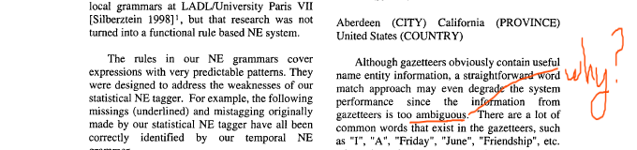

Our work is similar to the research on FST local grammars at LADL/University Paris VII [Silberztein 1998] 1, but that research was not turned into a functional rule based NE system. The rules in our NE grammars cover expressions with very predictable patterns. They were designed to address the weaknesses of our statistical NE tagger. For example, the following missings (underlined) and mistagging originally made by our statistical NE tagger have all been correctly identified by our temporal NE grammar. "United States". Aberdeen (CITY) California (PROVINCE) United States (COUNTRY) Although gazetteers obviously contain useful name entity information, a straightforward word match approach may even degrade the system performance since the information from gazetteers is too ambiguous. There are a lot of common words that exist in the gazetteers, such as 'T', "A", "Friday", "June", "Friendship", etc. Also, there is large overlap between person

■ Page 4: [revise]

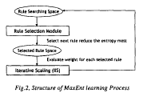

A weighted robust parsing approach to semantic annotation
2000 · Ghorbel, H. and Pallotta, V.
Proceedings of the workshop on Student research
■ Page 2: [*Highlights*]

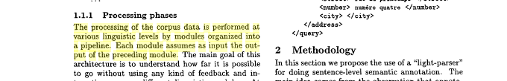

1.1.1 Processing phases The processing of the corpus data is performed at various linguistic levels by modules organized into a pipeline• Each module assumes as input the out- put of the preceding module• The main goal of this architecture is to understand how far it is possible to go without using any kind of feedback and in- teractions among different linguistic modules• At <street> rue du printemps </street> <number> num~ro quatre </number> <city> </city> </address> </query> 2 Methodology In this section we propose the use of a "light-parser" for doing sentence-level semantic annotation• The main idea comes from the observation that annota-

■ Page 2: [Methodology]
Methodology may be insufficient for this purpose.

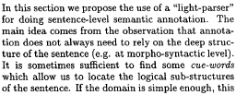

In this section we propose the use of a "light-parser" for doing sentence-level semantic annotation• The main idea comes from the observation that annotation does not always need to rely on the deep structure of the sentence (e.g. at morpho-syntactic level). It is sometimes sufficient to find some cue-words which allow us to locate the logical sub-structures of the sentence• If the domain is simple enough, this task can be easily mechanized. A similar approach,

Message classification in the call center
2000 · Busemann, S. and Schmeier, S. and Arens, R.G.
Proceedings of the sixth conference on Applied natural language processing
■ Page 1: [*Inks*]


Message Classification in the Call Center Stephan Busemann, Seen Schmeier~ Roman G. Arens DFKI GmbH Stuhlsatzenhausweg 3, D-66123 Saarbriicken, Germany

■ Page 1:
Example

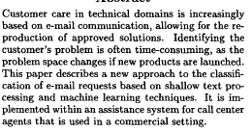
Abstract Customer care in technical domains is increasingly based on e-mail communication, allowing for the re- production of approved solutions. Identifying the customer's problem is often time-consuming, as the problem space changes if new products are launched. This paper describes a new approach to the classifi-cation of e-mail requests based on shallow text processing and machine learning techniques. It is implemented within an assistance system for call center agents that is used in a commercial setting.

■ Page 1: [*Highlights*]

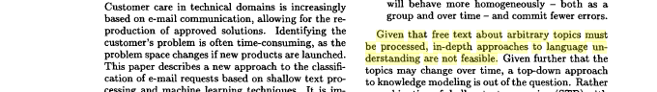

Customer care in technical domains is increasingly based on e-mail communication, allowing for the re- production of approved solutions. Identifying the customer's problem is often time-consuming, as the problem space changes if new products are launched. This paper describes a new approach to the classification of e-mail requests based on shallow text processing and machine learning techniques. It is im will behave more homogeneously - both as a group and over time - and commit fewer errors. Given that free text about arbitrary topics must be processed, in-depth approaches to language understanding are not feasible. Given further that the topics may change over time, a top-down approach to knowledge modeling is out of the question. Rather a combination of shallow text processing (STP) with

