**Small Business**

**Break-Time Scheduler**

* **Setup & Configuration**



©2022, James Melanson

Table of Contents

INSTALLATION 4

Computer Environment 4

Storage Location 4

Storage Capacity 4

Installation Process 4

OVERVIEW OF WORKBOOK 5

Info 5

Dashboard* 5

Create* 5

Staffing 5

Conf_Employees 5

Conf_Options 5

EmployeeHX (Employee History) 6

CONFIGURATION 7

Legal Defensibility 7

Configuring Employees 8

Add an Employee 8

Edit an Employee 8

Active Status 8

Editing Hidden Employees 9

Refresh 9

View Hx Button 9

Weekly & History 9

Configuring Breaks 11

Overview 11

Automated Breaks vs Manual Breaks 11

Manual Breaks Only 11

Automated and Manual Breaks 11

Concepts 12

PRO SCHEDULING TIP #1 14

PRO SCHEDULING TIP #2 15

PRO SCHEDULING TIP #3 15

PRO SCHEDULING TIP #4 15

Predefined Break Rule Templates 16

Custom Template 16

*This cover has been designed using images from Flaticon.com.*

# INSTALLATION

## Computer Environment

This scheduler is written in Excel VBA and should run on any system that fully supports Excel. This scheduling workbook should work in *Excel 2010* or higher. It has been tested on versions from *Excel 2010* to *Excel 2019*.

This workbook is a standalone solution. That means that one copy should be opened and used by only one person at a time. It can be opened by more than one person but the workbook that is closed last will overwrite any workbook changes in a workbook closed before it. That is to say, this workbook can work over a network but it is not a network application.

## Storage Location

I recommend that you store this workbook on a network or in the cloud so that the loss of a computer will not cause all of your work to be lost. I keep all my projects, finished and in development, in the cloud for this reason. Such services are not that expensive and protect all of your data in case of fire, equipment theft, sabotage. Do a Google search for “automated file backup system.”

Please add this workbook to any automated file backup system that you have in place.

## Storage Capacity

This workbook is distributed with a file size of less than 500 Kb. If you entered a full schedule every day (25 people) with break times and comments, that would add approximately 1Kb per day or 365Kb per year. At that rate, after 10 years, the workbook should have a footprint under 5Mb. You should not have any performance issues due to file size for the life of the workbook.

## Installation Process

You simply save the workbook to any directory that you want, with the caveat that it *should* be in a networked/cloud location. This scheduling solution was developed in the cloud.

You can have as many copies of the workbook as you want. This would be ideal if you run multiple businesses or have multiple, independent, locations. Just make sure the workbook file name is descriptive and that is different for workbooks, even if they are in different directories.

You can (and should) rename the workbook to anything you want. The only caveat is that it MUST maintain the extension “.xlsm” which indicates a macro-enabled workbook.

# OVERVIEW OF WORKBOOK

When you open the workbook you will see there are multiple worksheets. Each worksheet either lets you do something, it will display information you need, or it will store data for use in the background. There are several hidden worksheets that you will not see when you open the workbook. There are a few important things that you must never do to these worksheets:

* Never RENAME a worksheet.
* Never DELETE a worksheet.
* Never HIDE a worksheet.
* Never attempt to protect or unprotect a worksheet that is protected.

Here is a breakdown of each worksheet you will see when you open the workbook:

### Info

This sheet contains copyright and disclaimer information about the workbook. It is a requirement of distribution and using the workbook that this sheet remains in place and unaltered.

### Dashboard*

This is your starting point for creating and viewing schedules. If you aren’t sure where to find something, go to the *Dashboard* worksheet first.

### Create*

This is the sheet where you will make a new schedule or edit an existing schedule. This is the sheet where you will spend most of your time working.

### Staffing

This is an information sheet. You cannot make any changes on this worksheet. The staffing worksheet will show you how many people are working and at what time of day. The background processes make a lot of use of this worksheet. Not that the staffing sheet only gets updated when you click the Assess button, the Assign Breaks button, or the Update Count button.

### Conf_Employees

This worksheet is where you will add or modify employees. Once an employee has been added to the workbook, you cannot remove that employee.

### Conf_Options

This worksheet contains some information that the workbook needs and that you cannot edit (i.e., Semaphores, 1st Schedule Date, Last Schedule Date).

There are also configuration options for you on this worksheet:

* **Time Format**

You can select from four different time formats:

* + 24-Hour format is also known as military time.
  + 12-Hour clock. This could be problematic in a 24-hour operation and would not be recommended.
  + 12-Hour AMPM will show a 12-hour clock with a meridian (“A” or “P”) after the time.
  + French Format – The French clock is a 24-hour clock that has the letter “h” between the hours and minutes. For example, 03:15 PM would be written 15h15. I’m from Canada and we have a lot of French communities as well as a French province.
* **Date Format**

There are two different date formats you can choose:

* + mm-dd-yyyy - (American format)
  + yyyy-mm-dd - (ISO 8601 compliant)
* **Show ScheduleHx Button**

This button will open the schedule history worksheet. Normally, this sheet is hidden (as are many others) and you don’t need to access it. However, in the event of an audit trail or legal proceeding, you have the ability to display that sheet for examination.

* **Show Configure Breaks Button**

This button will open the breaks configuration page. This is addressed in detail further on in this document.

### EmployeeHX (Employee History)

The *EmployeeHx* worksheet is where the workbook stores configuration information about each employee that you enter into the system. NOTE: You can enter an unlimited number of employees in this workbook. However, you can only have a total of 125 active employees. Since each schedule can have a maximum of 25 people, and a 24-hour operation would have four or five teams in its shift rotation pattern, 125 people (5 teams x 25 each shift) should be sufficient.

If you need a larger number, you will have to contact me regarding a custom (paid) modification of the scheduling workbook.

# CONFIGURATION

There are two things that you need to configure before you start scheduling with this workbook. Those two items are the employees and the break definitions.

## Legal Defensibility

There are things in this book that you cannot access of modify. This is because this workbook provides you with a legally defensible document.

Sometimes an employee will launch a legal or union challenge that they are being scheduled unfairly. Some may claim they are working too much, some may claim they are not working enough, or they may claim that the shift dispersal is unfair. There is always a chance that an employee may bring up harassment through scheduling by a supervisor.

This workbook provides you with a legal document that can be defended. There are six reasons that this workbook is legally defensible:

1. You cannot remove an employee from the workbook. This means that any schedule that they have been entered into will show them in that schedule, even if they leave your organization.
2. When an employee is added to the workbook, a unique code is generated for that employee. Even if you were to edit that employee and give them a completely different name:
   1. That unique code would not change.
   2. Each employee profile contains an edit history to show name changes.
   3. You cannot make any changes to that employee code or to the edit history.
3. You cannot remove a schedule that is in the past. Once a schedule has been created and the date of that schedule has gone by, you cannot remove it.
4. You cannot edit a schedule that is in the past. Once a schedule has been created and the date of that schedule has gone by, you cannot make any changes to that schedule.
5. You do not have the password for the sheets that are password protected. Therefore, you cannot unlock a stored data sheet and make direct edits to that worksheet.
6. You do not have the password for the VBA editor. This means that you cannot access the code that runs the workbook or add new code that could make changes on your behalf.

## Configuring Employees

Adding employees is simple and is not something you need to worry about on a daily basis. When you hire a new employee, you will add them. If their name changes (e.g., marriage, divorce) you can edit their name. If an employee leaves then you can deactivate them.

The items in this section all refer to the *Conf_Employees* worksheet.

NOTE: Only active employees are show in the employee list on this page.

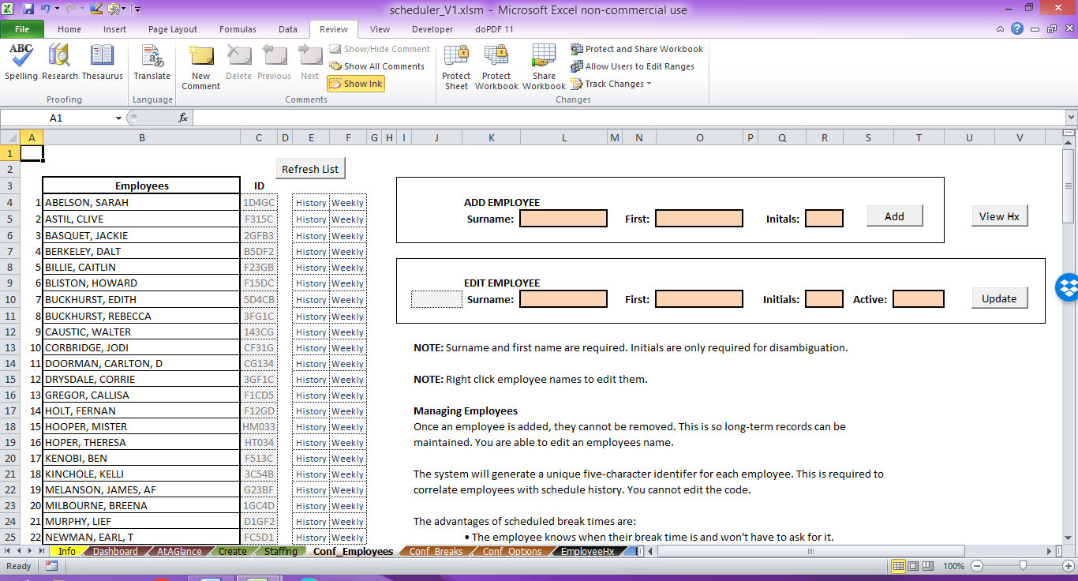

### Add an Employee

In the box titled “ADD EMPLOYEE” you need to enter a surname and first name. You can also add a middle name or initials for disambiguation between two employees with the same name. Once entered, click the Add button. Each employee added is automatically saved as being active.

The employee list will automatically refresh with the new employee added. The new employee names will always be stored in upper case regardless of how you enter them.

Each employee will also be assigned a five-character ID. This will follow the employee through every schedule that they are added to. It will be used to identify an employee in a schedule in case of future dispute. You cannot edit the employee ID.

### Edit an Employee

To make changes to an employee’s name or status, you need to right-click on their name or their employee ID code in the employee list. That person’s information will load in the Edit Employee box. You can then update their names or switch their active status between “Yes” and “No.”

### Active Status

The two settings for active status is “Yes” or “No.” This workbook will allow you to have as many active and inactive employees as you want. However, there are two caveats:

1. You can only schedule employees that have an active status of “Yes.”
2. You can only have a maximum of 125 employees with an active status of “Yes” at any given time.

### Editing Hidden Employees

If you have an employee with an active status of “No,” they will not appear in the employee list. To reactivate an employee that has their active status set to “No,” you will need to go to the *EmployeeHx* worksheet.

Scroll down the sheet to find their name, then right-click on “Edit” in column “A”. You will then be taken back to the *Conf_Employees* worksheet and their information will be loaded in the Edit Employee box. You can then change their active status to “Yes.”

### Refresh

It’s recommended that before making any changes to a name you see on this worksheet that you click the “Refresh” button. This will make sure you are looking at the most current information.

### View Hx Button

Clicking this button will take you to the *EmployeeHx* worksheet.

### Weekly & History

Next to each name you will see two words: Weekly and History.

If you right-click on the “Weekly” link, you will be presented with an on/off summary for that employee for the coming four weeks.

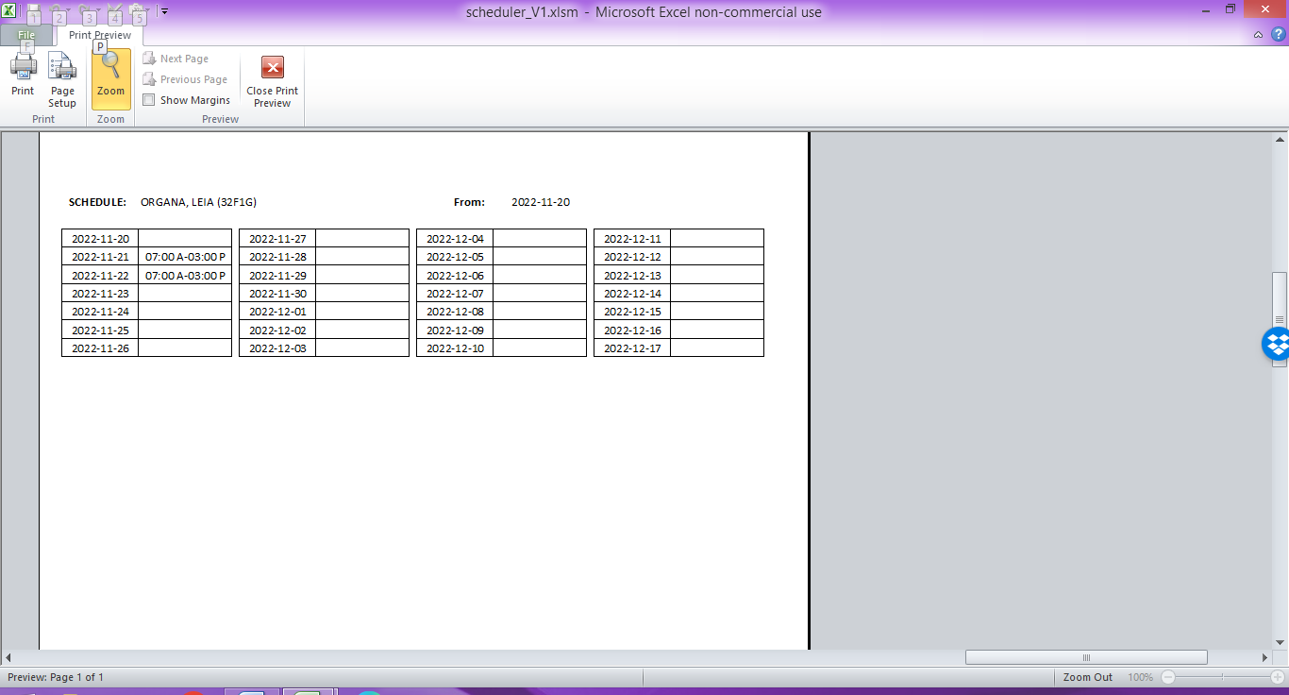

If you right-click on the “History” link, you will get a printout of the employees edits as well as their entire working schedule from the point they were first entered into the workbook until the moment you right-click the link.

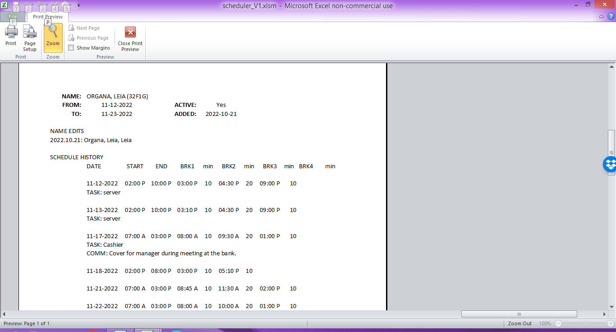

## Configuring Breaks

### Overview

This workbook’s main reason for being is so that you can schedule the hours a person is working, and so that you can schedule their break periods.

Why schedule breaks? This may be a new concept for you when you are used to just telling a person “go now.” However, that approach has several problems that scheduled break times will solve.

By scheduling break times in advance:

1. You can ensure that you are in compliance with all labour code requirements for employees required break periods.
2. You will ensure that all employees have been fairly scheduled for break periods.
3. You will prevent employees having to interrupt you for their break period while you are focussed on a task.
4. You will have a legally defensible documentation for your past practice of assignment of break periods.
5. You can balance break dispersal, legal conformity, and work period intensity in advance, rather than trying to do it on-the-day.
6. You will demonstrate to your employees that you are prioritizing their needs.

### Automated Breaks vs Manual Breaks

All of the following information on the automated break scheduling feature utilizes the worksheet *Conf_Breaks*. If you do not see that worksheet, then go to the C*onf_Options* worksheet and click the button labeled “Show Configure Breaks.”

The small business scheduler allows you to enter breaks two-ways. You can enter breaks manually, or you can just click a single button and have all the breaks calculated and assigned automatically.

### Manual Breaks Only

If you wish to use the “manual only” method of entering breaks, then you need to do the following:

1. Go to the *Conf_Breaks* worksheet.
2. Scroll down to the bottom of the information on the page.
3. Click the button labeled “No Template.”
4. Save the workbook.

NOTE: If you have “No Template” set, then you should not click on the “Assign Breaks” button as the response would be erratic and unreliable.

### Automated and Manual Breaks

To use the automated break assignment feature, you do have to invest a bit of time in configuring the rules for the breaks. The system comes with two predefined break configuration rules. It also allows you to save one configuration template.

Even though break times can be automatically entered, you still have the ability to enter break times manually or override an automated break time. The theory behind this is simple. The automated break feature will NOT assign a break period that already has an entry in that cell. So, breaks will not be changed by the automated process nor will a manual entry be changed. If you want to recalculate breaks, you need to delete the break time for that period first.

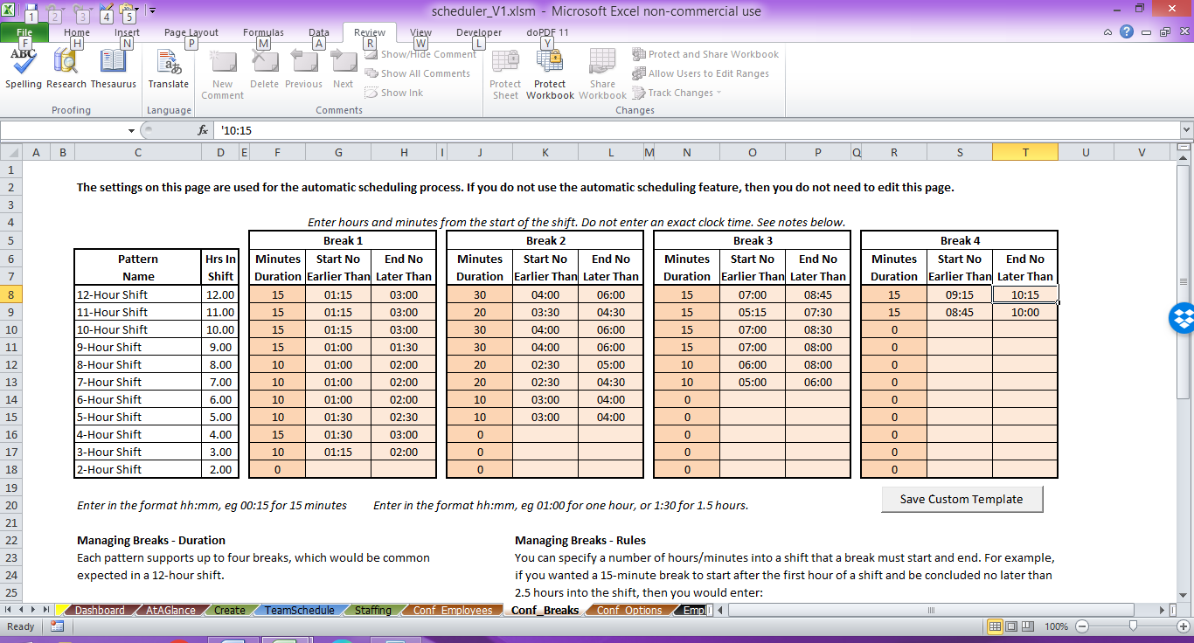

### Concepts

There are a few concepts that you need to understand to properly configure breaks. These are:

* **Number of Breaks per Shift**

As the business owner or manager, you will already be aware of how many break periods a person is legally required to have. Your business may even choose to provide a greater number of breaks or longer duration of breaks. Before you start configuring breaks, sit down with a pen and paper and work out the following:

* + If a person is working _____ number of hours, I have to give them _____ number of breaks. Each break must be _____ minutes long. For example, on one jurisdiction I worked in, the employee was required to:
    - Give an employee a 20 minute break that ended no later than the fifth hour of the shift.
    - Give an employee a 10 minute break that ended no later than each subsequent 3rd hour after the previous period.
    - There were additional rules for shifts that went longer than 8 hours.

Make sure that you do this for each duration that a shift can last. The workbook requires you to make these entries for every shift duration from 1 to 12 hours. Some of them may have no breaks (if only working a couple of hours) or they may have four breaks (in a full 12-hour shift in a union environment).

* **Break Time vs. Duration**

All breaks are composed of two values, even the manually entered breaks. Those two values are the time and the duration. When you are entering the break times on the *Create* worksheet, you will enter the hour and minute that the break starts AND you will enter the number of minutes in the break (duration). While it is possible to save a break time without a corresponding duration, this would most likely make your scheduling workbook no longer legally defensible.

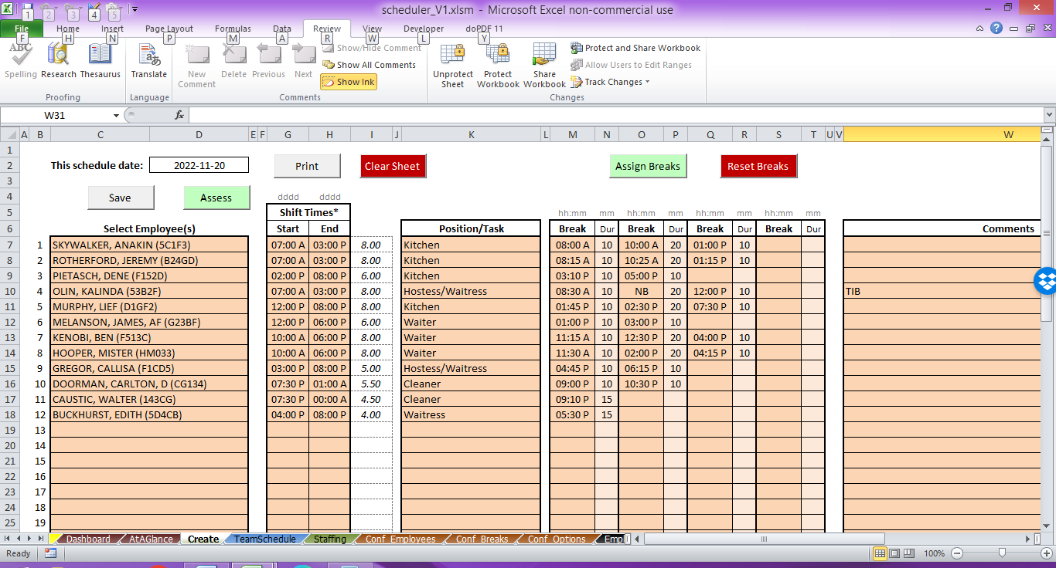

* **Start No Earlier Than**

In configuring the breaks, we are not looking at the start time of the break, we are looking at how many hours after the start of the shift that the break may start.

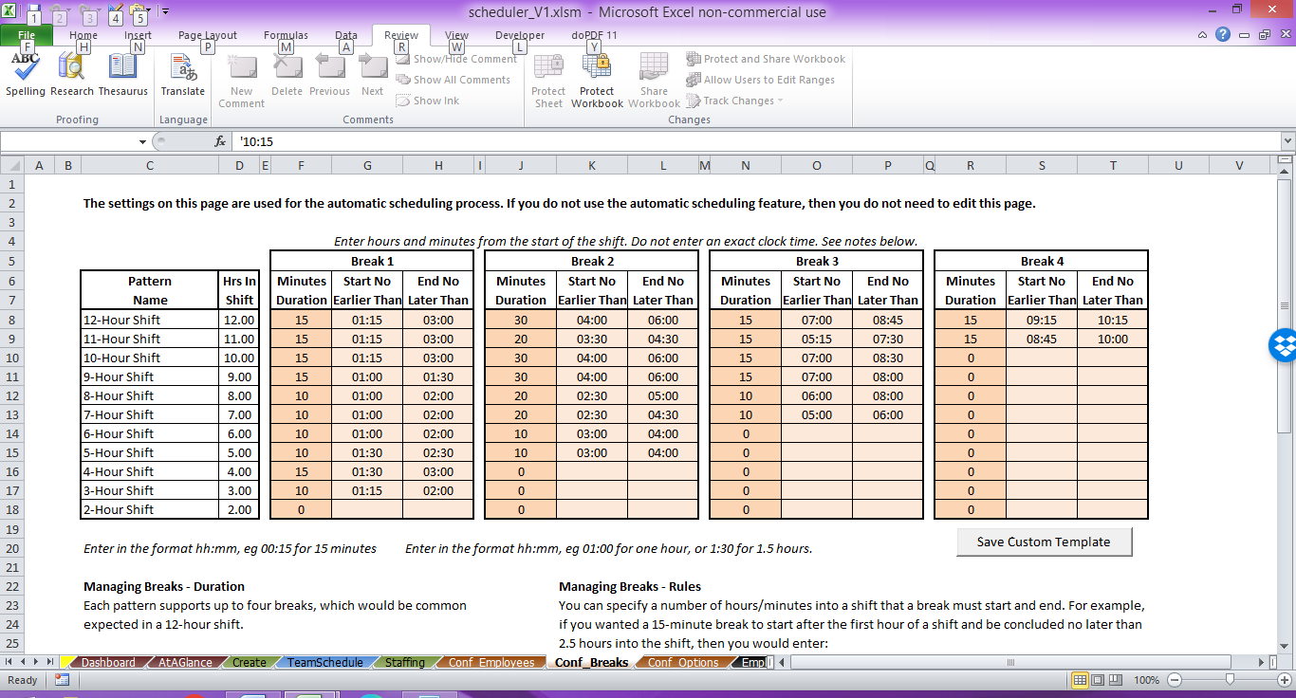

In this example, the person working a 3-hour shift gets a first break (of 10 minutes) that can start no earlier than 1.25 hours into the shift (01:15). A person working an 8-hour shift can have a first break (of 10 minutes) that can start no earlier than 1 hour into the shift (01:00).

So if the 3-hour person started at 10:00 A, then their first break could start no earlier than

11:15 A.

If the 8-hour person started at 04:00 P, then their first break could start no earlier than 05:00 P.

* **End No Later Than**

Again, this is not a clock time, this is the number of hours after the start of the shift that the break must END by.

In the screenshot above, the 3-Hour shift must have their 10-minute break end no later than the second hour of the shift. This means that if they started at 10:00 A then their 10-minute break could start no later than 11:50 A so that it would be over by the second hour of the shift, which would be 12:00 P.

In the screenshot above, the 8-Hour shift must have their first 10-minute break end no later than the second hour of the shift as well. So if they started at 04:00 P, then that first 10-minute break could start no later than 05:50 P.

### PRO SCHEDULING TIP #1

I’ve been developing schedules and scheduling systems for almost 20 years in a union environment. The key to working out scheduling rules is to always start with a pen and paper. Here is my workflow to help you along.

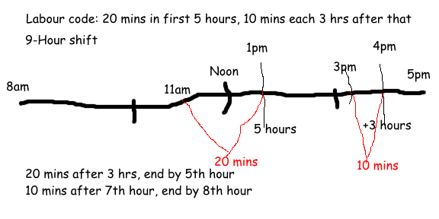

1. Draw a line across the paper.
2. Put shift start and end time at each end.
3. Mark the halfway point and quarter points on the line as a reference.
4. Mark the times that match legal/contract/labour code requirements.
5. In a different colour, mark where each break should start after and end before.
6. Write down the + hours for each start and end.

In the above 9-hour shift example, I would enter the following for break rules:

1st Break: Duration 20 minutes, start no earlier than 03:00 hours from the start of the shift, and end no later than 05:00 hours from the start of the shift.

2nd Break: Duration 10 minutes, start no earlier than 07:00 from the start of the shift, and end no later than 08:00 from the start of the shift.

NOTE: In the above example, the employee is working 5 hrs plus 3 hrs plus 1 hour, or nine hours in total. The labour code required a 20 minute break in the first five hours, plus a ten minute break in each 3 hour period following. As the 3rd period was not a full three hours, no break was required in the 9th hour.

For this workbook, you need to do this for each shift duration from 1 hour to 12 hours. You don’t need to give any breaks in the smaller shifts, and you can duplicate breaks in different hours shifts. However, in all of the shift break periods, you need to enter a duration for every entry space. If you do not want them to have a break (no start or end by), then enter a duration of zero “0” minutes. The only exception is “No Template.”

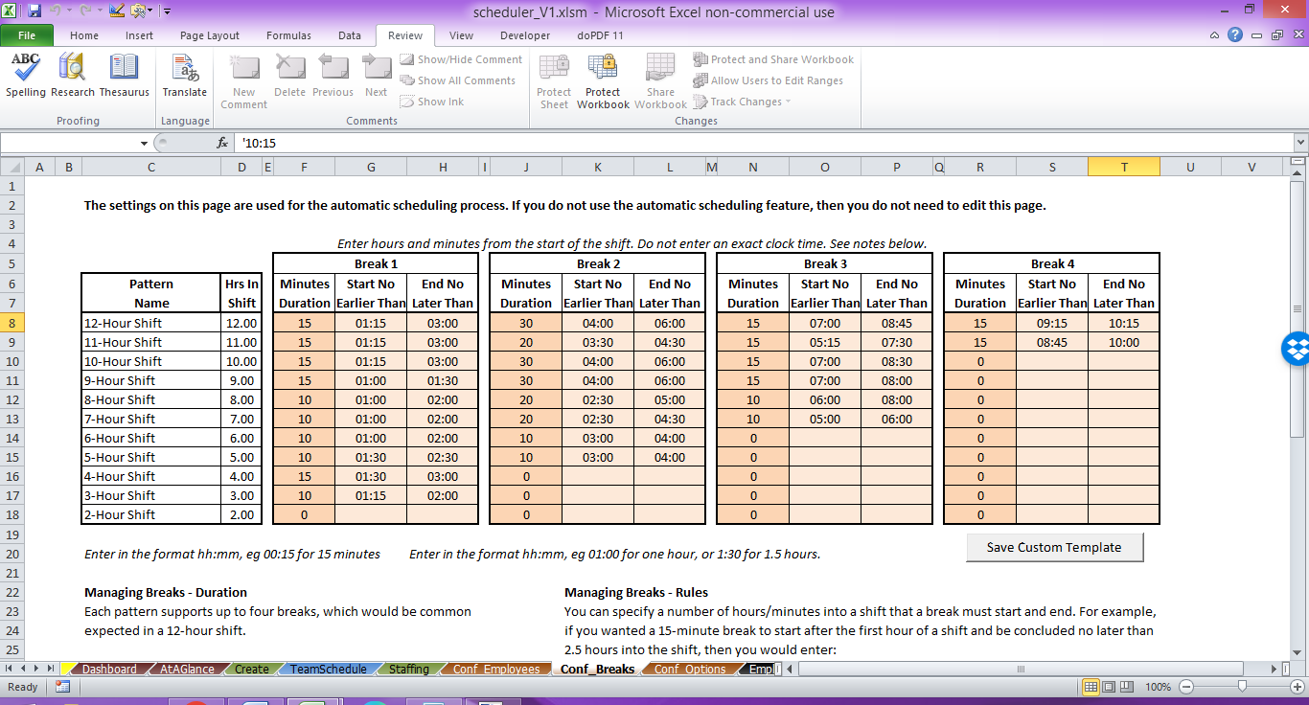

Fortunately, you only have to go through this setup process once. After it has been completed, you never have to change it again unless the law changes or employee contracts change.

### PRO SCHEDULING TIP #2

Keep two different workbooks. The second workbook will be one that you use to try out new break ideas. Don’t save this one to the same folder as your live scheduling workbook. Instead, save this one a different or private drive and name it something like “testing schedules only DO NOT USE.xlsm”

In this workbook you would still need to a handful of employees. You can then play around with changing the break parameters and trying out different values. This way you can create schedules under the different rules to get an idea of how well they will work. You can do this without affecting your live schedules with the testing workbook.

I make this suggestion because no matter how great you think your break configuration is, you need to actually put it in practice for a few days to identify any weaknesses. In reality, during the first two months of using this scheduling system, you will probably make changes to break definitions a few times to get it refined to an acceptable output.

### PRO SCHEDULING TIP #3

Remember: There is no history for break configuration changes. I would strongly recommend that you take a screenshot of the *Conf_Breaks* page after you have updated the break configurations. This will allow you to have a historical record of the break configurations to which you can refer. Someone may make changes inadvertently (or on purpose) and you might have to change settings back to what they were previously.

### PRO SCHEDULING TIP #4

After you have setup your scheduling workbook and are ready to go live with it for daily use, protect the workbook. Go to: Review -> Changes ->Protect Workbook. Use this to add a password that will be required to open the workbook. Make sure you only share that password with employees that you trust to use the workbook responsibly.

Do not lose the password. I may or may not be able to recover it for you. It is an expensive process.

## Predefined Break Rule Templates

The workbook comes with two predefined break rule templates. Template #1 is very conservative and template #2 is very liberal.

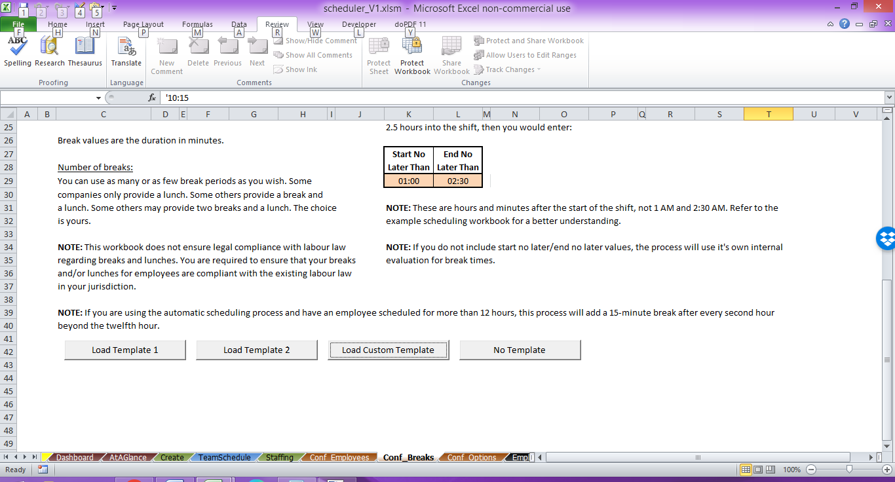

On the *Conf_Breaks* worksheet, scroll down to the bottom of the page. You can either Load Template 1 or Load Template 2 to see their definitions. Remember that making changes on this page will NOT make changes to schedules that have already been saved. Loading an existing schedule under a different template may exhibit inconsistent behaviour that I can’t predict, so it’s not recommended. I strongly urge you to work out your kinks with the break definitions early!

### Custom Template

Once you have refined your break rules and are satisfied with them. You should save them under the custom template. You will see the button to “Save Custom Template” for what you have entered. You can then reload that template from the bottom of the page if no one else has overwritten it (See pro tip #4 again).

