**Small Business**

**Break-Time Scheduler**

* **User Manual**



©2022, James Melanson

Table of Contents

INTRODUCTION 4

ABOUT THIS SCHEDULING SOLUTION 5

Background 5

Disclaimer 5

Terms and Conditions 5

Support 5

Bugs/Fixes 5

Contact 5

WORKFLOW 6

ENTERING DATA 9

Entering Dates 9

Date Formats 9

Input Formatting 9

Entering Times 9

Time Formats 9

Input Formatting 9

Entering Names 10

Select Name 10

Autocomplete Name 11

Add or Edit Employees 11

DASHBOARD 12

Generate Reports 13

Generate Reports -> Time Dispersion 13

Generate Reports -> Employee -> Summary 14

Generate Reports -> Employee -> Full Hx 15

AT-A-GLANCE 16

CREATE 17

Employee Name 17

Start and End Time 17

Start time of the break 18

Unsaved Changes 18

Print Button 19

Assess & Update Count Buttons 19

Staffing Plot/Count 20

*This cover has been designed using an image from Flaticon.com*

# INTRODUCTION

This instruction manual makes three assumptions:

1. You know how to open Excel and navigate worksheets and cells.
2. You have already entered all of your employees into the workbook.
3. You have configured break rules OR have opted to use manual only scheduling.

The topics of employee entry and break configuration can be found, with instructions, in the document for setup & configuration.

Please read this manual in full before you begin working with the Small Business Break-Time Scheduler. There are several things you need to know prior to using the workbook.

Watch for the following symbols:

|  |  |
| --- | --- |
| C:\Users\User\AppData\Local\Microsoft\Windows\INetCache\IE\RC062RLU\warning-17[1].png | This will highlight information that is important to the topic you are exploring. |
|  |  |
|  | This will highlight something that you should avoid doing. |
|  |  |
|  | This will highlight a process that you need to be patient with. |

# ABOUT THIS SCHEDULING SOLUTION

### Background

I have been developing both work schedules and scheduling applications from 2005 until I retired in 2020. Now I am sharing the knowledge and experience by developing some products for those scheduling employees for small businesses.

### Disclaimer

This product is provided "as is." It is up to each individual downloading this workbook to determine its suitability for any purpose or application. The author of this workbook makes no warranties or assertions for any suitability for this workbook. Corresponding with the author and having the author answer questions cannot be implied to be the author's warranty or assertion of suitability for any purpose.

### Terms and Conditions

You can download this workbook and use as many copies as you want. You may also give this workbook to any other person with the following conditions:

1. You cannot accept money for the workbook or transmitting the workbook.
2. You may not make any changes to the workbook.
3. You may not alter, remove, hide, or obscure the Info worksheet in any way.

### Support

Email support is offered for this free workbook on a casual basis. That is, I will respond as soon as I'm able to.

### Bugs/Fixes

If you implement this workbook for your business, send me an email and let me know. I don't have any marketing email lists and I don't sell email lists. I'm retired, and that crap is long behind me. I just want to be able to let users know if there are any fixes or enhancements being put out.

### Contact

James Melanson

jmelanson1965@gmail.com

New Brunswick, Canada

**Buy me a coffee!**

If you are using this scheduling solution and you like it, support the poor, pitiful, retired author by buying him a coffee at: <https://www.buymeacoffee.com/jmelanson>

…but you do not have to!!

# WORKFLOW

The workflow for creating a schedule is linear and involves a few steps for each employee being scheduled. Once you have reviewed the workflow, this manual will then provide and in-depth look at each page and each step in the process.

|  |  |
| --- | --- |
| C:\Users\User\AppData\Local\Microsoft\Windows\INetCache\IE\RC062RLU\warning-17[1].png | Refer back to this page the first few times you create a schedule as an aide-mémoire |

1. Go to the Dashboard worksheet.
2. Enter a date for the new schedule through one of the following:
   1. Enter a date in the Create Date box and click the Find/Create button.
   2. Click the Today button.
   3. Click the Tomorrow button.
   4. Click on the Refresh button, then right-click on the edit link next to a displayed date.
3. You are now on the *Create* worksheet.

|  |  |  |
| --- | --- | --- |
|  | The *Create* worksheet needs to have a date at the top of the page. If it does not, then go back to the Dashboard and start again. | |
| C:\Users\User\AppData\Local\Microsoft\Windows\INetCache\IE\RC062RLU\warning-17[1].png | | If you have started to enter schedule info and then realize there is no date at the top of the page, then:   1. Go back to the dashboard. 2. Use one of the methods above to enter a date. 3. Select “NO” when you are prompted to erase the data. | |

1. If you are using automated breaks, follow these steps. If you are not using automated breaks, then go directly to step 5.
   1. Select a person from the drop down list OR enter at least 3 characters of their name and tab out of the cell.
   2. Enter a shift start time.
   3. Enter a shift end time.

|  |  |
| --- | --- |
| C:\Users\User\AppData\Local\Microsoft\Windows\INetCache\IE\RC062RLU\warning-17[1].png | After entering a start and end time, the workbook will automatically fill in the duration for each break period to which they are entitled. This is based on how many hours are in their shift. |

* 1. You can enter a position or task for their shift. This is not a required field.
  2. You can enter comments in the comments field. This is not a required field.
  3. Repeat steps A to E for each employee working on the day’s schedule.
  4. After all employees and start/end times have been entered, click the green “Assign Breaks” button.

|  |  |
| --- | --- |
|  | The “Assign Breaks” feature can take several seconds to complete. Please be patient and do NOT try to use the workbook until the process is completed. |

* 1. You can now override any break times that you are dissatisfied with.
  2. Review the staffing plot graph at the bottom of the page. This will show you gaps or low points in coverage after the breaks have been assigned.

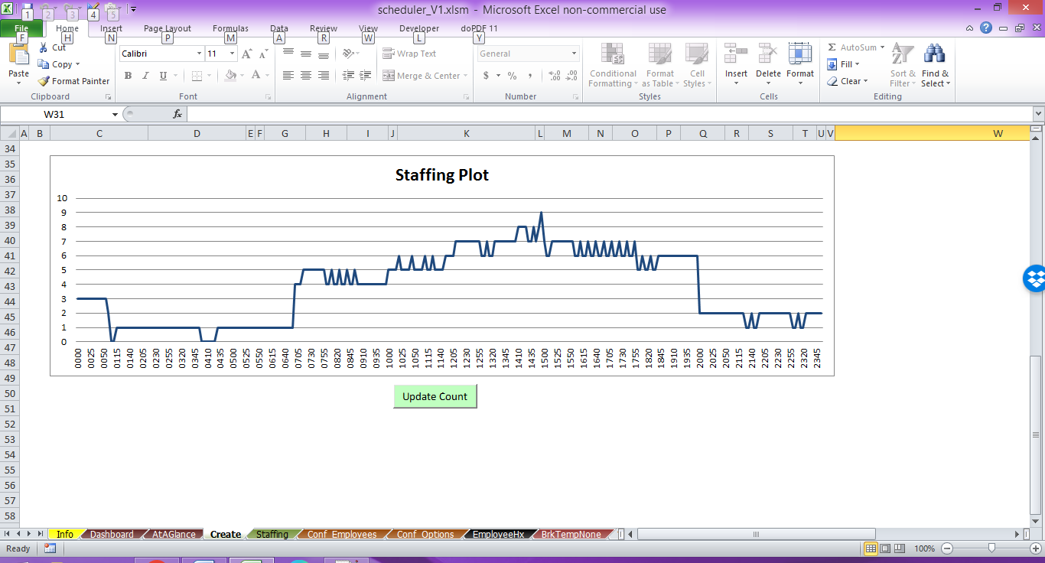

* 1. Click the green “Assess” button. This checks for certain errors and it will highlight any breaks you missed. Fix anything that has been highlighted.

|  |  |
| --- | --- |
|  | The “Assess” feature can take several seconds to complete. Please be patient and do NOT try to use the workbook until the process is completed. |
| C:\Users\User\AppData\Local\Microsoft\Windows\INetCache\IE\RC062RLU\warning-17[1].png | If an employee’s name is highlighted red, this means that the name appears more than once on the schedule. |

* 1. If you see a red warning “**Unsaved Changes!”** then click the gray “Save” button on the worksheet.
  2. Click the “Print” button for a hardcopy that you can post.
  3. Save and close the workbook.

1. If you are making manual break time entries and not using the automated break assignment, follow the steps in the setup and configuration manual. Follow these steps to create a schedule.
   1. Select a person from the drop down list OR enter at least 3 characters of their name and tab out of the cell.
   2. Enter a shift start time.
   3. Enter a shift end time.
   4. You can enter a position or task for their shift. This is not a required field.
   5. For each break that the employee is granted:
      1. Enter the time for the break to start.
      2. Enter the duration for each break you assign.

|  |  |
| --- | --- |
|  | You MUST assign *both* values – the *time* of the break and the *duration* of the break. If you do not, then your staffing plot graph will be wildly inaccurate. |

* 1. Review the staffing plot graph at the bottom of the page. This will show you gaps or low points in coverage after the breaks have been assigned.
  2. Click the green “Assess” button. This will check for certain errors.

|  |  |
| --- | --- |
|  | The “Assign Breaks” feature can take several seconds to complete. Please be patient and do NOT try to use the workbook until the process is completed. |
| C:\Users\User\AppData\Local\Microsoft\Windows\INetCache\IE\RC062RLU\warning-17[1].png | If an employee’s name is highlighted red, this means that the name appears more than once on the schedule. |

* 1. If you see a red warning “**Unsaved Changes!”** then click the grey “Save” button on the worksheet.
  2. Click the print button for a hardcopy that you can post.
  3. Save and close the workbook.

# ENTERING DATA

## Entering Dates

### Date Formats

If you go to the *Conf_Options* worksheet, you can select between two different date formats. Click on the round button next to the date option you prefer:

mm-dd-yyyy -> 12-25-2022 -> American Format

yyyy-mm-dd -> 2022-12-25 -> ISO 8601 compliant format

Regardless of which format you use, the internal date storage for all schedules is ISO8601 compliant.

### Input Formatting

Regardless of which date format you have chosen, you can enter the date in multiple ways. These would all be valid date inputs for June 15th, with the asterisk indicating the preferred formats:

|  |  |  |
| --- | --- | --- |
| * 2022-06-15* * 2022-6-15 * 2022/06/15* * 2022/6/15 * 22/6/15 | * 06/15/2022* * 6/15/22 * 06/15/22 * 6/15/22 | * 06-15-2022* * 6-15-2022 * 6-15-22 * 06-15-22 |

## Entering Times

### Time Formats

This workbook gives you the option of four different date formats. The format is in reference to what the workbook displays and not what you input. The formats are:

|  |  |  |  |
| --- | --- | --- | --- |
|  | Format | 9:30 am example | 3pm example |
| 12-Hour | hh:mm | 09:30 | 03:00 |
| 12-Hour AMPM | hh:mm Meridian | 09:30 A | 03:00 P |
| 24-Hour | hh:mm | 0930 | 15:00 |
| French | hh{h}mm | 09h30 | 15h00 |

Be aware that all schedules are stored internally in the 24-Hour format.

### Input Formatting

How you enter your schedule times is up to you. However, remember that a 12-Hour time like 07:00 could refer to 7am or 7pm. If you have employees that start after the noon hour, then I would strongly recommend that you not use the 12-Hour time format. You should opt instead for either of the 12-Hour AMPM or the 24-Hour formats.

When you are entering a time you can enter the full 24-Hour format, e.g., 0700, 1200 (noon), 1500, 1800.

You can also enter the 12 hour with meridians, e.g., 07:00 A, 12:00 P, 03:00 P, 06:00 P

You can also enter in French format, e.g., 07h00, 12h00, 15h00, 18h00.

This workbook also allows you to use shorthand for entering times, regardless of the output format you have chosen. Here are some examples:

|  |  |  |  |  |  |  |  |  |
| --- | --- | --- | --- | --- | --- | --- | --- | --- |
| **What you want** | **What you can enter** | | | | | | | |
| 6 a.m. | 6 | 6a | 6:00 | 06:00 | 06:00 A | 06h00 |  |  |
| 8:30 a.m. | 8.5 | 8.5a | 8:30 | 8:30a | 830 | 0830 | 08:30 A | 08h30 |
| 10:15 a.m. | 10.25 | 10.25a | 10:15 | 10:15a | 1015 | 10:15 A | 10h15 |  |
| 11:45 a.m. | 11.75 | 11.75a | 11:45 | 11:45a | 1145 | 11:45 A | 11h45 |  |
| Noon | 12 | 12a* | 1200 | 12:00 | 12:00 P | 12h00 | NOT 12p |  |
| 2 p.m. | 2p | 2:00p | 1400 | 02:00 p | 14h00 |  |  |  |
| 4:30 p.m. | 4.5p | 16.5 | 4:30p | 04:30 P | 1630 | 16h30 |  |  |
| 6:15 p.m. | 6.25p | 18.25 | 6:15p | 06:15 P | 1815 | 18h15 |  |  |
| 9.45 p.m. | 9.75p | 21.45 | 9:45p | 09:45 P | 2145 | 21h45 |  |  |
| Midnight | 00:00 | 0 | 0000 | 12p* | NOT 12a |  |  |  |

*NOTE: The time 12a converts to 12:00 P (noon) and the time 12p converts to 00:00 A (midnight). I know this seems weird, but it’s the way the internal maths work with those two specific entries.

|  |  |
| --- | --- |
|  | The above entries apply to the *Create* worksheet only. The *Conf_Breaks* worksheet requires times be entered as a duration of hours and minutes and not a time of hours and minutes. |

**The *Conf_Breaks* worksheet requires times be entered in the format hh:mm only.**

## Entering Names

The *Create* worksheet requires that all employee names include the employee ID that is generated when they are added. Therefore, the names entered must exactly match the value stored in the workbook. There are two ways of doing this.

### Select Name

You can click in the cell for the employee name and then click the down triangle that appears. This will let you select a name from the list.

### Autocomplete Name

Type a minimum of three characters of a person’s name and then tab out of the cell. The workbook will complete this with the first match that it finds. The workbook first looks at the last names, and if no match is found, it then looks at first names. If no matches are found, the cell will remain blank.

**Disambiguation**

The workbook may have people with identical or similar last names. For example:

* Blackburn, Anna
* Blackburn, Freddy
* Blacktil, Thomas
* Blalock, Thomas

1. If you entered “Bla” then the first name to autocompete would be Blackburn, Anna.
2. If you entered “Blac” then the first name to autocomplete would be Blackburn, Anna.
3. If you entered “Blackt” then the first name to autocompleted would be Blacktil, Thomas.
4. If you entered “Blal” then the first name to autocompleted would be Blalock, Thomas.
5. If you entered “Thom” then the first name to autocomplete would be Blacktil, Thomas.

## Add or Edit Employees

Complete information on adding or editing employees can be found in the setup & configuration manual.

# DASHBOARD

The *Dashboard* worksheet is your starting point for most activities in the workbook. When you open the workbook, it will give you a list showing the schedules for yesterday, today, and the following 8 days. If the schedule has not been created, the details will be blank but the Edit link will still be available.

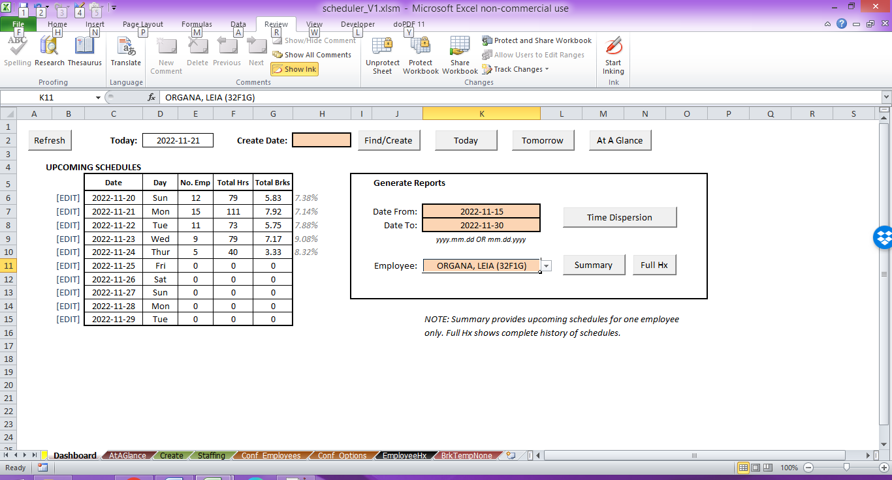

**Refresh:** If you create or edit a schedule, you will need to click the “Refresh” button to update the display. This display updates when you open the workbook, but after that the refresh requires the button click.

**At A Glance:** This feature is covered in the following chapter.

**Find/Create:** Enter a date in the Create Date box and click the “Find/Create” button. This will load an existing schedule in the *Create* worksheet. If a schedule has not yet been created, it will prep the *Create* worksheet for that new schedule.

**Today & Tomorrow Buttons:** Click these buttons to add or edit the schedule on the *Create* worksheet for today or tomorrow.

## Generate Reports

There are three reports that you can generate from this section of the Dashboard.

### Generate Reports -> Time Dispersion

The time dispersion feature shows you a breakdown of how many scheduled hours your active employees have within the workbook. This feature provides an easy way to review if scheduled hours are being given out equitably.

|  |  |
| --- | --- |
|  |  |

|  |  |
| --- | --- |
| C:\Users\User\AppData\Local\Microsoft\Windows\INetCache\IE\RC062RLU\warning-17[1].png | The default setting is to only show employees with an active status, but you can also show employees who are no longer active. However, that can be misleading if you are not careful. |

Things to remember about this report:

* When you launch the workbook, the *Dashboard* feature to generate reports is automatically loaded with today’s date to a point two weeks in the future.
* Anyone who is not active will not be represented in this report even if you select for them to be.
* If you remove both the start and end date from the report generation box, then the workbook will default to the very first schedule through to the very last schedule stored in the workbook. In this situation, the percentage will continually get smaller for each employee who is not active.
* The only way to ensure an accurate representation of time dispersion for employee’s who are not active is to set a time dispersion start and end date that covers a period when they were actively scheduled in the workbook.

### Generate Reports -> Employee -> Summary

For this report, you need to select an employee in the drop down list OR you can enter a partial name and tab out of the box to have it automatically completed.



The summary report provides an on/off schedule for the employee selected. This report only looks at the start date entered in the box above. It then presents the following four weeks (28 days) from that start date.

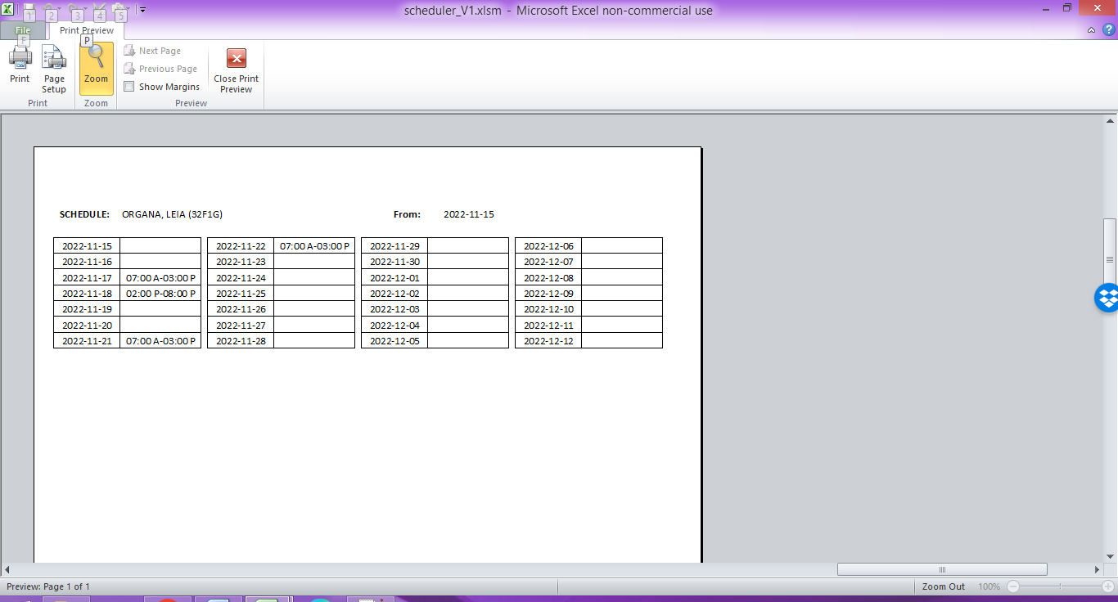

### Generate Reports -> Employee -> Full Hx

The full history button only requires the employee; it does not require any dates. The full history shows an employee status, the date they were added to the workbook, a full history of name edits, and a full scheduling history for that employee. This report could be several pages long.

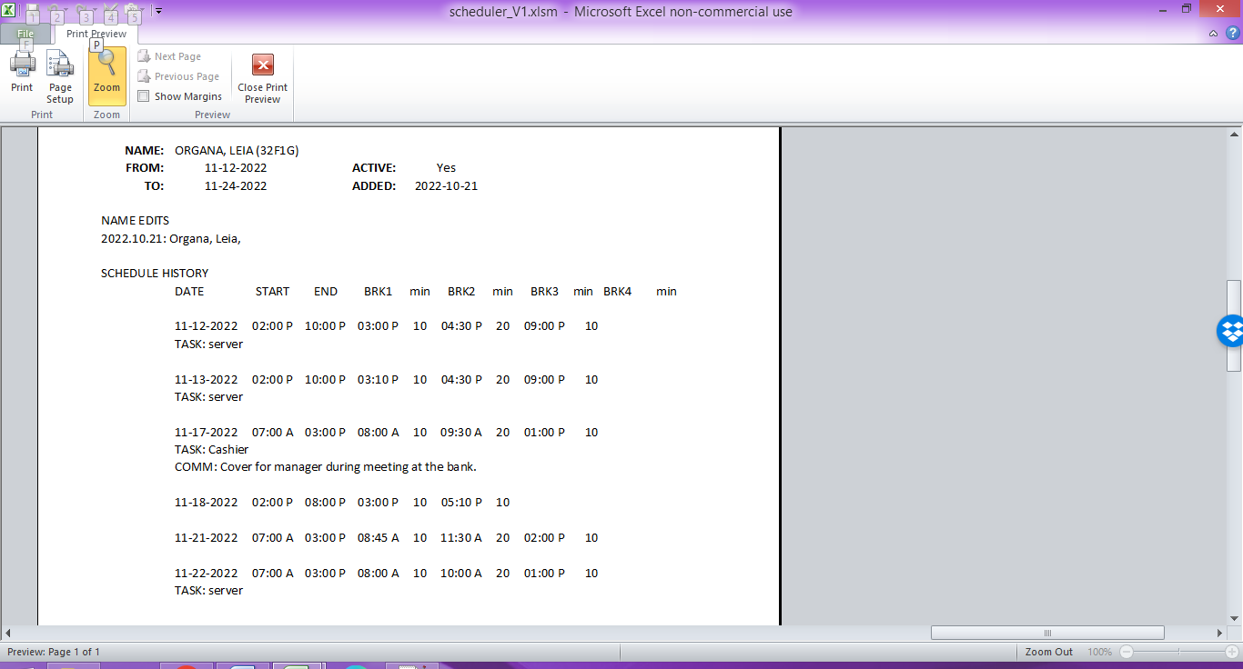

# AT-A-GLANCE

This feature does one thing and does it quickly. It displays a simple view of who is working and when they are working, over a two week period. The dates that it displays are from four days before today, through 10 days after today. You cannot adjust those dates; they are automatically set when the workbook opens. This feature is a tool for the person creating a schedule to help them ensure equitable dispersion of work hours.

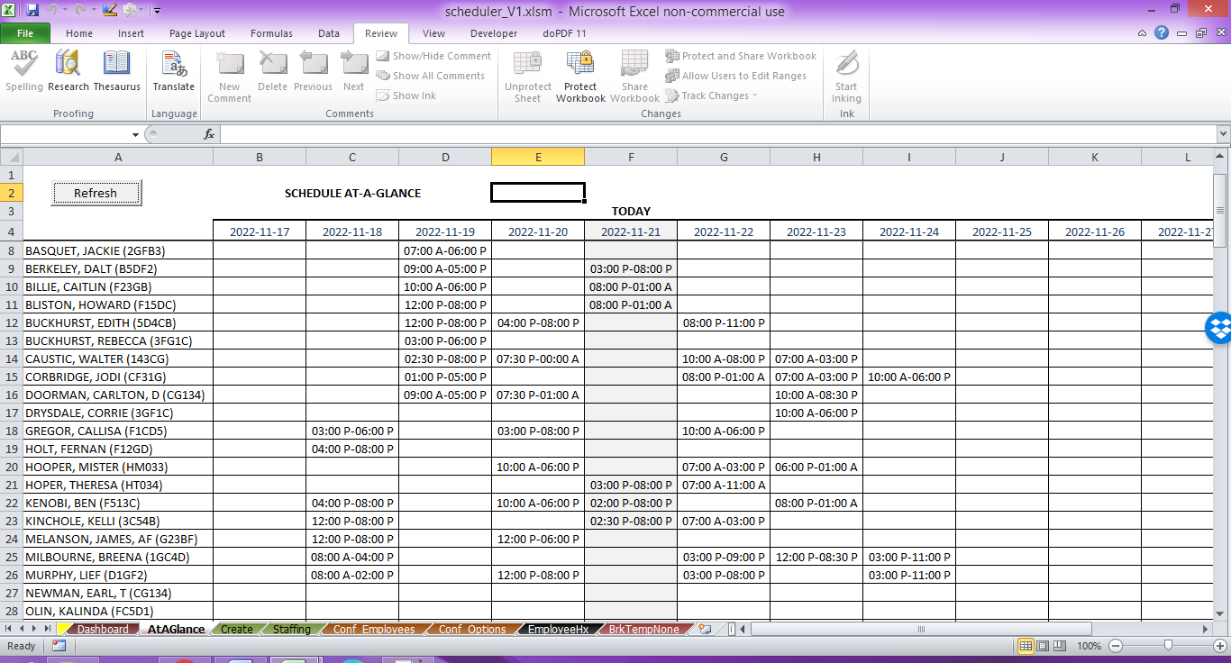

# CREATE

Once you have read and understand this section, you can refer back to the workflow at the start of this document as a reminder on what to do. In this section I am going to principally address automated break time assignment. However, I will highlight certain things that are done differently when you are using manual break times only.

There are four components to a single break. These are:

1. The employee name.
2. Their start AND end time, together providing a shift duration.
3. The duration of the break (in minutes).
4. The start time of the break.

|  |  |
| --- | --- |
|  | You cannot have a break time that spans the midnight hour. What I mean is, you cannot have a break that starts before midnight and ends after midnight. For example, you MAY assign a ten minute break at 23:50 P and 00:00 A, but you may NOT assign that ten minute break at 23:55P. |

Each break requires a clock start time and a duration in minutes. The duration is used by the staffing feature to calculate how many people are working during each 5-minute time block.

### Employee Name

You need to have a person’s name for the break times to be properly validated. If you delete a person’s name after entering breaks, the start/end times and the breaks will be automatically deleted as well.

### Start and End Time

When you enter a start and end time, the workbook can then calculate how long the shift is. With that information, it can look at the break rules and determine the duration, start after, and end by values as discussed in the setup and configuration manual. The break duration will then be automatically entered onto the *Create* worksheet. This is a visual cue for you to remember how many breaks have to be assigned to an employee.

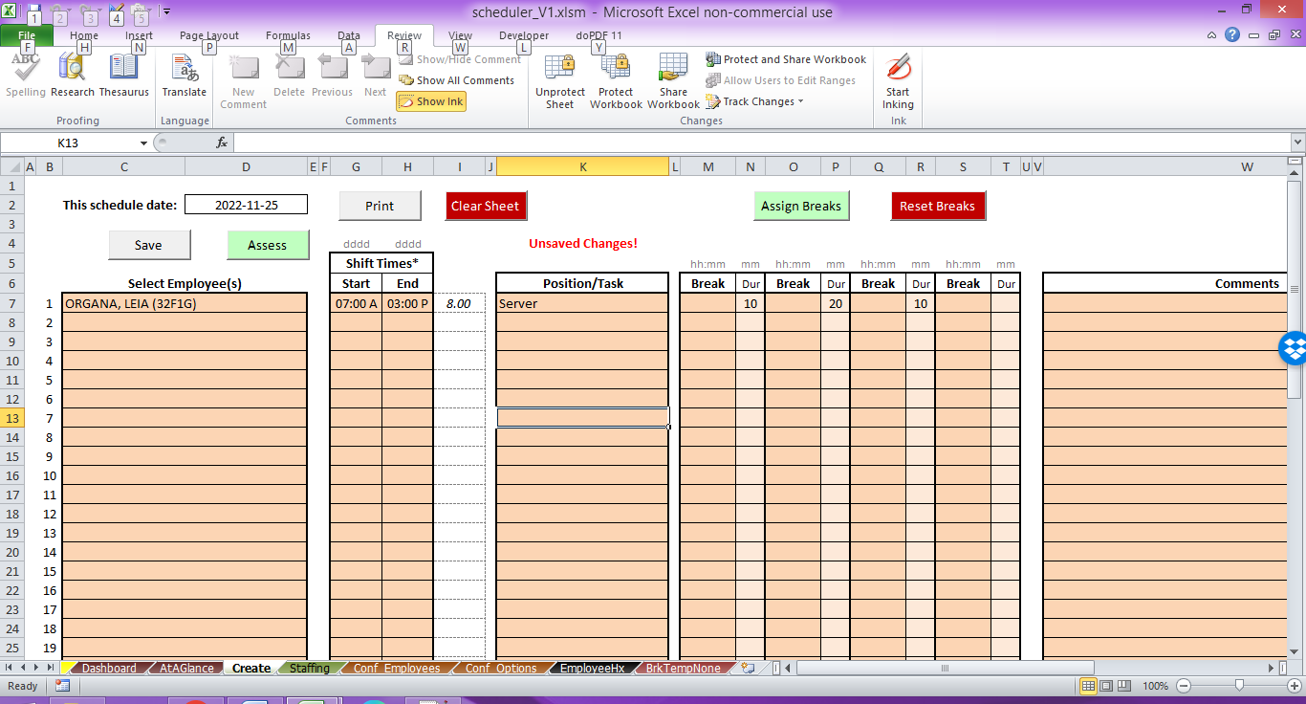

The automated break assignment looks for the duration. If the duration is not present, it will not assign a break time. You may edit the duration once it is loaded. If you delete the duration, the break time will not be assigned.

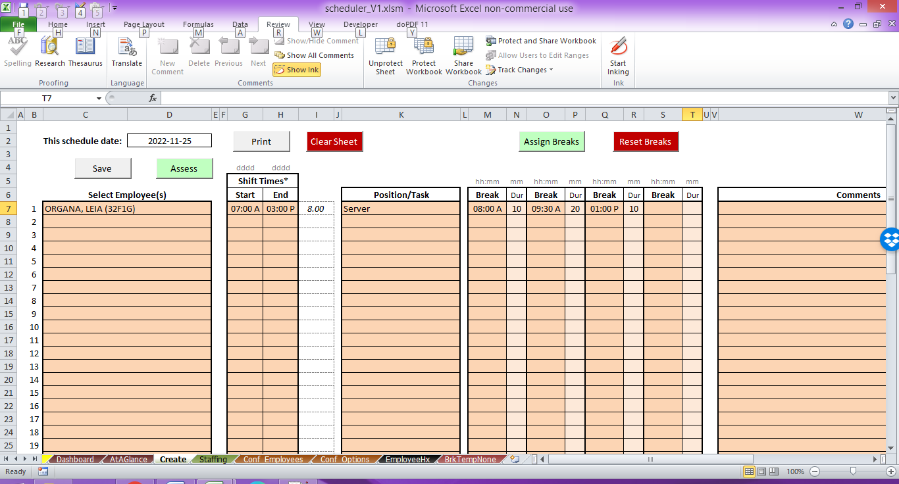

|  |  |
| --- | --- |
| C:\Users\User\AppData\Local\Microsoft\Windows\INetCache\IE\RC062RLU\warning-17[1].png | If you edit or delete the start time or end time, all of the breaks will be removed and the durations will be recast.  If your new start/end time changes the duration of the shift, then the value of the durations might change as well. |

### Start time of the break

Enter a time according to the instructions earlier in this manual. If the format is not recognized, the break time cell you entered it into will turn red and say “Error.” You just need to enter a time in a format that is recognized.

Additionally, the workbook will check to ensure that the break time is within the scheduled shift time for the employee. If it is not, a pop-up dialogue will let you know, the cell will turn red, and it will say “Error.”

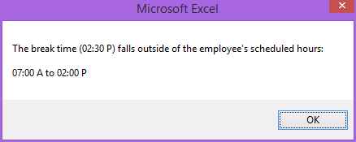

### Unsaved Changes

The workbook will save the content and save the workbook itself during several different processes.

* Click the “Save” button.
* Click the “Assign Breaks” button.
* Click the “Assess” button.
* Click the “Update Count” button.

When the data is saved to the workbook, the workbook is also saved. You will need to save the data if see the message “**Unsaved Changes!**” on the *Create* worksheet. If you close the workbook with this message on the screen, you may lose any unsaved changes.

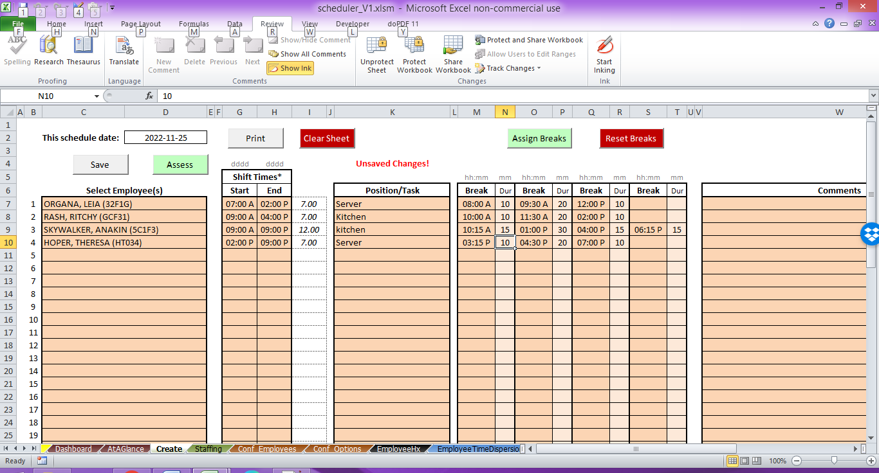

## Print Button

The print button on the *Create* worksheet will format the entries into a printer-friendly format, and then the workbook will present you with the print preview screen. You can print it to paper or to a PDF file for electronic distribution.

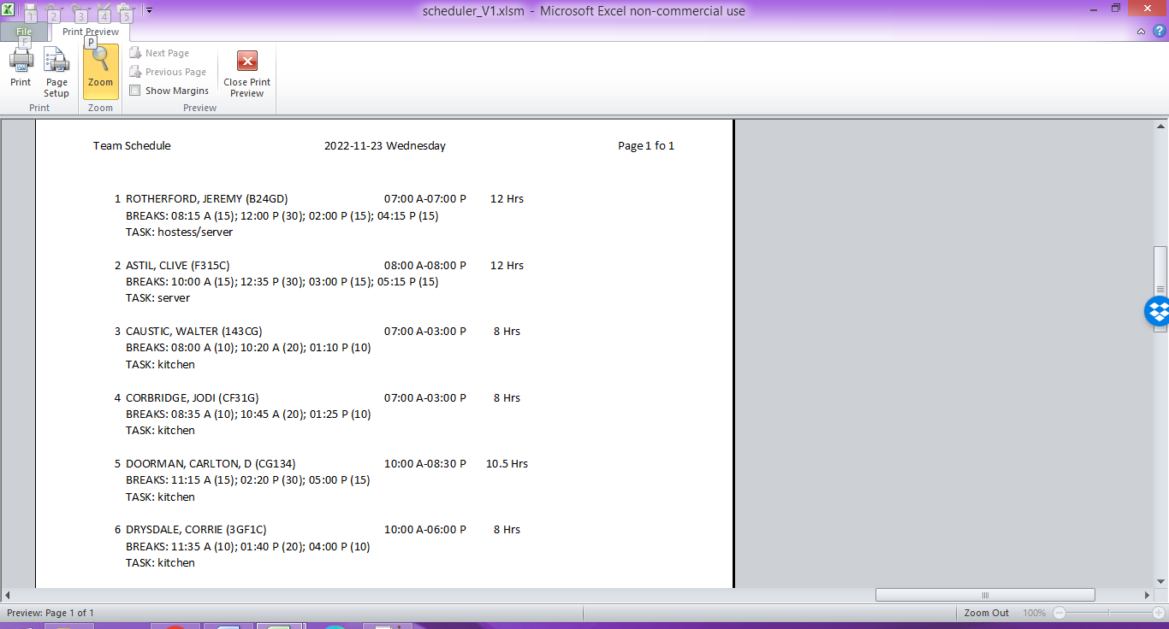

## Assess & Update Count Buttons

Both of these buttons do two things (the same things). The first thing they do is check the *Create* worksheet for any input errors. The second thing they do is update the staffing count.

## Staffing Plot/Count

On the bottom of the *Create* worksheet, you will see a graph that shows a visual representation of your staffing levels based on the entries made. This staffing level adds people when they are working and subtracts them during their breaks. This will give you a good visual cue in case you have scheduled too many breaks at the same time.

|  |  |
| --- | --- |
|  | The staffing plot/count is only as reliable as your break time entries. Remember that if you enter a break time, it also needs a break duration. If you omit durations, then the staffing count will not be accurate. |



To see the exact number of people working during any 5-minute time period, go to the staffing sheet. Row 27 will show you the exact number of people working (scheduled minus breaks).

