Student ID No: __________Name: ______________________________ Date: _____________

Course & Year/Section: _______________________ Score: ____________

**PERFORMANCE TASK 3**

**PROJECT KICKOFF & ENVIRONMENT SETUP**

**General Directions**

* Read and understand each statement carefully.
* Write your answers on your activity sheet.

**Objective:**

By the end of this lab, students should be able to:

1. Identify the tools required for system integration development and collaboration.
2. Set up a project repository for team-based work.
3. Document the initial project overview and team assignments.
4. Demonstrate proper use of version control for collaboration.

**Overview:**

This lab sets up your team repository and working structure for the semester-long integration project. You’ll form teams, assign roles, create a properly structured repository, draft your initial project overview, and practice collaboration using Git. Treat the repository as a living workspace—it will be used and expanded throughout the course.

**Step 1: Repository Setup**

1. Create a new Git repository for your team project on your chosen platform.

Recommended naming convention (include course code):

ITE412_SIA2_[TeamName]_Project

*e.g.ITE412_SIA2_TeamAce_LendingProject*

1. Initialize structure (create these folders at the repo root):

/docs → project documentation

/src → source code

/tests → test cases

/integration → integration scripts/configs

1. Add a **README.md** containing:
   * Team name and members (with roles)
   * Project title (tentative)
   * Short description of the system to be integrated
   * Repository usage notes (how to clone/run if applicable)

**Step 2: Project Overview Document**

Inside the /docs folder, create ProjectOverview.md with:

1. System Objectives – What problem will your project solve?
2. Proposed Scope – Modules or systems to be integrated.
3. Stakeholders – Identify at least 2 stakeholders (real or role-played).
4. Tools/Technologies – List the tools you expect to use.

*Note: Aim for clarity and feasibility. Keep it concise (1–2 pages).*

**Step 3: Version Control Practice**

Each member must:

1. Clone the repository:

1 git clone

2 cd ITE412_SIA2_[TeamName]_Project

3

1. Configure Git (if first time):

1 git config --global user.name "Your Name"

2 git config --global user.email [you@example.com](mailto:you@example.com)

1. Create a personal feature branch and make a small change  
   (e.g., add your name to README.md under “Team Members”):

git checkout -b feature/add-[your-name]

git add README.md

git commit -m "docs: add [Your Name] to team roster"

git push -u origin feature/add-[your-name]

1. Open a Pull/Merge Request and request review from a teammate.
2. Resolve conflicts if they occur, then merge into main.

**Deliverables:**

1. Repository Link (shared with instructor)
2. **README.md** with team info & project overview
3. **/docs/ProjectOverview.md**
4. Evidence of commits from all members
   1. Visible in **Commit History** / **Insights → Contributors**
   2. Screenshots or PR links acceptable

**Submission method:** Post the repo URL and screenshots/PR links to the MS Teams assignment titled Performance Task 3.

1. <https://github.com/jimmilynpascua/ITE412_SIA2_MCPP_Boardease.git>

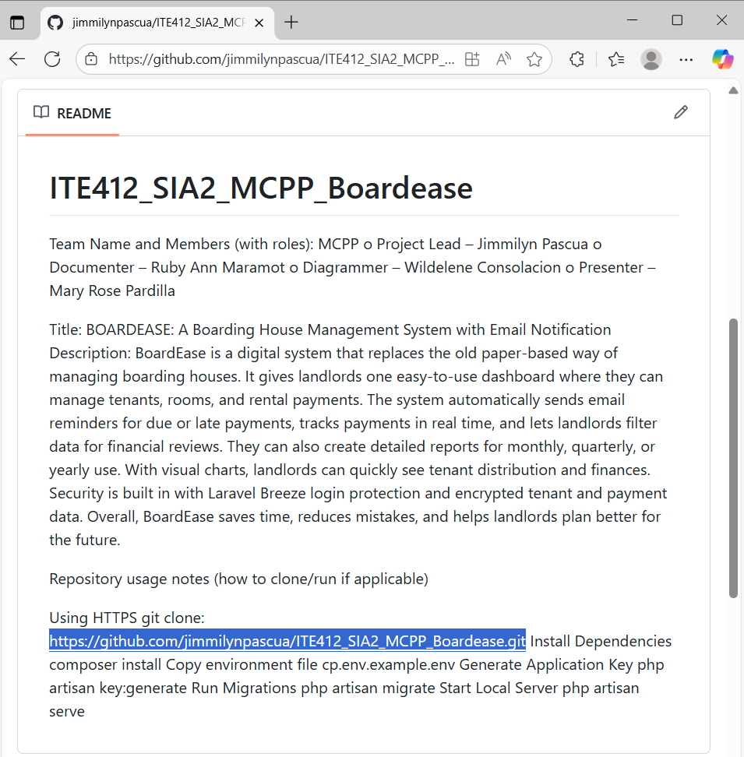

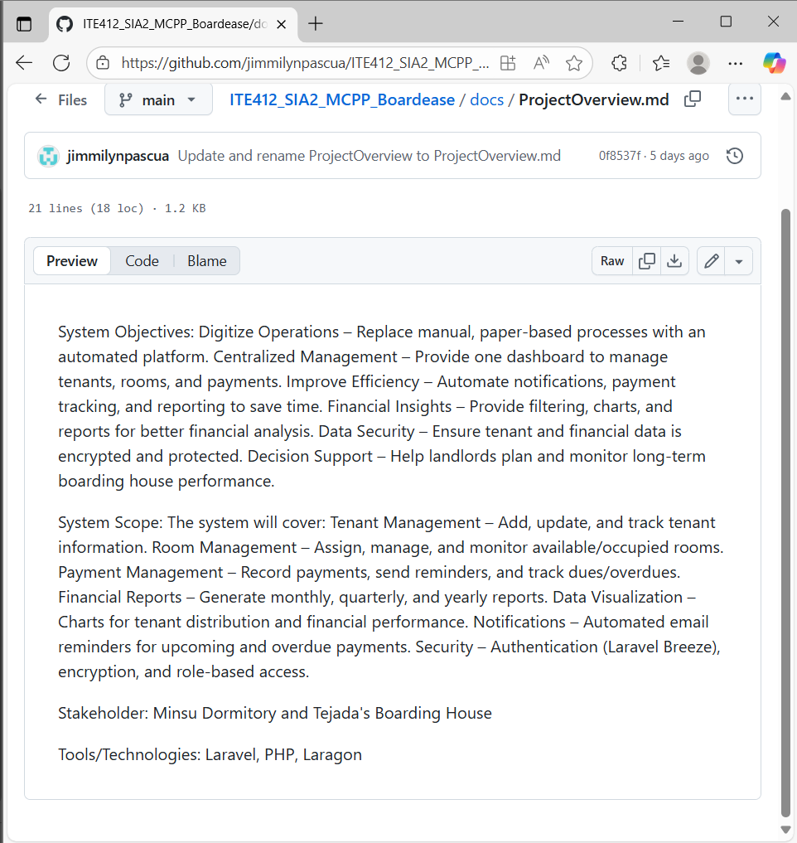

**Evaluation Criteria (Total: 100 pts)**

| **Criterion** | **Description** | **Pts** |
| --- | --- | --- |
| Repository Setup | Proper structure and naming conventions (ITE412_SIA2_[TeamName]_Project, correct folders, README present) | 30 |
| Documentation | Complete and clear ProjectOverview.md (objectives, scope, stakeholders, tools) | 30 |
| Version Control Usage | Each member contributed at least one commit via branch → PR/MR → merge | 20 |
| Team Organization | Roles clearly defined and documented in README.md | 20 |
| Total |  | 100 |