**Description**

* The flowchart for the problem is

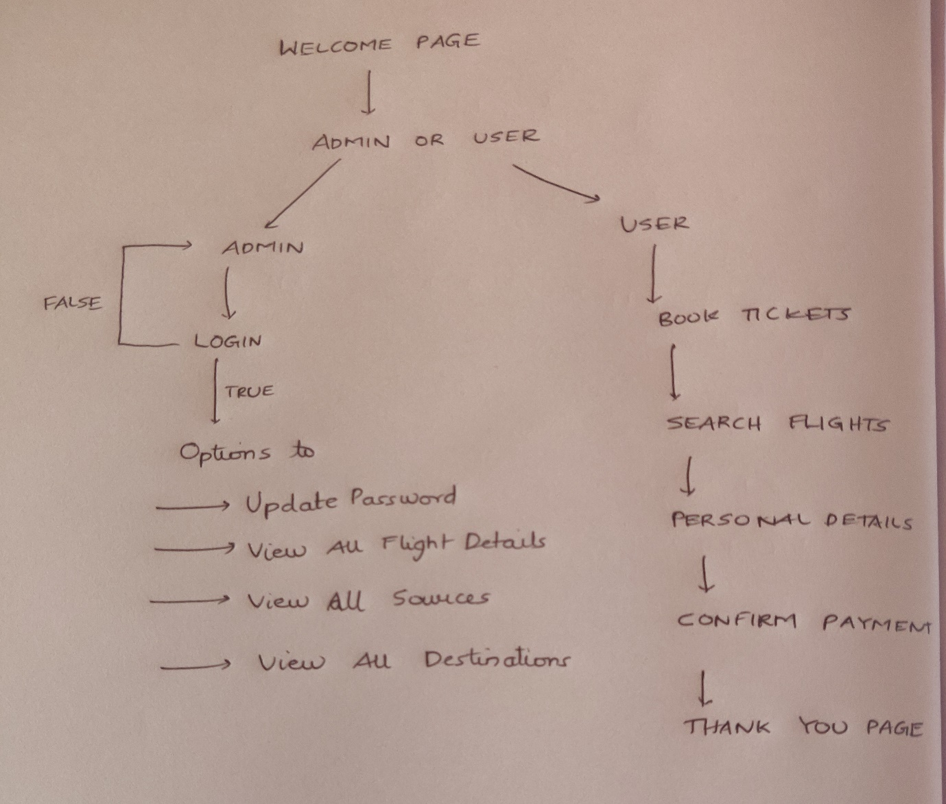

* Here we are using JDBC connectivity, servlets and some html pages.
* First there is the welcome screen that displays with two options of either Admin or user.
* If admin, then admin is asked to enter username and password .
* The credentials are verified with data entered in login table which contains the valid username and password.

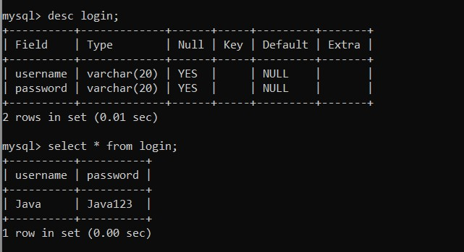

* Upon successful login admin has several privileges like update the password (upon which the table also gets modified), View all flight details, View all Sources, View all Destinations.
* There is a flights table in sql created that stores all the flight information.

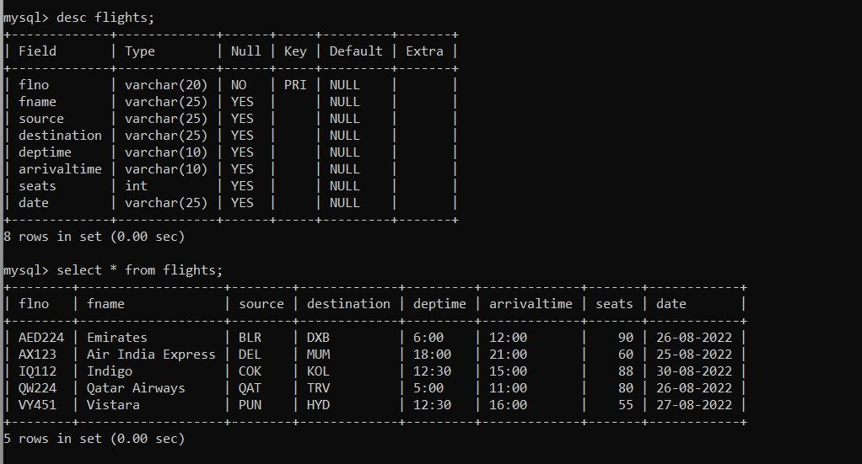

* Next if user , then he/she is provided with option of booking tickets.
* The source ,destination and date of travel are asked .
* Based on the input the available flights are displayed.
* To confirm next page asks about flight number, personal details and no: of seats needed.
* Personal details are stored in userdetails table.

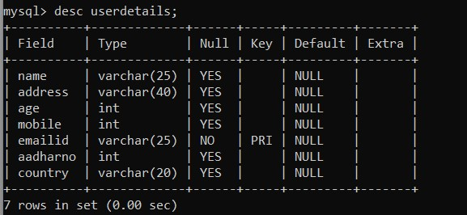

* Total payment required is displayed, along with all booking details.
* Thank you screen is displayed.