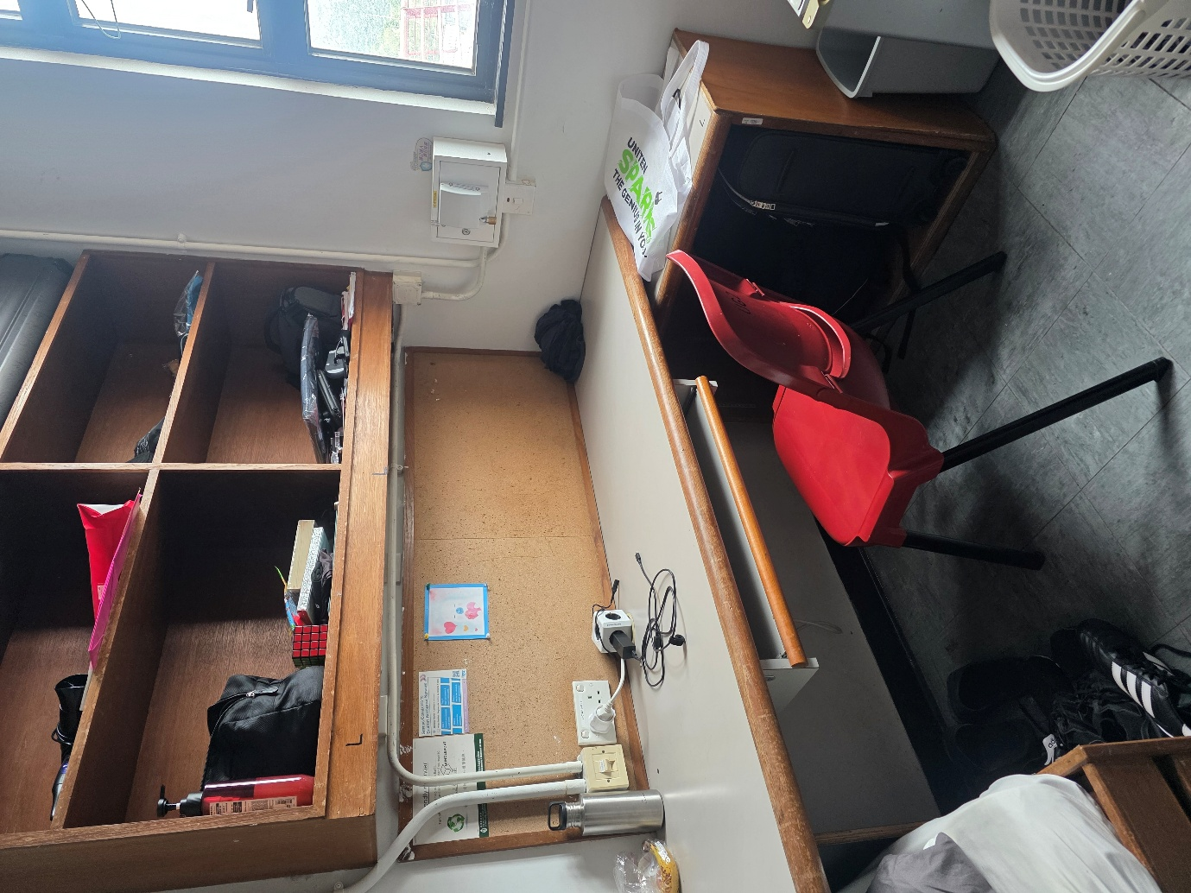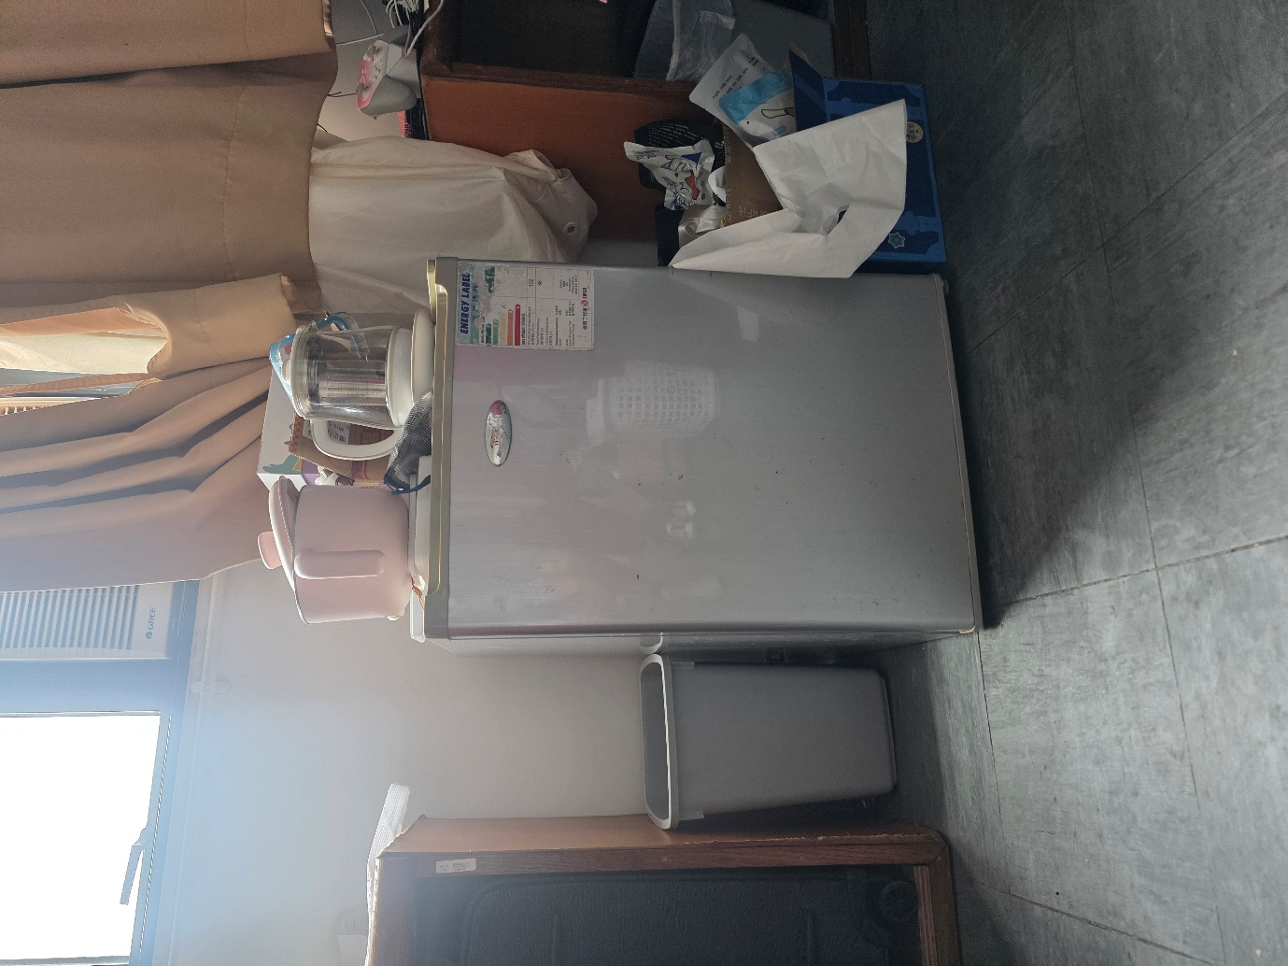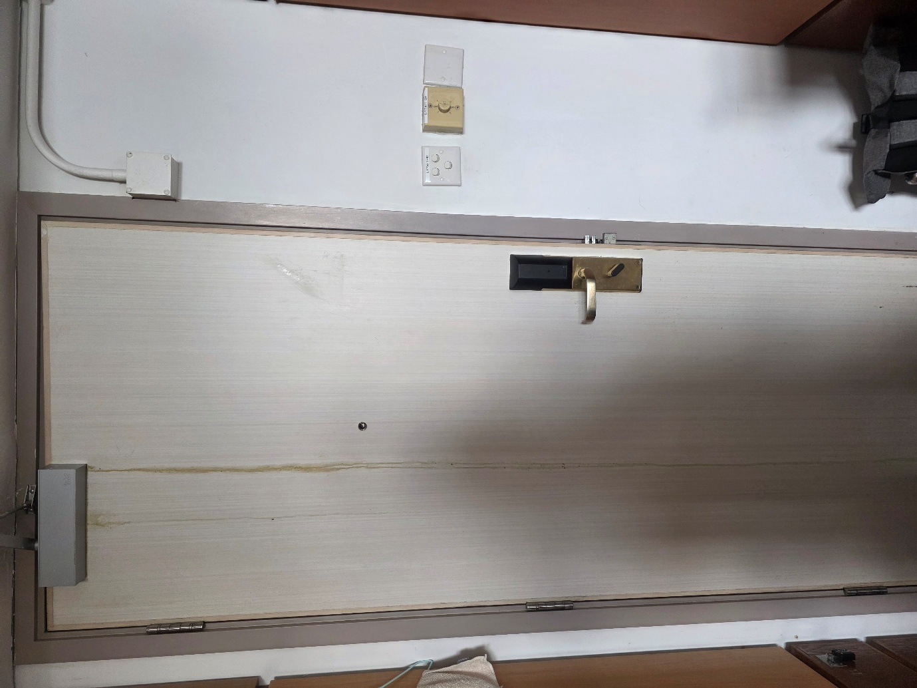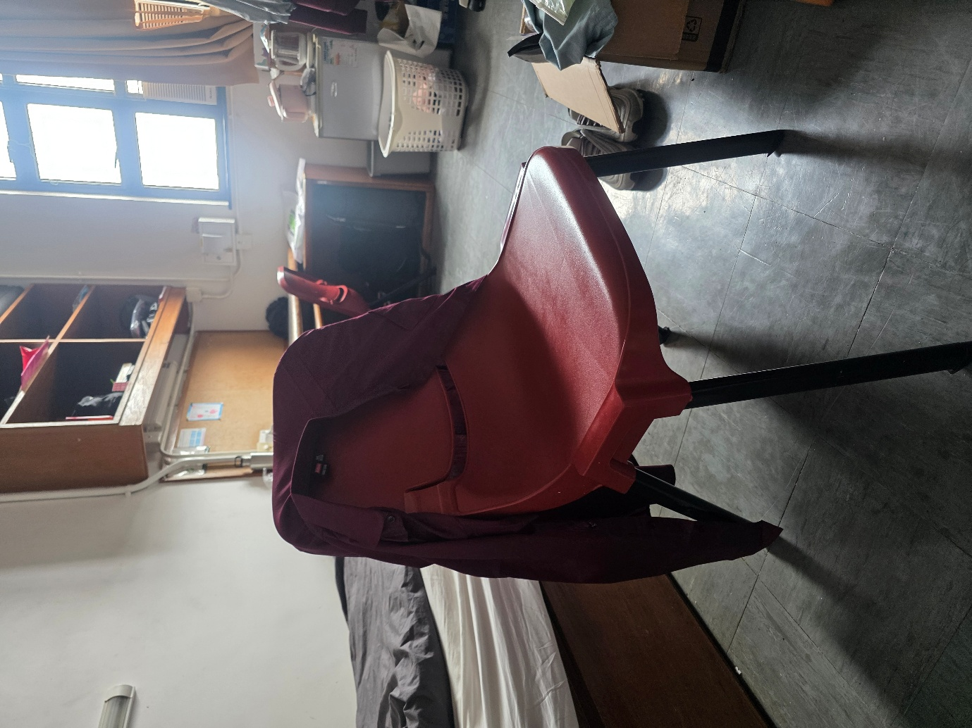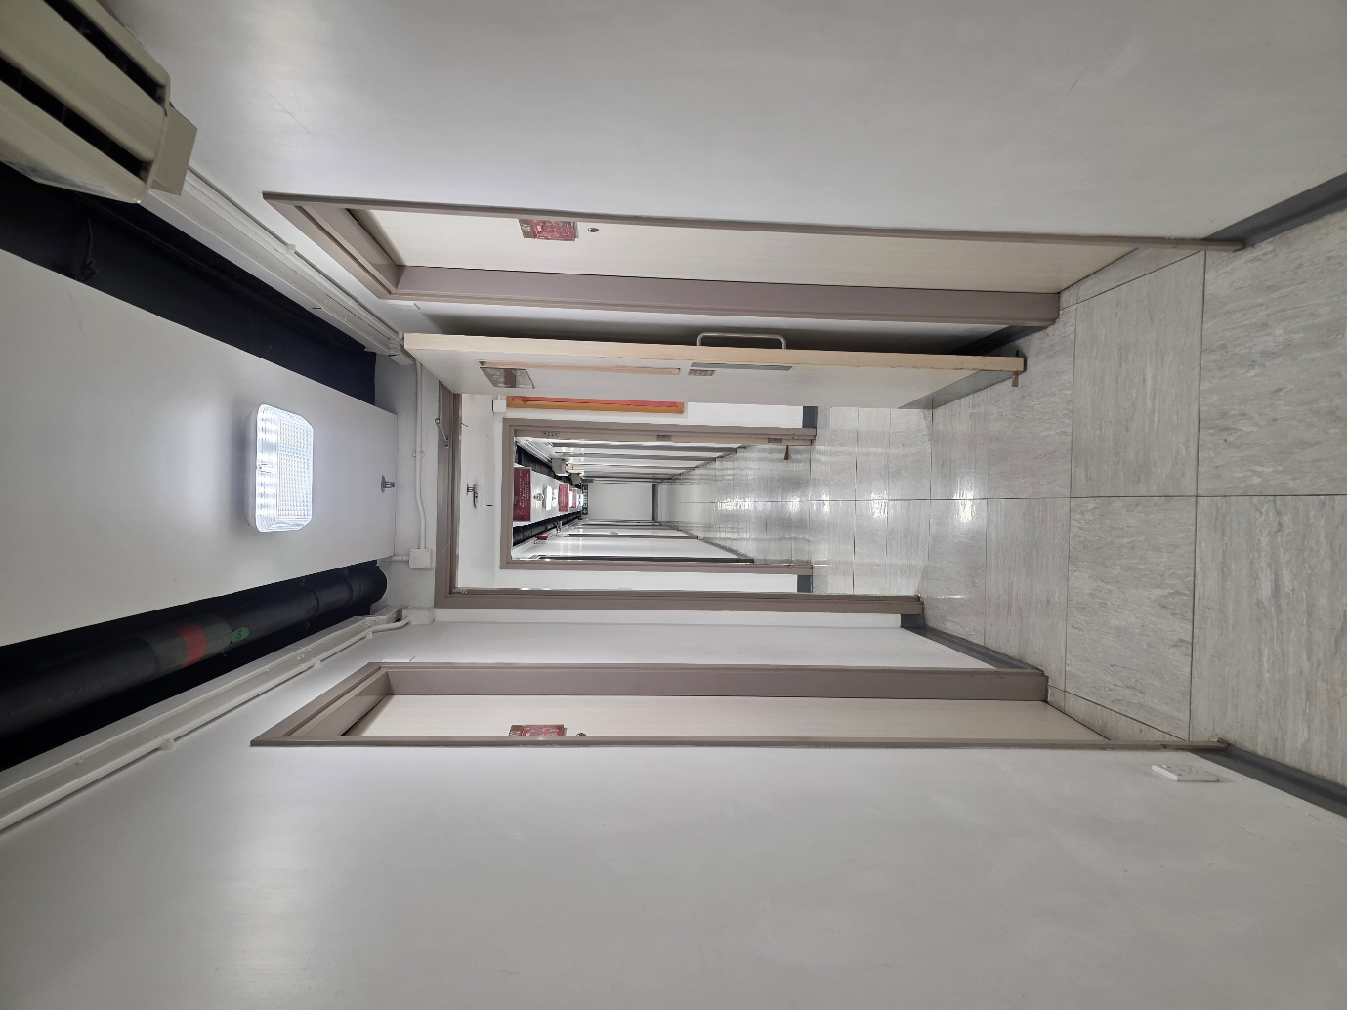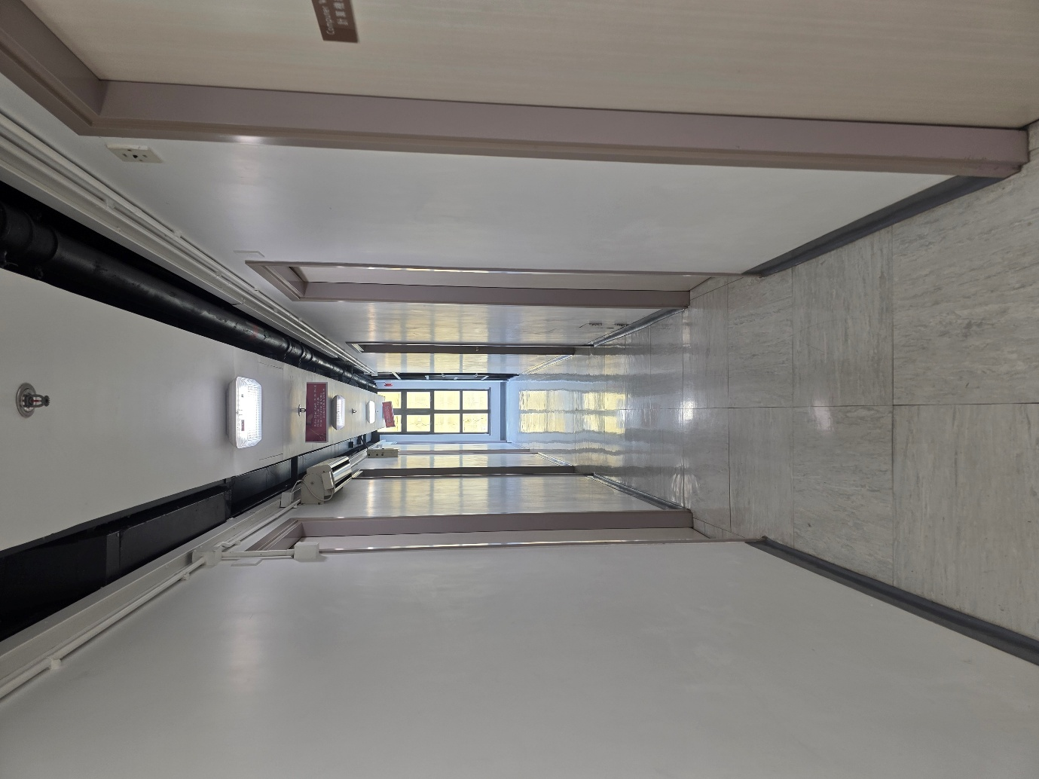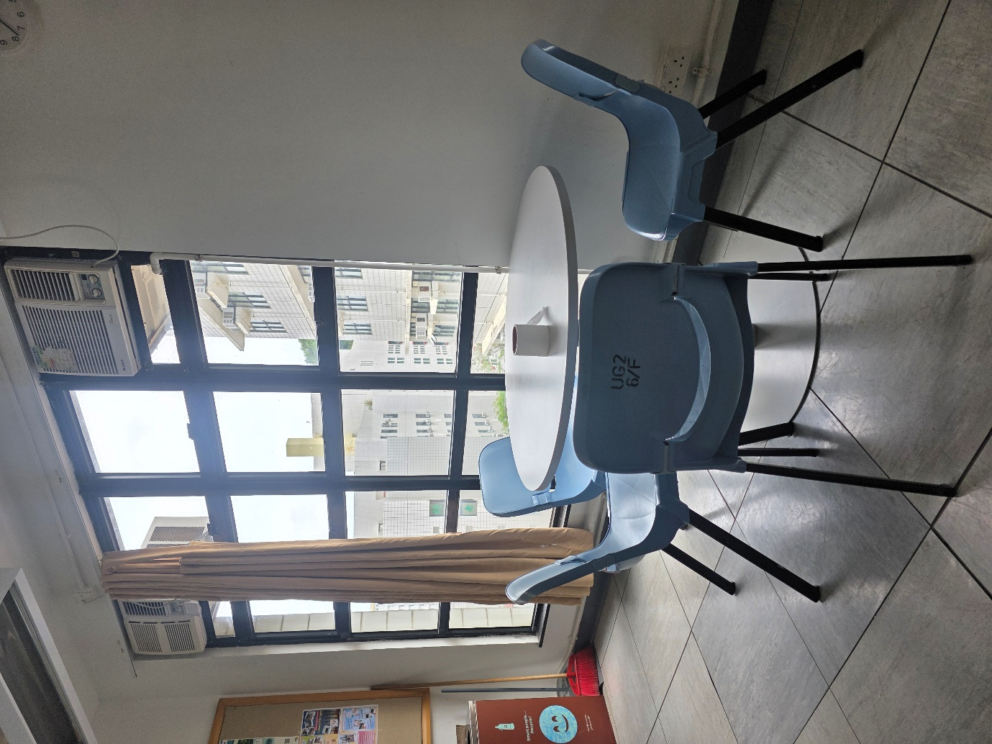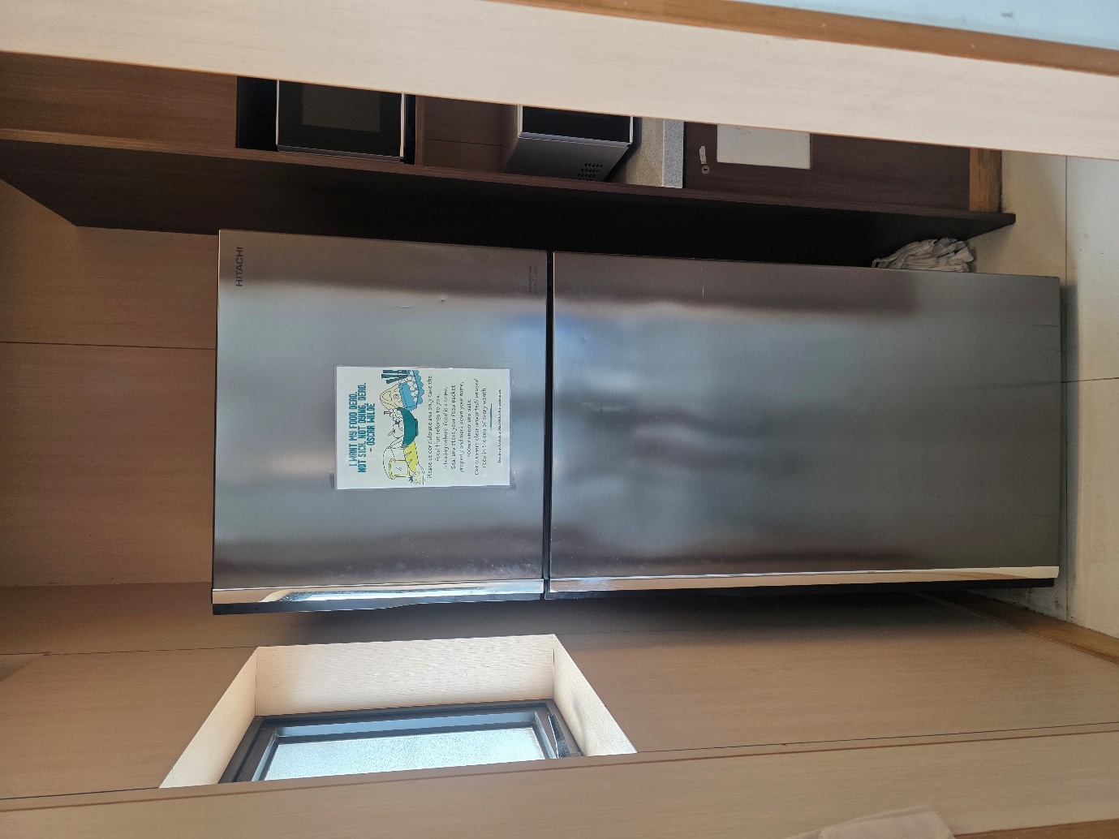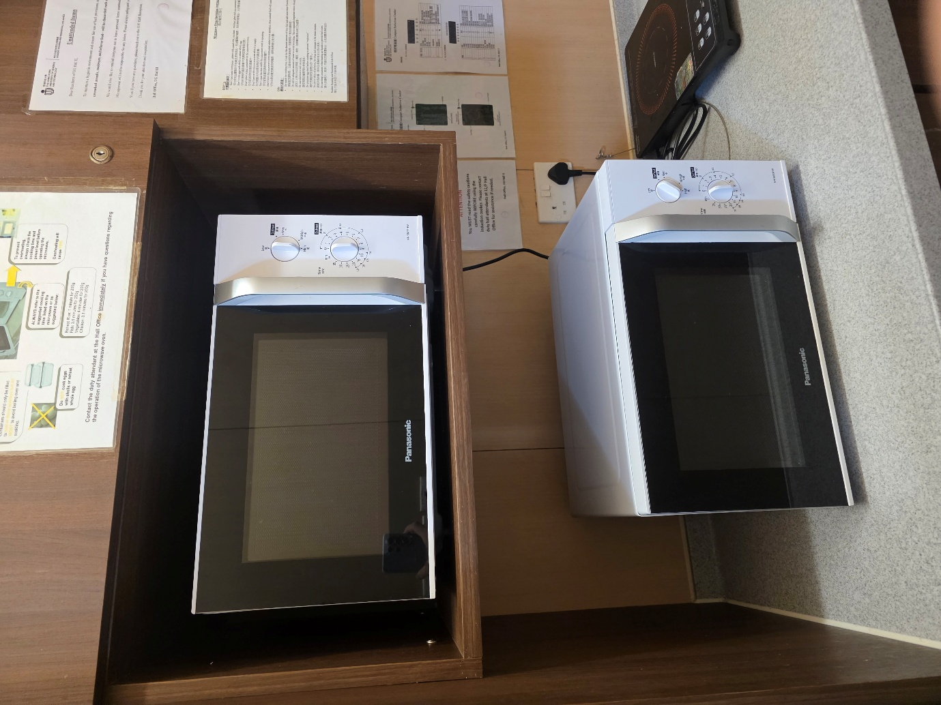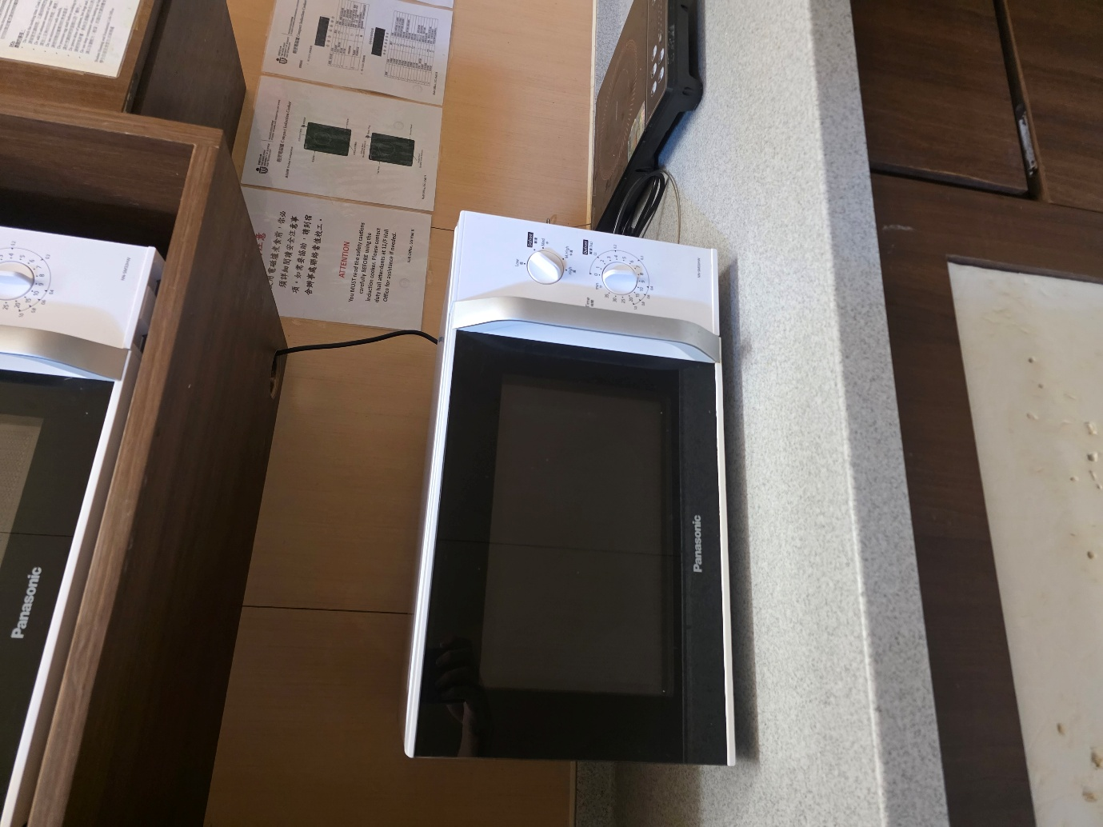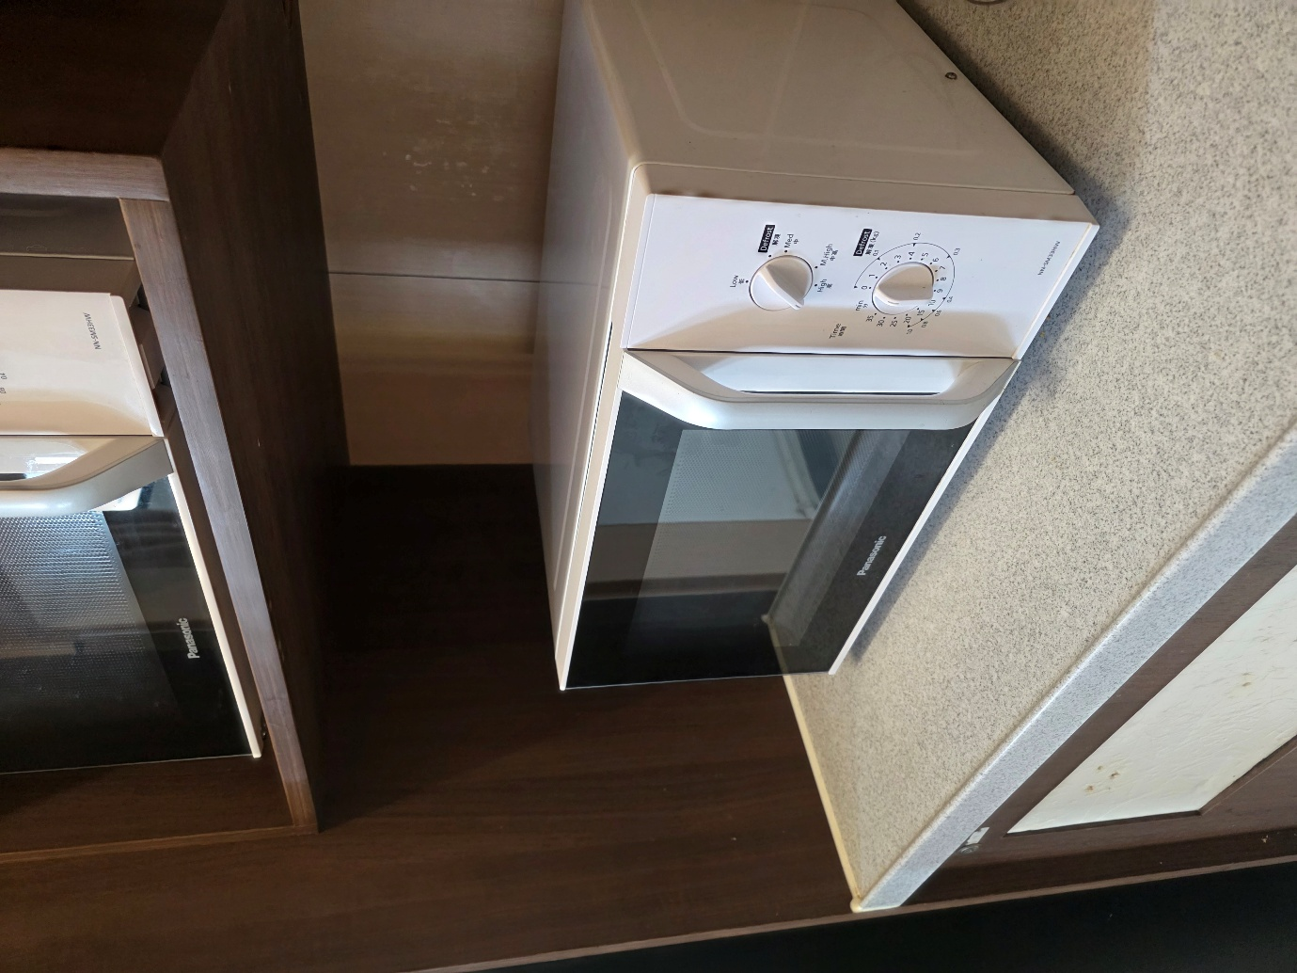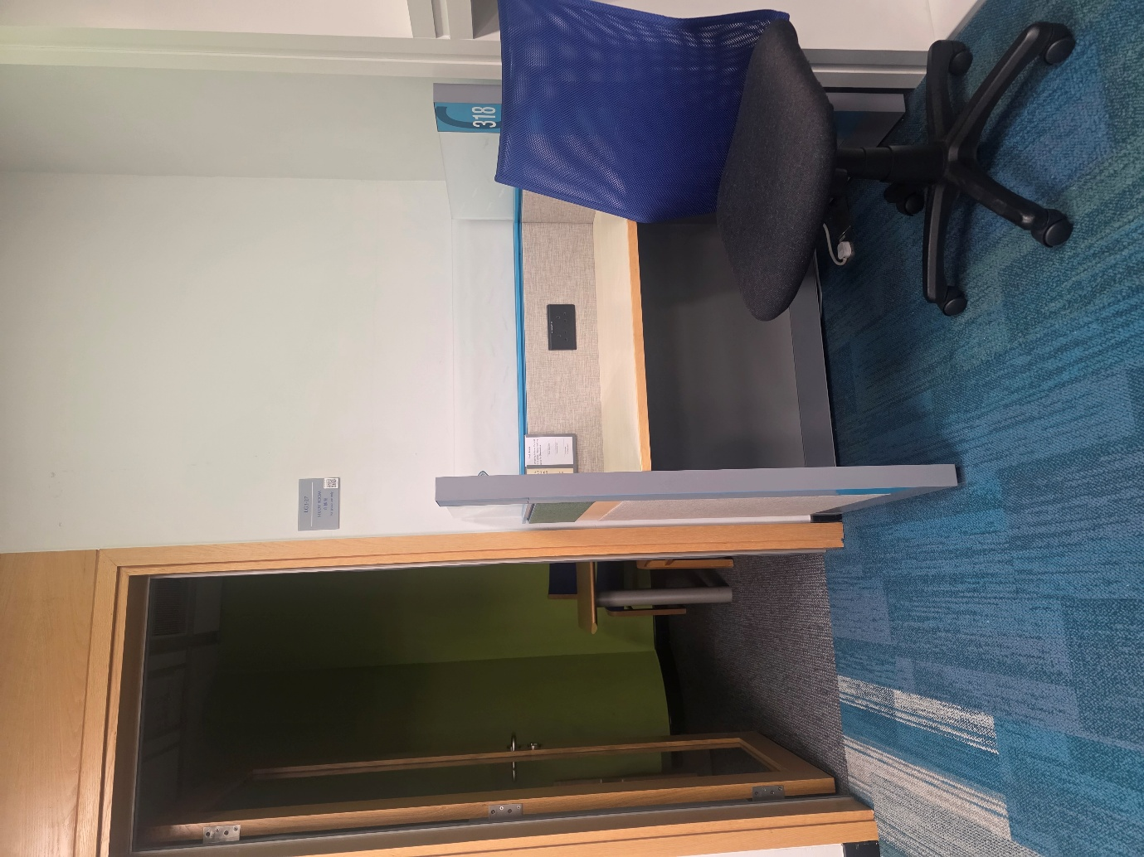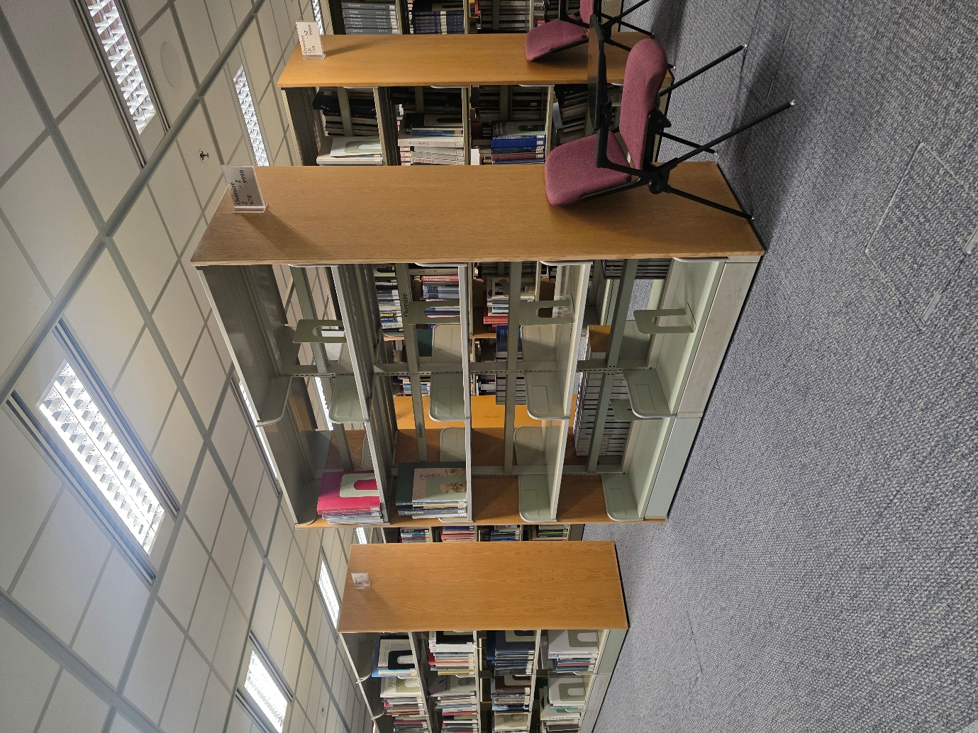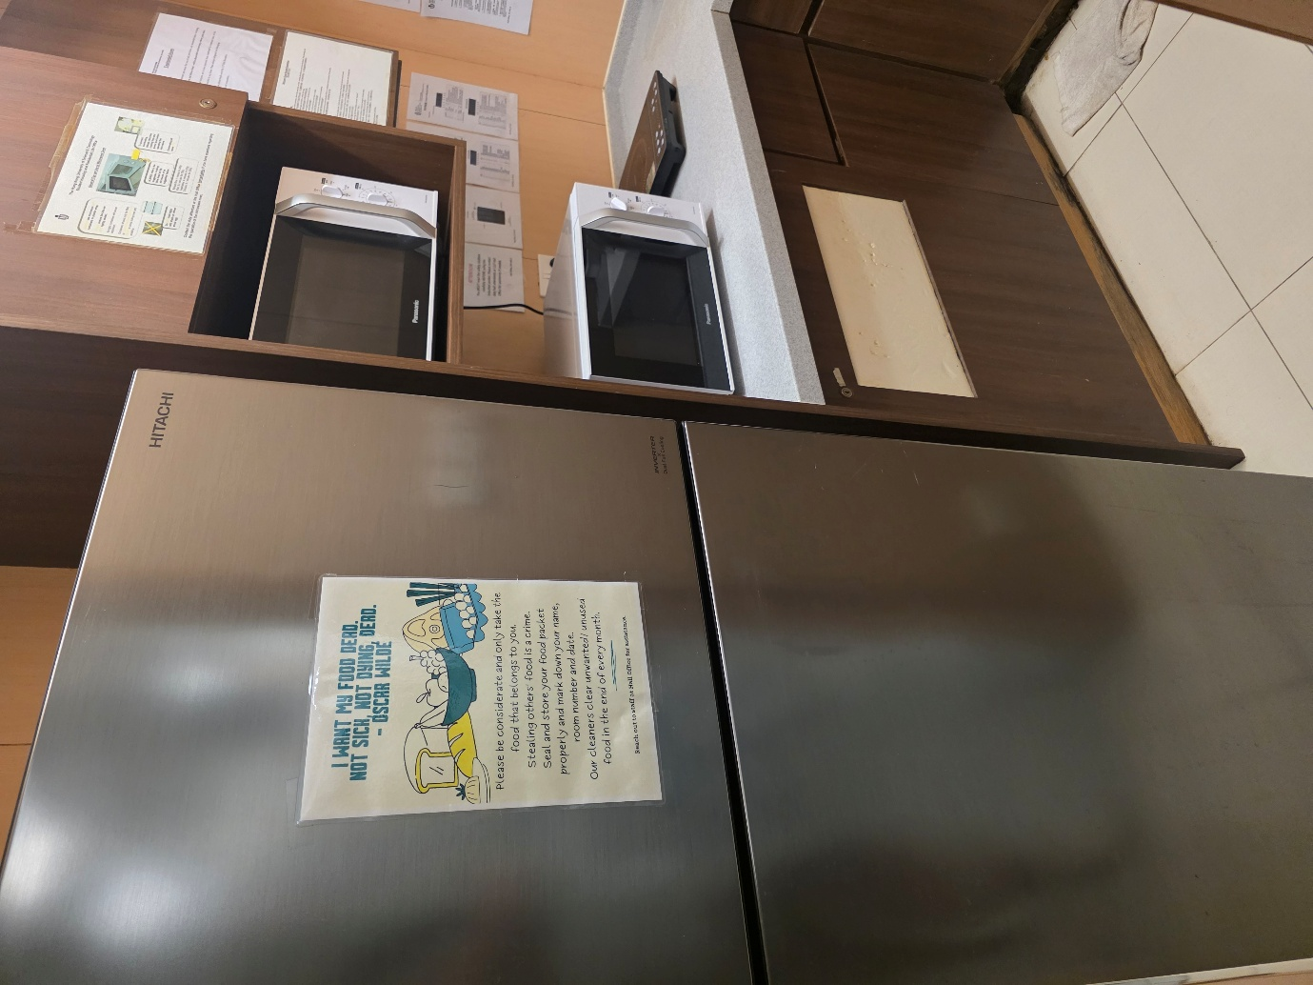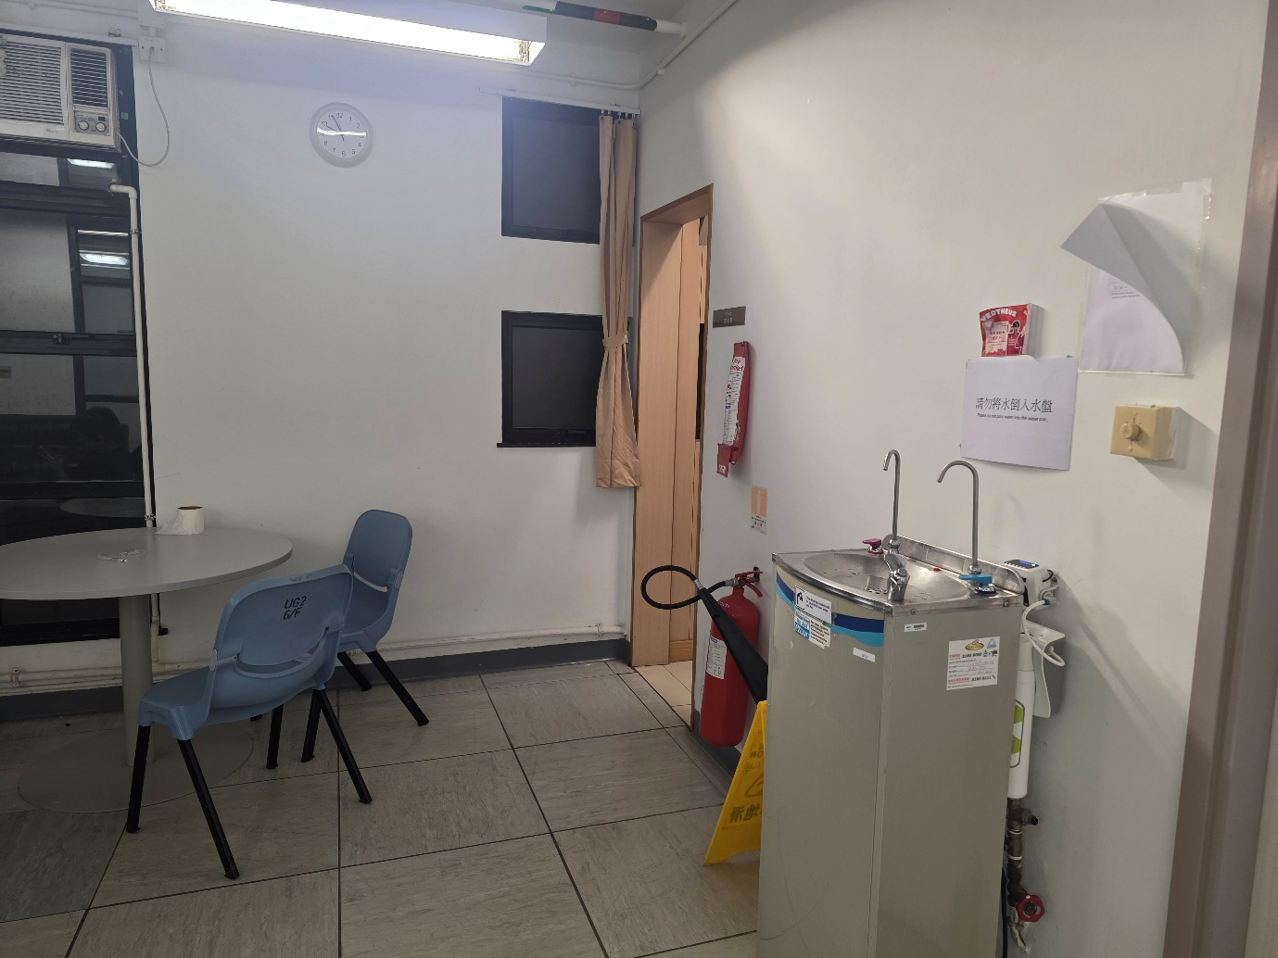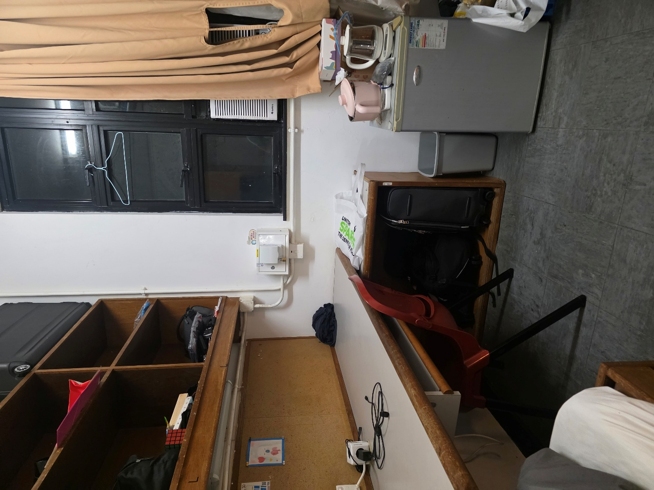

gt_labels_objects = {

# -- Dorm room: desk + red chair --
"1.jpg": [
{"class": "chair", "bbox": [0.3481, 0.6412, 0.7203, 0.9980], "info": [0.85, 12, 1.2]},
{"class": "table", "bbox": [0.0000, 0.4950, 0.9100, 0.7300], "info": [0.75, 12, 1.5]}
],

# -- Small mini-fridge --
"2.jpg": [
{"class": "refrigerator", "bbox": [0.2210, 0.3200, 0.7680, 0.9500], "info": [0.95, 12, 1.3]}
],

# -- Room door --
"3.jpg": [
{"class": "door", "bbox": [0.1350, 0.0100, 0.7600, 0.9900], "info": [2.1, 12, 1.5]}
],

# -- Chair in center of room --
"4.jpg": [
{"class": "chair", "bbox": [0.1300, 0.2200, 0.7800, 0.9700], "info": [0.85, 12, 0.9]}
],

# -- Clear corridor --
"5.jpg": [
{"class": None, "bbox": None, "info": None}
],

# -- Clear corridor --
"6.jpg": [
{"class": None, "bbox": None, "info": None}
],

# -- Common area: round table + 4 chairs --
"7.jpg": [
{"class": "table", "bbox": [0.1800, 0.3800, 0.8500, 0.7200], "info": [0.75, 12, 1.4]},
{"class": "chair", "bbox": [0.0500, 0.4500, 0.3500, 0.9600], "info": [0.85, 10, 1.6]},
{"class": "chair", "bbox": [0.2800, 0.3200, 0.5800, 0.8800], "info": [0.85, 12, 1.5]},
{"class": "chair", "bbox": [0.6000, 0.3800, 0.9200, 0.8800], "info": [0.85, 2, 1.6]}
],

# -- Large Hitachi fridge --
"8.jpg": [
{"class": "refrigerator", "bbox": [0.1800, 0.0600, 0.8200, 0.9800], "info": [1.7, 12, 1.1]}
],

# -- Microwaves on shelf (not in walking path) --
"9.jpg": [
{"class": None, "bbox": None, "info": None}
],

"10.jpg": [
{"class": None, "bbox": None, "info": None}
],

"11.jpg": [
{"class": None, "bbox": None, "info": None}
],

# -- Library study cubicle: chair, desk, door in background --
"12.jpg": [
{"class": "chair", "bbox": [0.5500, 0.5200, 1.0000, 0.9800], "info": [0.90, 2, 0.8]},
{"class": "table", "bbox": [0.3500, 0.5500, 1.0000, 0.7800], "info": [0.75, 1, 1.0]},
{"class": "door", "bbox": [0.0200, 0.1000, 0.3800, 0.8500], "info": [2.10, 10, 3.0]}
],

# -- Library: 2 chairs among bookshelves --
"13.jpg": [
{"class": "chair", "bbox": [0.6200, 0.5500, 0.8500, 0.9700], "info": [0.85, 2, 1.8]},
{"class": "chair", "bbox": [0.8000, 0.5800, 1.0000, 0.9800], "info": [0.85, 3, 1.9]}
],

# -- Kitchen: large fridge + microwaves --
"14.jpg": [
{"class": "refrigerator", "bbox": [0.0000, 0.0200, 0.6000, 0.9800], "info": [1.7, 11, 0.9]}
],

# -- Common room: table, 2 chairs, door in background --
"15.jpg": [
{"class": "table", "bbox": [0.0000, 0.4800, 0.3500, 0.7500], "info": [0.75, 10, 1.5]},
{"class": "chair", "bbox": [0.1200, 0.5500, 0.3800, 0.9200], "info": [0.85, 11, 1.4]},
{"class": "chair", "bbox": [0.2800, 0.5800, 0.5200, 0.9500], "info": [0.85, 11, 1.3]},
{"class": "door", "bbox": [0.4200, 0.1500, 0.6500, 0.8800], "info": [2.10, 12, 3.0]}
],

# -- Dorm room: desk + red chair + mini-fridge --
"16.jpg": [
{"class": "chair", "bbox": [0.2800, 0.5800, 0.5500, 0.9800], "info": [0.85, 11, 1.0]},
{"class": "table", "bbox": [0.0000, 0.4200, 0.7500, 0.7000], "info": [0.75, 12, 1.2]},
{"class": "refrigerator", "bbox": [0.7200, 0.5500, 0.9800, 0.9500], "info": [0.95, 2, 1.5]}
]
}

gt_labels_environment = {

"1.jpg": [{"class": "obstacle", "info": [1.0, 12]}],
"2.jpg": [{"class": "obstacle", "info": [1.3, 12]}],
"3.jpg": [{"class": None, "info": None}],
"4.jpg": [{"class": None, "info": None}],
"5.jpg": [{"class": None, "info": None}],
"6.jpg": [{"class": None, "info": None}],
"7.jpg": [{"class": None, "info": None}],
"8.jpg": [{"class": "obstacle", "info": [0.3, 3]}],
"9.jpg": [{"class": None, "info": None}],
"10.jpg": [{"class": None, "info": None}],
"11.jpg": [{"class": None, "info": None}],
"12.jpg": [{"class": "obstacle", "info": [0.5, 9]}],
"13.jpg": [{"class": "obstacle", "info": [1.5, 12]},
{"class": "obstacle", "info": [1.5, 10]}],
"14.jpg": [{"class": "obstacle", "info": [0.3, 3]}],
"15.jpg": [{"class": "obstacle", "info": [1.0, 1]}],
"16.jpg": [{"class": "obstacle", "info": [0.8, 12]}],
}

