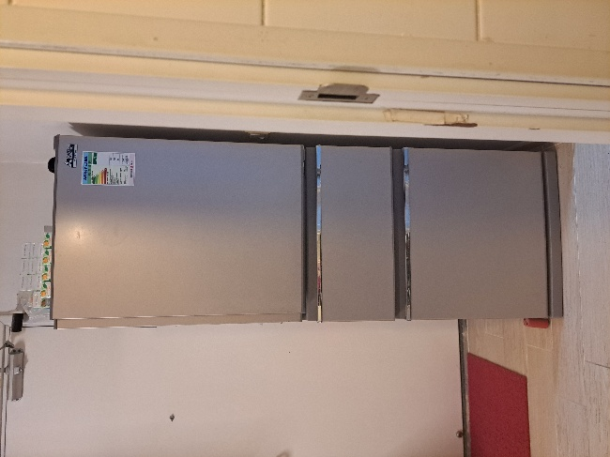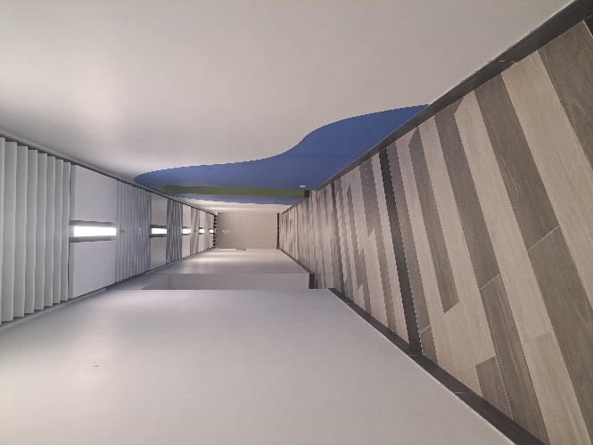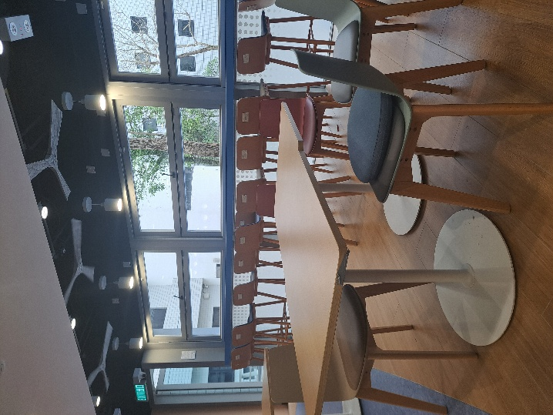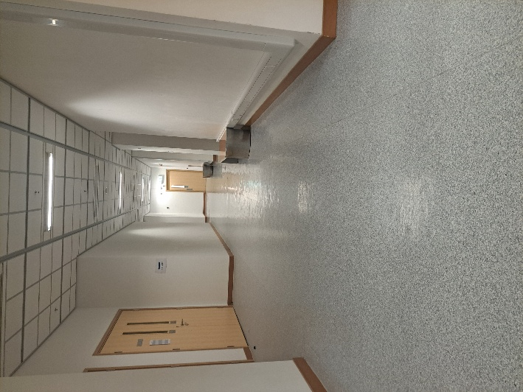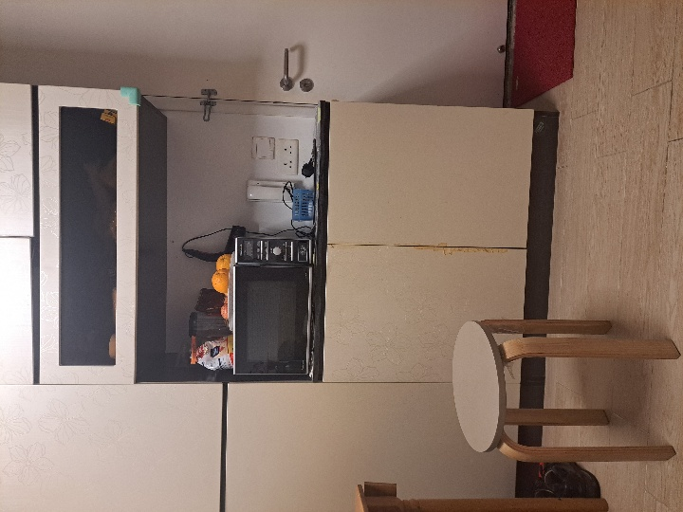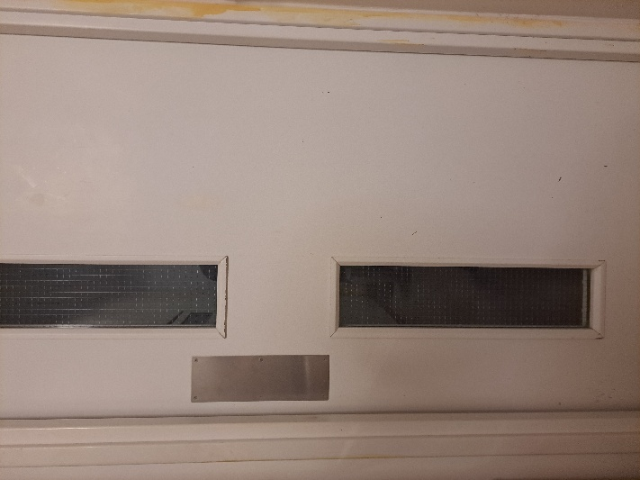
Top left :1 top right:2 …bottom right:6

gt_labels_objects = {
"1.jpg": [
{"class": "refrigerator", "bbox": [0.2813, 0.0853, 0.7067, 0.9196], "info":[ 1.7, 12, 1.4]}
],
"2.jpg": [
{"class": None, "bbox": None, "info":None}
],
"3.jpg": [
{"class": "chair", "bbox": [0.4839, 0.5244, 0.8810, 0.9980], "info":[0.7,12,1.2]},
{"class": "table", "bbox": [0.0030, 0.4836, 0.7681, 0.9343], "info":[0.7,12,1.1]}
],
"4.jpg": [
{"class": "chair", "bbox": None, "info":None}
],
"5.jpg": [
{"class": "chair", "bbox": [9.5008e-02, 6.5997e-01, 3.7862e-01, 9.9674e-01], "info":[0.46,11,1.26]}
],
"6.jpg": [
{"class": None, "bbox": None, "info":None}
]
}

gt_labels_environment = {
"1.jpg": [
{"class": "obstacle", "info": [0.3, 13]},
],
"2.jpg": [
{"class": None, "info": None}
],
"3.jpg": [
{"class": None, "info": None}
],
"4.jpg": [
{"class": None, "info": None}
],
"5.jpg": [
{"class": None, "info": None}
],
"6.jpg": [
{"class": "obstacle", "info": [12, 0.7]}
]
}

