Steam: Zarfie2 Steam ID: 76561198157169693

Handle: jimboslice2767 Discord ID: 277192014007631872

Gadot:

Inky:

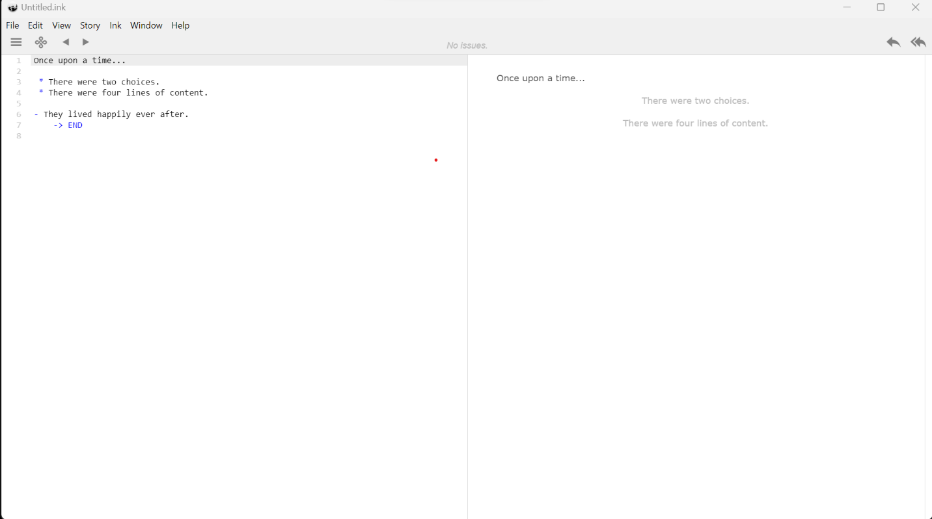

Github:

