ADS 506: Monthly Amtrak Ridership Forecasting Final Project

Team 3: Jimmy Nguyen, Luke Awino

12/04/2021

Table of Contents

# Libraries

library(astsa)  
library(readr)  
library(forecast)  
library(zoo)  
library(xts)  
library(pander)  
library(tidyverse)  
library(tseries)  
library(lubridate)  
  
knitr::opts_chunk$set(warning = FALSE, message = FALSE)

# Data Set

# Load the data set from CSV file  
df <- read_csv("../Data/Amtrak Ridership Data.csv")  
  
  
# Rename columns  
names(df)[1] <- 'Dates'  
names(df[2]) <- 'Number_of_Passengers'  
  
  
# First 12 months in 1991  
head(df, n = 12) %>%   
 pander(style = "grid", caption = "First 12 Months - 1991")

First 12 Months - 1991

| Dates | Number of Passengers |
| --- | --- |
| Jan-91 | 1708917 |
| Feb-91 | 1620586 |
| Mar-91 | 1972715 |
| Apr-91 | 1811665 |
| May-91 | 1974964 |
| Jun-91 | 1862356 |
| Jul-91 | 1939860 |
| Aug-91 | 2013264 |
| Sep-91 | 1595657 |
| Oct-91 | 1724924 |
| Nov-91 | 1675667 |
| Dec-91 | 1813863 |

## Data Exploration

# convert to time series object   
df<- ts(data = df[,2], start = c(1991,1),   
 end = c(2013,5), frequency = 12)  
  
print("Starting Year and Month: ")

## [1] "Starting Year and Month: "

start(df)

## [1] 1991 1

print("Final Year and Month: ")

## [1] "Final Year and Month: "

end(df)

## [1] 2013 5

# Make a quick time-series plot  
plot(df, xlab = "Year", ylab = "Number of Passengers",   
 bty = "l", col = "grey41",  
 main = "Amtrak Ridership, 1991-2013")

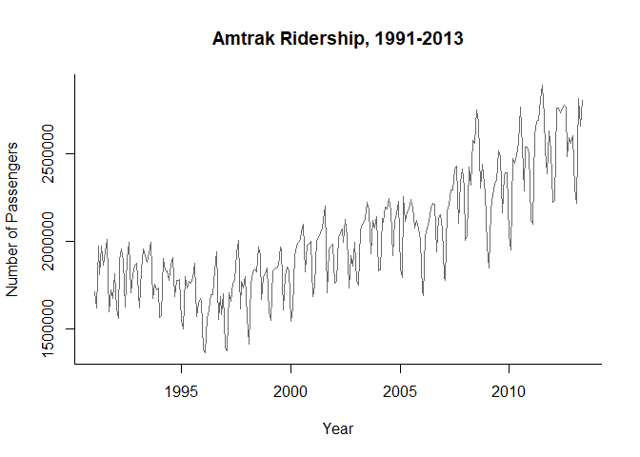

# Data Pre-processing

## Smoothing Methods (Moving Average)

At the beginning of our data exploration, we were able to see there are components that change over time. Thus, we will need to look into data-driven methods because it deals data without a predetermined structure.

### Moving Average

* This method is a simple smoother, it contains the average values across a time window, $w$, specified by the user. Two types of moving averages:
* a centered-moving average: useful for visualizing trends since averaging can suppress seasonality and noise
* a trailing moving average: useful for forecasting

# Trailing Average  
ma.trailing <- rollmean(df, k = 12, align = "right")  
  
# Centered-Average  
ma.centered <- ma(df, order = 12)  
  
# Original Data  
plot(df, ylab = "Ridership", xlab = "Time",  
 bty = "l", xaxt = "n", col = 'grey41',  
 main = "Centered vs. Trailing Moving Average")  
  
# Labels  
axis(1, at = seq(1991, 2013.50, 1), labels = format(seq(1991, 2013.50, 1)))  
  
# Centered average lines  
lines(ma.centered, lwd = 2, col = 'red')  
  
# trailing moving average  
lines(ma.trailing, lwd = 2, lty = 2, col ='blue')  
  
# legend  
legend(1991,2800000, c("Ridership","Centered Moving Average",   
 "Trailing Moving Average"), lty=c(1,1,2),  
lwd=c(1,2,2), bty = "n", col = c("grey41", 'red', 'blue'))

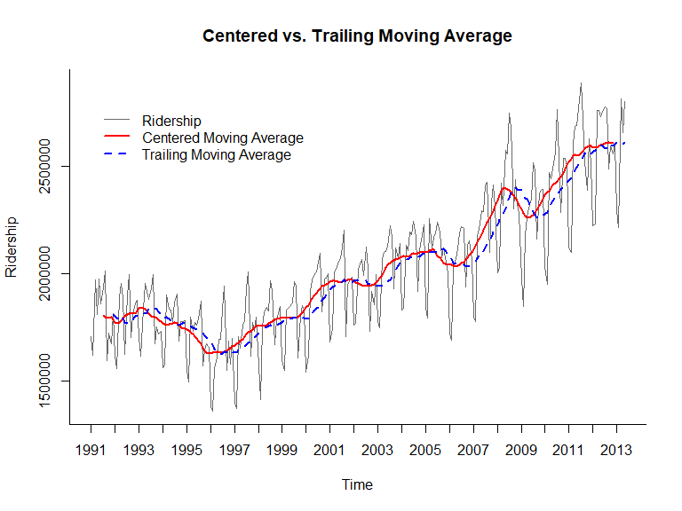

Since the goal is to suppress seasonality in the data to visualize the trend, we should choose the length of a seasonal cycle. *The Amtrak ridership data indicates a choice of $w=12$.*

* This figure shows somewhat of a global U-shape, but the moving average looks to increase as the year passes.
* However, since centered moving averages uses data both in the past and future of a given time point, they cannot be used for forecasting because the future is typically unknown.

### Trailing Moving Average

Therefore, trailing moving averages is the better approach here where the window of width is placed over the most recent available values.

# Validation Data  
nValid <- 36  
  
# Training data  
nTrain <- length(df) - nValid  
  
# time window for training data  
train.ts <- window(df, start = c(1991, 1), end = c(1991, nTrain))  
  
# time window for validation data  
valid.ts <- window(df, start = c(1991, nTrain + 1), end = c(1991, nTrain + nValid))  
  
# trailing moving average  
ma.trailing <- rollmean(train.ts, k = 12, align = "right")  
  
# last trailing moving average  
last.ma <- tail(ma.trailing, 1)  
  
# prediction by trailing moving average  
ma.trailing.pred <- ts(rep(last.ma, nValid), start = c(1991, nTrain + 1),  
end = c(1991, nTrain + nValid), freq = 12)  
  
# plot training data  
plot(train.ts, ylim = c(1300000, 2800000), ylab = "Ridership",   
 xlab = "Time", bty="l", xaxt = "n", col = 'grey41',  
xlim = c(1991,2013.50), main = "Forecasting with Trailing Moving Average")  
  
# labels  
axis(1, at = seq(1991, 2013.50, 1), labels = format(seq(1991, 2013.50, 1)))  
  
# training model  
lines(ma.trailing, lwd = 2, col = "blue")  
  
# validation data  
lines(valid.ts, col = 'grey41')  
  
# predictions on validation  
lines(ma.trailing.pred, lwd = 2, col = "blue", lty = 2)  
  
# legend  
legend(1991,2800000, c("Original Ridership","Training Predictions",   
 "Validation Predictions"), lty=c(1,1,2),  
lwd=c(1,2,2), bty = "n", col = c("grey41", 'blue', 'blue'))

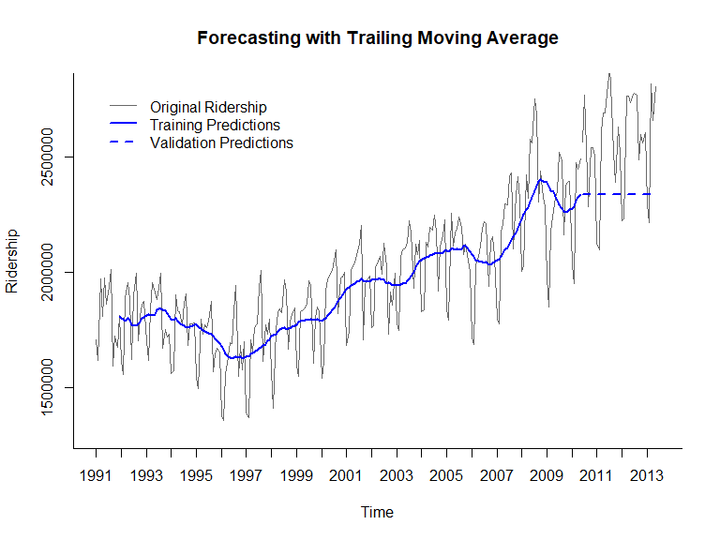

* The first thing to notice is that the forecasts for all the months in the validation period denoted in blue and blue dashes are identical because this method is not roll-forward next month forecasts. It is clear that the trailing moving average forecaster is inadequate for the Amtrak monthly forecast task. The reason why is because it does not capture the seasonality in the data. The forecaster predicted seasons with high ridership with lower ridership and seasons with low ridership with high ridership. This occurs because the moving average lags behind when forecasting a time series with a trend. Therefore, over-forecasting and under-forecasting in the presence of increasing and decreasing trends. So, between the smoothing methods of moving averages, it should only be use for forecasting when a series lack seasonality and trend, which is not true here for the Amtrak ridership data.
* However, there are other approaches for removing trends and seasonality, such as regression models or differencing.
* Then we can use the moving average to forecast a de-trended and de-seasonalized series.

## Differencing

Differencing is a popular method for removing trend or seasonality patterns by taking the difference between two values in a series.

* For example, the lag-1 difference takes the difference between every two consecutive values $\left(y_{t}−y_{t−1}\right)$.
* Meanwhile, differencing at lag-k means to subtract the value from k-periods back $\left(y_{t}−y_{t−k}\right)$.

### Dickey-Fuller Test

However, before using differencing as a pre-processing step, we should run a Dickey-Fuller test to see if differencing is actually needed. In other words, this test also check if the time series is stationary or not.

# Running the Dickey-Fuller Test on the original data without any pre-processing  
adf.test(df)

##   
## Augmented Dickey-Fuller Test  
##   
## data: df  
## Dickey-Fuller = -3.8062, Lag order = 6, p-value = 0.01915  
## alternative hypothesis: stationary

This may be a biased Dickey-Fuller test where we have a type 1 error. There is definitely visible seasonality happening in the data.  
Since the test rejects the null hypothesis that the series is non-stationary, in this case the series was actually non-stationary. Therefore, we will ignore that it ever happened because we will need to perform a second order difference due to a trend and seasonality pattern in the series. - Alternative approaches without differencing can be aggregating the monthly data into a coarser level such as yearly ridership as the total sum instead.

## Detrending

Detrending can be used by the lag-1 difference of a series. This would remove the somewhat U-shape of Amtrak ridership series. An advantage of difference is there are no assumptions that the trend is global.

* For quadratic or exponential trends, one more step of lag-1 differencing must be applied to remove the trend.

## Deseasonalizing

We can remove the seasonality of the Amtrak ridership data by using a lag-12 difference series. THis will remove the monthly pattern

## Removing seasonality and trend

* When both of these components exist, we can apply differencing twice to the series.
* Since the Amtrak ridership data has both trend and seasonality, we will perform the doube differencing method in order to de-trend and deseasonalize it.

par(mfrow=c(2,2))  
  
# Original  
plot(df, xlab = "Year", ylab = "Number of Passengers",   
 main = "Original Amtrak Ridership, 1991-2013", col = 'grey41')  
  
# lag-12 difference  
plot(diff(df, lag = 12), xlab = "Year", ylab = "Lag-12",   
 main = "Lag-12 Difference", col = 'blue')  
  
# lag-1 difference  
plot(diff(df), xlab = "Year", ylab = "Lag-1",   
 main = "Lag-1 Difference", col = 'red')  
  
  
# Double Differencing   
plot(diff(diff(df, s = 12)), xlab = "Year", ylab = "Lag-12, then Lag-1",   
 main = "Twice-Differenced (Lag-12, Lag-1)", col = 1)

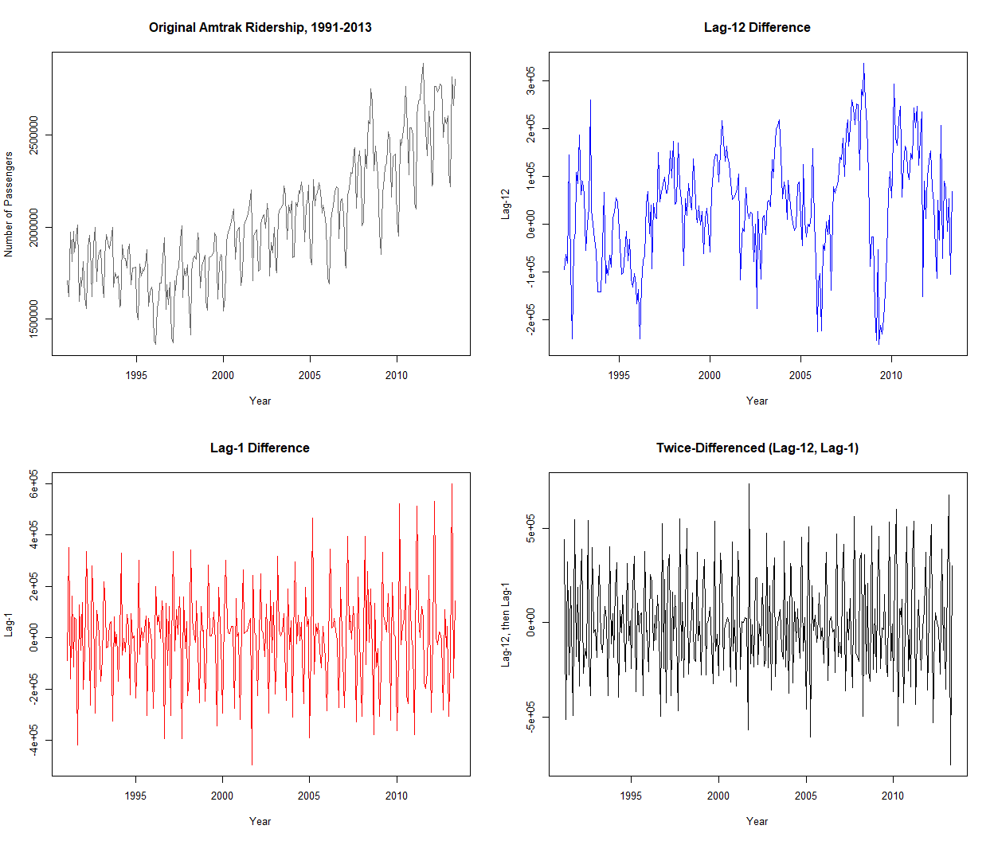

* The lag-1 difference plot on the bottom left contains no visible trend compared to the original series above.
* If we are dealing with daily data ridership, then we could remove a seasonal pattern of lag-7 differences. However, since we are have monthly data, we are using a lag-12 difference series as shown in the top right figure where the monthly pattern is absent.
* Lastly, since there are both a seasonality and trend, the double differencing effect on the bottom right panel is a series without trend or monthly seasonality.

# Data Modeling

## Simple Exponential Smoothing

Exponential smoothing works very similar to forecasting with a moving average, except it takes the weighted average over all the past values of a series. By doing so, the weights will decrease exponentially into the past. This is valuable because we give weight to recent information more than the older information. This method is also very popular due to its low computation costs, easy automation, and good performance. However, it is important to note that using exponential smoothing for forecasting assumes no trend or seasonality in a series. So the idea is similar to before with moving averages, by first removing the trend and seasonality, then apply the exponential smoothing forecaster.

# remove trend and seasonality by doing double-differencing  
diff_twice <- diff(diff(df, lag = 12), lag = 1)  
  
# Number of validation data  
nValid <- 36  
  
# number of training data  
nTrain <- length(diff_twice) - nValid  
  
# specified time window for training data   
train.ts <- window(diff_twice, start = c(1992, 2), end = c(1992, nTrain + 1))  
  
# specified time window for validation data  
valid.ts <- window(diff_twice, start = c(1992, nTrain + 2),   
 end = c(1992, nTrain + 1 + nValid))  
  
# Additive, no trend, no seasonality model using a constant (learning rate) of 0.2  
ses <- ets(train.ts, model = "ANN", alpha = 0.2)  
  
# make predictions using model  
ses.pred <- forecast(ses, h = nValid, level = 0)  
  
# training data then validation forecasts  
plot(ses.pred, ylab = "Ridership (Twice-Differenced)", xlab = "Time",  
bty = "l", xaxt = "n", xlim = c(1991,2013.50), main = "Simple Exponential Smoother on   
Double Differenced Data", flty = 2)  
  
# labels  
axis(1, at = seq(1991, 2013, 1), labels = format(seq(1991, 2013, 1)))  
  
# training model - predictions  
lines(ses.pred$fitted, lwd = 2, col = "darkslategray2")  
  
# validaiton data  
lines(valid.ts)  
  
# legend  
legend(1994,230000, c("Original Ridership","Training Predictions",   
 "Validation Predictions"), lty=c(1,1,2),  
lwd=c(1,2,2), bty = "n", col = c("black", 'darkslategray2', 'blue'))

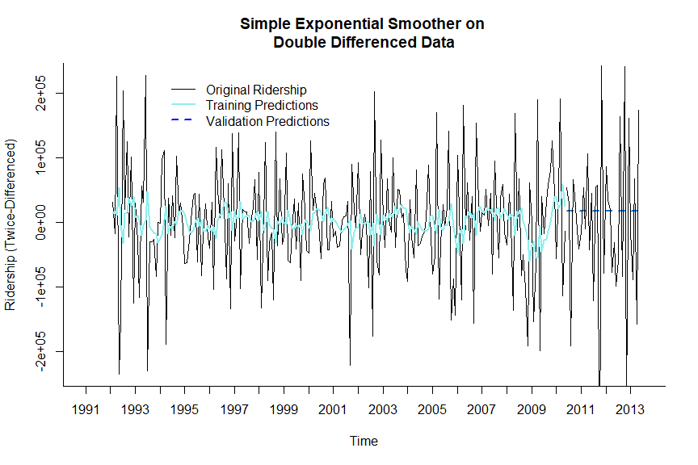

For forecasting with simple exponential smoothing, the data trained on was the double-difference ridership data that contains no seasonality or trend. Then we fit the simple exponential smoothing model to the training data set with $α=0.2$ as default. This smoothing model is under the *ets* framework using the model with additive (A), no trend (N), and no seasonality (N), denoted as “ANN”. The forecasts for the validation set for each month remained as the same value similar to the moving average forecast model. This would mean that the simple exponential forecaster or ANN model is also inadequate for the monthly forecasting task. The reason why is because it also does not capture the seasonality in the data.

* The simple exponential smoothing models did a poor job at forecasting this time series without trend or seasonality.
* Another solution is to use a more complex and sophisticated exponential smoothing that is able to model data with both trend and seasonality.

## Additive Trends

Double exponential smoothing can be used on a series that contain an additive trend. This is also called the Holt’s linear trend model. The local trend is estimated and is updated as more data comes in. The equation is specified by $F_{t+k}=L_{t}+kT_{t}$, where the k-step-ahead forecast is a combination of the level estimate at time $t$ $L\left(t\right)$ and the trend estimate at time $t$ $\left(Tt\right)$. There is also two smoothing constants $α$ and $β$ which determine the rate of learning and can be constants between 0 and 1 set by the user (Higher values = faster learning). However, there are two types of errors in an exponential model:

* Additive error (additive trend): This is where errors are assumed to have a fixed magnitude, meaning the forecasts contain not only the level + trend but also an additional error. $y_{t+1}=L_{t}+T_{t}+e_{t}$
* Multiplicative error (additive trend): This is where the size of the error grows as the level of the series increase, or the error is a percentage increase in the current level plus trend. $y_{t+1}=\left(L_{t}+T_{t}\right)*\left(1+e_{t}\right)$

## Multiplicative trends

Although additive trend models assumes the level changes from one period to the next by a fixed amount, multiplicative trends assumes it changes by a factor instead. Thus, the formula is different specified by: $F_{t+k}=L_{t}*T_{t}^{k}$

* For the additive error, it will be $y_{t+1}=L_{t}*T_{t}+e_{t}$ for the multiplicative trend model instead.
* While the multiplicative error stays the same as $y_{t+1}=\left(L_{t}+T_{t}\right)*\left(1+e_{t}\right)$

## Exponential smoothing with both a trend and seasonality

A further extension of the double exponential smoothing where the k-step-ahead forecasts also takes into consideration the seasonality of the current period. While the trend is considered from the additive and multiplicative seasonality. - This is specified as: $F_{t+k}=\left(L_{t}+kT_{t}\right)S_{t+k−M}$ where M denotes the number of seasons in a series (e.g., M = 12 for monthly seasonality). This is an adaptive method that allows the components (levels, trends, and seasonality) to change over time.

In this case we would make **June 2012 to May 2013** the validation period.

# Validation Data  
nValid <- 12  
  
# number of training data  
nTrain <- length(df) - nValid  
  
# time window for training data  
train.ts <- window(df, start = c(1991, 1), end = c(1991, nTrain))  
  
# time window for validation data  
valid.ts <- window(df, start = c(1991, nTrain + 1), end = c(1991, nTrain + nValid))  
  
# multiplicative error with additive trend and additive seasonality model  
maa <- ets(train.ts, model = "MAA")  
  
# Forecasts  
maa.pred <- forecast(maa, h = nValid, level = 0)  
  
# training data and validation data - forecasts  
plot(maa.pred, ylab = "Ridership", xlab = "Time",   
main = "Additive Trend and Additive Seasonality Model on Original   
Data", flty = 2, bty="l", xaxt = "n")  
  
# labels   
axis(1, at = seq(1991, 2013, 1), labels = format(seq(1991, 2013, 1)))  
  
# training data - forecasts  
lines(maa.pred$fitted, lwd = 2, col = "darkslategray2")  
  
# validation data only  
lines(valid.ts)  
  
# legend  
legend(1991,2800000, c("Training and Validation Data","Training Predictions",   
 "Validation Predictions"), lty=c(1,1,2),  
lwd=c(1,2,2), bty = "n", col = c("black", 'darkslategray2', 'blue'))

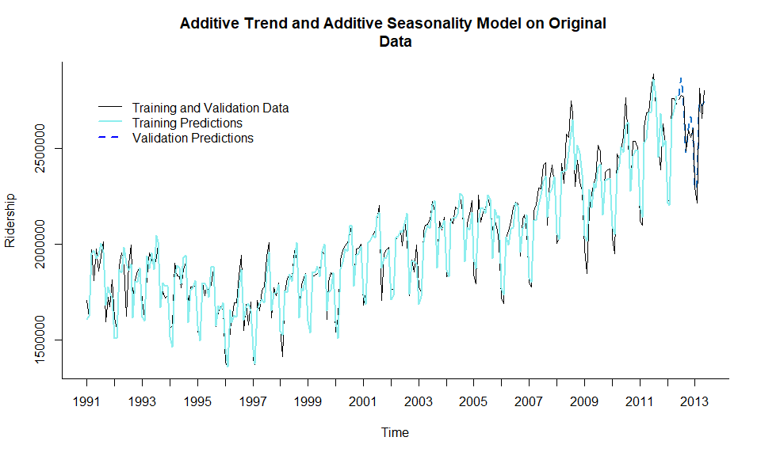

## ETS(M,Ad,A)   
##   
## Call:  
## ets(y = train.ts, model = "MAA")   
##   
## Smoothing parameters:  
## alpha = 0.5146   
## beta = 1e-04   
## gamma = 0.2007   
## phi = 0.8692   
##   
## Initial states:  
## l = 1868559.4037   
## b = -3079.4402   
## s = 23126.2 11233.09 11079.87 -128642.4 177366.8 187591.1  
## 81511.92 89042.49 49616.47 43289.88 -288877.1 -256338.3  
##   
## sigma: 0.0357  
##   
## AIC AICc BIC   
## 7181.096 7183.970 7244.979

This approach uses Holt-Winter’s method to build an additive trend and seasonality model with multiplicative error on the original data without a second order difference. This falls under the ets framework using the “MAA” model. However, what if the choice was to use an multiplicative trend and seasonality model, and so forth. There is an automated approach for model selection. In this case we would make **June 2012 to May 2013** the validation period.

### Automated Exponential Model Sections

By leaving out the model parameter inside the ets function, this will fit several different models and choose the best one based on the lowest AIC score.

# Validation Data  
nValid <- 12  
  
# number of training data  
nTrain <- length(df) - nValid  
  
# time window for training data  
train.ts <- window(df, start = c(1991, 1), end = c(1991, nTrain))  
  
# time window for validation data  
valid.ts <- window(df, start = c(1991, nTrain + 1), end = c(1991, nTrain + nValid))  
  
#automated selection - optimal model  
optimal <- ets(train.ts, restrict = FALSE, allow.multiplicative.trend = TRUE)  
optimal

## ETS(M,Ad,M)   
##   
## Call:  
## ets(y = train.ts, restrict = FALSE, allow.multiplicative.trend = TRUE)   
##   
## Smoothing parameters:  
## alpha = 0.5545   
## beta = 6e-04   
## gamma = 0.1467   
## phi = 0.98   
##   
## Initial states:  
## l = 1860206.6141   
## b = -2853.0529   
## s = 1.0049 0.9822 0.9979 0.9348 1.1141 1.0792  
## 1.0222 1.0606 1.0344 1.0276 0.8596 0.8826  
##   
## sigma: 0.0339  
##   
## AIC AICc BIC   
## 7155.162 7158.036 7219.045

# Optimal Forecasts  
op.pred <- forecast(optimal, h = nValid, level = 0)  
  
# training data - then validation forecasts  
plot(op.pred, ylab = "Ridership", xlab = "Time",   
 bty = "l", xaxt = "n", lwd =2,  
main = "Optimal Model from Automated Model Selections", flty = 2)  
  
# labels   
axis(1, at = seq(1991, 2013, 1), labels = format(seq(1991, 2013, 1)))  
  
# training data - forecasts  
lines(op.pred$fitted, lwd = 2, col = "darkslategray2")  
  
# validation data   
lines(valid.ts)  
  
# legend  
legend(1991,2800000, c("Training and Validation Data","Training Predictions",   
 "Validation Predictions"), lty=c(1,1,2),  
lwd=c(1,2,2), bty = "n", col = c("black", 'darkslategray2', 'blue'))

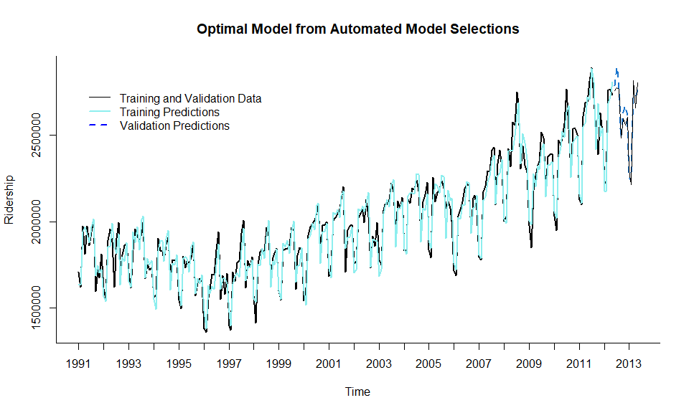

The optimal model chosen was a multiplicative error, additive trend, and multiplicative seasonality with an improved AIC score of 7155.16 which was lower than the previous ANN model with an AIC of 7181.09

## Regression-Based Models

There are different types of common trends and seasonality that can be modeled by regression-based models estimated during the training period and used to forecast on future data. Such trends include linear, exponential, or polynomial, while the different seasonality are additive and multiplicative seasons.

* Linear trends = a series is increasing/decreasing linearly over time
* Quadratic/polynomials functions = These are used to capture the more complex trends.

### Linear Trend

We can start with creating a linear regression model using a predictor index by time and the output, y, which is the number of ridership each month. Keep in mind that a linear regression model will capture the global linear trend in a time series.

However, before we move on we will need to partition the series into training and validation periods. In this case we would make **June 2012 to May 2013** the validation period. This will allow us to keep 12 months in the validation set to provide monthly forecasts for the following year and evaluate each forecasts individually from their respective years.

# Validation Data  
nValid <- 12  
  
# number of training data  
nTrain <- length(df) - nValid  
  
# time window for training data  
train.ts <- window(df, start = c(1991, 1), end = c(1991, nTrain))  
  
# time window for validation data  
valid.ts <- window(df, start = c(1991, nTrain + 1), end = c(1991, nTrain + nValid))  
  
# trend of data  
trend <- time(df)  
  
# linear regression model  
train.lm <- tslm(train.ts ~ trend)  
  
  
# validation forecasts  
train.lm.pred <- forecast(train.lm, h = nValid, level = 0)  
  
# Plot training data along with validation forecasts  
plot(train.lm.pred, ylab = "Ridership", xlab = "Time",   
 bty = "l", xaxt = "n", main = "Linear Regression  
 with Trend Model", flty = 2)  
  
# labels  
axis(1, at = seq(1991, 2013.9, 1), labels = format(seq(1991, 2013.9, 1)))  
  
# validation data  
lines(valid.ts)  
  
# training model forecasts  
lines(train.lm.pred$fitted, lwd = 2, col = "darkslategray2")  
  
# legend  
legend(1991,2800000, c("Training and Validation Data","Training Predictions",   
 "Validation Predictions"), lty=c(1,1,2),  
lwd=c(1,2,2), bty = "n", col = c("black", 'darkslategray2', 'dodgerblue4'))

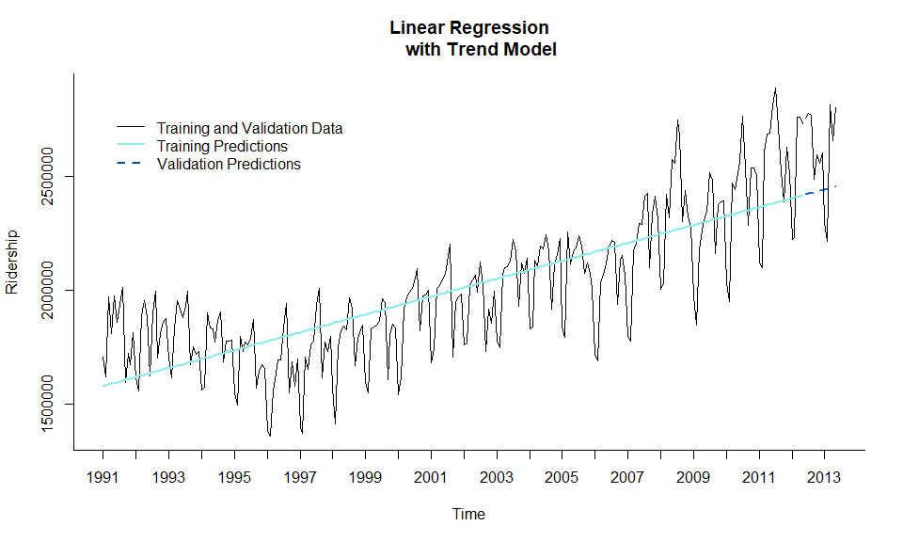

summary(train.lm)

##   
## Call:  
## tslm(formula = train.ts ~ trend)  
##   
## Residuals:  
## Min 1Q Median 3Q Max   
## -483625 -116651 24726 119568 504688   
##   
## Coefficients:  
## Estimate Std. Error t value Pr(>|t|)   
## (Intercept) 1577216.9 24624.3 64.05 <2e-16 ***  
## trend 3274.7 165.5 19.79 <2e-16 ***  
## ---  
## Signif. codes: 0 '***' 0.001 '**' 0.01 '*' 0.05 '.' 0.1 ' ' 1  
##   
## Residual standard error: 196800 on 255 degrees of freedom  
## Multiple R-squared: 0.6057, Adjusted R-squared: 0.6041   
## F-statistic: 391.6 on 1 and 255 DF, p-value: < 2.2e-16

print(paste0("AIC: ", round(AIC(train.lm),2)))

## [1] "AIC: 6998.97"

This linear trend does not fit the global trend at all. The global trend in fact is not linear. This is why we will consider other models for this series. Also the reason why this linear trend model performed poorly is because we did not model seasonality.

### Model with Trend and Seasonality

We can model a series with both trend and seasonality by adding predictors of both types. For example, we can build a new model with both linear and quadratic trend. Then we can add a monthly seasonality which was a factor of 12, however it is redundant to use all 12. In this case, except season 1 which was January. In total, we will have 13 predictors, with $tandt^{2}$ for the trends and the 11 dummy variables for months.

# Validation Data  
nValid <- 12  
  
# number of training data  
nTrain <- length(df) - nValid  
  
# time window for training data  
train.ts <- window(df, start = c(1991, 1), end = c(1991, nTrain))  
  
# time window for validation data  
valid.ts <- window(df, start = c(1991, nTrain + 1), end = c(1991, nTrain + nValid))  
  
# trend of data  
trend <- time(df)  
  
# seasonality  
season <- factor(cycle(df))  
  
model.lm <- tslm(train.ts ~ trend + I(trend^2) + season)  
model.lm

##   
## Call:  
## tslm(formula = train.ts ~ trend + I(trend^2) + season)  
##   
## Coefficients:  
## (Intercept) trend I(trend^2) season2 season3 season4   
## 1540670.38 -1732.47 19.39 -35131.64 307758.22 305931.76   
## season5 season6 season7 season8 season9 season10   
## 347646.93 334705.28 441363.24 430168.00 123687.04 263579.06   
## season11 season12   
## 263809.12 270626.31

# validation forecasts  
model.lm.pred <- forecast(model.lm, h = nValid, level = 0)  
  
# Plot training data along with validation forecasts  
plot(model.lm.pred, ylab = "Ridership", xlab = "Time",   
 bty = "l", xaxt = "n", flty = 2,  
 main = "Linear Regression with  
 Linear Trend, Quadratic Trend, and Seasonality Model")  
  
# labels  
axis(1, at = seq(1991, 2013.9, 1), labels = format(seq(1991, 2013.9, 1)))  
  
# validation data  
lines(valid.ts)  
  
# training model forecasts  
lines(model.lm.pred$fitted, lwd = 2, col = "darkslategray2")  
  
# legend  
legend(1991,2800000, c("Training and Validation Data","Training Predictions",   
 "Validation Predictions"), lty=c(1,1,2),  
lwd=c(1,2,2), bty = "n", col = c("black", 'darkslategray2', 'dodgerblue4'))

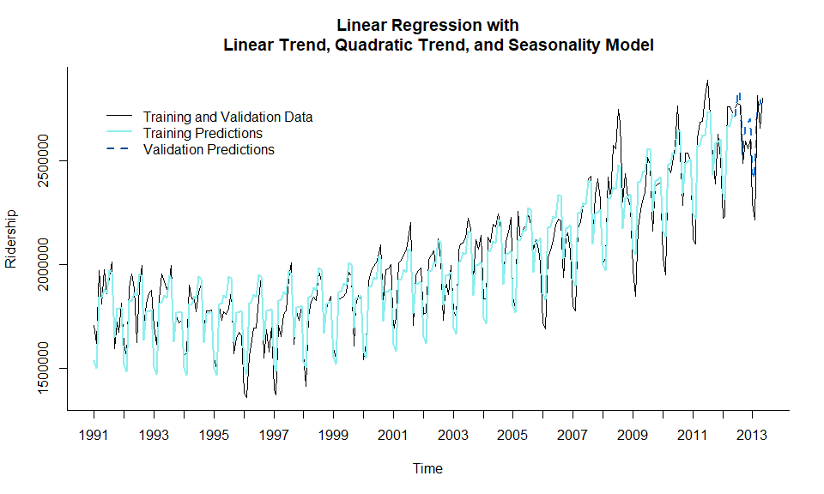

# summary of model  
summary(model.lm)

##   
## Call:  
## tslm(formula = train.ts ~ trend + I(trend^2) + season)  
##   
## Residuals:  
## Min 1Q Median 3Q Max   
## -257653 -64600 1511 67372 270695   
##   
## Coefficients:  
## Estimate Std. Error t value Pr(>|t|)   
## (Intercept) 1.541e+06 2.630e+04 58.575 < 2e-16 ***  
## trend -1.732e+03 3.229e+02 -5.365 1.89e-07 ***  
## I(trend^2) 1.939e+01 1.212e+00 15.991 < 2e-16 ***  
## season2 -3.513e+04 2.881e+04 -1.220 0.224   
## season3 3.078e+05 2.881e+04 10.683 < 2e-16 ***  
## season4 3.059e+05 2.881e+04 10.619 < 2e-16 ***  
## season5 3.476e+05 2.881e+04 12.067 < 2e-16 ***  
## season6 3.347e+05 2.916e+04 11.480 < 2e-16 ***  
## season7 4.414e+05 2.916e+04 15.138 < 2e-16 ***  
## season8 4.302e+05 2.916e+04 14.754 < 2e-16 ***  
## season9 1.237e+05 2.916e+04 4.242 3.15e-05 ***  
## season10 2.636e+05 2.916e+04 9.040 < 2e-16 ***  
## season11 2.638e+05 2.916e+04 9.048 < 2e-16 ***  
## season12 2.706e+05 2.916e+04 9.281 < 2e-16 ***  
## ---  
## Signif. codes: 0 '***' 0.001 '**' 0.01 '*' 0.05 '.' 0.1 ' ' 1  
##   
## Residual standard error: 95550 on 243 degrees of freedom  
## Multiple R-squared: 0.9114, Adjusted R-squared: 0.9067   
## F-statistic: 192.4 on 13 and 243 DF, p-value: < 2.2e-16

print(paste0("AIC: ", round(AIC(model.lm),2)))

## [1] "AIC: 6639.16"

accuracy(model.lm.pred, valid.ts)

## ME RMSE MAE MPE MAPE MASE  
## Training set 1.806244e-12 92906.36 76159.61 -0.2116348 3.915444 0.7704515  
## Test set -7.274081e+04 100660.82 87295.84 -2.9639564 3.485683 0.8831086  
## ACF1 Theil's U  
## Training set 0.6770800 NA  
## Test set -0.1252874 0.424056

The AIC score has dropped significantly compared to the model with only linear trend. In comparison with the exponential smoothing model, this score has dropped drastically, making the linear, quadratic, and monthly seasonality model the best.

### Naive Forecasts

Instead of sophisticated modeling, naive forecasts are basically the most recent values of the ridership data. While a seasonal naive forecast is from the recent value from the most identical season. For example, if we are forecasting August 2012, the forecasts for this month would be the value from August 2011 instead.

Ironically, naive forecasts are actually good at achieving great performance even though its easy to understand and deploy. Also, this naive model should be used as a baseline to compare other model’s predictive performance against.

# Seasonality naive forecasts  
snaive.pred <- snaive(train.ts, h = nValid)  
  
# Plot training data along with validation forecasts  
plot(snaive.pred, ylab = "Ridership", xlab = "Time",   
 bty = "l", xaxt = "n", flty = 2,  
 main = "Seasonality Naive Model")  
  
# labels  
axis(1, at = seq(1991, 2013.9, 1), labels = format(seq(1991, 2013.9, 1)))

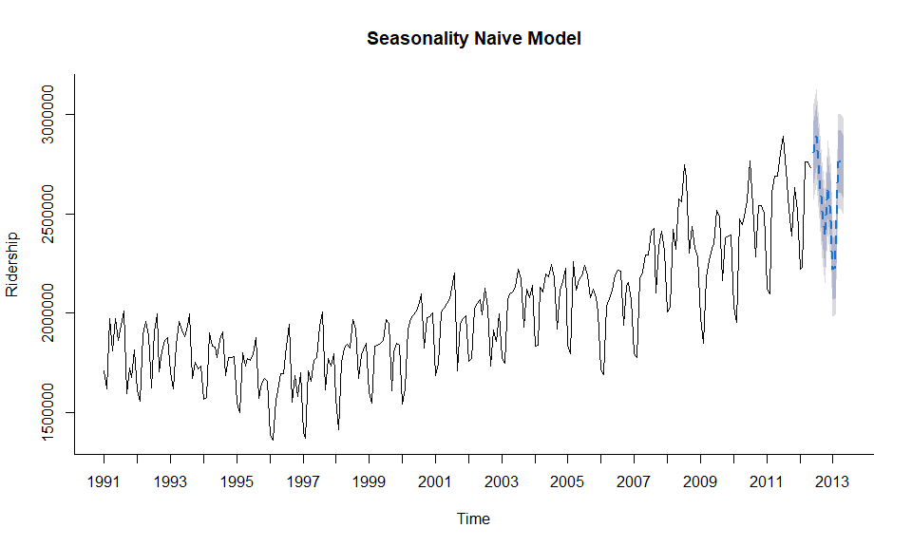

## Results

Optimal Exponential Model

|  | ME | RMSE | MAE | MPE | MAPE | MASE |
| --- | --- | --- | --- | --- | --- | --- |
| **Training set** | 6027 | 66103 | 52183 | 0.2028 | 2.624 | 0.5279 |
| **Test set** | -21561 | 61488 | 49641 | -0.824 | 1.866 | 0.5022 |

Regression with Linear and Quadratic Trends, and Seasonality Model

|  | ME | RMSE | MAE | MPE | MAPE | MASE |
| --- | --- | --- | --- | --- | --- | --- |
| **Training set** | 1.806e-12 | 92906 | 76160 | -0.2116 | 3.915 | 0.7705 |
| **Test set** | -72741 | 100661 | 87296 | -2.964 | 3.486 | 0.8831 |

Seasonality Naive Model

|  | ME | RMSE | MAE | MPE | MAPE | MASE |
| --- | --- | --- | --- | --- | --- | --- |
| **Training set** | 38708 | 122794 | 98851 | 1.595 | 4.854 | 1 |
| **Test set** | 12386 | 91056 | 77756 | 0.4937 | 2.959 | 0.7866 |

#Inspect ACF and PACF  
as <-acf2(df)

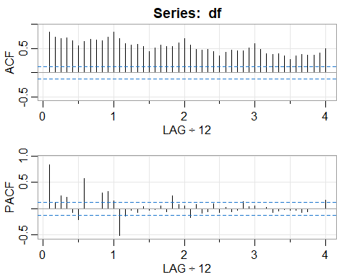 the acf shows high lag coefficients starting ar lag 1 indicating seasonality.

# decompose the components of the dataset  
d1 <-decompose(df, type = c("additive","multiplicative"))  
plot(d1)

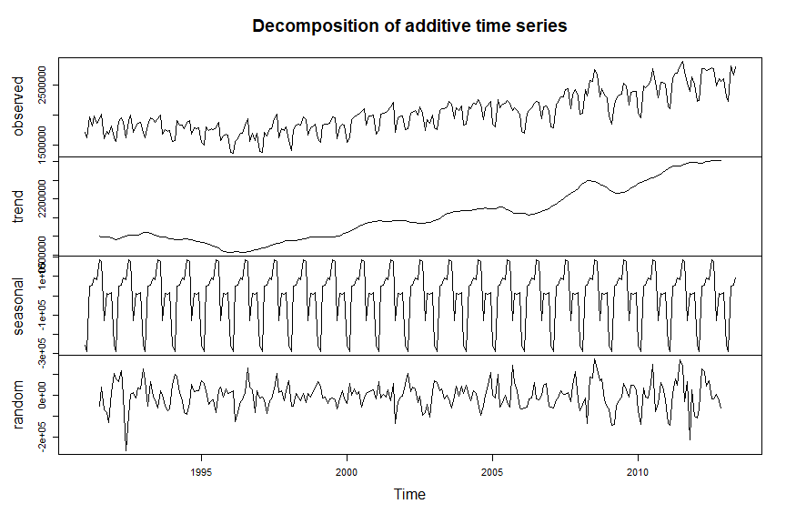 there is a strong seasonal component in the dataset, there is a consistent upward trend in the dataset.

#create basic AR model  
ar1 = arima(train.ts, order=c(1,0,0))  
ar1

##   
## Call:  
## arima(x = train.ts, order = c(1, 0, 0))  
##   
## Coefficients:  
## ar1 intercept  
## 0.8388 2008415.12  
## s.e. 0.0346 65740.01  
##   
## sigma^2 estimated as 3.002e+10: log likelihood = -3465.35, aic = 6936.7

#forecast ar1 model  
ar1f <- forecast(ar1,3)  
  
#check accuracy of the model  
accuracy(ar1f, valid.ts)

## ME RMSE MAE MPE MAPE MASE  
## Training set 1492.036 173259.5 129640.3 -0.6899507 6.683191 1.311476  
## Test set 242852.632 255399.2 242852.6 8.7677875 8.767787 2.456764  
## ACF1 Theil's U  
## Training set -0.07475080 NA  
## Test set -0.01092189 20.15339

#plot the model  
autoplot(ar1f, lwd =3)

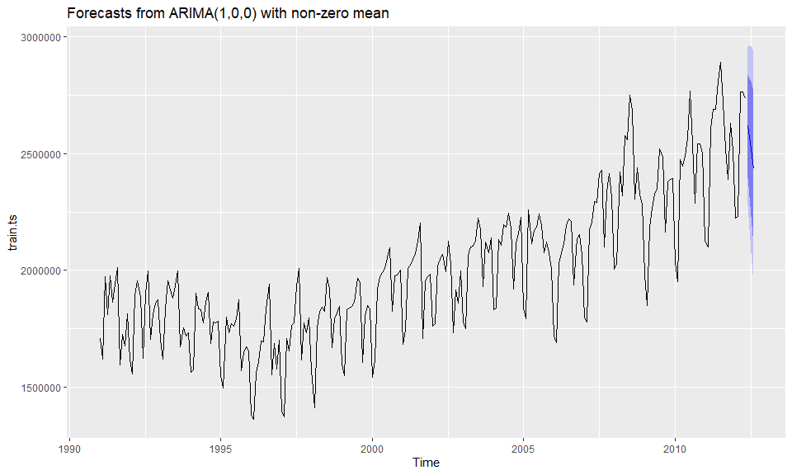

#create tatble with results  
  
ar1.df <- as.data.frame(accuracy(ar1f, valid.ts))  
ar1.df[,1:6] %>%   
 pander(style = "grid", caption = "AR1 Model")

AR1 Model

|  | ME | RMSE | MAE | MPE | MAPE | MASE |
| --- | --- | --- | --- | --- | --- | --- |
| **Training set** | 1492 | 173260 | 129640 | -0.69 | 6.683 | 1.311 |
| **Test set** | 242853 | 255399 | 242853 | 8.768 | 8.768 | 2.457 |

plot a logged version of the ar model

#plot logged ar model  
arima1 <- arima(log(df), order = c(0,1,1), seasonal = c(0,1,1))  
#summary of the model  
summary(arima1)

##   
## Call:  
## arima(x = log(df), order = c(0, 1, 1), seasonal = c(0, 1, 1))  
##   
## Coefficients:  
## ma1 sma1  
## -0.4392 -0.7578  
## s.e. 0.0609 0.0534  
##   
## sigma^2 estimated as 0.001159: log likelihood = 496.8, aic = -987.6  
##   
## Training set error measures:  
## ME RMSE MAE MPE MAPE MASE  
## Training set 0.001429915 0.03336652 0.0258796 0.009602988 0.1784959 0.3839386  
## ACF1  
## Training set -6.673837e-05

#arima model  
arima.df <- as.data.frame(accuracy(arima1))  
arima.df[,1:6] %>%   
 pander(style = "grid", caption = "Arima Model")

Arima Model

|  | ME | RMSE | MAE | MPE | MAPE | MASE |
| --- | --- | --- | --- | --- | --- | --- |
| **Training set** | 0.00143 | 0.03337 | 0.02588 | 0.009603 | 0.1785 | 0.3839 |

we used the auto arima function to get the best parameters for fitting the dataset

#auto arima  
# Validation Data  
nValid <- 12  
  
# number of training data  
nTrain <- length(df) - nValid  
  
# time window for training data  
train.ts <- window(df, start = c(1991, 1), end = c(1991, nTrain))  
  
# time window for validation data  
valid.ts <- window(df, start = c(1991, nTrain + 1), end = c(1991, nTrain + nValid))  
  
autoarima = auto.arima(train.ts)  
autoarima

## Series: train.ts   
## ARIMA(2,1,1)(2,1,1)[12]   
##   
## Coefficients:  
## ar1 ar2 ma1 sar1 sar2 sma1  
## -0.5596 -0.2037 0.1352 0.0763 0.0017 -0.7054  
## s.e. 0.4954 0.1855 0.5050 0.1184 0.0952 0.0976  
##   
## sigma^2 estimated as 4.92e+09: log likelihood=-3069.4  
## AIC=6152.79 AICc=6153.27 BIC=6177.27

the auto arima suggested ARIMA(2,1,1)(2,1,1)[12]

arima.for <- forecast(autoarima, 16)  
arima.for

## Point Forecast Lo 80 Hi 80 Lo 95 Hi 95  
## Jun 2012 2838811 2748917 2928705 2701330 2976292  
## Jul 2012 2957260 2853539 3060981 2798633 3115888  
## Aug 2012 2832728 2715430 2950027 2653336 3012121  
## Sep 2012 2578319 2446176 2710462 2376224 2780414  
## Oct 2012 2656018 2512171 2799865 2436023 2876012  
## Nov 2012 2741088 2586046 2896130 2503972 2978204  
## Dec 2012 2680340 2514770 2845910 2427123 2933557  
## Jan 2013 2361326 2185974 2536679 2093148 2629505  
## Feb 2013 2335236 2150574 2519898 2052819 2617652  
## Mar 2013 2807680 2614158 3001202 2511714 3103647  
## Apr 2013 2820214 2618228 3022201 2511302 3129126  
## May 2013 2846930 2636815 3057044 2525587 3168272  
## Jun 2013 2920869 2691807 3149930 2570549 3271188  
## Jul 2013 3046185 2804507 3287863 2676570 3415800  
## Aug 2013 2928796 2674783 3182809 2540316 3317276  
## Sep 2013 2667435 2400988 2933882 2259939 3074931

a1<-accuracy(arima.for, valid.ts)  
  
plot(arima.for, lwd = 2)

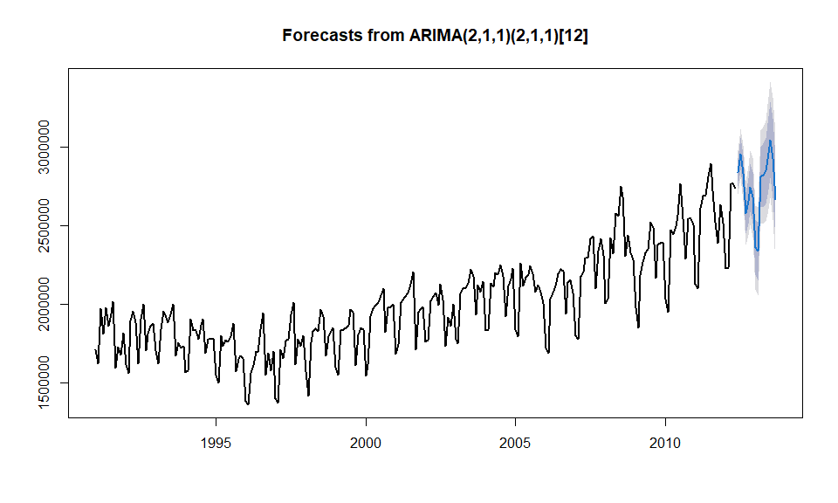

autoar.df <- as.data.frame(accuracy(arima.for, valid.ts))  
autoar.df[,1:6] %>%   
 pander(style = "grid", caption = "Auto ARIMA Model")

Auto ARIMA Model

|  | ME | RMSE | MAE | MPE | MAPE | MASE |
| --- | --- | --- | --- | --- | --- | --- |
| **Training set** | 2825 | 67502 | 50835 | 0.06815 | 2.555 | 0.5143 |
| **Test set** | -92458 | 107742 | 93867 | -3.587 | 3.637 | 0.9496 |

#plot different sarima models  
library(sarima)  
s1<-sarima.for(df, 3, 1,1,1, 0,1,1,12)

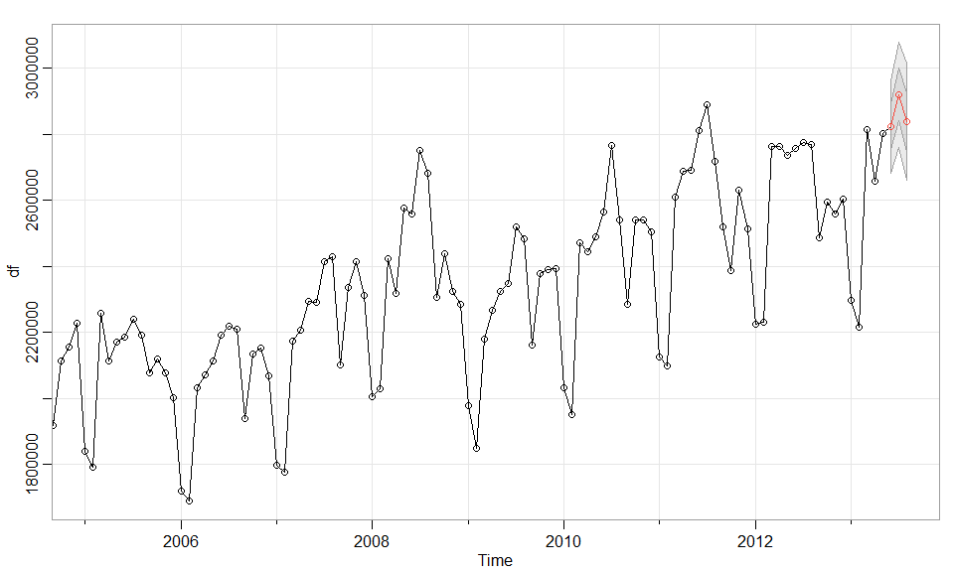

s2<-sarima.for(df, 3, 0,0,1, 0,0,1,12)

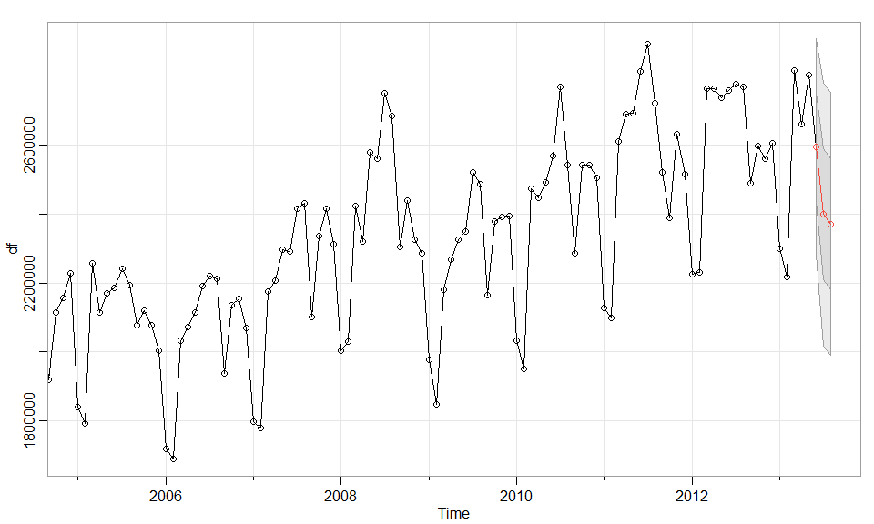

s3<-sarima.for(df, 3, 1,0,0, 0,0,1,12)

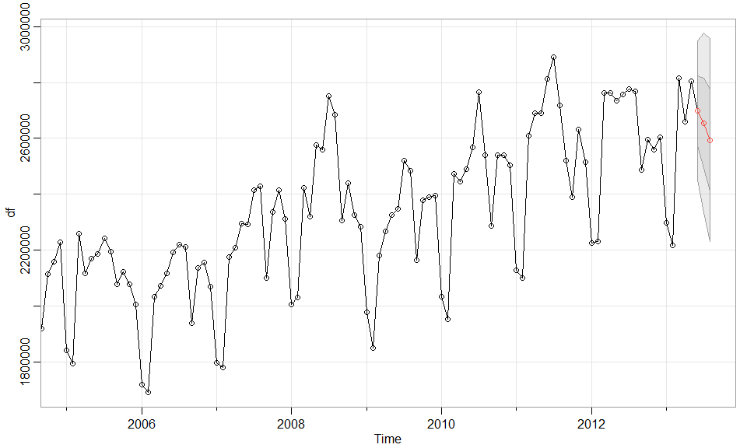

s4<-sarima.for(df, 3, 0,0,0, 0,0,1,12)

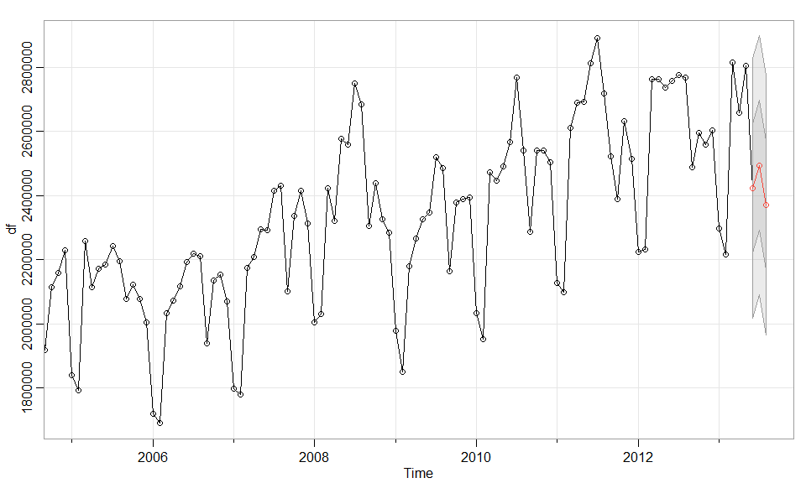

s5<-sarima.for(df, 3, 1,0,0, 0,0,2,12)

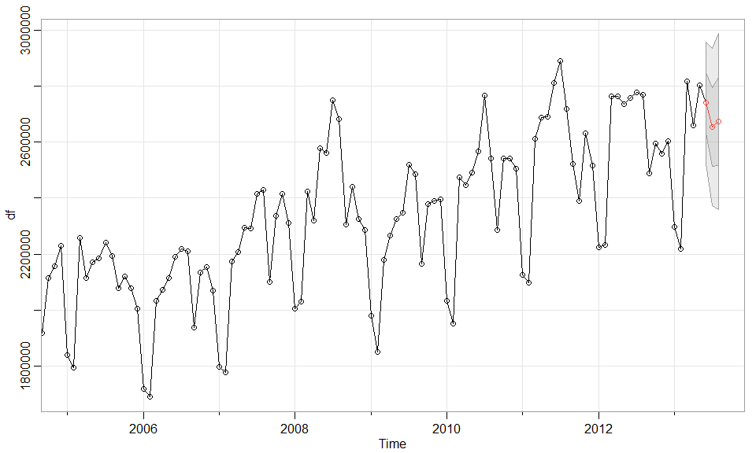

s6<-sarima.for(df, 3, 2,1,1, 2,1,1,12)

