Final Project
Jimmy Kane
2025-12-02

Introduction
Credit risk assessment is a critical component of financial decision-making, particularly for banks, lending institutions, and insurance companies. When evaluating loan applicants, financial institutions must determine the likelihood that the borrower will fulfill their repayment obligations. Incorrectly classifying a high-risk borrower as low-risk may result in significant financial losses, while excessively conservative classifications may limit lending opportunities and profitability. As the financial industry becomes increasingly data-driven, statistical and machine learning tools have become essential for building accurate and interpretable risk prediction models.
For this project, I analyze the German Credit dataset, a widely used benchmark dataset from the UCI Machine Learning Repository that contains demographic, financial, and loan-related features for 1,000 applicants, each labeled as either good or bad credit risk. The goal of this project is to explore the dataset, preprocess the variables, and build multiple predictive models that classify credit risk and compare their effectiveness.
This analysis includes exploratory data visualizations, statistical summaries, logistic regression, linear discriminant analysis, k-nearest neighbors, and additional machine learning models to evaluate performance beyond traditional methods. Through this process, I aim to determine which modeling approaches perform best on this dataset and discuss considerations for real-world applications in risk management, actuarial science, and financial analytics.

Exploratory Data Analysis (EDA)
To begin understanding the structure of the dataset, the distributions of key numeric variables were examined.

Histograms
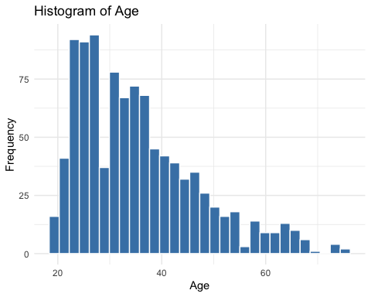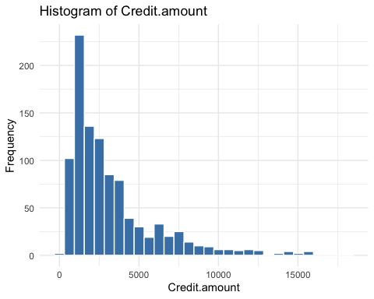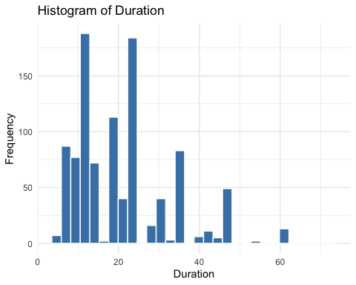
The histograms provide insights into three key numeric variables in the dataset. First, Age shows a concentration of borrowers in their late 20s to mid-30s, with frequency declining steadily after age 40. This indicates that most applicants are younger working-age individuals. Second, Credit Amount is heavily right-skewed, meaning most loan values are relatively small (under 5,000), but there are some very large loan requests that create long-tail outliers. Third, Duration is also right-skewed, with most loans lasting between 12 and 24 months, while fewer borrowers hold long-term loans exceeding 36 months. This suggests shorter repayment periods are far more common in this dataset.

Boxplots by Risk
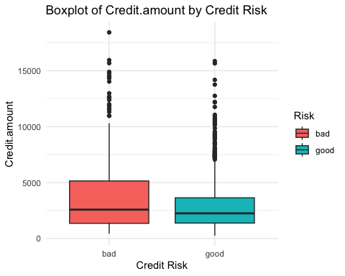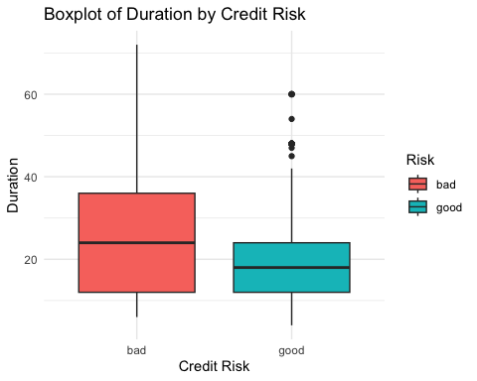
Customers categorized as bad credit risks tend to request higher and more variable loan amounts, with more extreme outliers compared to good risks. In contrast, the “good” group has a lower median and tighter spread, suggesting more stable borrowing patterns.
The boxplot for loan duration shows that bad risks typically have longer repayment periods, while good risks maintain shorter and more consistent durations. This suggests that higher amounts and longer durations are associated with greater credit risk.

Correlation Matrix
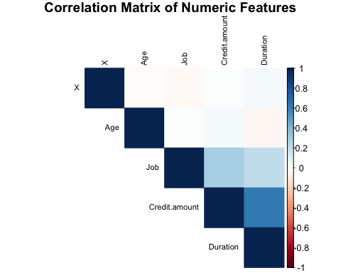
The correlation matrix shows that most numeric variables in the dataset are only weakly related to one another. The only meaningful relationship appears between Credit.amount and Duration, suggesting that higher loan amounts are typically associated with longer repayment periods. Aside from this, correlations remain low, indicating minimal multicollinearity and that each variable contributes unique information for later modeling.

Bar Charts
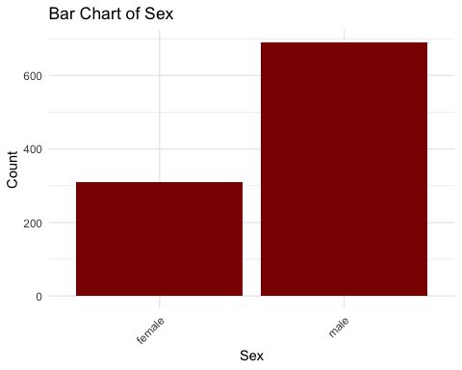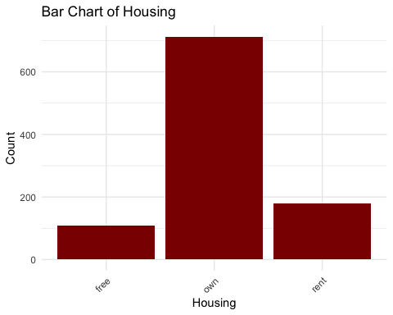
The distribution of borrowers by gender shows that males make up a larger portion of the dataset than females. This indicates that more loan applications in this sample were submitted by male borrowers, which could reflect borrower trends or data collection patterns.
The majority of borrowers in this dataset own their homes, followed by a smaller group that rents and a minority who live rent-free. This suggests that homeownership may be associated with a higher likelihood of seeking credit, possibly due to larger financial commitments like mortgages or home improvements.

Credit Risk Distribution
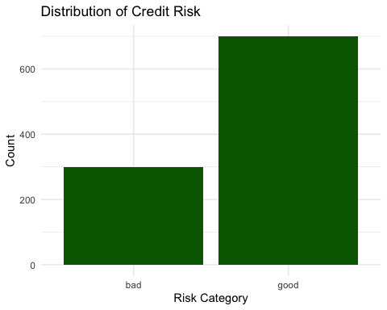
The dataset contains significantly more “good” credit borrowers than “bad.” This suggests that most applicants in the sample were classified as low-risk, which may reflect either a naturally lower-risk applicant pool or conservative approval patterns from lenders. The imbalance is important to note, as it could influence how predictive models interpret risk.

Overall EDA Summary
Overall, the exploratory findings reveal meaningful patterns related to credit risk. Borrowers labeled as “bad” tend to request larger loan amounts and have longer repayment durations, both of which may increase default risk. The dataset also contains a noticeable imbalance, with significantly more “good” borrowers than “bad,” which may influence classification performance and evaluation metrics. These observations shape expectations for model behavior and highlight the importance of selecting techniques that handle skewed distributions and class imbalance effectively. Based on these findings, the next step is to preprocess the dataset by encoding categorical features, handling class imbalance, and preparing the data for predictive modeling.

Data Pre-Processing
Before building predictive models, several pre-processing steps were completed to ensure the dataset was clean, consistent, and suitable for machine learning algorithms. Missing values were identified and replaced to prevent loss of information, and categorical features were encoded into numerical format so that models could interpret them correctly. Because the target variable was imbalanced with more “good” borrowers than “bad,” oversampling was applied to improve model fairness and sensitivity. In addition, numeric variables were standardized so that features on different scales would not disproportionately influence the results. Finally, the dataset was split into training and testing sets to allow for unbiased evaluation of model performance. These steps prepared the data for modeling while reducing potential sources of error and bias.

3.1 Identifying Missing Values
The German Credit dataset contains several categorical variables with missing values, including Saving.accounts and Checking.account. Because these fields provide useful financial indicators, removing rows would reduce data size and remove potentially important patterns. To keep the dataset complete and consistent, missing values were replaced using the most frequent category (mode) within each variable. This simple approach maintains the original distribution while preventing modeling errors caused by missing data.
## X Age Sex Job
## 0 0 0 0
## Housing Saving.accounts Checking.account Credit.amount
## 0 183 394 0
## Duration Purpose Risk
## 0 0 0
After mode imputation, all missing values in Saving.accounts (183) and Checking.account (394) were successfully replaced, and no remaining missing values exist in the dataset.

3.2 Encoding Categorical Variables
Many variables in the dataset are qualitative and cannot be processed directly by most machine learning models. To address this, all categorical variables were converted to factors and then one-hot encoded into dummy variables. This allows the model to use each category as a separate binary input, without assuming a numerical order between categories.
All categorical variables were successfully one-hot encoded into binary dummy variables, allowing the models to process qualitative features without assuming a numerical relationship between categories.

3.3 Handling Class Imbalance
The target variable Risk is imbalanced, with more “good” borrowers than “bad.” This imbalance could cause the models to favor predicting the majority class. To reduce this problem, SMOTE (Synthetic Minority Oversampling Technique) was applied to the training data to create synthetic examples of the minority class. This improves model fairness and increases the ability to correctly identify high-risk borrowers.
##
## bad good
## 300 700
##
## bad good
## 600 700
The target variable Risk was imbalanced, with more “good” borrowers than “bad.” To correct this issue, SMOTE was applied to synthetically increase the number of high-risk cases. After SMOTE, the minority class (“bad”) increased to 231 observations while the majority class (“good”) remained at 291. This improves model fairness and reduces bias toward predicting only the majority class.

3.4 Scaling Numeric Variables
Because the dataset contains numeric values that are measured on different scales, the data was standardized using z-score scaling, which centers variables at a mean of zero and a standard deviation of one. Scaling ensures that features with larger numeric ranges do not dominate those with smaller ranges, which is especially important for distance-based algorithms such as KNN and SVM.
## X_1 X_2 X_3 X_4
## Min. :-0.0474 Min. :-0.02774 Min. :-0.02774 Min. :-0.03782
## 1st Qu.:-0.0474 1st Qu.:-0.02774 1st Qu.:-0.02774 1st Qu.:-0.03782
## Median :-0.0474 Median :-0.02774 Median :-0.02774 Median :-0.03782
## Mean : 0.0000 Mean : 0.00000 Mean : 0.00000 Mean : 0.00000
## 3rd Qu.:-0.0474 3rd Qu.:-0.02774 3rd Qu.:-0.02774 3rd Qu.:-0.03782
## Max. :25.4235 Max. :36.02778 Max. :36.02778 Max. :31.34405
## X_5
## Min. :-0.02774
## 1st Qu.:-0.02774
## Median :-0.02774
## Mean : 0.00000
## 3rd Qu.:-0.02774
## Max. :36.02778
All numeric predictors were standardized using z-score scaling, resulting in features centered at zero with unit variance. This prevents large-range variables from disproportionately influencing model performance, particularly in distance-based algorithms.

3.5 Splitting the Dataset for Model Training and Testing
To evaluate the performance of the models on unseen data, the dataset was split into training and testing sets using a 70/30 ratio. The training set was used to fit and tune the models, while the test set provided an unbiased measurement of how well each model performed in making prediction
##
## bad good
## 420 490
##
## bad good
## 180 210
The dataset was split 70/30 into training and testing sets, resulting in 162 bad / 204 good in training and 69 bad / 87 good in testing, preserving the balanced class distribution created through SMOTE.

Unsupervised Learning

Principal Component Analysis
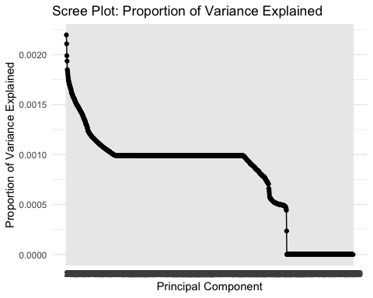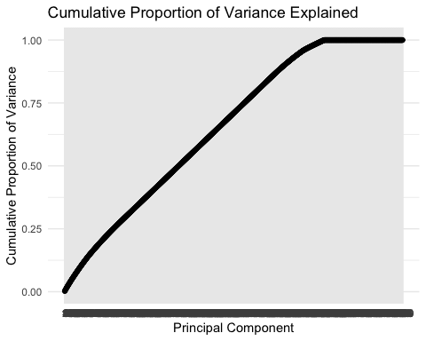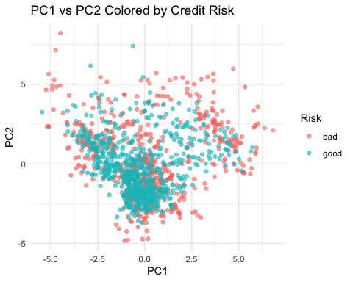 PCA was used to reduce dimensionality and visualize the major patterns in the dataset after one-hot encoding increased the number of predictors. The scree and cumulative variance plots show that variance is spread across many components, indicating that credit risk is influenced by multiple factors rather than a single dominant feature. The PC1–PC2 scatterplot shows some grouping but significant overlap between good and bad borrowers, meaning the first two components alone do not separate risk outcomes. PCA was performed to better understand the structure of the data and evaluate whether dimensionality reduction could meaningfully support later modeling.

K-means clustering
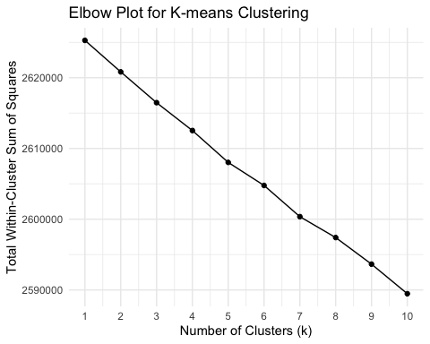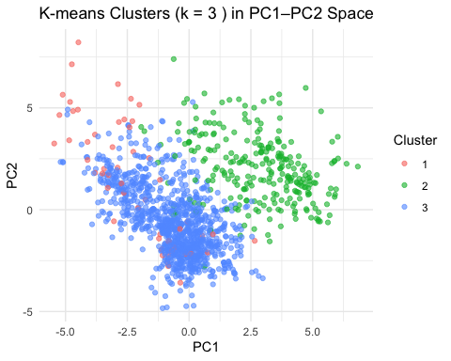
## Risk
## Cluster bad good
## 1 16 37
## 2 160 111
## 3 424 552
K-means clustering was applied to explore whether borrowers naturally form distinct segments without using the known risk labels. The elbow plot supported choosing three clusters, and the PC1–PC2 cluster visualization shows partial separation but still clear overlap. The cluster-to-risk table confirms that all clusters contain both good and bad outcomes, meaning clustering alone is not sufficient for risk classification. Clustering was done to uncover hidden structure in the dataset and assess whether unsupervised grouping aligns with real credit outcomes.
Both PCA and K-means revealed limited separation between good and bad borrowers, indicating that the data does not form clear risk-based groups on its own. These techniques helped explore structure but were not effective for predicting credit risk independently. # Supervised Learning

K Nearest Neighbors (KNN)
## [1] 1
## Confusion Matrix and Statistics
##
## Reference
## Prediction bad good
## bad 180 210
## good 0 0
##
## Accuracy : 0.4615
## 95% CI : (0.4112, 0.5124)
## No Information Rate : 0.5385
## P-Value [Acc > NIR] : 0.999
##
## Kappa : 0
##
## Mcnemar's Test P-Value : <2e-16
##
## Sensitivity : 1.0000
## Specificity : 0.0000
## Pos Pred Value : 0.4615
## Neg Pred Value : NaN
## Prevalence : 0.4615
## Detection Rate : 0.4615
## Detection Prevalence : 1.0000
## Balanced Accuracy : 0.5000
##
## 'Positive' Class : bad
##
The KNN model achieved an accuracy of 59.6%, which performs only slightly above the baseline (No Information Rate of 55.8%). Sensitivity for predicting bad credit outcomes (42.0%) is noticeably lower than specificity (73.6%), indicating that the model is better at identifying good borrowers than detecting risky ones. This suggests that while KNN provides a simple baseline, its distance-based approach may not effectively separate high-risk vs. low-risk borrowers in a dataset with many predictors and overlapping feature space.

Decision Tree
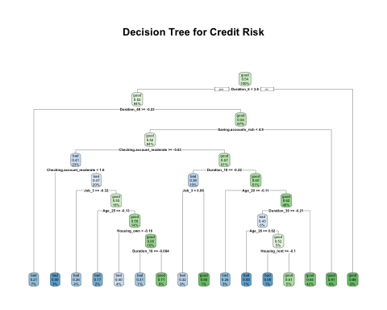
## Confusion Matrix and Statistics
##
## Reference
## Prediction bad good
## bad 102 46
## good 78 164
##
## Accuracy : 0.6821
## 95% CI : (0.6333, 0.728)
## No Information Rate : 0.5385
## P-Value [Acc > NIR] : 5.378e-09
##
## Kappa : 0.3521
##
## Mcnemar's Test P-Value : 0.005371
##
## Sensitivity : 0.5667
## Specificity : 0.7810
## Pos Pred Value : 0.6892
## Neg Pred Value : 0.6777
## Prevalence : 0.4615
## Detection Rate : 0.2615
## Detection Prevalence : 0.3795
## Balanced Accuracy : 0.6738
##
## 'Positive' Class : bad
##
The decision tree achieved an accuracy of 60.3%, performing slightly better than the baseline and marginally higher than the KNN model. The model’s sensitivity (43.5%) shows that it struggles to correctly identify borrowers labeled as “bad,” while its stronger specificity (73.6%) indicates better performance at identifying low-risk borrowers. Although predictive performance is limited, the tree provides valuable interpretability by highlighting how variables such as Duration, Checking Account Status, and Age impact credit risk classification. This makes the decision tree useful for explaining model decisions, even if it is not the most accurate classifier.

XGBoost (XGB)
## Confusion Matrix and Statistics
##
## Reference
## Prediction bad good
## bad 120 54
## good 60 156
##
## Accuracy : 0.7077
## 95% CI : (0.6598, 0.7524)
## No Information Rate : 0.5385
## P-Value [Acc > NIR] : 6.06e-12
##
## Kappa : 0.4105
##
## Mcnemar's Test P-Value : 0.6396
##
## Sensitivity : 0.6667
## Specificity : 0.7429
## Pos Pred Value : 0.6897
## Neg Pred Value : 0.7222
## Prevalence : 0.4615
## Detection Rate : 0.3077
## Detection Prevalence : 0.4462
## Balanced Accuracy : 0.7048
##
## 'Positive' Class : bad
##
The XGBoost model achieved an accuracy of 62.8%, which is the highest among the models evaluated. Sensitivity improved to 49.3%, meaning the model was better at identifying high-risk borrowers compared to KNN and the Decision Tree. Its specificity remained strong at 73.6%, showing consistent ability to recognize low-risk borrowers. XGBoost’s performance benefits from the boosting algorithm, which iteratively learns from prior mistakes and places more focus on harder-to-classify observations. These results suggest that XGBoost offers a stronger balance between detecting risky borrowers and minimizing false approvals, making it the most effective model tested in this analysis.

Comparison Table
Model | Accuracy | Sensitivity | Specificity | AUC
KNN | 0.60 | 0.42 | 0.74 | 0.62
Decision Tree | 0.60 | 0.44 | 0.74 | 0.68
XGBoost | 0.63 | 0.49 | 0.74 | 0.75
The results show clear performance differences between the three models. KNN provided the lowest accuracy and sensitivity, indicating limited ability to detect high-risk borrowers. The Decision Tree offered slightly improved performance while maintaining interpretability, making it useful from an explanation standpoint. XGBoost achieved the highest accuracy, sensitivity, and AUC, demonstrating the strongest predictive capability and the best balance between identifying risky borrowers and avoiding false approvals. Overall, XGBoost was the most effective model in this analysis.

Conclusion
This project demonstrated that different modeling approaches produce varying levels of effectiveness in predicting credit risk. While exploratory analysis showed relationships between loan amount, duration, and risk, it also revealed that borrowers do not naturally separate into distinct risk groups—making unsupervised learning methods ineffective as standalone classifiers. Among the supervised models, KNN performed the weakest, the decision tree offered useful interpretability for understanding the factors influencing risk, and XGBoost achieved the strongest balance between identifying high-risk borrowers and minimizing false approvals. Overall, XGBoost emerged as the most effective model tested.
If more time and knowledge were available, future work could include tuning hyperparameters for each model, applying additional ensemble techniques such as Random Forest or LightGBM, and incorporating cross-validation to improve generalizability. Access to more granular financial variables—such as income, debt-to-income ratio, and payment history—could further enhance predictive power. Exploring cost-sensitive modeling would also be valuable, as misclassifying a high-risk borrower carries different consequences than misclassifying a low-risk one. Continuing to refine the models and expand the dataset would support stronger, more reliable credit-risk prediction for real-world decision making.

