

**SOX control automation**

**SAP-PPS reconciliation**

**Template Revision:**

|  |  |  |  |
| --- | --- | --- | --- |
| **Version** | **Prepared by** | **Description** | **Date** |
| 1.0.0 | Jimmy.n.lacanaria.jr | SAP-PPS reconciliation tool manual | 4/15/2019 |
|  |  |  |  |

**Document Revision:**

|  |  |  |  |
| --- | --- | --- | --- |
| **Version** | **Prepared by** | **Description** | **Date** |
| 1.0.0 | Jimmy.n.lacanaria.jr | SAP-PPS reconciliation tool manual | 4/15/2019 |
|  |  |  |  |

**Access List:**

|  |  |  |
| --- | --- | --- |
| **List of Users** | **Access Type**  **(Read, Write)** | **Type of Media** |
| HRSS-EDA | Read / Write | Electronic |
|  |  |  |
|  |  |  |

|  |  |
| --- | --- |
| **Table of Contents** | |
| Page 3 | Scope, Objectives, Declaration |
| Page 4 | Dependencies, Set up, Lay out |
| Page 5 | Processes, Contact List |

# Scope

This document shall apply to the users of the tool, specifically the project members of HRSS-EDA, herein referred to as the Operations Team.

Some parts of this document also define the role and responsibilities of Health BPO Cluster (Tools and Tech)/ Central Operations – Automation Team, herein referred to as the Automation Team.

The word tool in this document refers to SOX Control Automation, including its succeeding versions and derivatives.

# Objectives

This document defines the policies that covers the use of the tools developed by Health BPO Cluster (Tools and Tech)/ Central Operations – Automation Team for HRSS-EDA, specifically SOX Control Automation, including its succeeding versions and derivatives.

This document also outlines the procedures of using the tool. The users shall read and understand this document before using the tool.

# Declaration

It is understood that the tool is developed and deployed for the exclusive use of the Operations Team. Any unauthorized alteration, reverse engineering, reduction, copying and use of the tool outside the Operations Team is strictly prohibited.

The Automation Team shall provide support to the Operations Team in using the tool, unless waived. Contact list is provided at the end of this document.

The codes and techniques imbedded within the tool, as well as this document shall remain an intellectual property of the Automation Team, while the Business Process implemented to the tool belongs to the Operations Team.

It is also understood that the Automation Team held no liability for any unlawful use of the tool, within the Operations Team.

The Automation Team reserves the right to recall the deployed tool, for immediate update and optimization. Continuous use of recalled tools within the Operations Team, unless authorized by the Automation Team is strictly prohibited.

# Dependencies

|  |  |
| --- | --- |
| **Item** | **Specification** |
| Operating System | Windows 7 |
| OS Type | 64 Bit |
| Microsoft Access | 2007 |
| Microsoft Excel | 2007 |

# Set Up

1. Go to Sharepoint site and add folder for file upload.
2. Open SOX CONTROL TOOL (keep the file name as is).
3. Go to Config tab and update (if necessary) “Security” fields and “SharepointPath”.
4. Go to Mappings tab (if necessary) and update columns I:Y.

# Layout

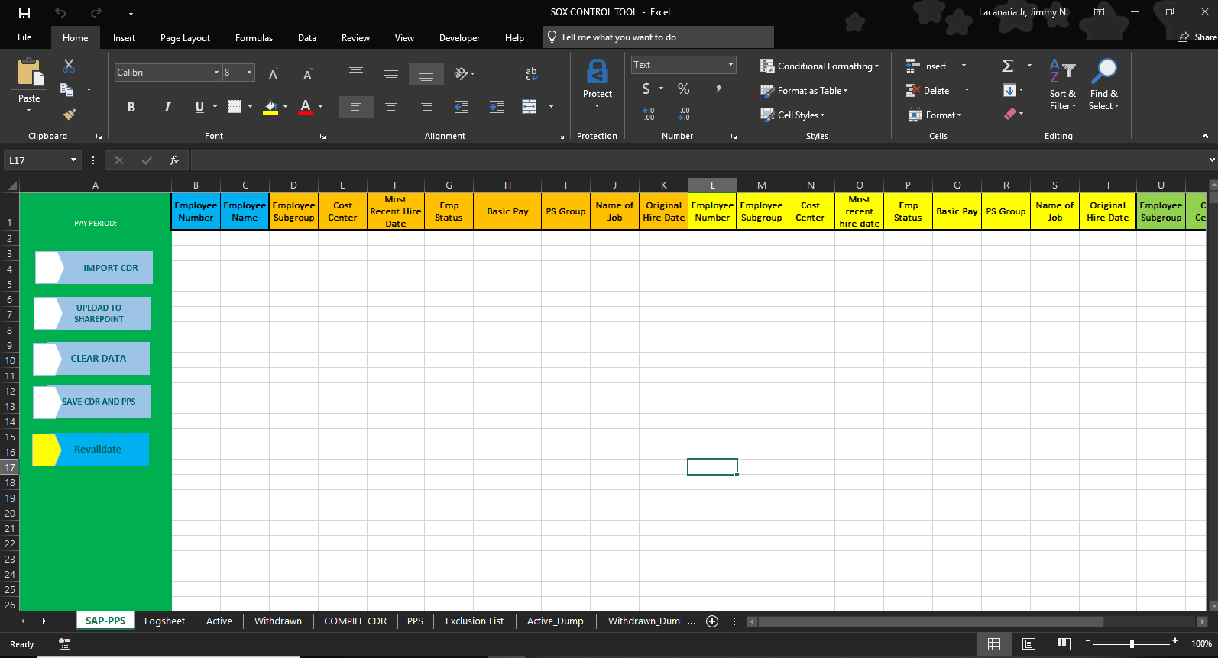

# Processes

1. For Day 1-3
2. Prepare the updated files to be process in local drive.
3. CDR Original Download
4. Exclusion List
5. PPS - Most Recent Hire Date, Original Hire Date, R Payroll
6. Open SOX Control Tool
7. Go to SAP-PPS Tab
8. Click CLEAR DATA
9. Click IMPORT CDR and upload the needed files per Tool instruction.
10. Once the SAP-PPS Logsheet is created choose whether upload the file automatically or Check the output first and go to SAP-PPS tab and click Upload to sharepoint.
11. Go to Config tab and go to link on (B17) cell in sharepoint to check the uploaded Data Validation Discrepancy Logsheet file.
12. For Day 6
13. Prepare the updated file to be process in local drive.
14. Data Validation Discrepancy Logsheet
15. Open SOX Control Tool
16. Go to SAP-PPS Tab
17. Click Revalidate
18. Go to Config tab and go to link on (B17) cell in sharepoint to check the uploaded Data Validation Discrepancy Logsheet file.

**Contact List**

|  |  |  |  |
| --- | --- | --- | --- |
| **Name** | **Accenture Email** | **Location** | **Contact** |
| Jimmy N. Lacanaria Jr. | jimmy.n.lacanaria.jr@accenture.com | Cybergate Tower 1 |  |
| Ariel M. Alemania | ariel.m.alemania@accenture.com | Cybergate Tower 1 |  |