Final Programming Test

Group 4

2) 

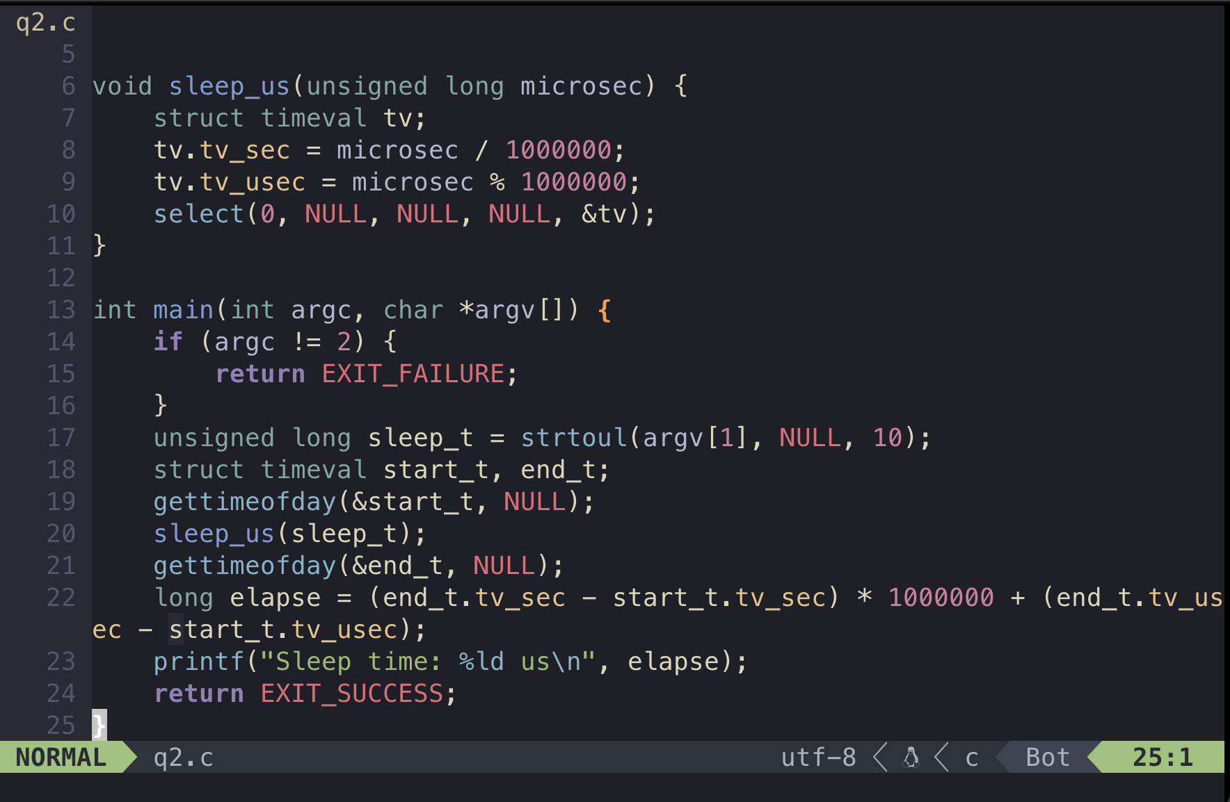

We use select to simulate sleep, which is select(0, NULL, NULL, NULL, NULL, NULL, &tv); The select system call introduces a sleep or delay in the program with a specified timeout.

Then, we use gettimeofday to retrieve the ending time and starting time.

Finally, we get the time interval in micro second by subtracting the ending and starting time.