Fuel Surcharge Update is an application which allows billing department to update fuel surcharge rate without interacting with our database directly.

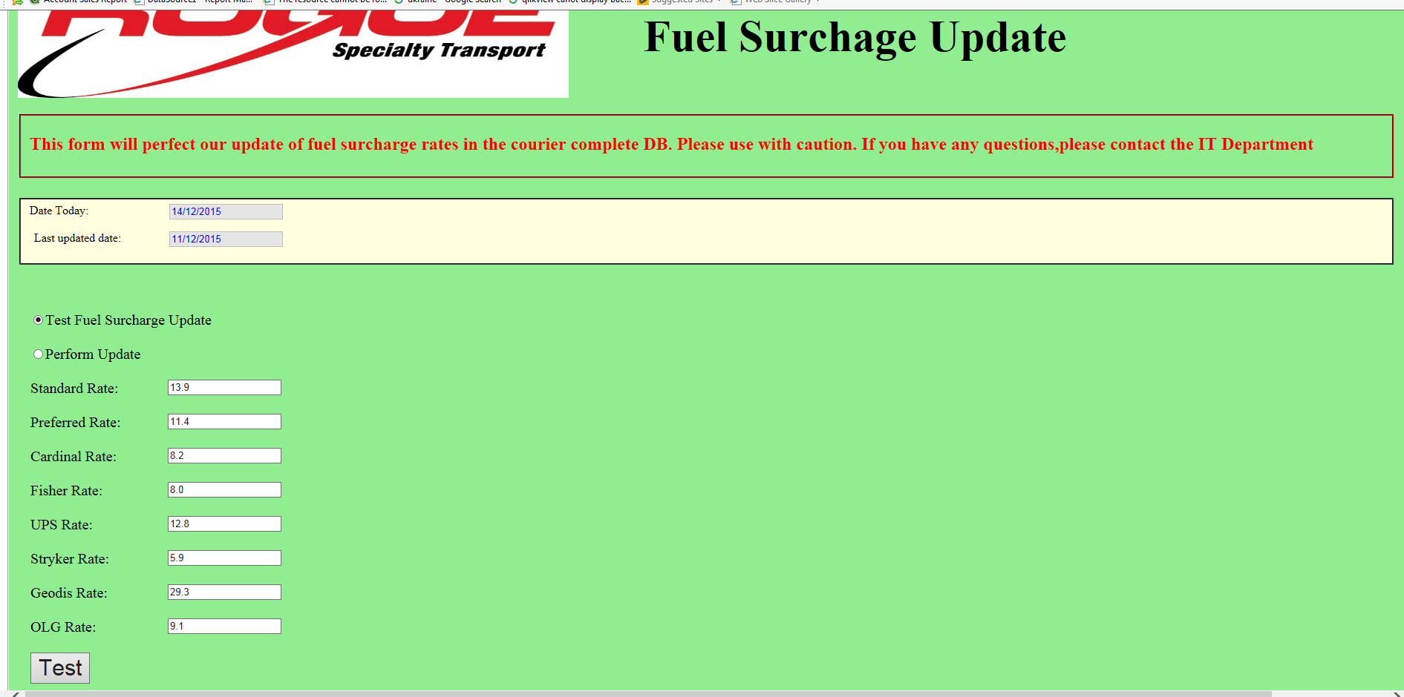

When the radio button “test fuel surcharge update” is on, a grid view which shows a list of current fuel surcharge rate will be shown on the right side when a user click on “Test”.

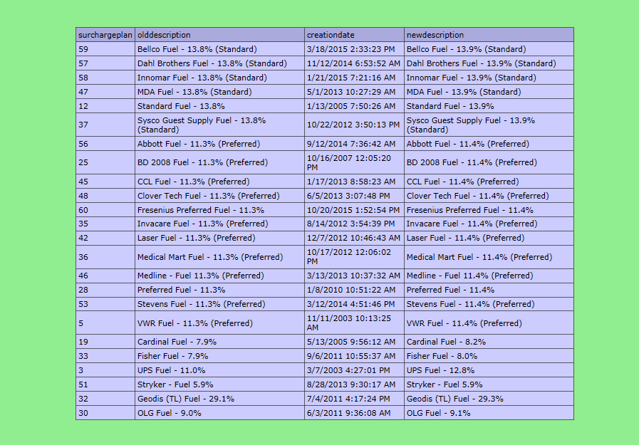

When the radio button “Perform Update” is on, the fuel surcharges rate will be updated using the rate displayed on the

Left side when a user click on “test”

