Single-instance application execution Gantt charts

- Radar Correlator:
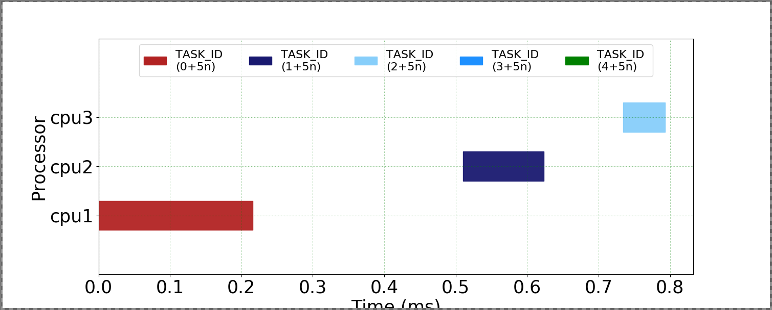-
Gantt chart for Radar Correlator Execution
- How many APIs are executed as part of Radar Correlator?
Answer: 3

- Does the Gantt chart indicate parallel execution of multiple APIs?
Answer: No, the execution occurs sequentially. Each cpu executes a different API call, but it waits for the previous call to be completed before beginning execution.

- What order are the tasks assigned to the available CPU cores?
Answer: 0 1 2.

- Pulse Doppler:
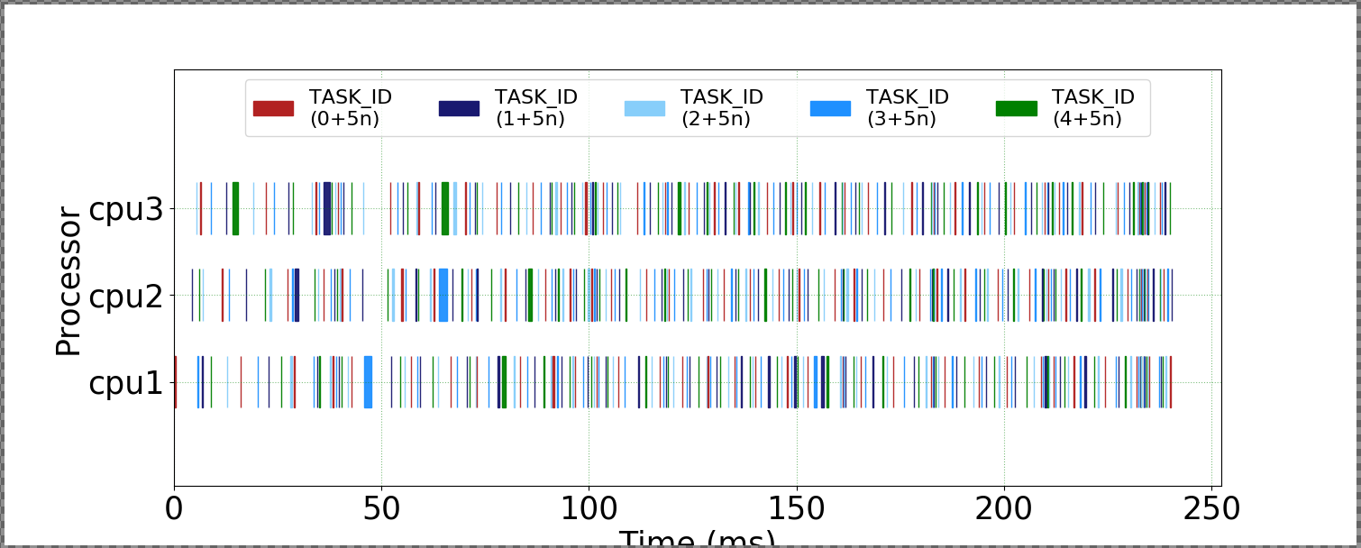
Gantt chart for Pulse Doppler Execution
- Are the API calls in the Gantt chart clustered into groups (execution phases/loops)? If so, how many groups do you observe?
Answer: There appear to be two major clusters of execution for the three processors (shown within boxed regions). Cluster 1 has lots of Task 0 and 2, whereas Cluster 2 has lots of Task 1 and 4.

- Based on the Gantt chart, are the API calls being executed fully sequentially across all cores, or do they exhibit some parallel execution?
Answer: There is some parallel execution between the API calls. Looking at dashed line on the Gantt chart, Tasks 4 and 3 clearly execute in parallel on cpu’s 3 and 2 respectively.

- SAR:
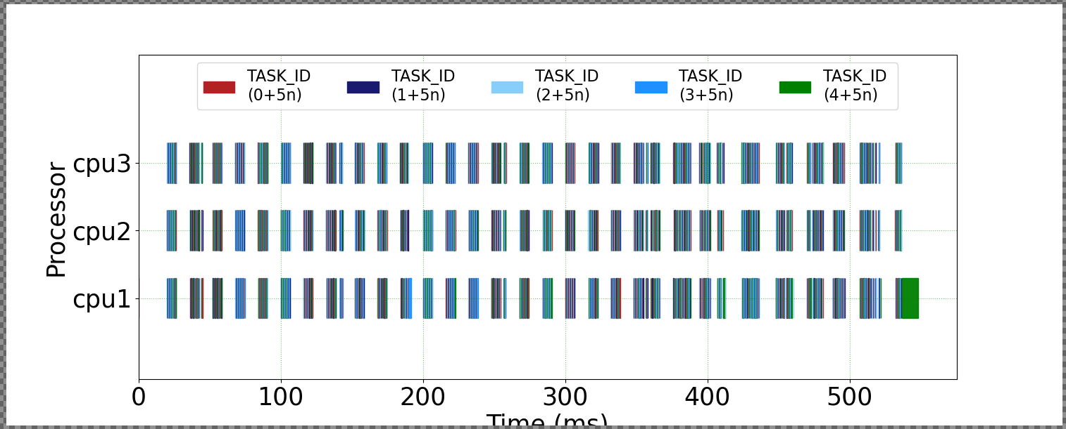
Gantt chart for SAR Execution

- How many clusters/groups of API call do you observe in the Gantt chart?
Answer: cpu1, cpu2, and cpu3 all execute 36 clusters.

- If multiple groups observed, can you identify which API calls in the SAR source code correspond to each of the clusters?

Answer: In general, yes. The Gantt chart distinguishes different API calls by color. There is a slight challenge determining the exact sequences due to the resolution of the image, and the quantity of groups present throughout the SAR runtime, but each group can have its API calls broken down and analyzed. For example, the first group for cpu3 has the API call sequence: 23123123523502.
Time (ms)

- WiFi-TX:
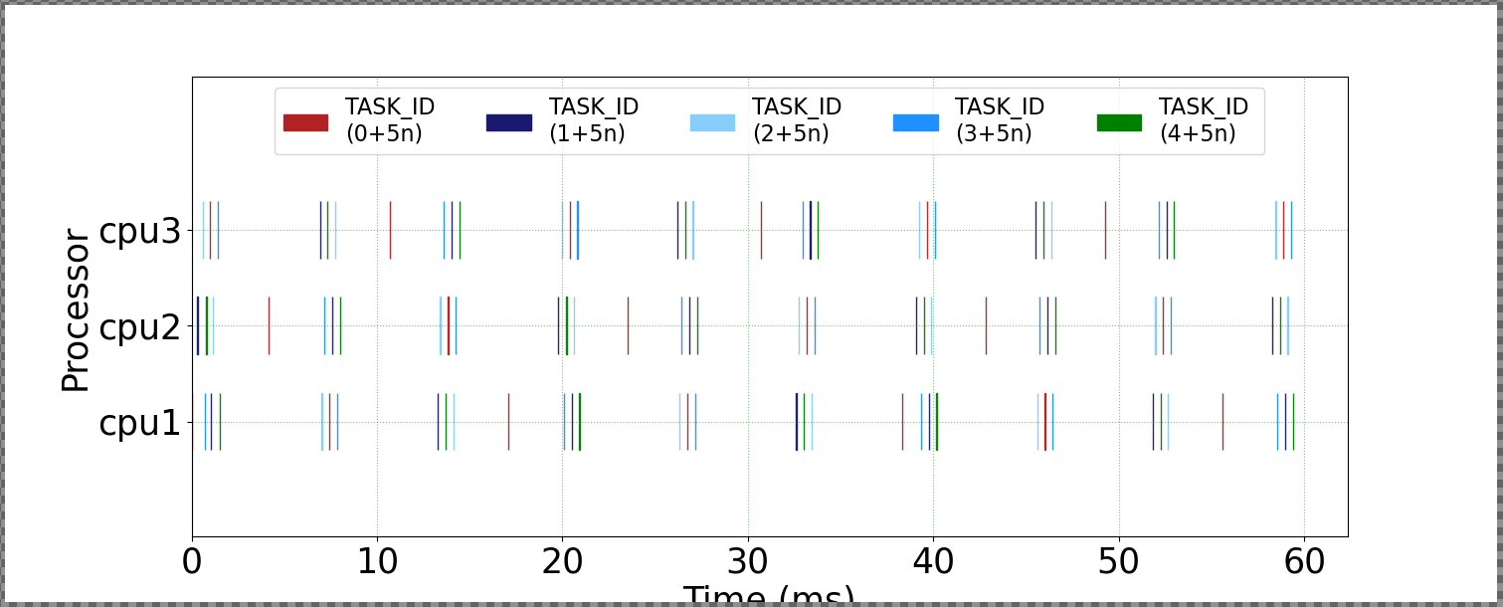
Gantt chart for WiFi-TX Execution

- What API calls did you use in this WiFi-TX source code- blocking or non-blocking?
Answer: Blocking.
- According to this Gantt chart, are the API calls executed in sequence, or in parallel? If executed in sequence, based on your understanding of the WiFi-TX source code can these operations be executed in parallel?
Answer: In sequence. The API calls occur slightly after one another between all the cpu’s. Some portions of Wi-Fi transmission are parallelizable (such as packetizing), other portions are not (such as sending packets).

