Single-instance application execution Gantt charts

- Functional Correctness:
  - For each of the four applications considered in this assignment, did the output from accelerator-based execution fully match the output from CPU-only execution in assignment 1?
Answer: The outputs are identical for Radar, Pulse Doppler, and WiFi. They are not identical for SAR.

  - If one or more application outputs are different compared to reference outputs from assignment 1, is the margin of difference large enough to consider the output wrong? Justify your answer numerically.
Answer: For SAR, the outputs are CLOSE to the correct values. The correct values are on the order of 10^-9 and 10^-10. All of the values are off by ~1/5 of the value at most (eg; what is meant to be 0.0000000008 instead outputs 0.0000000010).

  - If one or more application outputs are different, what could be the potential reason for the mismatch?
Answer: The error in SAR may stem from a VERY small bias towards “0”, potentially due to the difference between truncation and rounding. It may also have occurred due to floating point errors.

- Gantt chart analysis:
Please add Gantt chart for each application below, and answer the following questions:

  - Radar Correlator:
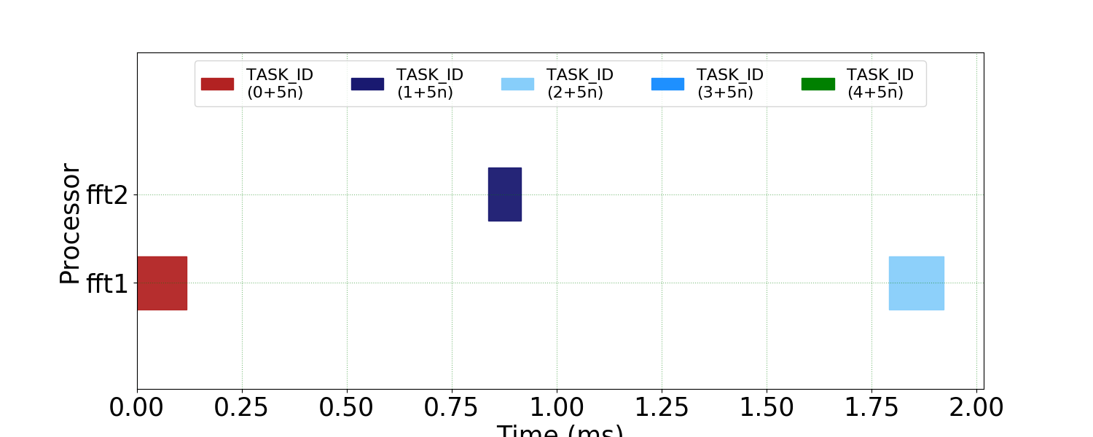
Gantt chart for Radar Correlator Execution

- Why are no CPUs visible in this Gantt chart?
Answer: All CPUs were removed and replaced with Accelerators – 2 FFTs and 2 ZIPs (Note: a location for the ZIPs was not able to be determined for Radar Correlator).

- What is the resource configuration (# of CPUs, FFT and ZIP accelerators, and scheduler) used for this execution? Given this information, if Radar Correlator had another ZIP API in the end, which Processing Element (PE) would it be scheduled on and why?
Answer: The current execution only uses two FFT Accelerators. Because of this, adding an additional ZIP API would result in it being scheduled on fft2, because a simple scheduler is being utilized, and it will be available before (and idle for longer than) fft1.

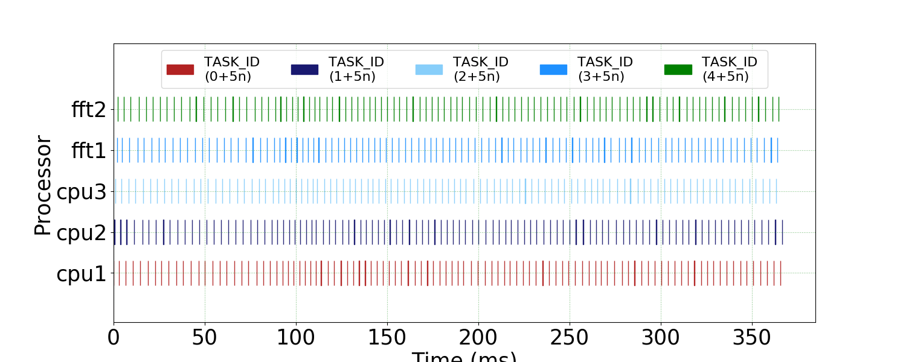
  - Pulse Doppler:

Gantt chart for Pulse Doppler Execution
- Based on the Gantt chart, is there any disparity between CPUs and Accelerators in terms of how densely APIs are running on each of them? If there is disparity, despite RR (SIMPLE) scheduler trying to distribute workload evenly, visually from the graph what seems to be the reason for this disparity?
Answer: There does not appear to be a disparity between the density of API execution on CPUs versus Accelerators.

  - SAR:
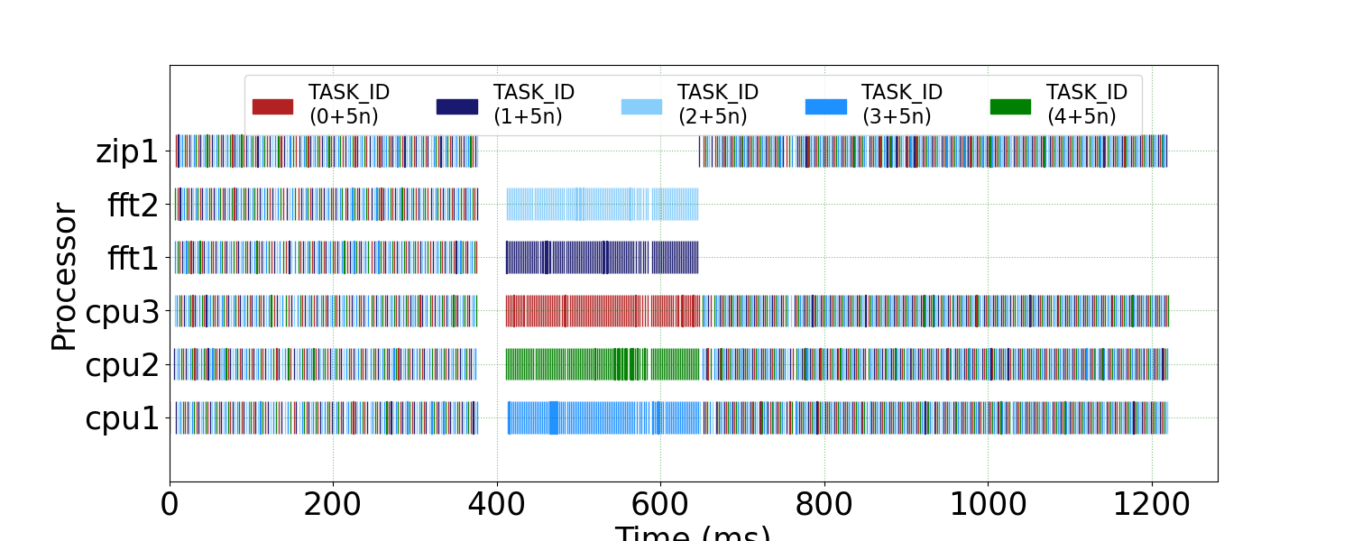
Gantt chart for SAR Execution

- Based on this Gantt chart, which resource/resources are determining/increasing the end-to-end execution time of the application?
Answer: The CPUs and ZIP accelerators are increasing the end-to-end execution time of the application. The FFT accelerators finish all tasks before 700 ms, and the remaining hardware continues running until the 1.2s mark.

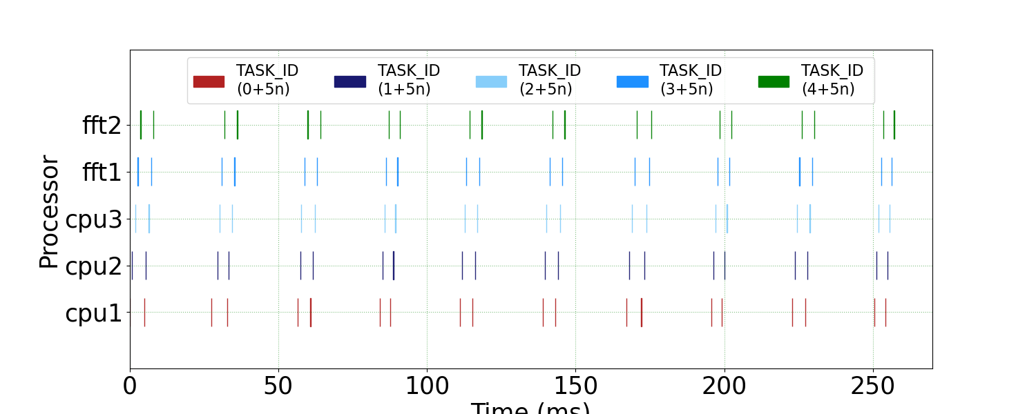
  - WiFi-TX:

Gantt chart for WiFi-TX Execution

- Based on this Gantt chart, do all PEs (CPUs and Accelerators) stay occupied to the same degree? If not, what would a better scheduling strategy do to even workloads across different PEs?
Answer: All of the PE’s seem to stay occupied to the same degree. There are significant delays between each task assignment, but PE utilization seems somewhat optimal.

