Installation
The ASP.NET Forums is designed to run on Microsoft Windows Server 2003, Windows 2000 Server, and Windows XP using a variety of databases– the default being SQL Server 2000.

Installation Checklist & Requirements
Prior to installation, ensure you have the items on the checklist below:

□ Web Server
The ASP.NET Forums requires Windows Server 2003 (recommended), Windows 2000 Server, or Windows XP running version 1.1 of ASP.NET. Internet Information Services (IIS) must be installed as does ASP.NET. ASP.NET is part of the .NET Framework and can be freely downloaded from www.asp.net.

□ Database Server
The default installation of the ASP.NET Forums requires either SQL Server 2000 (or newer) or Microsoft Desktop Engine (MSDE). MSDE can be freely downloaded:
http://www.microsoft.com/downloads/details.aspx?FamilyID=413744d1-a0bc-479f-bafa-e4b278eb9147&DisplayLang=en

You will need permissions to create a database or permissions to create tables, procedures, and functions in an existing database. Please have the appropriate administrative level credentials available.

□ ASP.NET Forums Source
The most current build of the ASP.NET Forums can be found at http://forums.asp.net/builds/. Please check the /Alpha, /Beta, and /Release sub-directories for public/deployable builds. All other builds in the /builds are daily or weekly builds of the current source base. You can determine the age of a build as follows [year].[month].[build]. For example, 2003.10.1427 translates to build 1427 from started on October 2003. There are 2 executable files that can be downloaded from this location: AspNetForums.exe and AspNetForumsSDK.exe. The AspNetForums.exe contains only the files needed to run the forums. The AspNetForumsSDK.exe contains all the source code to the forums. You can additionally sync with the most recent versions by downloading the code directly from the GotDotNet workspace:
http://www.gotdotnet.com/Community/Workspaces/workspace.aspx?id=d9e0d1dc-122a-4dc7-a216-b76bd927b20b

Building the Project from the GotDotNet Workspace
If you copied the files from the GotDotNet workspace you will need to build the project otherwise this section can be skipped.

To build the project:

- Open a command prompt windows: (Start | Run) and then type cmd
- Navigate to the location on your harddrive where the files were copied to. For example, c:\workspace\AspNetForums\.
- Next, you will need to decide if you wish to create a retail or debug build:

To create a retail/production build, type the following at the command prompt:
BuildSetupDevEnv.cmd release

To create a debug/development build, type the following at the command prompt:
BuildSetupDevEnv.cmd debug

In either case this will wipe and create a new folder \Builds. Within the \Builds folder you will also find a versioned build directory, for example \2003.10. Beneath the 2003.10 directory you will find a \Release or \Debug (or both) for the versions you built. The \web directory beneath \Release or \Debug is what you will need to configure as your web application root in IIS.

For example, using c:\workspace\AspNetForums\ and building a retail build you would expect to see something similar to:

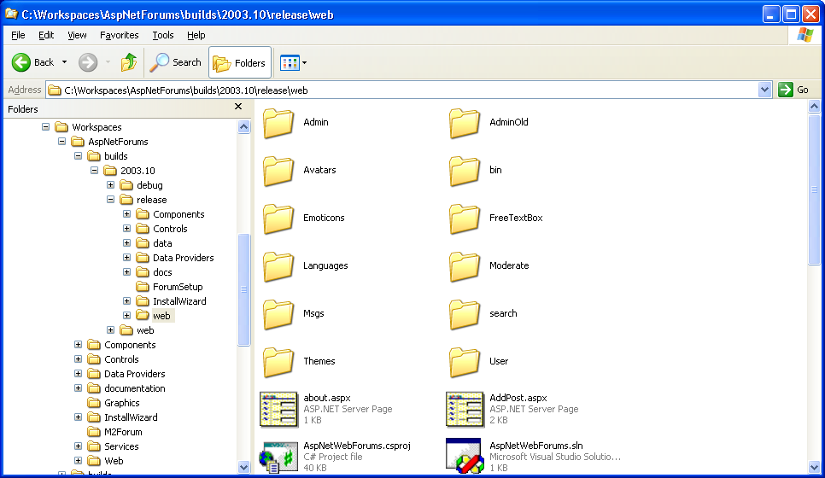

There are two ways in which the forums may be installed:
- Install Package – Use a pre-built installation package.
- Manual – Install the forums manually.

Manual Installation
Installing the forum manually is an advanced option and requires knowledge of SQL Server and IIS. This guide will attempt to detail some of the required steps, but you may need to contact your systems administrator.

Creating the Forums Web Application
- Start Internet Information Services.
Start | All Programs | Administrative Tools | Internet Information Services

- Create a new Web Application (from within Internet Information Services)
  - Pick the Web Application root to install the forums into, e.g. ‘Default Web Site’.
  - Right-Click on the Application root and select New | Virtual Directory.
  - Click Next > to by-pass the Virtual Directory Creation Welcome screen and enter an alias for the forums, e.g. Forums:

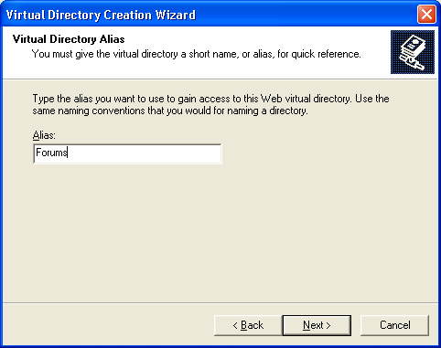

  - Click Next. On the next screen select the directory where the forums web application is installed:

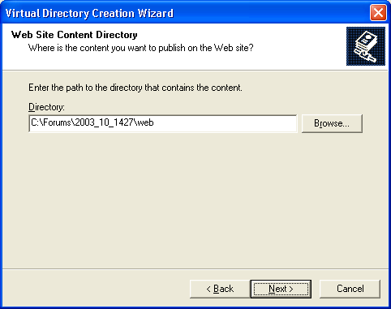

  - Click Next. On the Access Permissions wizard step leave the default settings and click Next and then Finish to complete the Wizard.

The ASP.NET Forums is now configured to run as http://localhost/Forums/ - however, accessing at this point will result in an error as you still need to configure the database.

Creating the Forums Database
To create the database used by the forums start SQL Query Analyzer from the Database server or a client machine with SQL Server tools installed:

- Start | All Programs | Microsoft SQL Server | Query Analyzer
- Create a new database or use an existing database

Step 1: Create* a new database type:
create database [database name]

Step 2: Use database type:
use [database name]

* It is highly recommended that you have your DBA create a database for you rather than using create database yourself.

After typing the commands into SQL Query Analyzer press F5 or click the ‘Play’ button – note you must run each command separately:

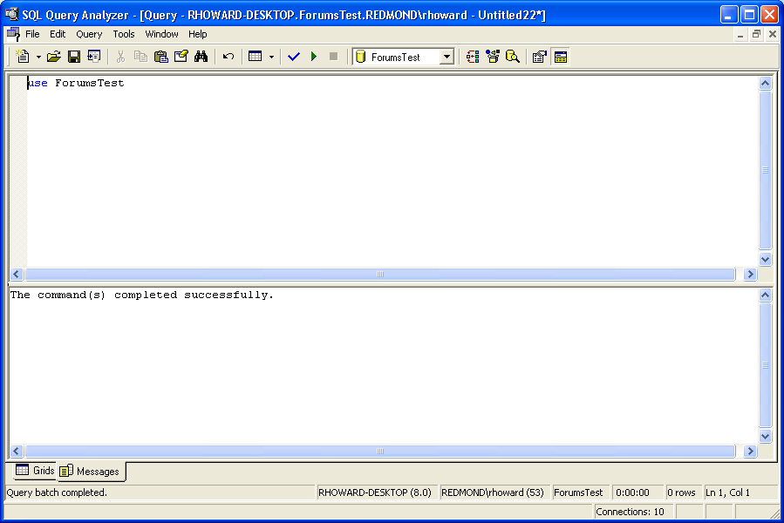

- From within SQL Query Analyzer repeat the following steps for each of the 4 files:
- 2003.10-Tables.sql
- 2003.10-Procedures.sql
- 2003.10-Functions.sql
- 2003.10-Data.sql

Note, these files must be processed in order.

These files will be found in the \Data Providers\SqlDataProvider\sql\ directory which is a peer of the \web directory:

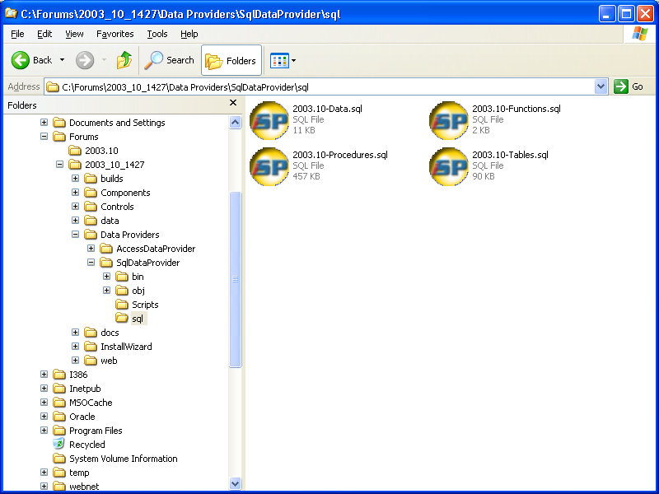

  - File | Open (select file)
  - Press F5 or click the ‘Play’ button to execute the script. You may see warnings, these can be safely ignored.
  - Repeat for remaining files.

Configuring the forums to use the database
Once the database is created and the necessary SQL scripts run the last step is to configure the forums application to use the database.

- Open the web.config file found in the \web directory.
- Find the <forums> section and look for the string “^SqlConnectionString^” this string needs to be replaced with a valid connection string for connecting to your database.

Example: assuming a database server with an IP address 123.12.3.1, with a forums database named ‘Forums’ and a username of ‘ForumsDB’ and password ‘secret’ the connection string would look as follows:
"server=123.12.3.1;database=Forums;uid=ForumsDB;pwd=secret"

It is recommended that you use Integrated authentication. For details on setting up integrated authentication, please see: http://www.asp.net/faq/AspNetAndIIS6.aspx

