Software Issue Tracer (SIT) Quick User Guide

Introduction

The tool “Software Issue Tracer” can collect essential and useful traces one-time for software issues like ACPI dump, Graphics related, Storage related and Thunderbolt related.

As being the official vendor of Windows Operating System, Intel is now providing the assistance for ODM/OEM customers to reduce logs/traces collection efforts of Intel to release. Intel will use built-in-house tools to collect the platforms software issues automatically and make recommendations quicker and better on potential point of Software issues that will provide solutions or next actions.

What the SIT can do

* Establishing one quick way to collect logs and traces and gathering them for investigation
* Automated logs and traces collection in one time and no extra applications installed
* Provide comprehensive Software issues logs/traces automated collection which would include:
* All ACPI tables and codes dump
* Graphics related traces-Display and Video/Performance
* Storage related logs-Optane and RST
* Thunderbolt related traces- Stress test (S3/S4/S5/boot) traces
* Live Dump file collection
* One button Click for Collect System configurations/settings and forced dump file

Benefits

1. ODM/OEM can leverage this SIT tool to collect logs/traces automatically
2. Intel and its partners can reduce communication efforts and human error and drivers setting for traces collection
3. Accelerate debugging time to root cause Software issues.

*Quick Start guidance*

* Overview

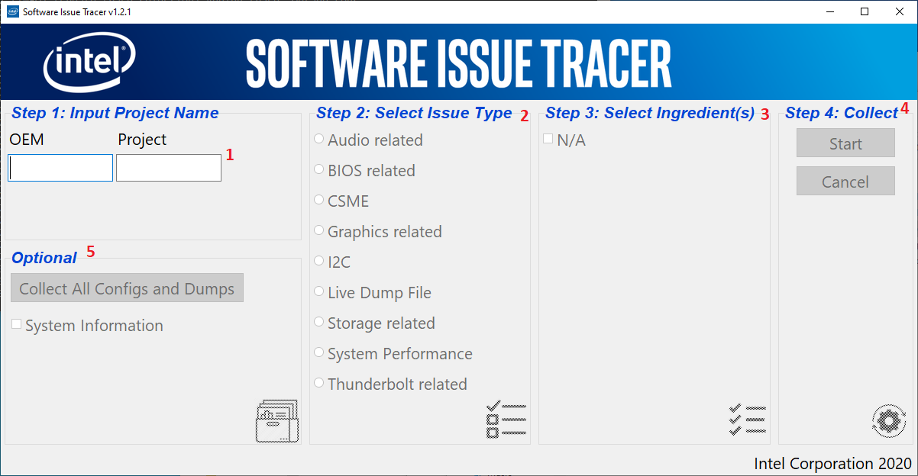

➀ Project Name: please key in your project name

➁ Issue Type: please choose what issue type you want to collect logs/traces

➂ Ingredient: please choose which one specific driver this issue causes problems on

➃ Collect: Just press one button “Start” to perform traces/logs capture or “Cancel” to reset all items you chosen and re-do it.

➄ Optional: One button to perform all configurations, logs and forced dump file automated collection

* Audio related traces Collection

Please must key your project then all gray-out items would be selectable then choose Audio related issue type then press “Start” to collect. Unless you need to uncheck one of Step 3: Select ingredient(s) items then press “Start” to collect.

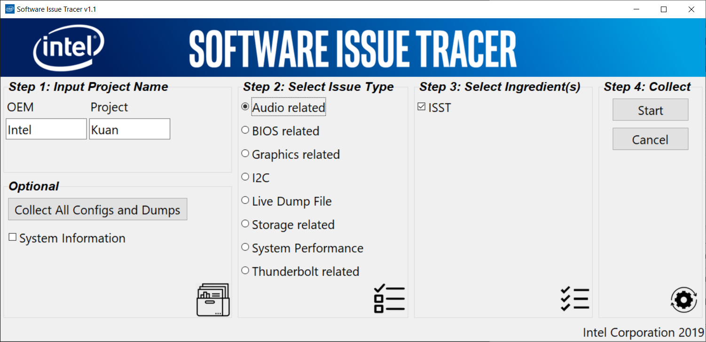

* I2C related traces Collection

Please must key your project then all gray-out items would be selectable then choose I2C related issue type then choose I2C or I2C ACPI then press “Start” to collect.

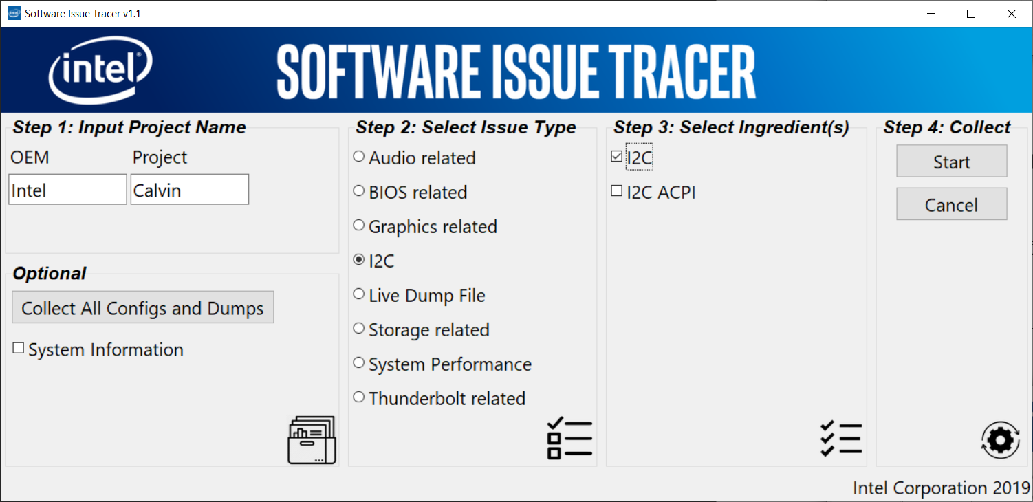

* ACPI Tables and Codes Collection

Please must key your OEM and project then all gray-out items would be selectable then choose BIOS related issue type then press “Start” to collect. Unless you need to uncheck one of Step 3: Select ingredient(s) items then press “Start” to collect.

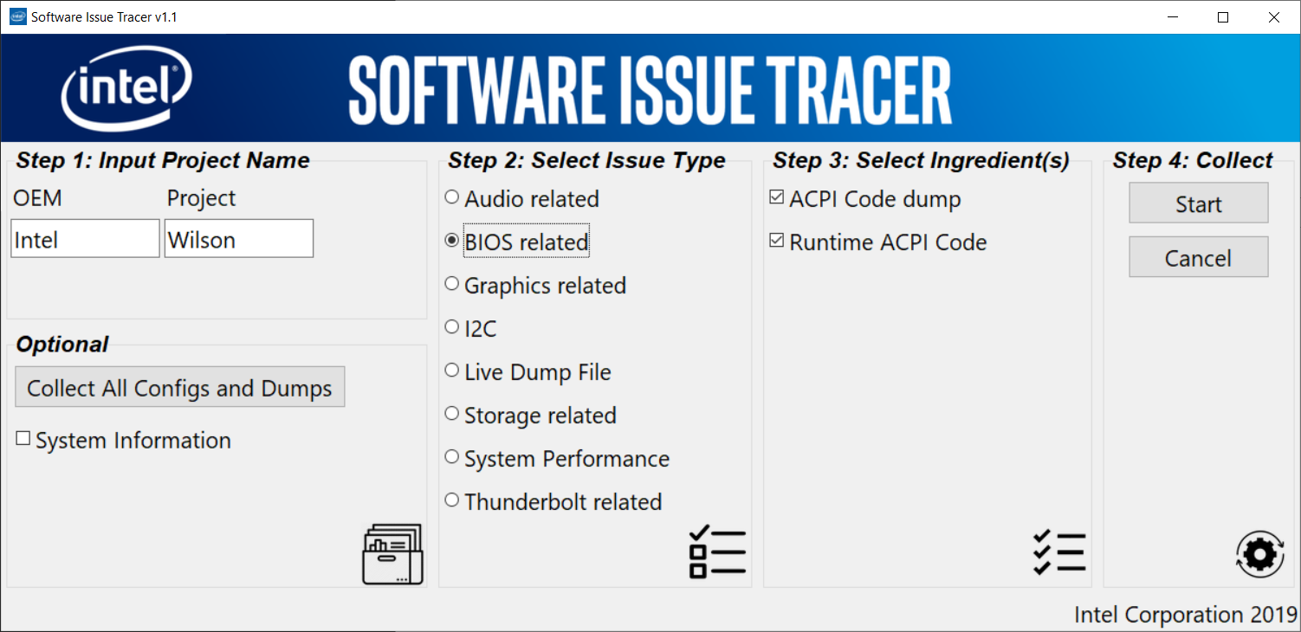

* Graphics related traces Collection

Please must key your project then all gray-out items would be selectable then choose Graphics related issue type then choose Display area or Video/Performance area then press “Start” to collect

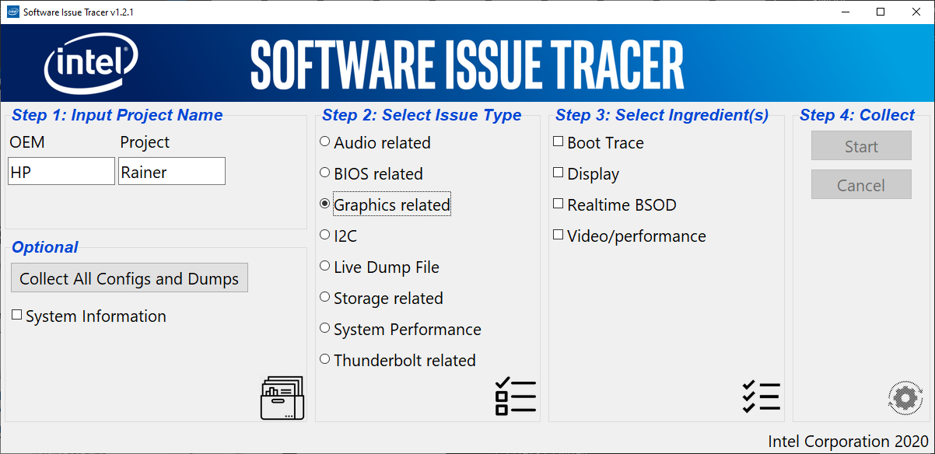

* TBT related traces Collection

Please must input your project then all gray-out items would be selectable then choose TBT related issue type then choose S0/S3/S4/ stress test or Boot test then press “Start” to collect

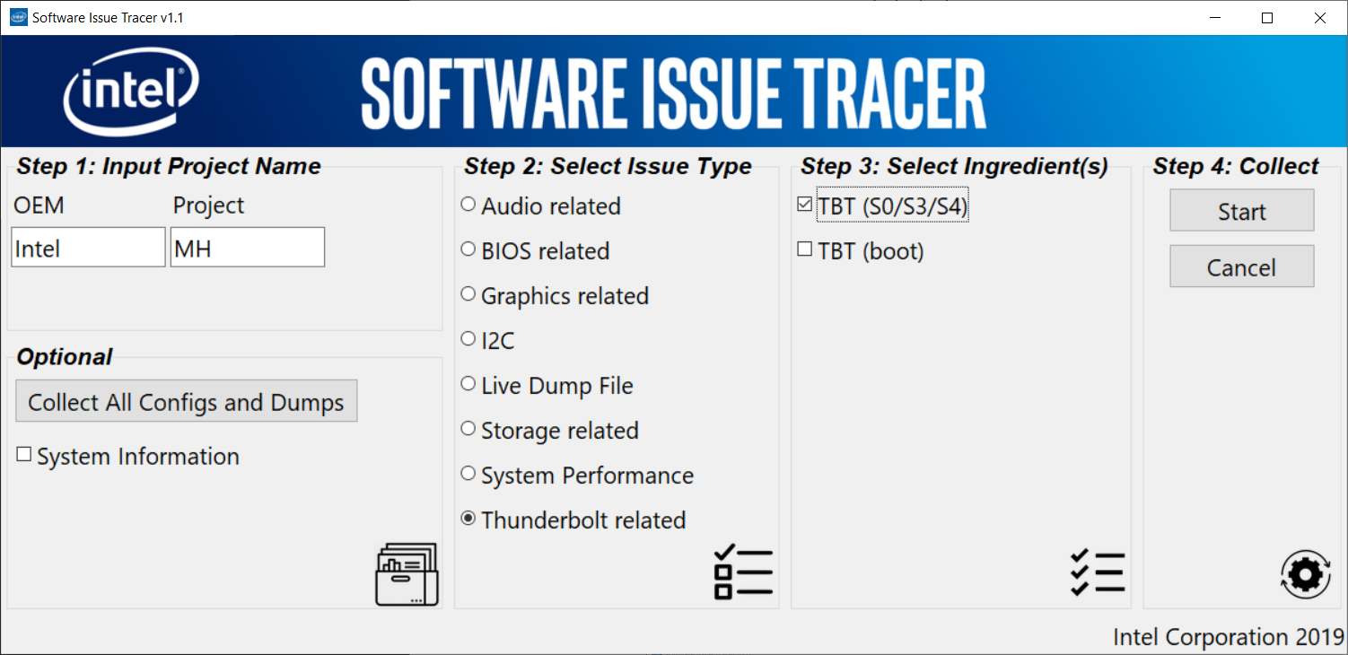

* Thunderbolt without reboot condition (S0/S3/S4)
  1. Enter a project name in step 1
  2. Select Thunderbolt related option in step 2
  3. Select TBT (S0/S3/S4) option in step 3
  4. Press start button in step 4
  5. SIT tool will collect system information when start button pressed
  6. Run the scenario you wish to log after system information completely collected
  7. Once the scenario is completed, press any key in the command line. This will stop the log.  
     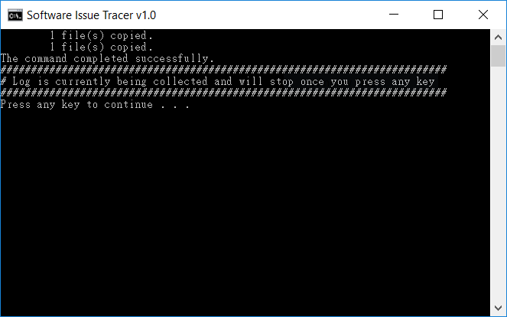
  8. A folder will be created timestamp and the log will be saved in it.
* Thunderbolt with reboot condition (system boot)
  1. Enter a project name in step 1
  2. Select Thunderbolt related option in step 2
  3. Select TBT (boot) option in step 3
  4. Press start button in step 4
  5. SIT tool will collect system information when start button pressed
  6. Run the reboot scenario you wish to log after system information completely collected
  7. Reboot system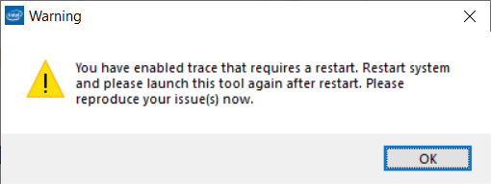
  8. Once the scenario is complete, please launch SIT tool again
  9. SIT tool will confirm boot trace be active and please press yes button to continue complete the log.
  10. A folder will be created timestamp and the log will be saved in it.

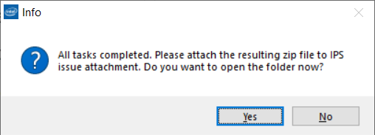

* Storage related logs Collection
* Please must key your project then all gray-out items would be selectable then choose Storage related issue type then choose Optane logs or RST logs then press “Start” to collect. Unless you need to uncheck one of Step 3: Select ingredient(s) items then press “Start” to collect.

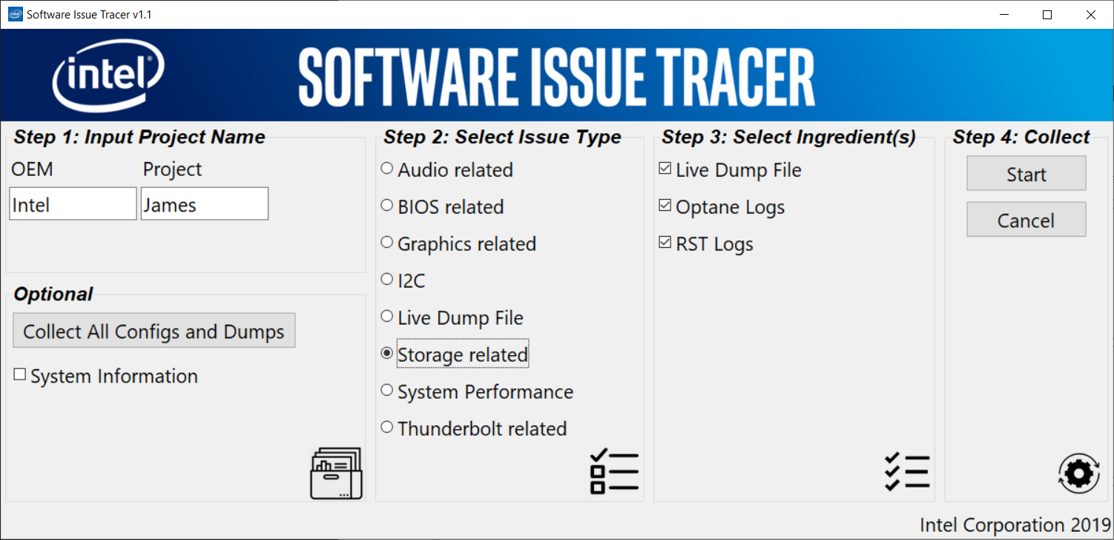

* Forced Dump file Collection

Please must key your project then all gray-out items would be selectable then choose Live Dump file then press “Start” to collect.

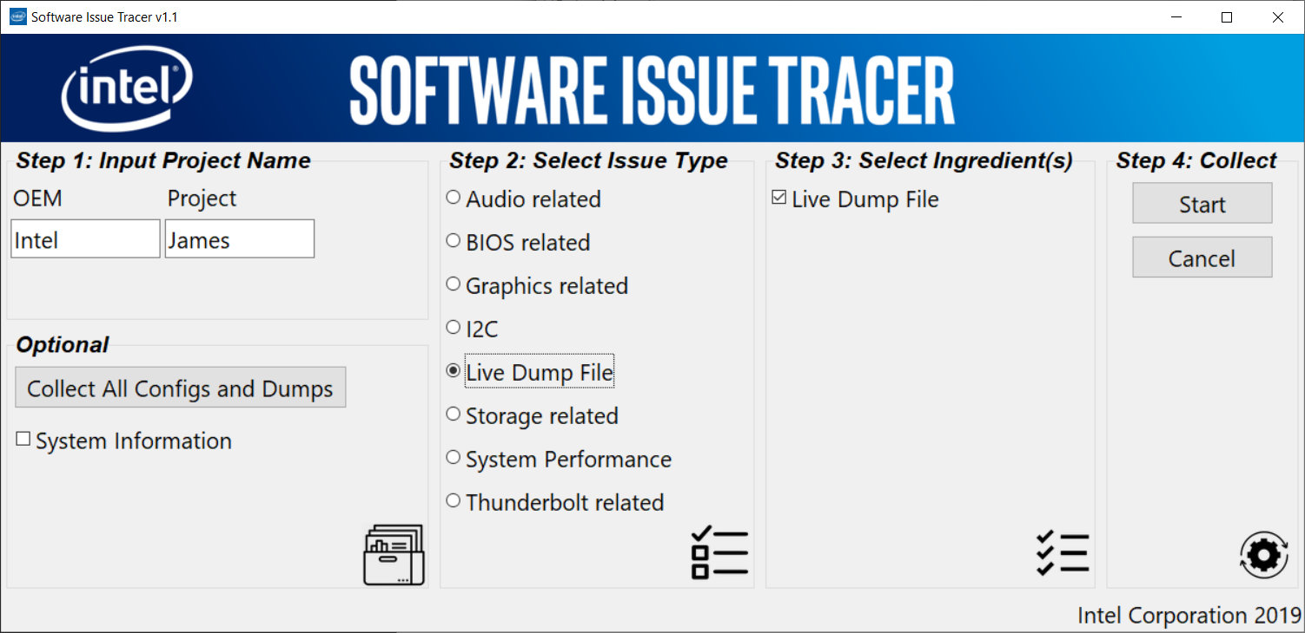

Before Live dump file collection, **please insert USB storage and its size must be more than system memory. Create the folder “NTFS_LIVEKD_MEMORY_DMP in USB storage. Then connecting internet for symbol download.** Then you have to insert USB storage as formatted NTFS to be where to save live dump file.

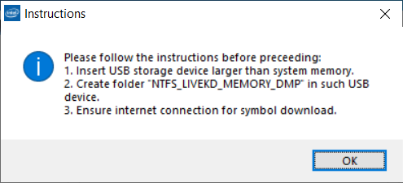

* Optional-One button to do All Configs, logs and forced Dump file Collection

Please must key your project then press Optional one button for all system info and logs and forced dump file collection

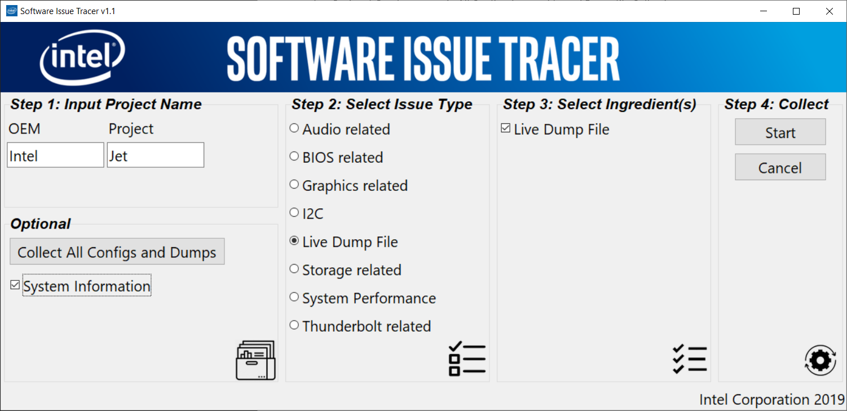

* Finally, please copy the folder where all traces/logs were saved and it is named by project name then offer it to Intel’s further investigation.

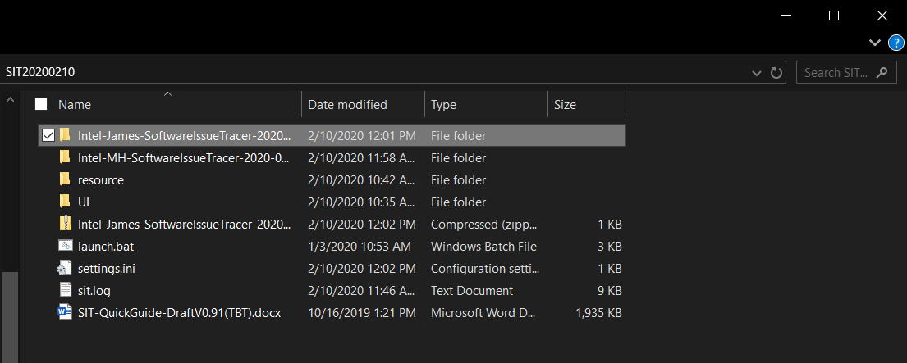

* CSME related traces Collection

Step 1: Please must input your project then all gray-out items would be selectable.

Step 2: Choose CSME and related log for ME SW issue type will be listed in Step3 column.

Step 3: Choose required log according to issue types

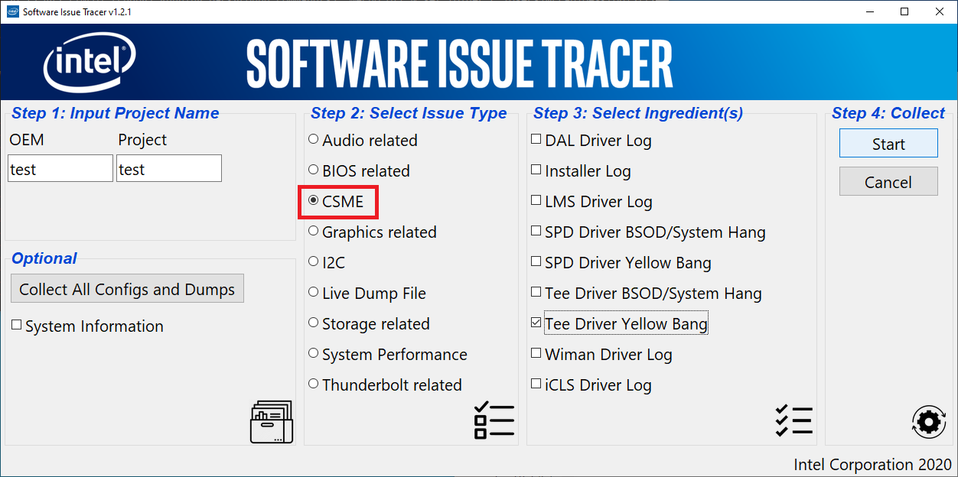

**Note**: For Installer log, LMS Driver log and iCLS Driver log, please launch the program **after** the issue is reproduced.

For other options, please launch the program **before** the issue is reproduced. In addition, reboot is required after clicking the start button.

For Tee Driver BSOD/System Hang and SPD Driver BSOD/System Hang case, the following message will be pop up after clicking “Start”

Step 4: The following message pop up:

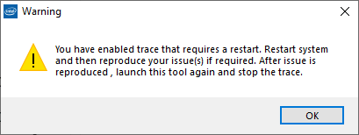

Or

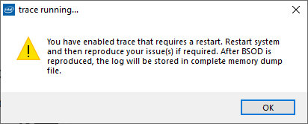

Click “OK” and then reboot the system manually.

Step 5:

For “Tee Driver BSOD/System Hang” or “SPD Driver BSOD/System Hang” options, after reboot, user may reproduce the issue and log will be saved in complete memory dump file. Get the complete memory dump file for issue investigation and user doesn’t need to launch the tool again.

For other cases, after reboot, User need to launch the program again after issues are reproduced. The program will ask whether to stop the boot trace for every active boot trace respectively when the tool is launched. You may stop the boot trace you want to stop and keep others running.

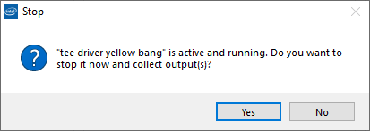

❖Please contact with Intel Folks as below if you have any problems when you perform this tool

Jet Chen([jet.gs.chen@intel.com](mailto:jet.gs.chen@intel.com))

James Lee([james.lee@intel.com](mailto:james.lee@intel.com))

Jack Ko([jack.ko@intel.com](mailto:jack.ko@intel.com))

MH Hsieh([mh.hsieh@intel.com](mailto:mh.hsieh@intel.com))

Wilson Lee([wilson1.lee@intel.com](mailto:wilson1.lee@intel.com))

Kuan Han([Kuan.han@intel.com](mailto:Kuan.han@intel.com))

Calvin Jiang ([calvin.jiang@intel.com](mailto:calvin.jiang@intel.com))

JW Chen([jw.chen@intel.com](mailto:jw.chen@intel.com)) for CSME