Module 21 Deep Learning Challenge

Alphabet Soup Non-Profit Organization prediction model

The purpose of this project is to create a model that will predict if applicants for funding will be successful. Variables include Application Type and Classification.

Three layers were used for this model:

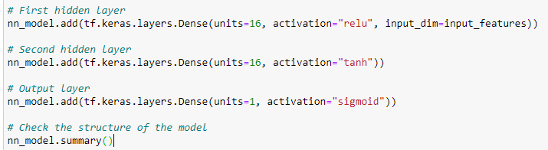

20 epochs used for this model:

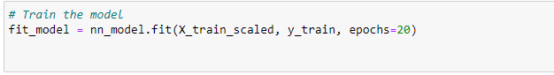

Accuracy of this model: 72%



Optimizing the model to improve accuracy:

6 layers used:

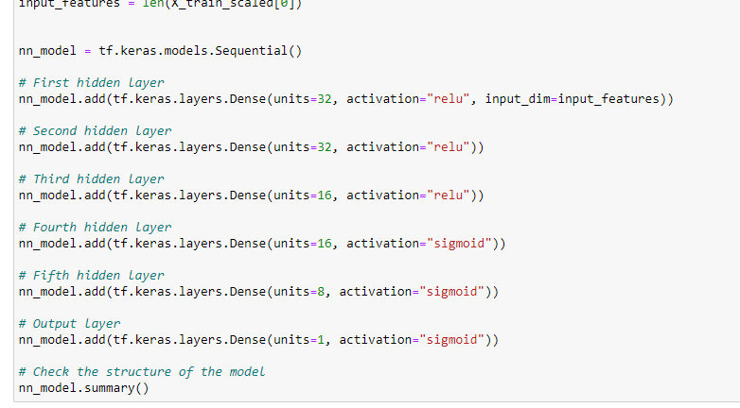

20 epochs:

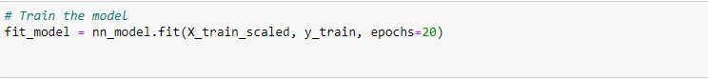

Accuracy slightly improved to 73%.

