**Multi-Agent Search report**

071125葉長瀚

**Part I. Implementation:**

**Minimax:**

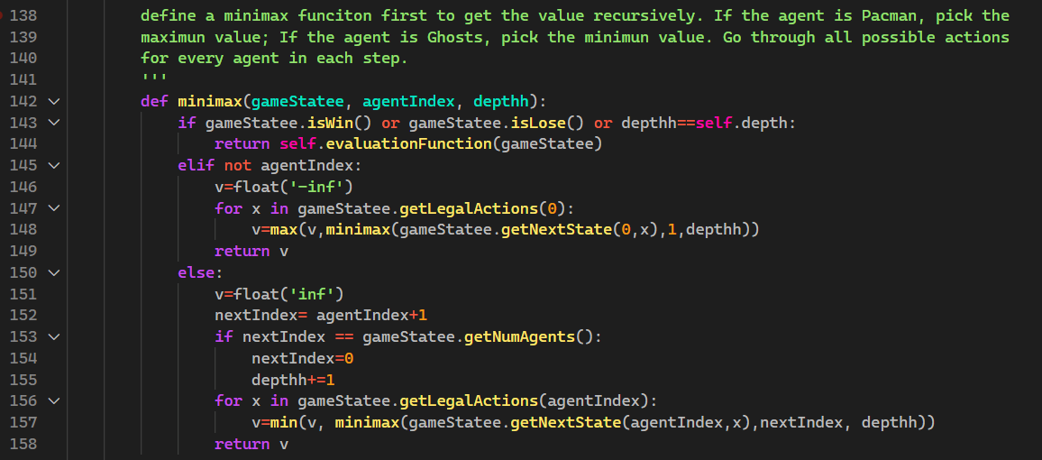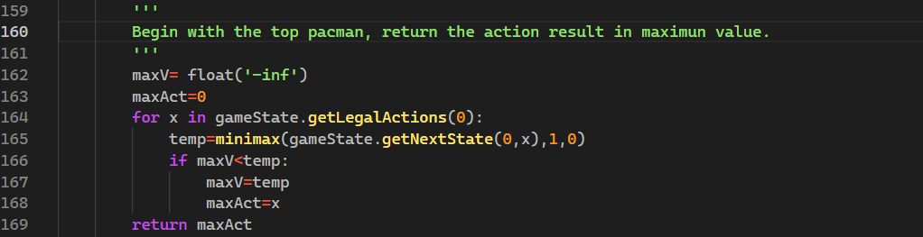

**Alphabeta pruning:**

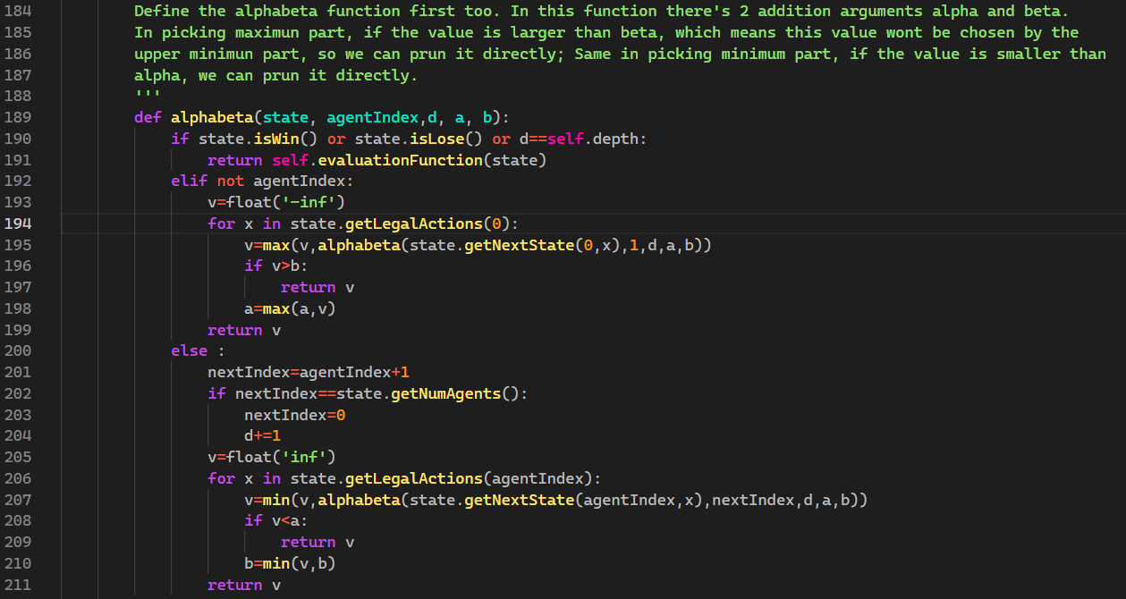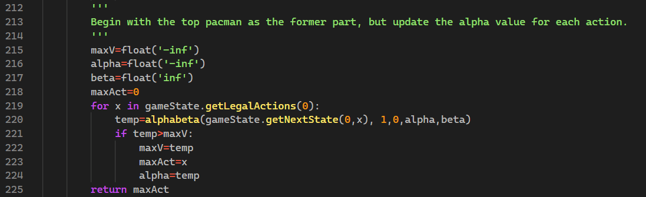

**Expectimax:**

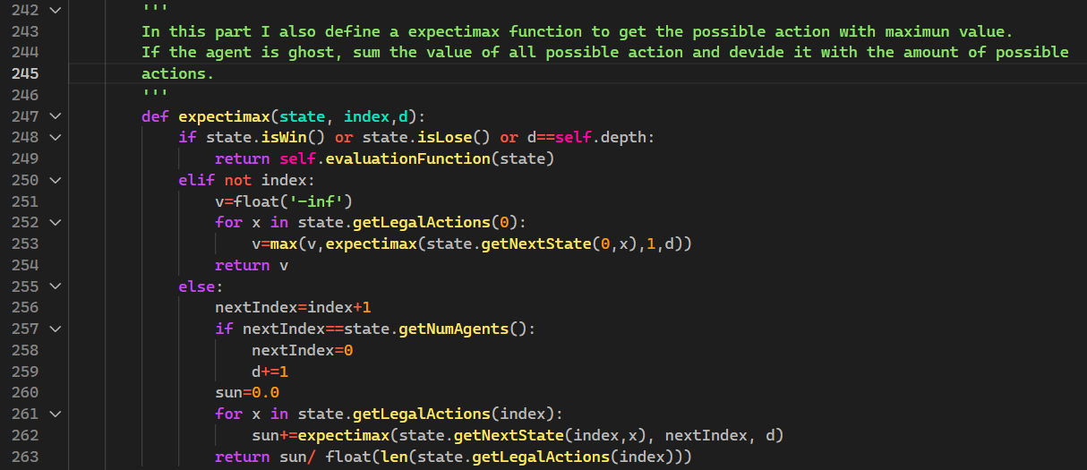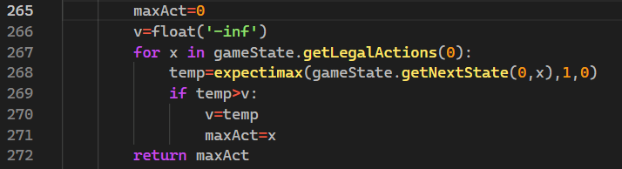

**Better evaluation function:**

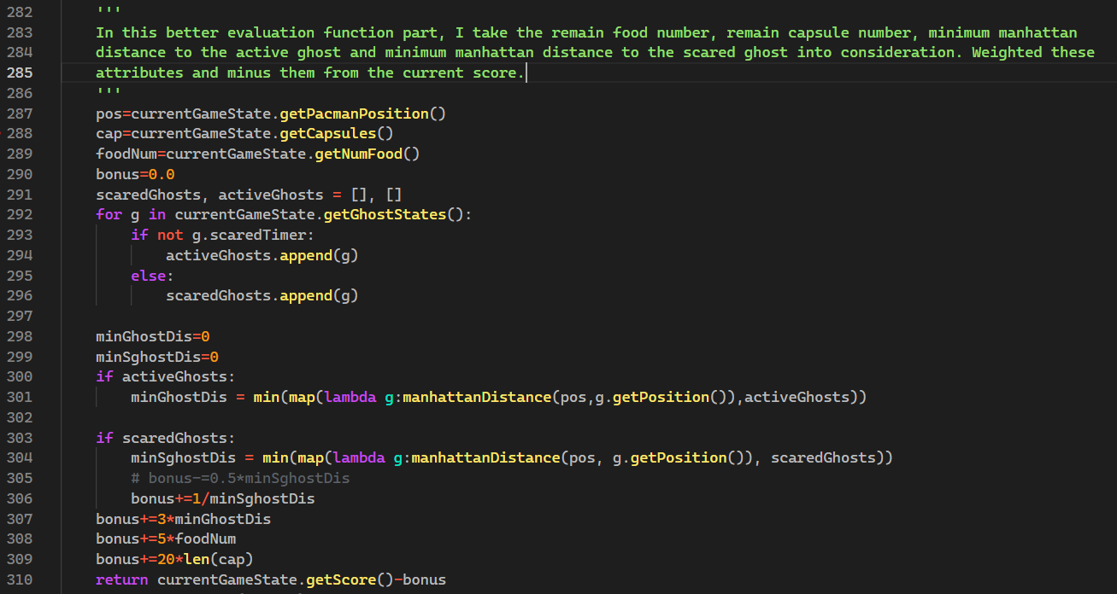

**Part II. Results & Analysis:**

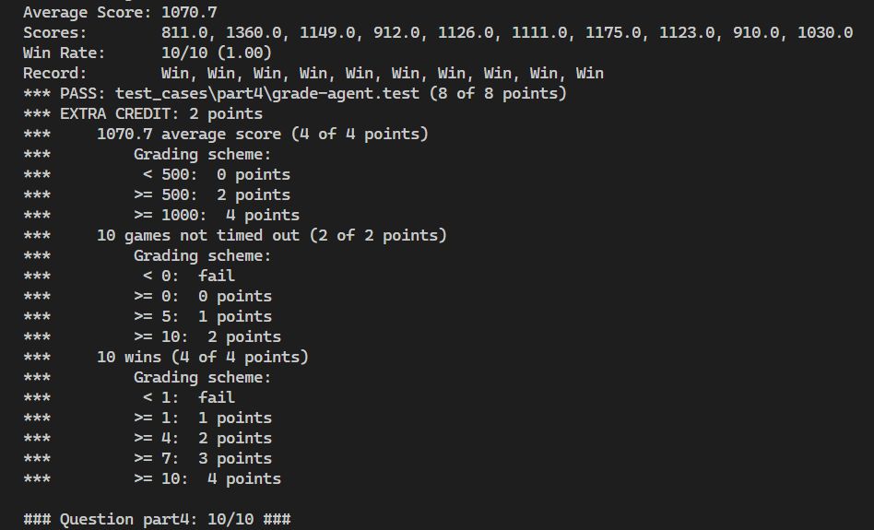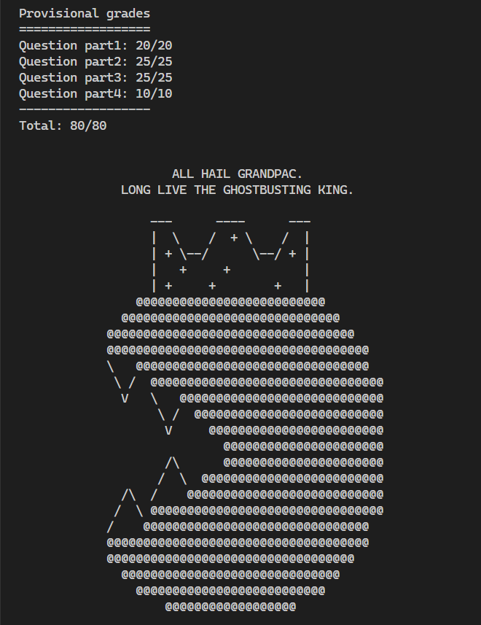

By repeatedly testing, I finally weighted the attributes as

* Amount of remaining food: 5
* Amount of remaining capsules: 20
* Minimum Manhattan distance to the active ghost: 3
* Minimum Manhattan distance to the scared ghost: reciprocal

Initially, I also want to consider the total distance of all remaining food, and their density degree, but after implementation, I found that it’s extremely time consuming if I run through the whole map to calculate the total distance, causing nearly time out in every game.