**Car Tracking report**

071125葉長瀚

**Part I. Implementation:**

**Part 1:**

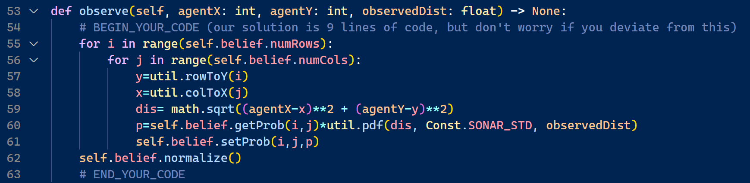



Update the probability on each tile by multiply the original one with the emission probability got from *util.pdf*, and normalize the updated probability.

**Part 2:** 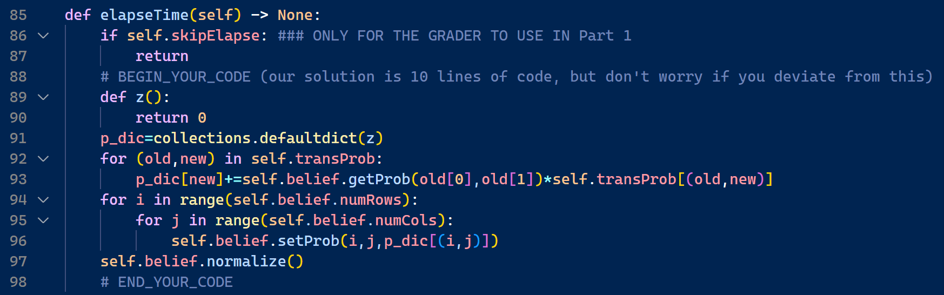

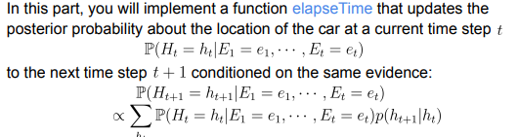

Create a dictionary with default value 0 to store the new probability updated by transition probability. Sum the new probability in each tile, set them to be the belief probability and normalize it.

**Part 3:**

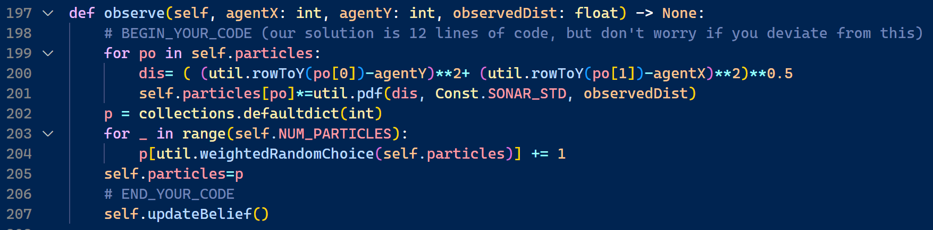

Update the probability by multiply it with the emission probability for all the particles. Create a new dictionary to store new particles, resample a same amount of particles according to the reweighted probability, and set the particle distribution to be the new one.

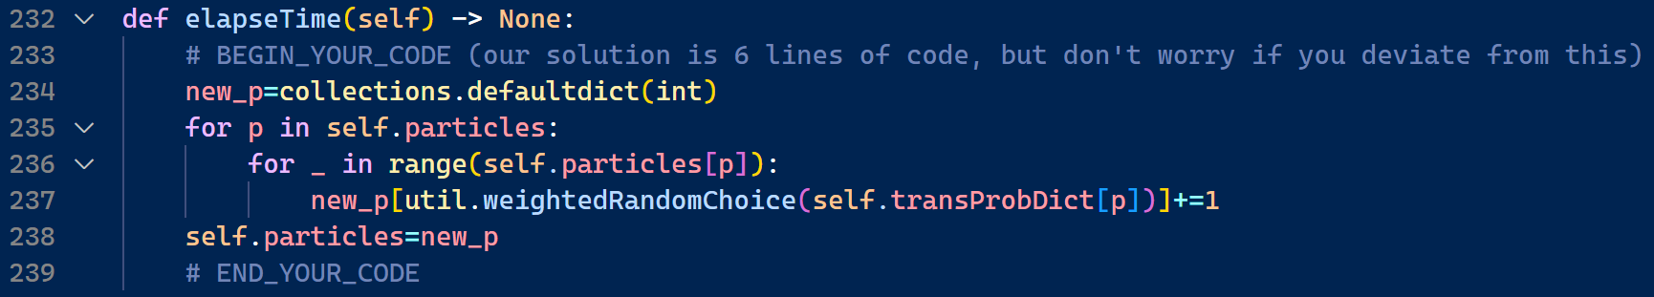

Update particles by the transition probability. For each particle in each tile, resample its next most probable location base on the transition probability dictionary, and then set the particles distribution to be the new one.

**Problem faced and solved:**

The most difficult problem I faced during this homework is indeed as the spec mentioned, that is to understand the concept of Bayesian network in order to correctly update the probability, so before start coding, I watch some video and review the course slide to ensure my comprehension.