CRM PRODUCT REPORT
BK FastLane CRM:
Contact to Petition Prep
Plain-English product review for Jimmy Stein and Matt McCune
Date: July 14, 2026
Status: Live fake-data demo verified
Branch: Jimmy - Contact to Petition Prep
Live demo: jimmydanol.github.io/bkfl-crm-lite
VERDICT The product direction is now clear enough to explain to a solo bankruptcy attorney in a few minutes. Keep this design and make the workflow secure, reliable, and connected before adding more screens.

Executive verdict
The CRM is now centered on one job: move a potential bankruptcy client from first contact to a complete file that can be used to start preparing the petition.
The record name changes automatically based on what the firm actually has, not on a staff member's guess.
LEAD | CONTACT | MATTER
No Intake answers received | Some Intake data received; answers or documents still need work | Data and documents complete; ready for petition prep

Recommendation
Use this version as the product-design baseline. Do not add broad case-management or post-filing features yet. First connect this workflow to secure storage, the live Intake, and a controlled pilot.

What changed
- Matt's four-part structure remains, but the four sections are Dashboard, Leads, Contacts, and Matters.
- Settings remains available as a small utility instead of competing with daily work.
- The Dashboard explains the workflow at a glance and lists the files that need work next.
- Contacts appear ahead of Leads because they are closer to petition prep and contain the most valuable staff work.
- Each Contact shows Intake-data progress, document progress, and one plain-language next step.
- A Contact becomes a Matter only when required data and every document request are complete.
- A Matter returns to Contacts if new activity reopens data or document work.
- Each debtor file has four focused tabs: Overview, Intake Data, Documents, and Activity.
- The document resolved count now includes only approved or excused requests.
- Hover explanations and a fake-data-only banner make the demo easier and safer to understand.
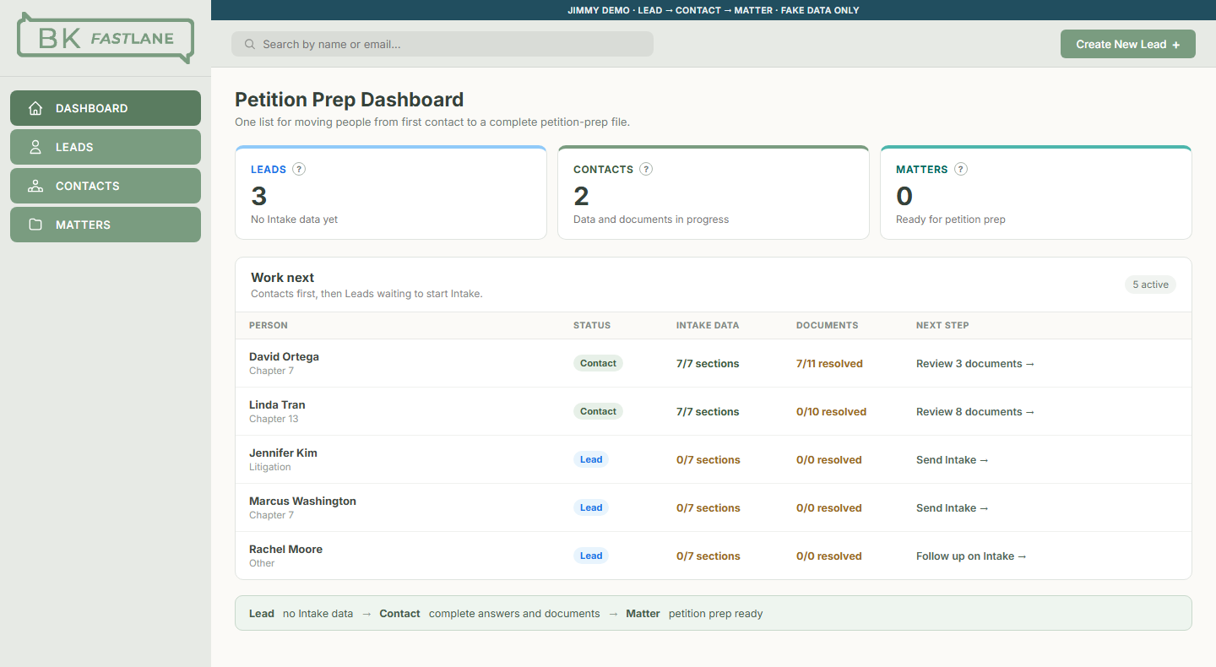
Figure 1. The live Dashboard gives the firm one prioritized work list and makes the lifecycle visible.

The intended daily workflow

1. Create the Lead
The firm records the person's name and contact information. The person remains a Lead even if the secure Intake link has been sent, because no answers have been received.

2. Receive Intake data
As soon as any Intake answers arrive, the person becomes a Contact. This tells the firm there is now a real file to complete.

3. Complete the Contact
The Contact screen separates Intake answers from documents. Staff should always be able to answer: What is missing, and who needs to act next?

4. Reach petition prep
When required Intake sections have answers and all document requests are approved or excused, the Contact automatically becomes a Matter. The next action is to begin petition preparation.
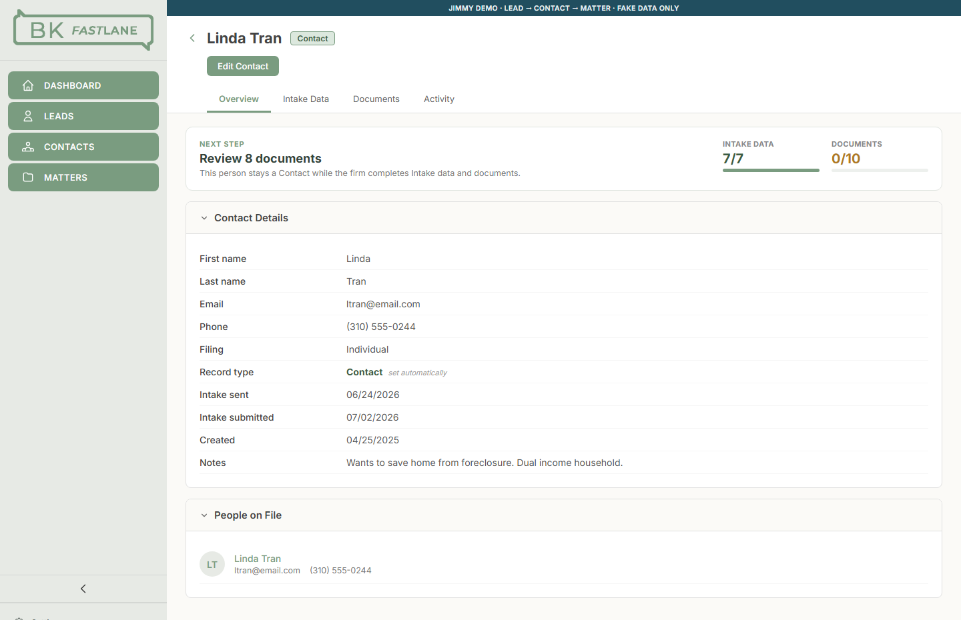
Figure 2. A Contact record shows the next step and keeps Intake data and document readiness separate.

What works well now
The language matches a small bankruptcy firm. Lead, Contact, and Matter describe real changes in the file, not vague sales stages.
The Dashboard answers what to do next. It shows counts, progress, and one short work list instead of acting as a general control center.
Data and documents stay separate. A complete questionnaire does not mean the documents are complete, and complete documents do not cure missing answers.
A Matter cannot be created too early. The file must earn the Matter label from actual readiness.
Firm judgment remains in control. AI may flag or preliminarily accept an upload, but the firm approves, rejects, or excuses it.
The design stays narrow. The CRM stops at a clean, reviewable package instead of trying to replace mature petition-preparation software.

What is not production-ready
SAFETY BOUNDARY This demo is appropriate for product review and synthetic testing. It is not ready for real client data.

Must be completed before a real-client pilot
- Real accounts and permissions for attorneys, paralegals, and administrators.
- Encrypted client-data and document storage, backups, retention rules, and tested recovery.
- A reliable live Intake connection with retries and visible error handling.
- Real file controls, malware scanning, and dependable preview and download behavior.
- A permanent activity history showing who changed data, approved documents, or sent requests.
- Attorney-approved, versioned rules for chapter-specific required answers and documents.
- End-to-end synthetic testing of submission, partial completion, follow-up, Matter promotion, reopening, and export.

Important next improvements
- Duplicate detection and safe joint-filer handling.
- Reliable email and text reminders with consent and delivery history.
- Clear ownership so each Contact has a responsible staff member.
- Export into the selected petition-preparation system.
- Accessibility, keyboard, mobile, performance, and browser testing.
- Simple reporting on time waiting for the client versus time waiting for the firm.

Competitive lessons applied

BK Questionnaire
Guided mobile Intake, exact document requests, organized uploads, and reminders show the value of making missing information obvious and the next request easy.

NextChapter / MyChapter
A clean debtor-portal handoff keeps client entry separate from firm review and avoids redundant entry.

Jubilee
Client data, documents, and communications belong on one debtor file rather than across disconnected tools.

Stretto Best Case
Mature petition-preparation software already owns forms preparation and filing. BK FastLane should export or integrate later, not reproduce it here.
BEST POSITIONING The fastest, clearest way for a solo bankruptcy firm to turn debtor information and documents into a complete petition-prep package.

Recommended production order

Phase 1 - Make the current workflow real
- Confirm the Lead, Contact, and Matter rules with the attorneys.
- Define the authoritative Intake and document data model.
- Add authentication, permissions, secure storage, and audit history.
- Connect the live Intake to the CRM.
- Complete the real document-review and follow-up loop.

Phase 2 - Run a controlled synthetic pilot
- Use varied fake clients with missing, inconsistent, and incomplete information.
- Confirm staff can always identify what is missing and who acts next.
- Test Matter promotion and reopening back to Contacts.
- Fix confusion before allowing real client data.

Phase 3 - Limited real-client pilot
- Select a small number of matters with attorney supervision.
- Keep a manual fallback and verify every export.
- Track errors, staff time, follow-up counts, and time to readiness.
- Expand only after handling is reliable and repeatable.

Measures that matter
- Time from Lead creation to first Intake response.
- Time from Contact creation to Matter readiness.
- Missing Intake sections per Contact.
- Documents waiting on the client versus waiting on the firm.
- Follow-ups required per Contact.
- Matters reopened because work was incomplete.
- Staff time spent per file before petition prep.

Go / no-go recommendation
Share this fake-data demo | YES
Use this design as the CRM baseline | YES
Begin a controlled synthetic pilot | YES
Store real client information today | NO
Sell it as production-ready software today | NO

The next value will come from making this exact workflow secure, reliable, and connected - not from adding more screens.

Build and verification record
Matt's unchanged base | a94e1793dac7d08d8e1632f74c2b05b1a9a4a517
Jimmy feature branch | codex/jimmy-contact-to-petition-ready
CRM feature commit | d59accaa6dab9c26e94d261a0c287cf6295f429e
GitHub Pages branch | Jimmy
Live verification | Lifecycle checks, JSX parsing, four rendered routes, Pages build, HTTP response, and browser inspection
Matt's branch | Not changed

Sources
- BK Questionnaire: https://www.bkquestionnaire.com/
- BK Questionnaire pricing: https://www.bkquestionnaire.com/public/pricing
- NextChapter / MyChapter: https://app.nextchapterbk.com/sign_in_attempts/new
- Jubilee: https://www.jubileepro.com/
- Stretto Best Case: https://www.stretto.com/bankruptcy-software-services/best-case/

