# Team Paper

# Hope Holland, Jimmy Dao, Hailey Hendrick, Bryce Pennock

## **OVERVIEW**

Through our research done with Superstore’s data, based on our findings we can confirm that revenue is up, but profitability is stagnant/in decline. When looking at a company’s financial data it’s essential to analyze past years in different categories. Superstore’s data provided us with four years' worth of data regarding their profits, sales, the number of goods, orders, discounts, and much more. With this information provided, we were able to formulate a consensus on how Superstore revenue is up, and that profitability is on the decline/stagnant. We determined that looking at the profit ratio (sales turnover to profit) over the four years shows a decline/stagnate in profitability, and that declines is due to the factors that include; product, region, and their relation together.

## **KEY FINDINGS**

Our research into the status of the Superstore’s revenue and profitability has revealed numerous factors that lead to a decrease in profitability but an increase in revenue. A more in-depth of Superstore’s status is the sales and profit that play a part in the increasing revenue over the years. With profits/sales increasing it’s easy to believe Superstore is profitable. This is not the case, as the profitability ratio starts to hit decline in the year 2022. With the data provided we were able to narrow down the causes of the profitability decrease, which a major cause would be the products and region and their relations together.

To start off, products sold are one of the main causes of an increase in revenue but a decrease in profitability. The main product that made the most profit for Superstore was copiers, which can be seen in *Figure 1 Profit and Sales by Product*. Overall, in total of four years of data copiers made $56,094 in profit, while Superstore did 150,745 in sales for copiers. In comparison to other products that Superstore sold, copiers made the most profit (37% profit ratio for copiers). Now, copiers may have increased revenue, however, chair products halted Superstore’s progress in being more of a profitable business. Again, as seen in *Figure 1 Profit and Sales by Product* Superstore did 335,768 in sales for chairs, but in profit, they only made $27,224 (8% profit ratio for chairs). So, the director’s mention of products having something to do with profitability being stagnated/declined is correct.

Moving forward, the director’s mention of region affecting revenue and the profitability of Superstore was also correct. To look more in-depth at a region, we choose to look at the United States of America (USA). As seen in *Figure 1 Sales by Region*, California was the state with the most sales (457,688 in four years), and with the data provided, they profited $76,381 in a total of four years, the state to generate the most profit (17% profit ratio). However, when looking at Texas they generated 170,188 in sales but went negative in profit by $25,729 (-15% profit ratio). However, when we look at the Canadian region, they do fewer sales and have smaller profits, but they carry no negative profit ratios. Thus, the USA region has created an increase in revenue over the years but has also hurt the profitability, meanwhile, the Canadian region hasn’t.

Now to piece these two factors together to build a bigger picture as to why Superstore is facing an increase in revenue but a decline/stagnate profitability. A big factor is the expenses that are hurting the transformation of sales into profit. Expenses can include transportation, shipping the products, domestic/offshoring production, and much more. Thus, with the data provided and the KPI’s in *Figure 1 Canada v. USA* has shown that Superstore has more success in the Canadian region most likely since it cost less to operate in that region. Superstore makes more off their products as the shipping from their warehouses aren’t far from the Canadian providences, while products sold to the United States may be inclined to more shipping fees (customs fee, airfare, etc.).

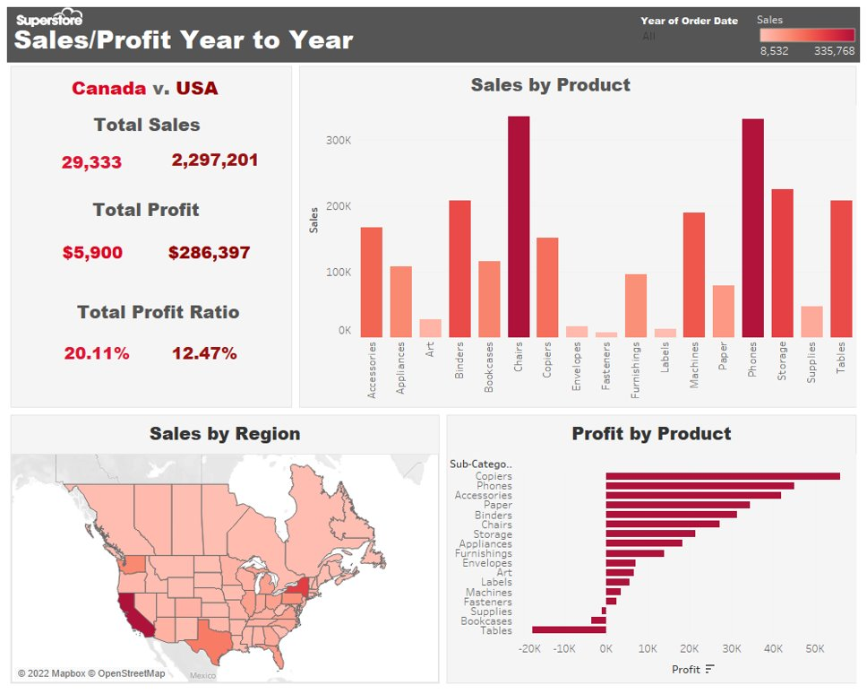

## **SUMMARY**

In conclusion, we can confirm that Superstore has been increasing in revenue but has hit a decline/stagnate in profitability. Product and region affect the profitability of the company because of the expenses that Superstore faces when they ship/manufacture their products to a non-domestic area (USA). Seeing that Superstore mainly operates in Canada, profitability is higher there as expenses for shipping and manufacturing cost less. So, a recommendation for the director is to lower expenses as much as possible overall but then expand their sales/business more into the Canadian region. Create more of a presence in the Canadian region, which will lead to profitability. It’s been shown Superstore can increase revenue, so with these recommendations, it will be able to improve profitability.