Site name – ~scoots

URL - cozumelscoots.com

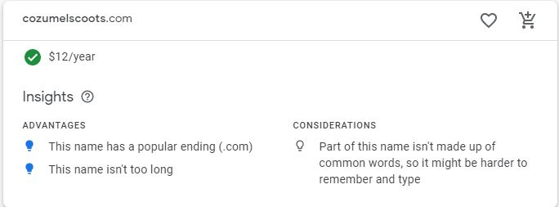

Site Purpose - to promote the rental services for those customers that like to do their homework before getting to the island and to provide information about the services, requirements, and rental process. The website should reflect the fun and carefree attitude of the island and the ability to escape the touristy western part of the island by exploring the vast coasts and inlets on the southern and eastern shores.

Target Audience and Scenarios – The target audience is people who are planning their trip ahead of coming to the island and want to get an idea of what they can do around our shops as well as prices of the scooters they can rent from us to go see everything they want to see.

Person Frank S. Julie R.

|  |  |  |
| --- | --- | --- |
| Person | Frank S. | Julie R. |
| Reason for travel | Planning for 25th anniversary | Planning college graduation trip |
| Amount of people | Booking for 2 people | Booking for 5 people |
| What they want to see | Looking for romantic spots | Looking for tourist places |
| Where they want to stay | Wants to stay on the coast | Wants to stay in cities near downtown |
| budget | Budget is pretty high | Low budget and split between everyone |
| Age | 50 | 22 |
| Job | Software Dev | Recent grad - unemployed |
| Website awareness | Is very familiar with how to navigate websites | Is more familiar with apps. Doesn’t spend much time on a screen larger then her phone. |

Fonts:

Regular text:

Source Sans Pro - <link href="https://fonts.googleapis.com/css2?family=Source+Sans+Pro&display=swap" rel="stylesheet"> - font-family: 'Source Sans Pro', sans-serif;

Headlines:

Merriweather - <link href="https://fonts.googleapis.com/css2?family=Merriweather:wght@700&display=swap" rel="stylesheet"> - font-family: 'Merriweather', serif;

Color Pallet

|  |  |  |  |  |
| --- | --- | --- | --- | --- |
| Background  May go lighter | Accent Color 2 | Header and Footer |  | Accent Color 1 |

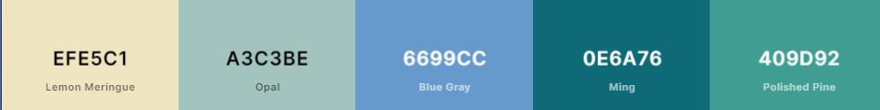

Icons made by <a href="https://www.flaticon.com/authors/freepik" title="Freepik">Freepik</a> from <a href="https://www.flaticon.com/" title="Flaticon"> www.flaticon.com</a>

Wire frames:

Order is Web, Tablet, Phone

