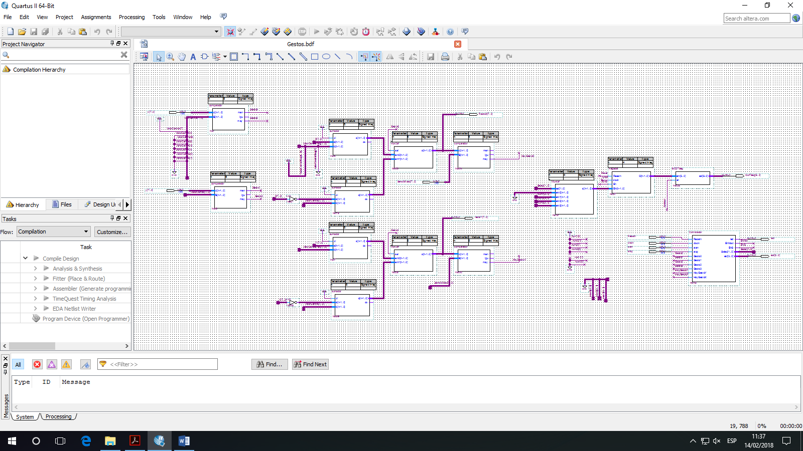

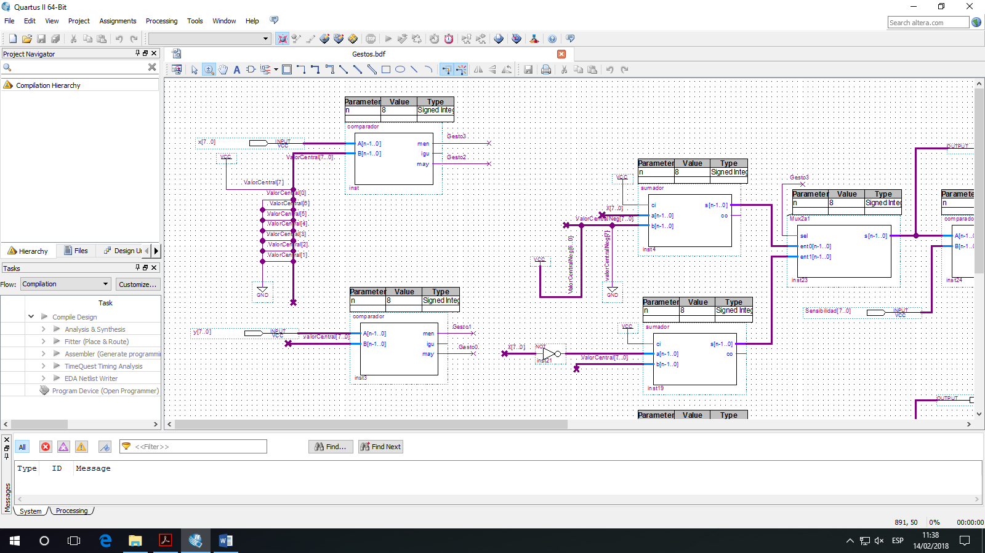

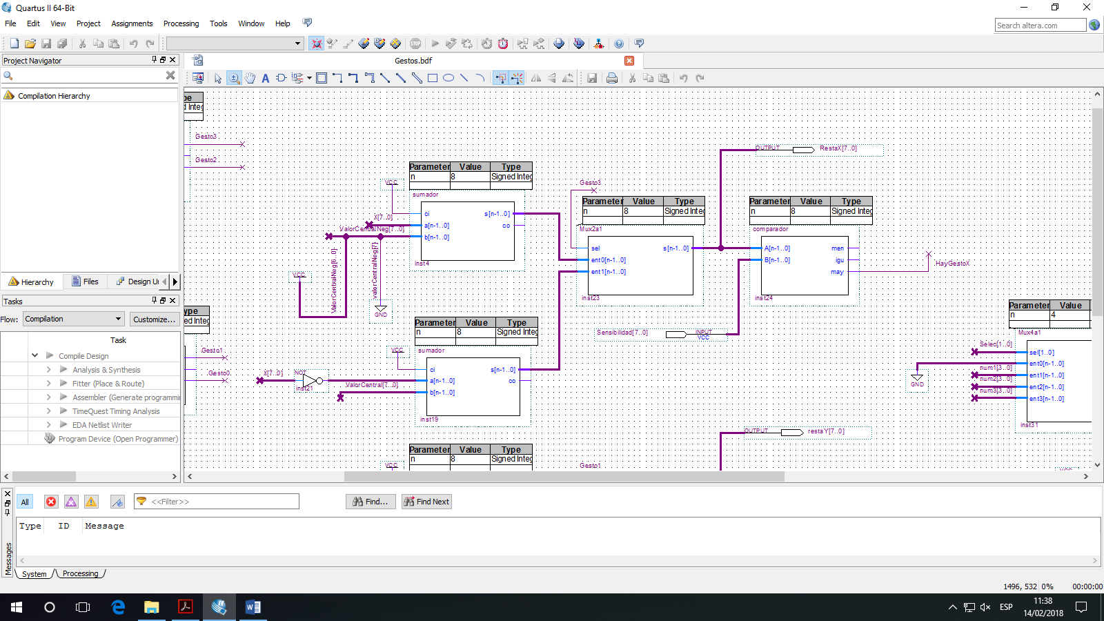

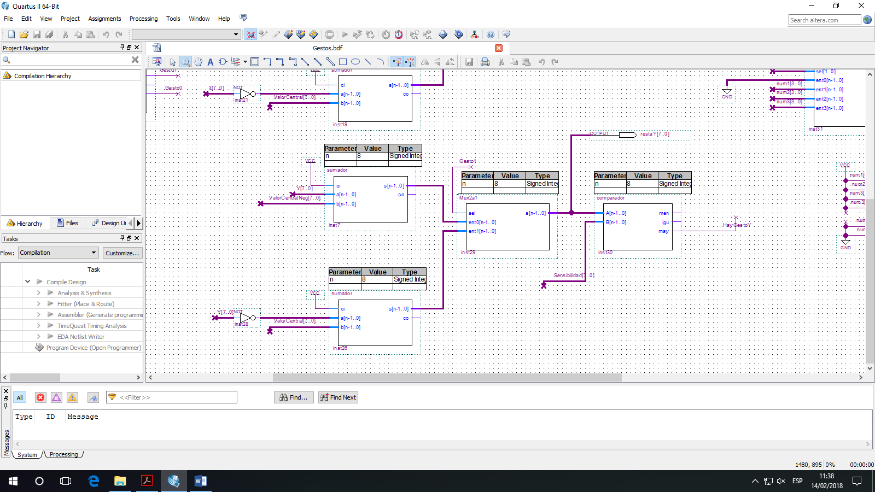

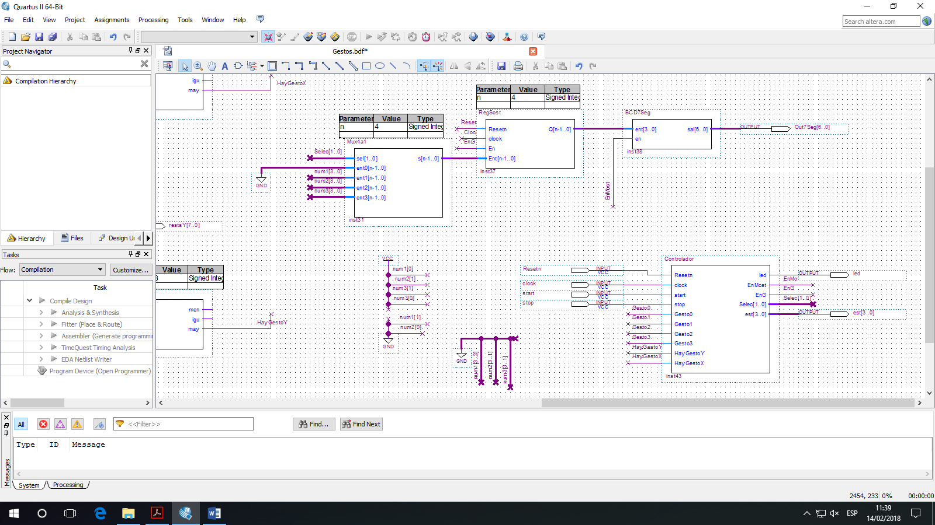

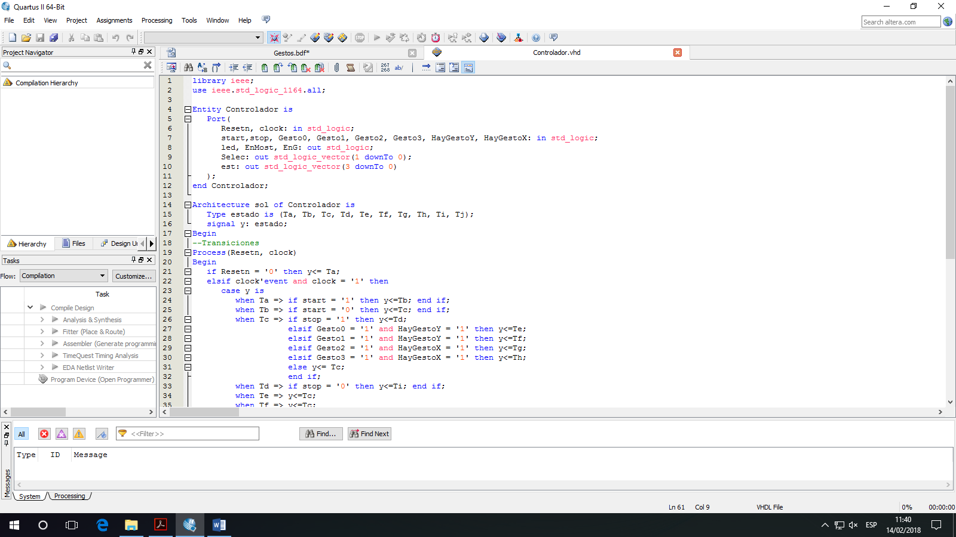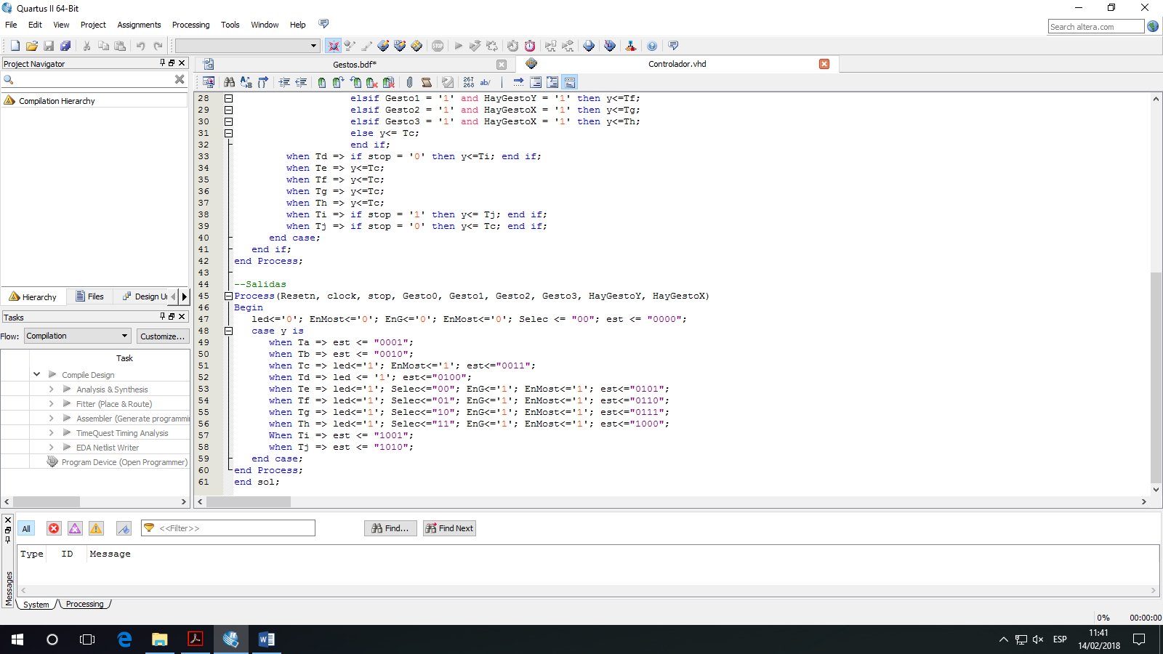

library ieee;

use ieee.std_logic_1164.all;

Entity Controlador is

Port(

Resetn, clock: in std_logic;

start,stop, Gesto0, Gesto1, Gesto2, Gesto3, HayGestoY, HayGestoX: in std_logic;

led, EnMost, EnG: out std_logic;

Selec: out std_logic_vector(1 downTo 0);

est: out std_logic_vector(3 downTo 0)

);

end Controlador;

Architecture sol of Controlador is

Type estado is (Ta, Tb, Tc, Td, Te, Tf, Tg, Th, Ti, Tj);

signal y: estado;

Begin

--Transiciones

Process(Resetn, clock)

Begin

if Resetn = '0' then y<= Ta;

elsif clock'event and clock = '1' then

case y is

when Ta => if start = '1' then y<=Tb; end if;

when Tb => if start = '0' then y<=Tc; end if;

when Tc => if stop = '1' then y<=Td;

elsif Gesto0 = '1' and HayGestoY = '1' then y<=Te;

elsif Gesto1 = '1' and HayGestoY = '1' then y<=Tf;

elsif Gesto2 = '1' and HayGestoX = '1' then y<=Tg;

elsif Gesto3 = '1' and HayGestoX = '1' then y<=Th;

else y<= Tc;

end if;

when Td => if stop = '0' then y<=Ti; end if;

when Te => y<=Tc;

when Tf => y<=Tc;

when Tg => y<=Tc;

when Th => y<=Tc;

when Ti => if stop = '1' then y<= Tj; end if;

when Tj => if stop = '0' then y<= Tc; end if;

end case;

end if;

end Process;

--Salidas

Process(Resetn, clock, stop, Gesto0, Gesto1, Gesto2, Gesto3, HayGestoY, HayGestoX)

Begin

led<='0'; EnMost<='0'; EnG<='0'; EnMost<='0'; Selec <= "00"; est <= "0000";

case y is

when Ta => est <= "0001";

when Tb => est <= "0010";

when Tc => led<='1'; EnMost<='1'; est<="0011";

when Td => led <= '1'; est<="0100";

when Te => led<='1'; Selec<="00"; EnG<='1'; EnMost<='1'; est<="0101";

when Tf => led<='1'; Selec<="01"; EnG<='1'; EnMost<='1'; est<="0110";

when Tg => led<='1'; Selec<="10"; EnG<='1'; EnMost<='1'; est<="0111";

when Th => led<='1'; Selec<="11"; EnG<='1'; EnMost<='1'; est<="1000";

When Ti => est <= "1001";

when Tj => est <= "1010";

end case;

end Process;

end sol;