Trail Bound America Site Plan

Noah Whittacre

WDD 130

Overview

Purpose
The website is designed to help people discover the best backpacking and hiking places around the United States. Visitors can discover different locations and what they offer – their difficulties and the landscape and scenery, and can help them plan their next trip.

Audience
Anyone interested in backpacking and outdoor activities.

Branding

Website Logo
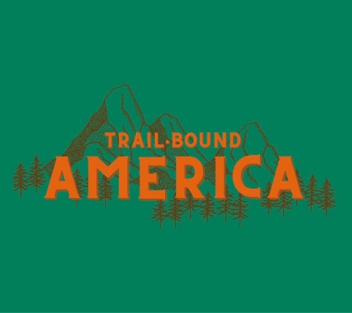

Style Guide

Color Palette
Primary | Secondary | Accent 1 | Accent 2
#007F5C | #2D6A4F | #D6C599 | #E36414

Typography

Heading Font: Montserrat

Paragraph Font: Open Sans

Navigation
Home Explore About

Content

Home Page
A header with the title “Trail Bound America” with the Logo and Nav followed by a hero image and button that links to the Explore page. A short paragraph with a description of the website and a header that says, “Discover the depths of nature.” A featured box with three images showing featured trails and points of interest. A footer at the bottom with contact information and a copyright.
Explore Page
Main content page that shows a list of locations to explore, their locations, and brief descriptions of them.
About Page
A page with a small paragraph introducing myself and another paragraph of what interests me in backpacking and nature. A few pictures of places I’ve been.

Wireframes

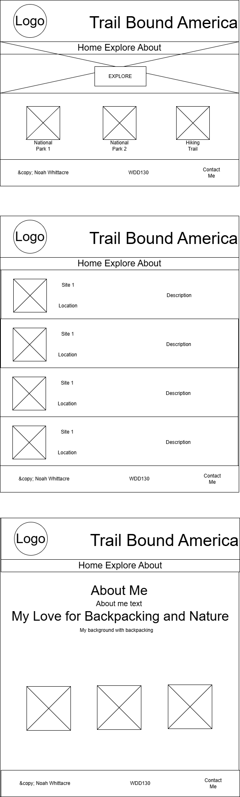
Home

Explore

About

