Name: *Jimmy Gaspard Jean*

Internship Batch: *LISUM04*

Submission date: 2021-10-30

Submitted to: [DataGlacier-internship/lisum04-w4-Flask at master · jimmygjean/DataGlacier-internship (github.com)](https://github.com/jimmygjean/DataGlacier-internship/tree/master/lisum04-w4-Flask)

Deployment on Flask

1. The user is provided with an interface where he/she can upload an image.

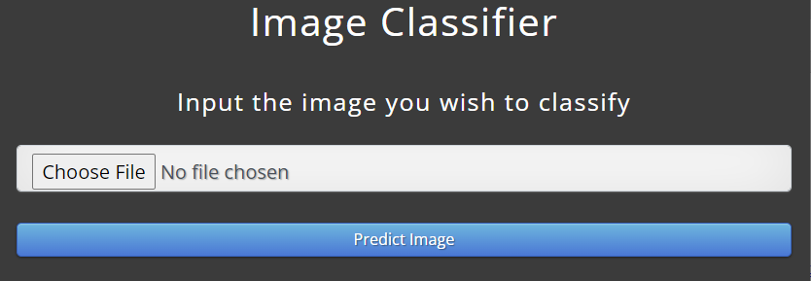

1. The user might for example choose to upload a picture of this car or of this dog:

 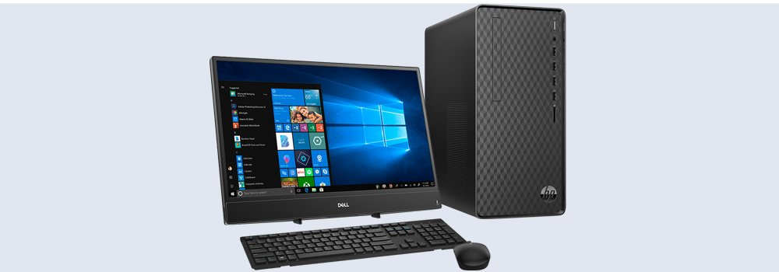

1. After submission, a deep learning model processes the image and makes a prediction of what the image could be (a MobileNet model was used). The result is then displayed to the user.

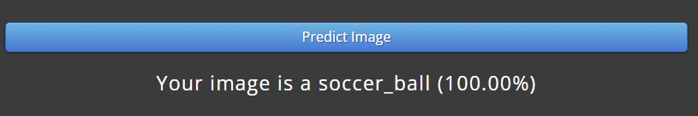 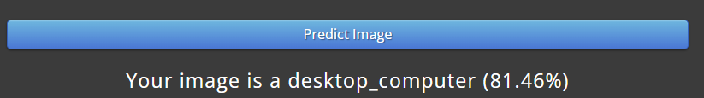

A snapshot of the main code is provided below. The complete code is available on GitHub. Feel free to interact with it.

