Name: Jimmy Goh Han Jie

ID: 23A464A

Model file size and accuracy score comparison report.

**Tensorflow model Epoch result.**

As the 60 per class images are generally having the same features, the training converges quickly. Ie within 5 epochs.

From experimenting, further training of i.e. 10 /20 epochs resulted in model overfitting and high bias toward 1 class even when no images are presented for inference.

This is undesirable in our use case, as our intent is, if the model is not able inference with more than 70% confidence score, the robot should remain going straight.

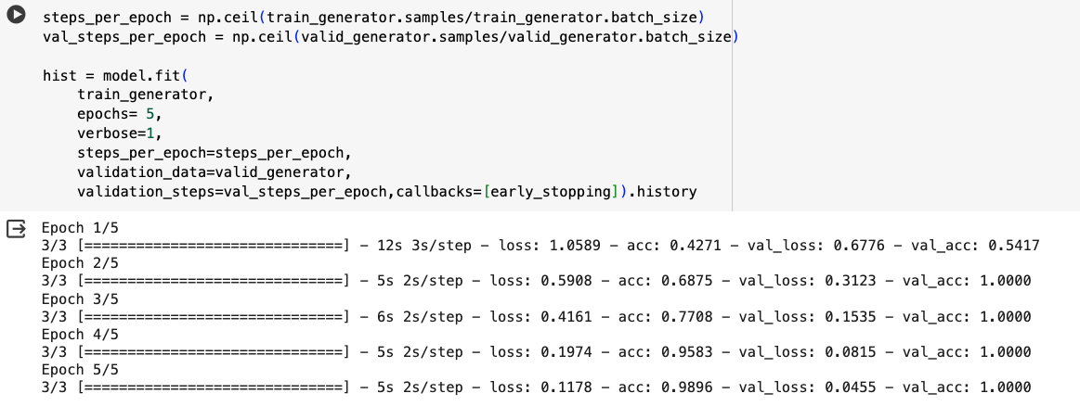

**Tensorflow validation result.**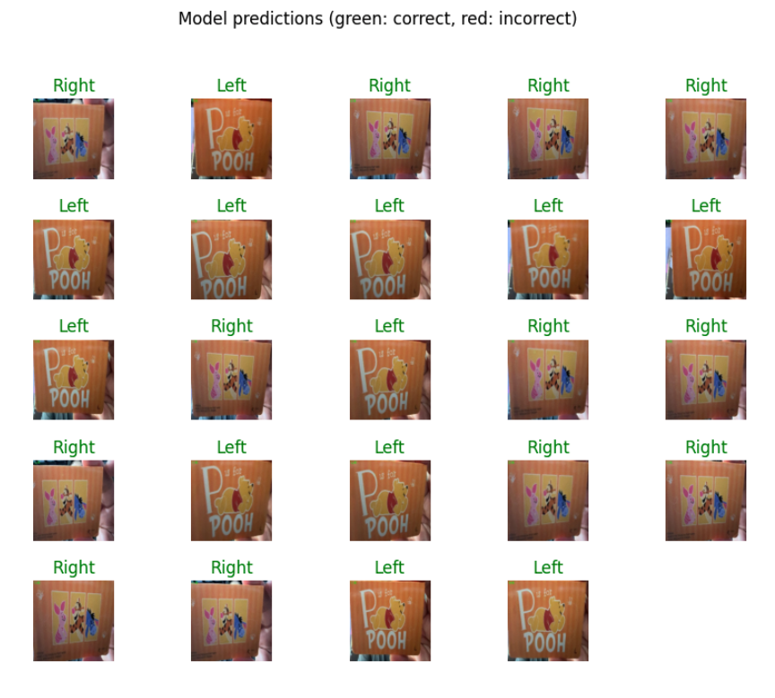

**Model Size and accuracy score.**

2.5M for model_quant.tflite

8.5M for model.tflite

The Quantized model produces a similar accuracy score at a 3 time smaller file size. Hence we will use the Quantized model for our application.

