"pages/login/login",

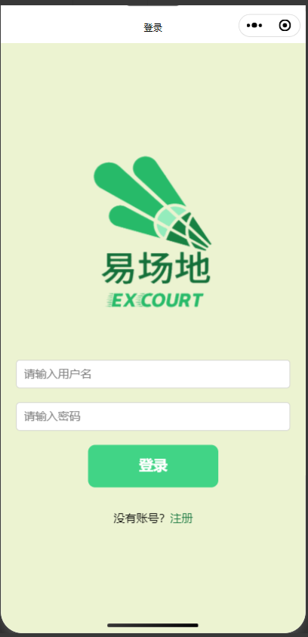

"pages/index/index",

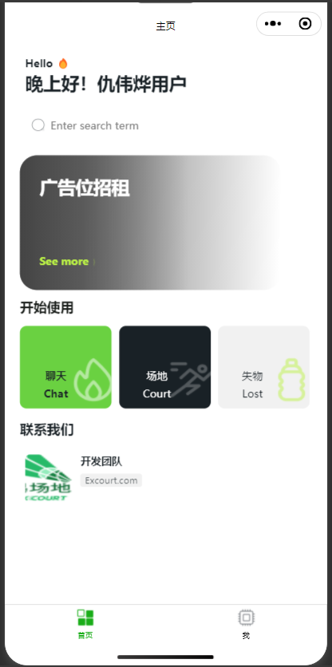

"pages/teamUp/teamUp",

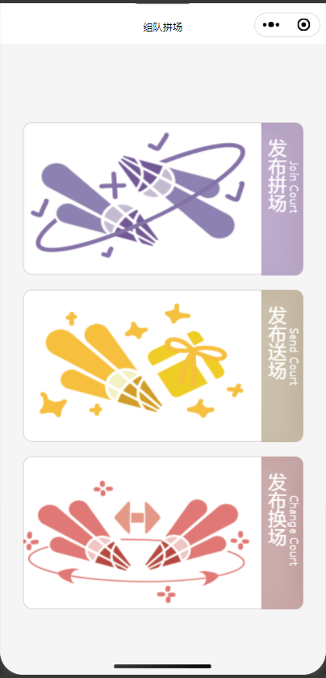

"pages/courtView/courtView",



"pages/exchangeCourt/exchangeCourt",

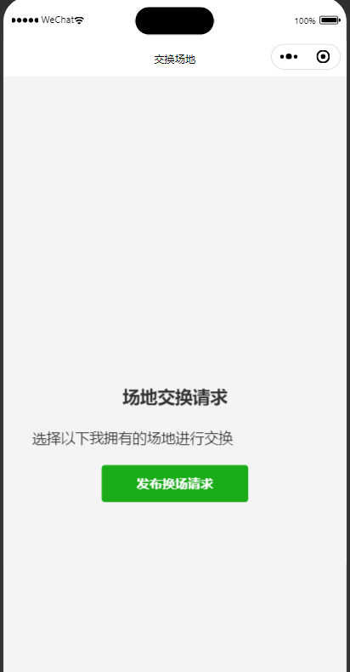

"pages/exchangeRequest/exchangeRequest",

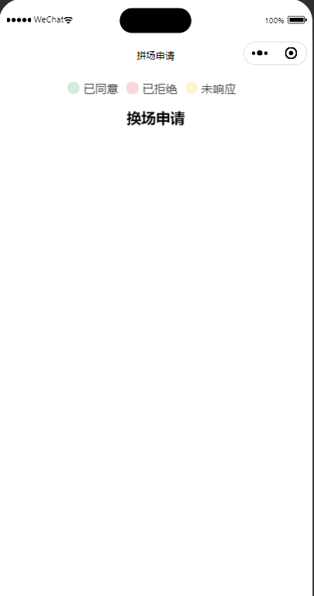

"pages/lostIndex/lostIndex",



"pages/publishCourt/publishCourt",

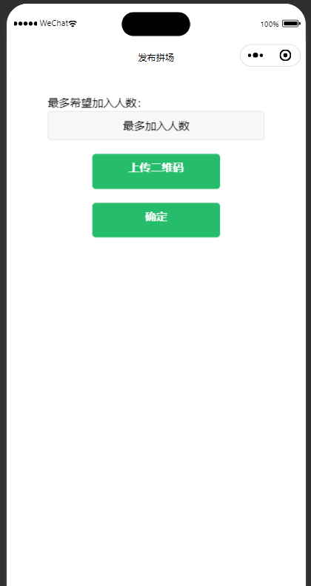

"pages/register/register",

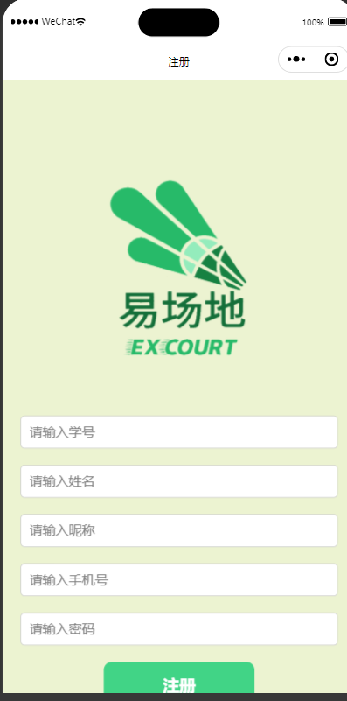

"pages/publishLost/publishLost",

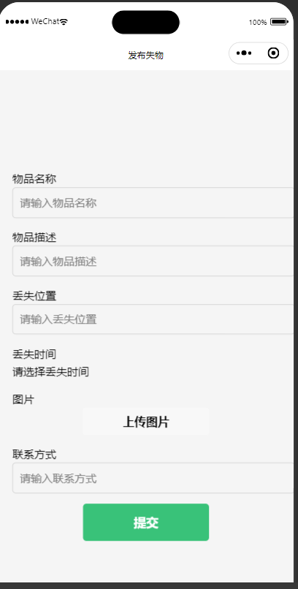

"pages/me/me",

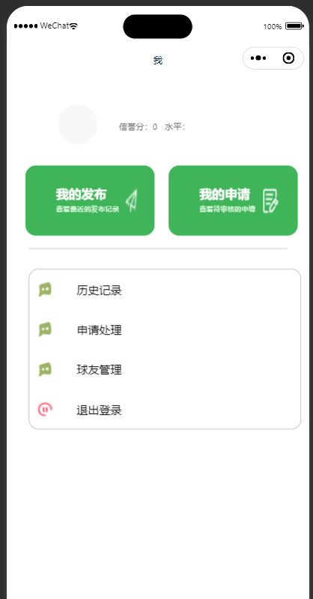

"pages/personalInfo/personalInfo",

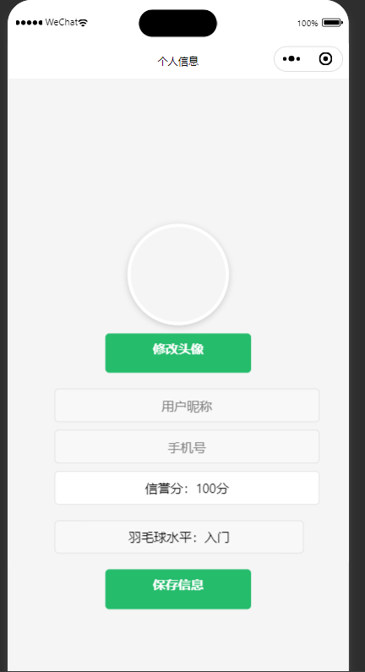

"pages/historyRecord/historyRecord",（假前端）

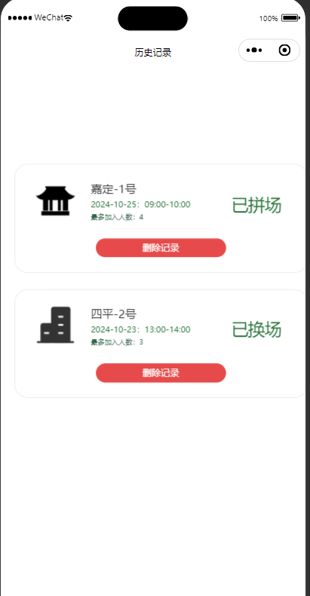

"pages/operationRecord/operationRecord",

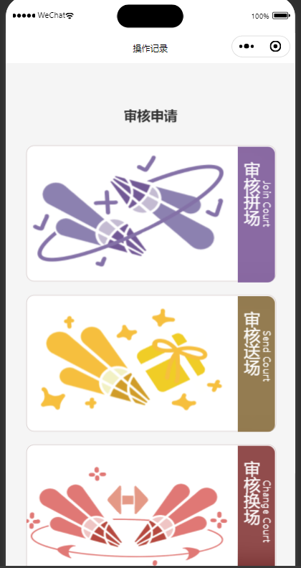

"pages/buddyManagement/buddyManagement",

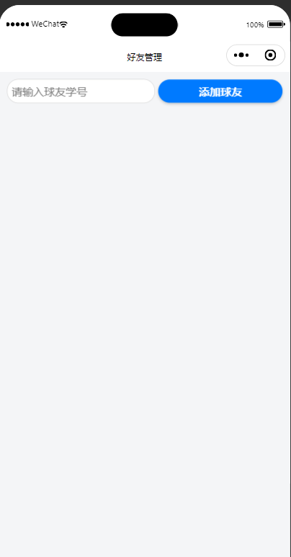

"pages/chating/chating",

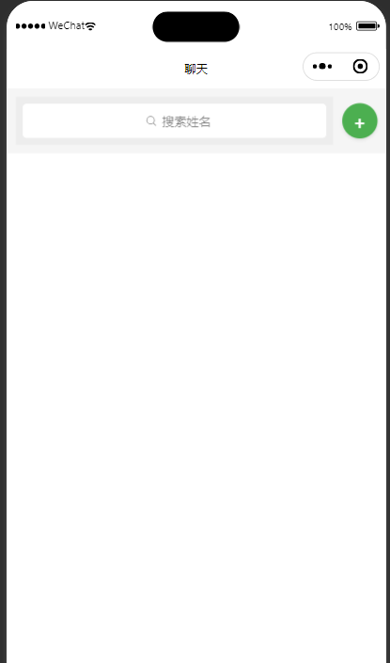

"pages/conversation/conversation",

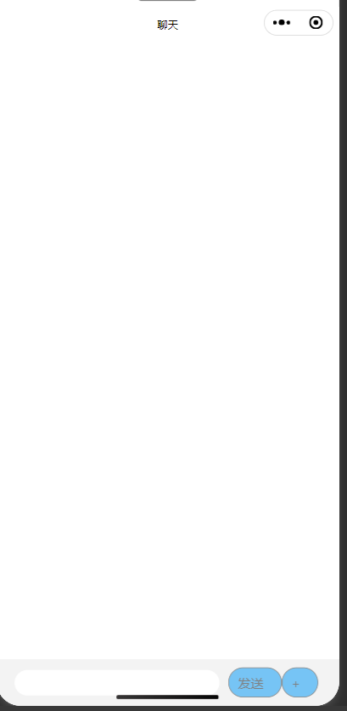

"pages/acceptOffer/acceptOffer",（送场）

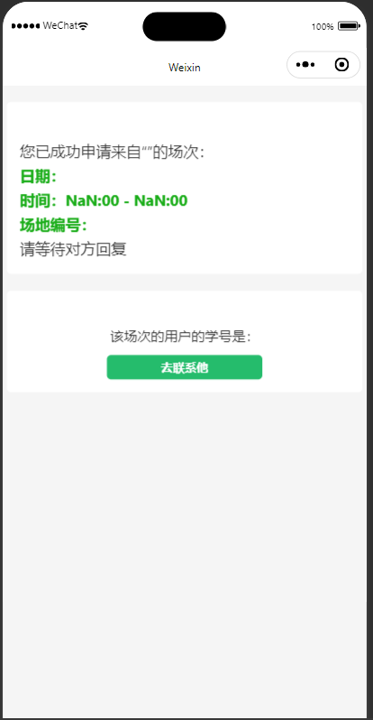

"pages/joinIn/joinIn",（组队拼场）

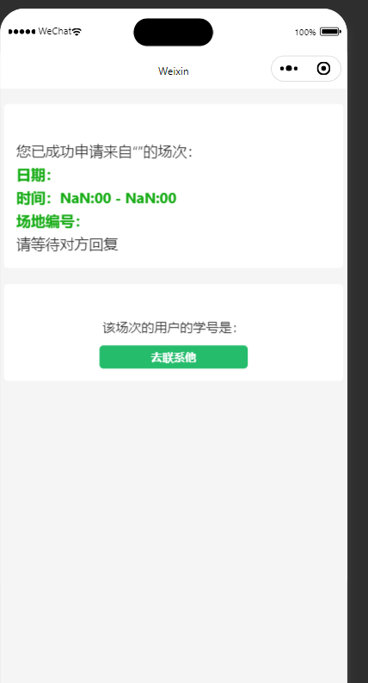

"pages/sendCourt/sendCourt",

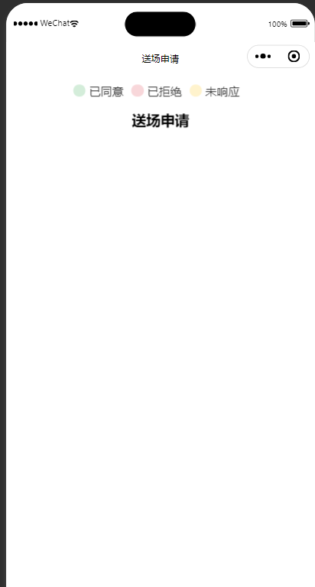

"pages/joinCourt/joinCourt",

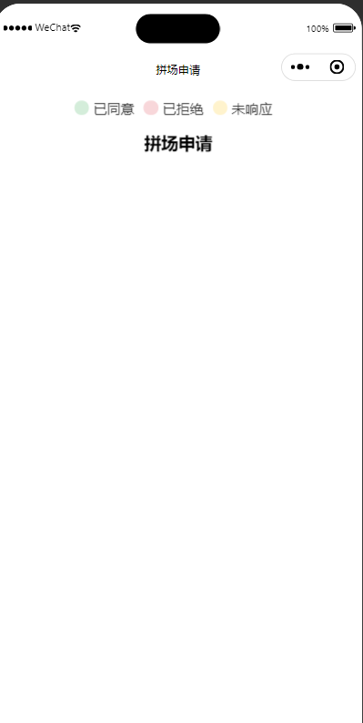

"pages/myPublish/myPublish",



"pages/myClaim/myClaim",



"pages/teamIntro/teamIntro"（团队介绍）

