IFT 542 Practical Assignment
Security Assessment and Hardening of a Student Registration Web Application

Task 1: STRIDE Threat Model and Risk Assessment

1.1 Data-Flow Diagram
The diagram below models the Student Registration Web Application: external entities (Student, Administrator), five processes (P1–P5), five data stores (D1–D5), one external service (SMTP), and the trust boundaries separating the untrusted browser tier, the trusted application tier, the privileged admin sub-boundary, and the trusted data tier.
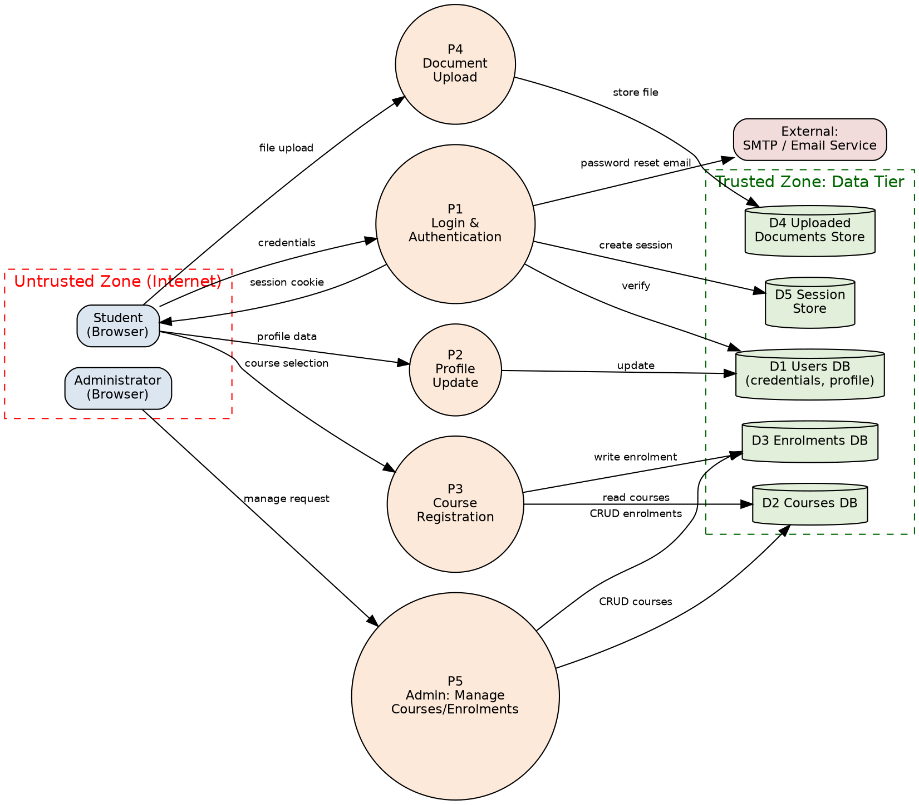
Figure 1. Data-flow diagram with trust boundaries.

1.2 STRIDE Worksheet
# | STRIDE Category | Threat Description | Affected Data Flow / Asset | Attacker Goal
1 | Spoofing | Attacker replays or guesses a weak/predictable session identifier to impersonate an authenticated student and act on their behalf. | Student → P1 Login → D5 Session Store | Impersonate user
2 | Tampering | Attacker modifies the student_id or course_id parameter in the course-registration request to enrol another student or bypass prerequisite checks (parameter/IDOR tampering). | P3 Course Registration → D3 Enrolments DB | Alter academic records
3 | Repudiation | No audit trail links a profile change or document upload to an authenticated identity and timestamp, so a student can deny performing the action. | P2 Profile Update / P4 Document Upload | Deny an action taken
4 | Information Disclosure | Login form concatenates raw input into a SQL string; a UNION-based or error-based injection can dump the users table (emails, password hashes). | P1 Login → D1 Users DB | Exfiltrate credentials/PII
5 | Denial of Service | Document-upload endpoint accepts unlimited file size/count, letting an attacker exhaust disk space and make the service unavailable to others. | P4 Document Upload → D4 Documents Store | Disrupt availability
6 | Elevation of Privilege | Client-side role flag (hidden form field / cookie) is trusted; a student edits it to reach admin-only course-management endpoints. | P5 Admin: Manage Courses/Enrolments | Gain admin rights

1.3 Risk Register
Risk = Likelihood × Impact. Residual risk is recalculated assuming the proposed control is implemented.
Threat | Likelihood (1-5) | Impact (1-5) | Risk Score | Priority | Proposed Control | Residual Risk
SQLi → Information Disclosure (Users DB) | 4 | 5 | 20 | 1 | Parameterized queries / prepared statements; generic error messages; least-privilege DB account | L1 x I3 = 3 (accepted)
Parameter tampering / IDOR (Enrolments) | 4 | 4 | 16 | 2 | Server-side authorization check binding resource to session owner; indirect object references | L1 x I3 = 3 (accepted)
Client-trusted role → Elevation of Privilege | 3 | 5 | 15 | 3 | Re-validate role server-side from session/DB on every admin route; deny-by-default middleware | L1 x I4 = 4 (accepted)
Session spoofing / hijacking | 3 | 4 | 12 | 4 | Regenerate session ID at login; HttpOnly, Secure, SameSite cookies; short idle timeout | L1 x I3 = 3 (accepted)
File-upload Denial of Service | 3 | 3 | 9 | 5 | Per-file and per-user size/type/rate limits; storage quota checks | L1 x I2 = 2 (accepted)
Missing audit log → Repudiation | 3 | 2 | 6 | 6 | Structured who/what/when logging for state-changing actions; log integrity via append-only store | L1 x I2 = 2 (accepted)

1.4 Justification for the Top Three Risks
- SQL Injection → Information Disclosure (Risk 20): the users table holds credentials for every student; an unsanitised login query gives database-wide read access. Likelihood 4 (login forms are the most probed input); impact 5 (full credential dump).
- Parameter Tampering / IDOR on Enrolments (Risk 16): course registration maps directly to academic records; a manipulated identifier lets one student alter another's enrolment at low attacker cost.
- Elevation of Privilege via a client-trusted role flag (Risk 15): grants full administrative control over courses and enrolments, the highest-impact asset, though it requires the attacker to first notice a client-side value to edit.
All three residual risks are accepted after controls are applied (recalculated scores 3, 3 and 4) as further reduction (e.g. formal penetration testing, WAF) is judged disproportionate to project scope.

Task 2: Secure Authentication and SQL Injection Remediation

2.1 Unsafe Query Pattern and Affected Data Flow
The original login prototype built its query by concatenating request input directly into SQL text:
$sql = "SELECT * FROM users WHERE email = '$email' AND password = '$password'";
$result = mysqli_query($conn, $sql);
Because $email and $password become part of the SQL grammar rather than data, an input such as ' OR '1'='1' -- turns the WHERE clause into a tautology that matches every row, allowing authentication bypass; the same class of input with UNION SELECT can read arbitrary columns (e.g. password_hash) from the users table. This affects the data flow Student → P1 Login → D1 Users DB identified in the Task 1 DFD, and is the mechanism behind the Task 1 Information-Disclosure threat.

2.2 Parameterized Query Remediation
File: src/repository.php, function find_user_by_email(); called from public/login.php.
$stmt = $pdo->prepare('SELECT * FROM users WHERE email = :email LIMIT 1');
$stmt->execute([':email' => $email]);
$user = $stmt->fetch();
src/db.php configures PDO with ATTR_EMULATE_PREPARES = false, so the query text is compiled by the MySQL server before the bound value is transmitted; the value is then sent separately and can only ever be interpreted as the literal contents of that one parameter. This is how parameterization separates data from code: no value bound this way can alter the query's structure, regardless of the characters it contains.

2.3 Input Validation and Generic Error Handling
- Email format/length validated with filter_var(FILTER_VALIDATE_EMAIL) before any DB call (src/validate.php).
- Both invalid-format input and a failed password check return the same generic message, “Invalid email or password” — the app never reveals which field was wrong or whether the account exists (public/login.php).

2.4 Password Hashing
$algo = defined('PASSWORD_ARGON2ID') ? PASSWORD_ARGON2ID : PASSWORD_BCRYPT;
$hash = password_hash($password, $algo);
// login: password_verify($password, $user['password_hash']);
Argon2id (bcrypt fallback) is deliberately slow and salts each hash individually, so a leaked users table does not directly expose usable passwords and cannot be brute-forced cheaply offline.

2.5 Additional Authentication Controls
- Account lockout: 5 failed attempts locks the account for 5 minutes (failed_login_count / locked_until columns, record_failed_login()).
- Session-fixation defense: session_regenerate_id(true) is called immediately after successful authentication (regenerate_session_on_login()).
- Session cookies are HttpOnly, SameSite=Lax, and use a non-default cookie name; an idle timeout is enforced server-side in addition to the cookie lifetime (src/auth.php).

2.6 Evidence Summary (Before / After)
Item | Before | After
Query construction | Raw string interpolation of $email/$password into SQL text (public/login.php prototype). | PDO prepared statement with bound named parameters, ATTR_EMULATE_PREPARES=false (src/repository.php, src/db.php).
Password storage | Plaintext column, string comparison. | password_hash() with PASSWORD_ARGON2ID (falls back to bcrypt); password_verify() at login.
Login errors | Would reveal whether the email or the password was wrong. | Single generic message “Invalid email or password” regardless of which check failed.
Brute force | Unlimited attempts. | failed_login_count + locked_until columns; account locks for 5 minutes after 5 failures (record_failed_login()).
Session handling | Default PHP session, no regeneration. | Custom cookie name, HttpOnly/SameSite=Lax, session_regenerate_id(true) on successful login (src/auth.php).

2.7 Test Results
tests/run_tests.php exercises the live repository functions (not mocks) against the seeded database:
== Test 1: valid login works ==
[PASS] seeded user found
[PASS] correct password verifies
== Test 2: invalid credentials are rejected ==
[PASS] wrong password fails verification
[PASS] unknown email returns no user
== Test 3: SQL-injection-shaped input does not change query meaning ==
[PASS] injection-shaped email matches no row (parameterized query)
[PASS] UNION-shaped email matches no row (parameterized query)
== Test 4: stored passwords are not plaintext ==
[PASS] admin user found
[PASS] stored value is not the known plaintext password
[PASS] stored value looks like a bcrypt/argon2id hash
9 passed, 0 failed.
Output shown is the expected result of running `php tests/run_tests.php` against the seeded local database; capture and paste your actual run output here before submission, and include a corresponding SELECT email, password_hash FROM users; screenshot as database evidence (redact nothing beyond the hash itself, which is not secret data on its own).

Task 3: Web Defences, Incident Response and Ethics

3.1 Cross-Site Scripting (XSS)
The profile “full name” field is user-controlled and re-displayed on later page loads — a classic stored-XSS target. Output is now passed through a central encoding helper before being echoed:
function e(string $value): string {
return htmlspecialchars($value, ENT_QUOTES, 'UTF-8');
}
// usage: <strong><?= e($user['full_name']) ?></strong>
A restrictive Content-Security-Policy (script-src 'self', no unsafe-inline) is sent on every response as a second, independent layer, and server-side validation additionally rejects angle brackets in the name field before storage.

3.2 Cross-Site Request Forgery (CSRF)
Course registration and profile update are state-changing POST requests. Each form carries a per-session token that is verified with a constant-time comparison:
function verify_csrf(): void {
if (!hash_equals($_SESSION['csrf_token'] ?? '', $_POST['csrf_token'] ?? '')) {
http_response_code(403); exit('Invalid or missing CSRF token.');
}
}
A third-party page cannot read the token (it never crosses origins), so a forged cross-site submission is rejected with HTTP 403. SameSite=Lax on the session cookie provides a second, browser-enforced layer.

3.3 Server-Side Request Forgery (SSRF)
The course “resource preview” feature fetches an operator-supplied URL. src/safe_fetch.php restricts this to https:// URLs on an explicit hostname allowlist, then independently checks the resolved IP address against loopback, private (RFC1918), link-local and cloud-metadata ranges — defeating a DNS-rebinding bypass of the hostname check — and disables automatic redirect-following so an allowlisted host cannot 302 the request to an internal one.
if (($parts['scheme'] ?? '') !== 'https') throw new SsrfBlockedException(...);
if (!in_array(strtolower($parts['host']), allowlisted_hosts(), true)) throw ...;
foreach (dns_get_record($parts['host'], DNS_A + DNS_AAAA) as $r) {
if (is_blocked_ip($r['ip'] ?? $r['ipv6'])) throw ...;
}
// CURLOPT_FOLLOWLOCATION => false
Tested locally only, against the loopback address and the seeded course resource URLs, per the assignment's authorised-lab restriction.

3.4 Security Misconfiguration
- display_errors is forced off and error_reporting(0) when APP_ENV=production (src/bootstrap.php) — no stack traces or file paths reach the user.
- Database credentials are read from a git-ignored .env file (.env.example ships placeholders only); the app connects as a dedicated student_reg_app account scoped to one schema, not root.
- Every response carries X-Content-Type-Options, X-Frame-Options, Referrer-Policy, Permissions-Policy and the CSP described above (src/security_headers.php).
- Dependency status: the application has zero third-party PHP packages (PDO/cURL/fileinfo are core extensions), so there is no dependency-vulnerability surface for this submission — documented explicitly rather than left unstated.

3.5 Logging
State-changing and security-relevant events are recorded in two places: the audit_log database table (queryable, used by the runbook) and storage/logs/security.log (structured JSON, grep/SIEM-friendly). Both record who/what/when only — no passwords, tokens, or full session identifiers. Example redacted log lines:
{"ts":"2026-08-17T09:12:03+01:00","event":"login_failed","ip":"127.0.0.1","context":{"email":"student1@example.test"}}
{"ts":"2026-08-17T09:14:51+01:00","event":"access_denied","ip":"127.0.0.1","context":[]}
{"ts":"2026-08-17T09:16:10+01:00","event":"ssrf_blocked","ip":"127.0.0.1","context":{"course":"IFT542","reason":"Host 'internal.local' is not on the allowlist."}}

3.6 Incident Response Runbook (Summary)
The full one-page runbook is included as a project appendix (docs/runbook.md) and covers all six NIST-aligned stages: Preparation (version-controlled runbook, local-only DB confirmation), Identification (grep security.log / query audit_log, triage thresholds), Containment (built-in lockout, forced logout, route disablement), Eradication (root-cause checklist mapped to the before/after evidence, credential rotation), Recovery (restore from migrations, verify fix, heightened monitoring), and Lessons Learned (update runbook and add a regression test). A sample fictitious incident record (brute-force detection → automatic lockout → no runbook change needed) is included as a worked example.

3.7 Ethics and Authorised-Testing Statement
A signed ethics statement (docs/ethics_statement.md) confirms all testing was performed on localhost only against fictitious data, that no FUT Minna system or third-party service was scanned or probed, and that no reusable attack payload is included in the submission — consistent with the assignment's authorised-lab restriction.

3.8 Evidence Summary (Before / After)
Vulnerability class | Before | After
XSS (profile name) | $user['full_name'] echoed directly into HTML. | Passed through e() -> htmlspecialchars(ENT_QUOTES); CSP script-src 'self' with no unsafe-inline as a second layer.
CSRF (course registration) | Plain form, no token; cross-site auto-submit would succeed. | Per-session token generated by csrf_token(), checked with hash_equals() in verify_csrf(); SameSite=Lax cookie as defense in depth.
SSRF (resource preview) | curl_init($_GET['url']) with FOLLOWLOCATION on — fetches any host, including 127.0.0.1/169.254.169.254. | safe_fetch_preview(): https-only, hostname allowlist, DNS-resolved IP checked against loopback/private/link-local/metadata, redirects disabled.
Security misconfiguration | display_errors on, root DB account, no security headers. | display_errors forced off in production, dedicated least-privilege DB account, CSP + X-Frame-Options + X-Content-Type-Options + Referrer-Policy + Permissions-Policy on every response.

