CS2003 Practical 1 report
Tutor: Name Surname
Matriculation ID: 2345678901
2021-08-31
Reports for your CS2003 practicals should be written using this structure and submitted in PDF. Refer to each individual practical’s grade descriptors for further details about assessment.

Overview
This section should include a description of the practical:
- what were you asked to do?
- what did you achieve?
- which parts have you completed and to what extent?

Design
This section should include a description of the design of your program and justification of any design decisions. If you have used papers, websites and so forth to help you, please make sure that these are cited appropriately in line with GAP. For instance, if you had used one of the CS2003 textbooks, you would cite it as (Peterson and Davie 2012).

Testing
This section should describe how you tested your program. In CS2003 we will not be using stacscheck, so you must describe how you ensured that your program was complete and worked correctly. Please check individual practical specifications as they may also include specific tests. For all practical reports, you must include a table of tests that looks like the following:
What is being tested | Pre-conditions | Expected Outcome | Actual Outcome
The purpose of this test. | What needs to be set up for the test. | What do you want to see? | What do you actually see?
You may wish to include screenshots to demonstrate the results of testing. Rather than squeeze these into the table, you may choose to put them inline in the main document with a figure number and reference this number in the table and any other discussion. For instance:
What is being tested | Pre-conditions | Expected Outcome | Actual Outcome
Printing “Hello, world!” | The user runs the program with no arguments. | “Hello, world!” output to the terminal. | “Hello, world!” output to the terminal (see Figure 1).
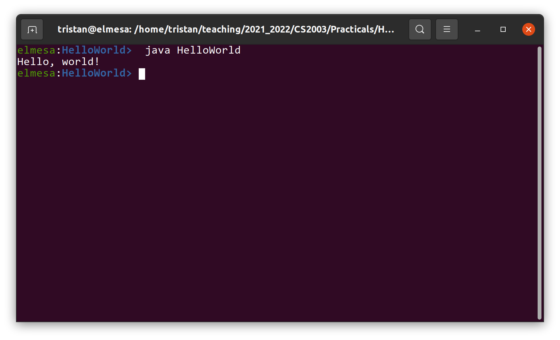
Figure 1: Testing hello world.
When adding screenshots, try to keep the original aspect ratio of the image and make sure the text in the image is readable.

Evaluation
This section should include an evaluation of the success of your submission compared to what you were asked to do.

Conclusion
This section should address:
- what you have achieved
- what you found difficult
- what you would have done if you had more time

Bibliography
Peterson, Larry, and Bruce Davie. 2012. Computer Networks: A Systems Approach. Elsevier. https://github.com/SystemsApproach/book.

