Appendix A-2: Construction Aggregate Samples

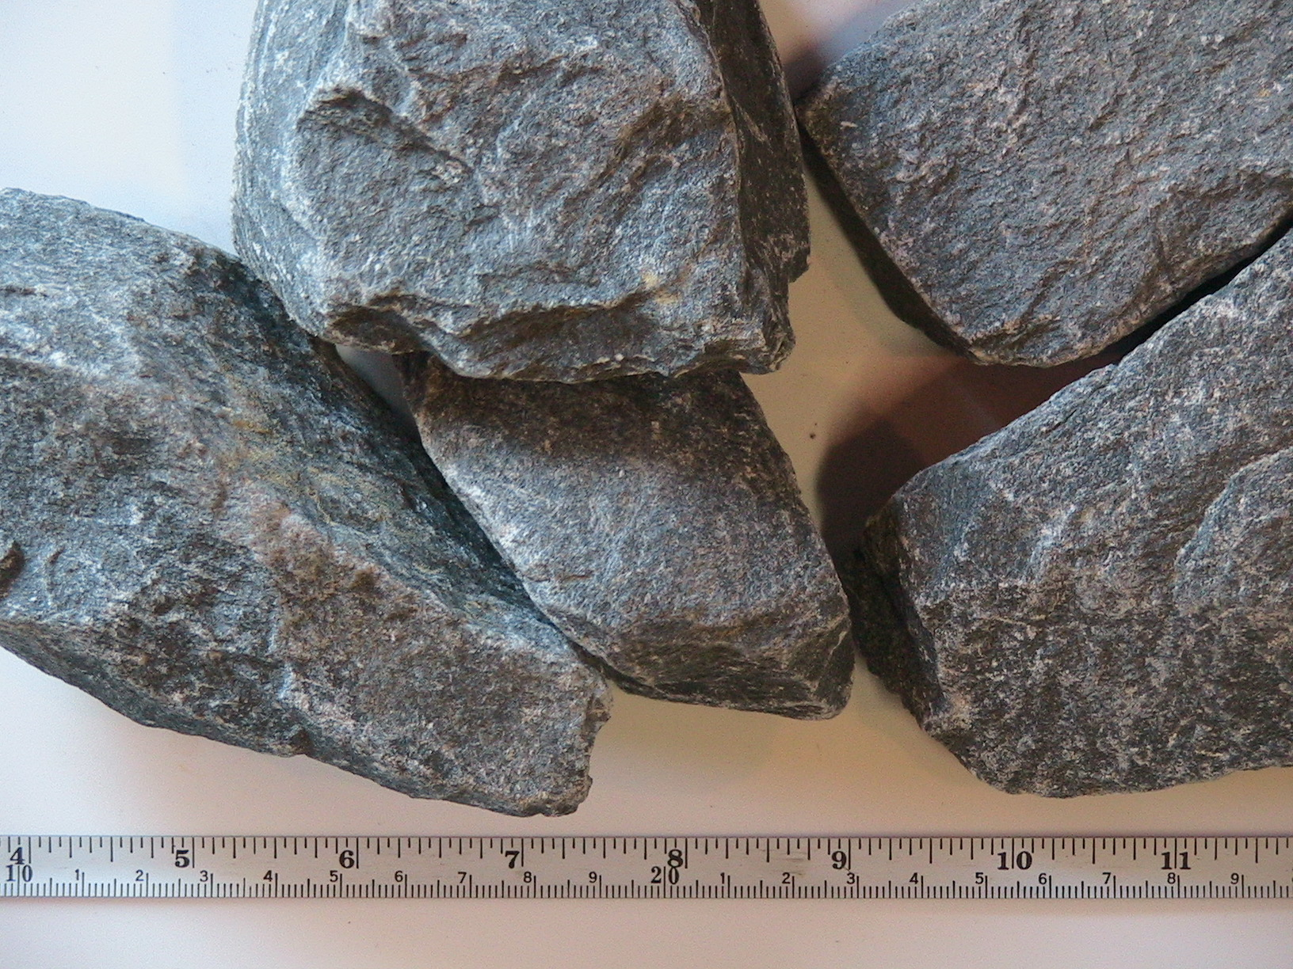
QM5: Quartzite/Metasiltstone 5”
R_{s} (cm) | 4.69
M_{s} (kg) | 5.990
ρ_{s} | 2.42
ρ_{bulk} (kg/m³) | 1.07
I_{v} (liters) | 3.088
V/V_{s} | 0.44
n/kg | 3
k (W/m/K) | 35-29
c (J/kg/K) | 410
α_{bulk} (m²/s) | 28

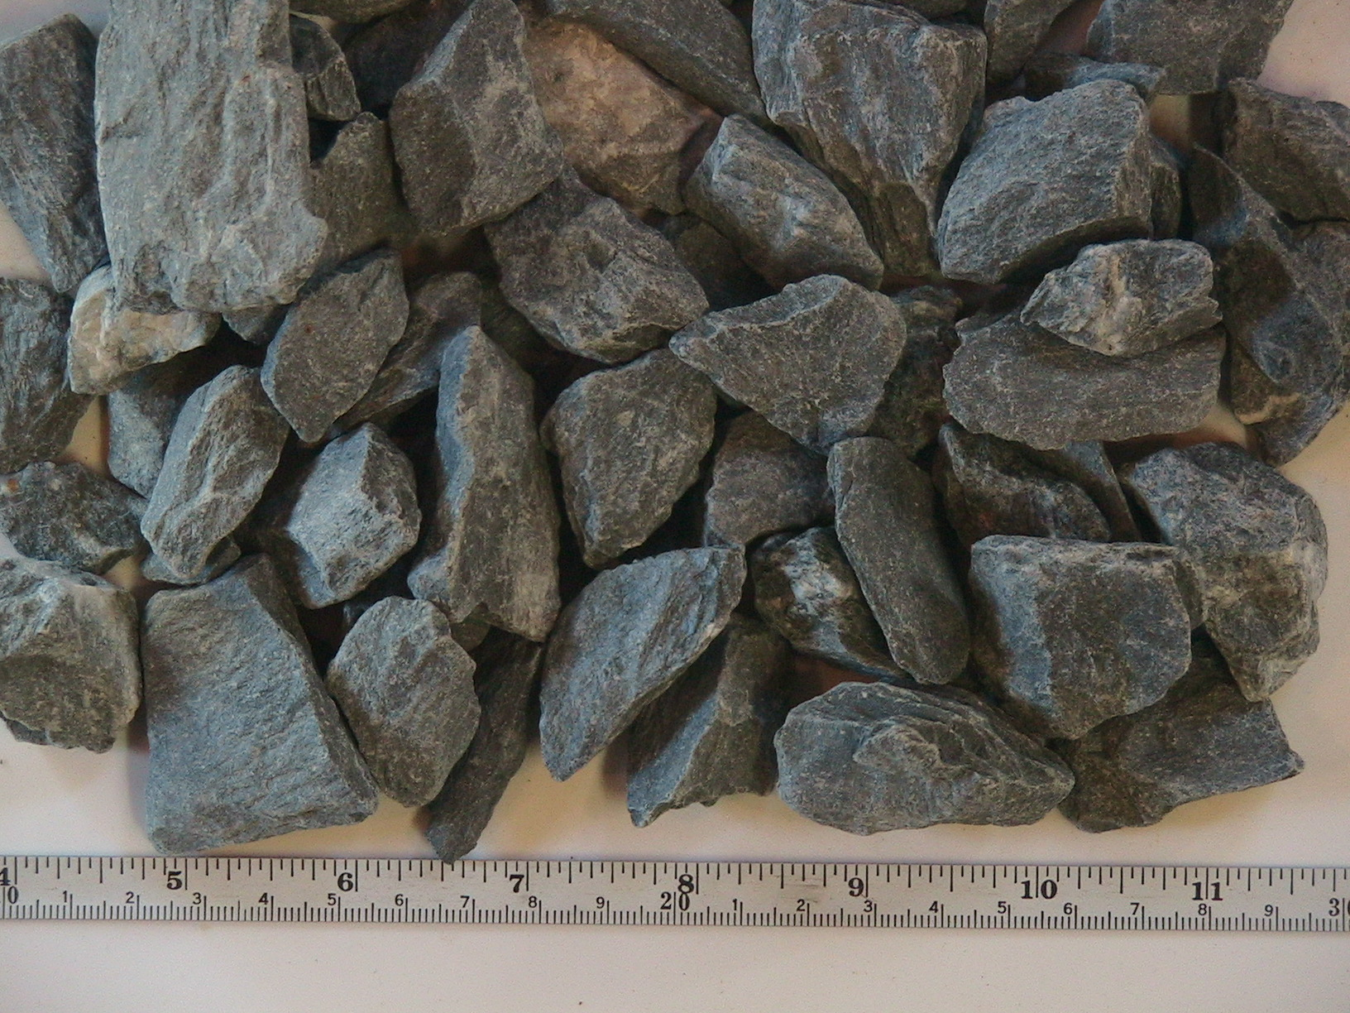
QM1: Quartzite/Metasiltstone 1”
R_{s} (cm) | 1.67
M_{s} (kg) | 5.590
ρ_{s} | 2.02
ρ_{bulk} (kg/m³) | 1.01
I_{v} (liters) | 2.786
V/V_{s} | 0.50
n/kg | 80
k (W/m/K) | 16-12
c (J/kg/K) | 1100
α_{bulk} (m²/s) | 6.1
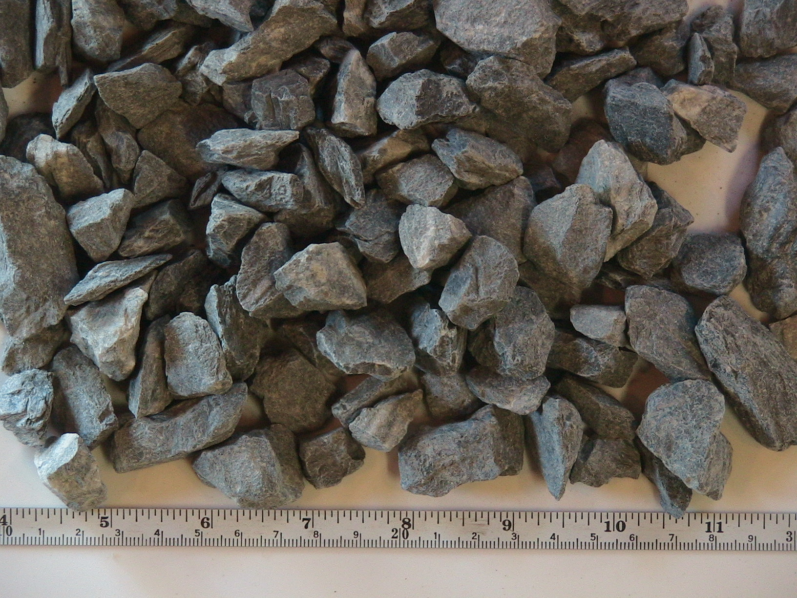
QM.6: Quartzite/Metasiltstone 5/8”
R_{s} (cm) | 1.27
M_{s} (kg) | 5.540
ρ_{s} | 1.87
ρ_{bulk} (kg/m³) | 1.00
I_{v} (liters) | 2.598
V/V_{s} | 0.53
n/kg | 195
k (W/m/K) | 8-9
c (J/kg/K) | 1200
α_{bulk} (m²/s) | 3.9

QM.3: Quartzite/Metasiltstone 3/8”
R_{s} (cm) | 0.72
M_{s} (kg) | 5.640
ρ_{s} | 1.77
ρ_{bulk} (kg/m³) | 1.02
I_{v} (liters) | 2.367
V/V_{s} | 0.57
n/kg | 1123
k (W/m/K) | 2-6
c (J/kg/K) | 930
α_{bulk} (m²/s) | 2.2

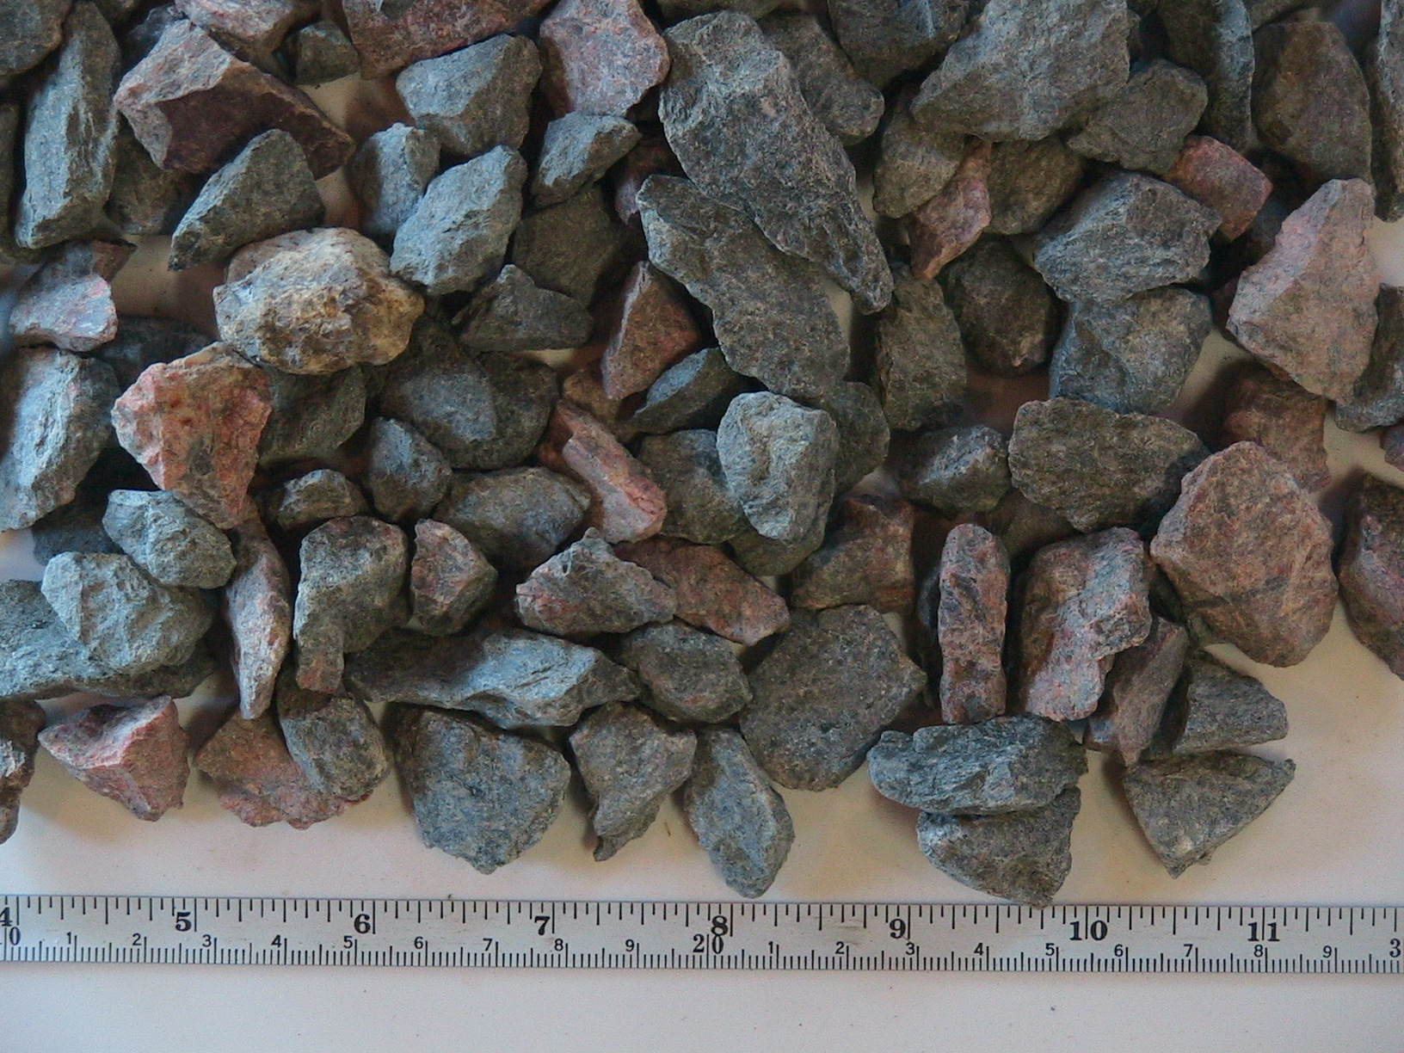
FQ.5: Felsic Quartzite 0.5”
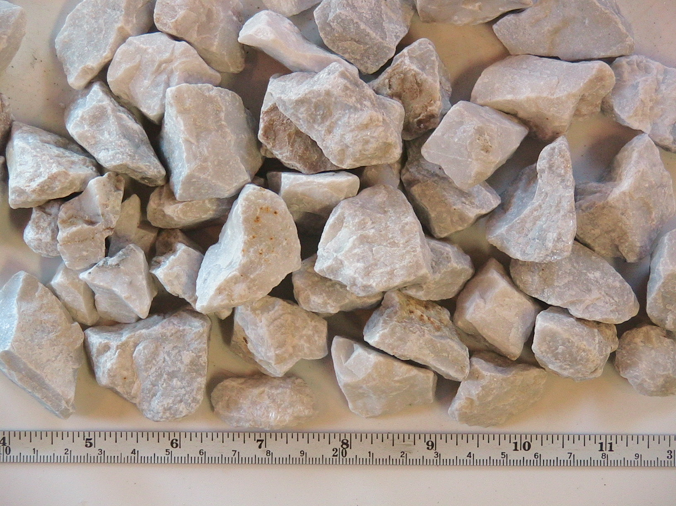  R_{s} (cm) | 1.26
M_{s} (kg) | 5.690
ρ_{s} | 1.93
ρ_{bulk} (kg/m³) | 1.02
I_{v} (liters) | 2.608
V/V_{s} | 0.53
n/kg | 196
k (W/m/K) | 8
c (J/kg/K) | 1000
α_{bulk} (m²/s) | 4.2

M1: Crushed Marble 1”
R_{s} (cm) | 1.98
M_{s} (kg) | 5.940
ρ_{s} | 2.06
ρ_{bulk} (kg/m³) | 1.07
I_{v} (liters) | 2.675
V/V_{s} | 0.52
n/kg | 47
k (W/m/K) | 16-19
c (J/kg/K) | 940
α_{bulk} (m²/s) | 8.0

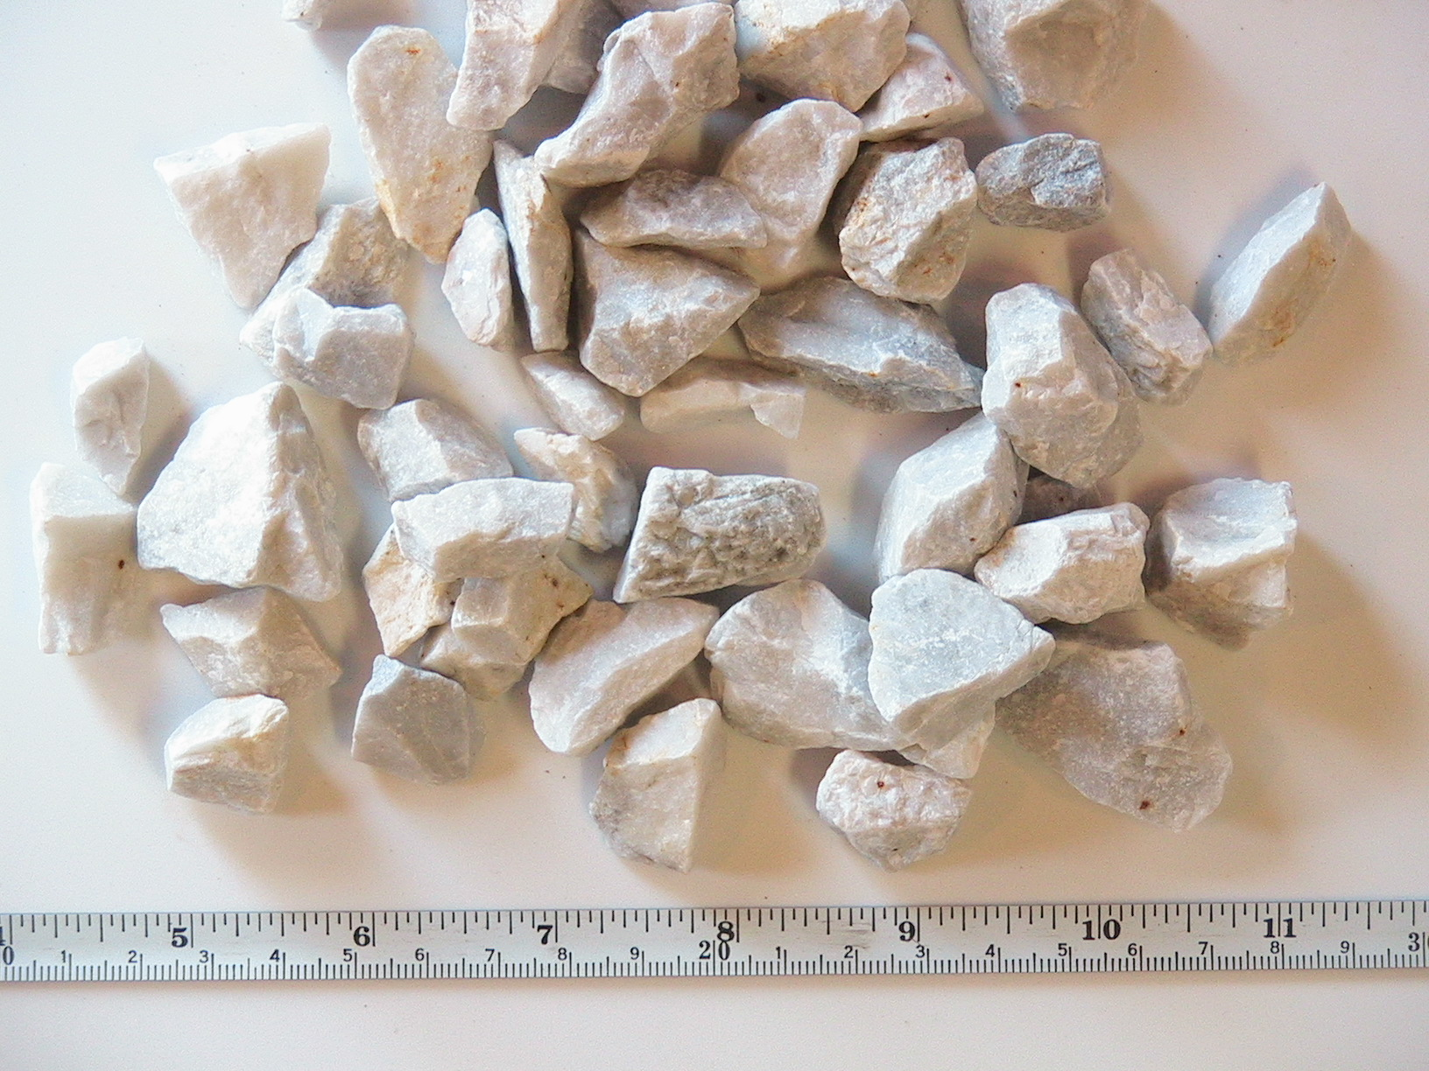
M0.8: Crushed Marble 0.75”
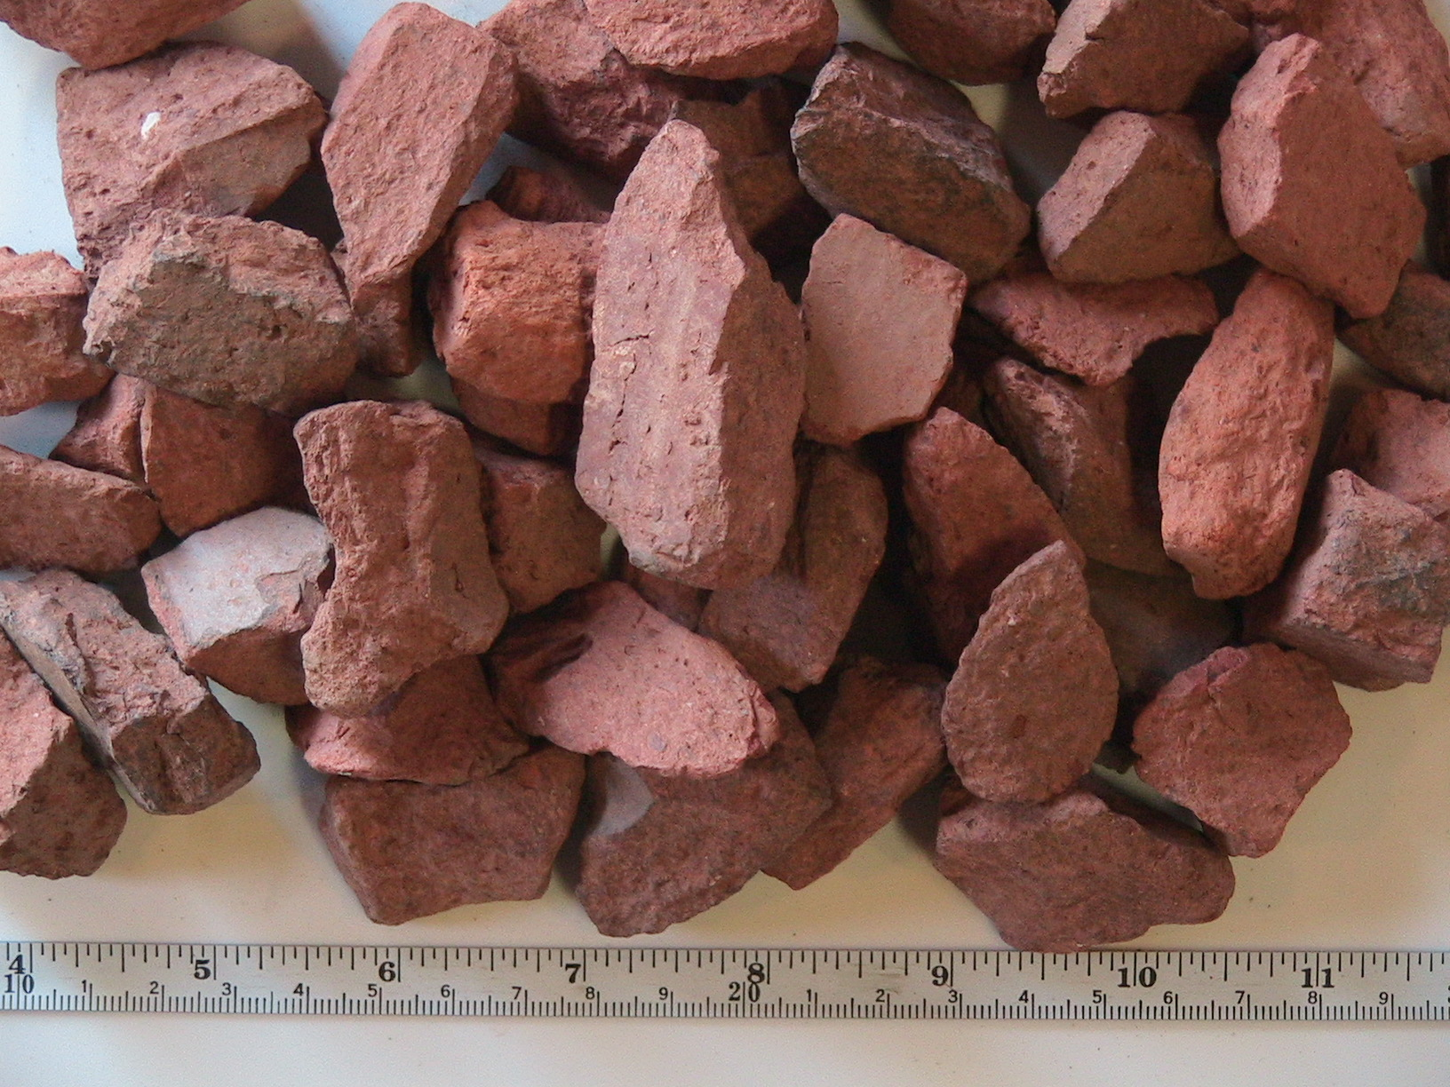  R_{s} (cm) | 1.24
M_{s} (kg) | 6.250
ρ_{s} | 2.12
ρ_{bulk} (kg/m³) | 1.13
I_{v} (liters) | 2.608
V/V_{s} | 0.53
n/kg | 184
k (W/m/K) | 36-29
c (J/kg/K) | 940
α_{bulk} (m²/s) | 16

B1: Crushed Brick 1”
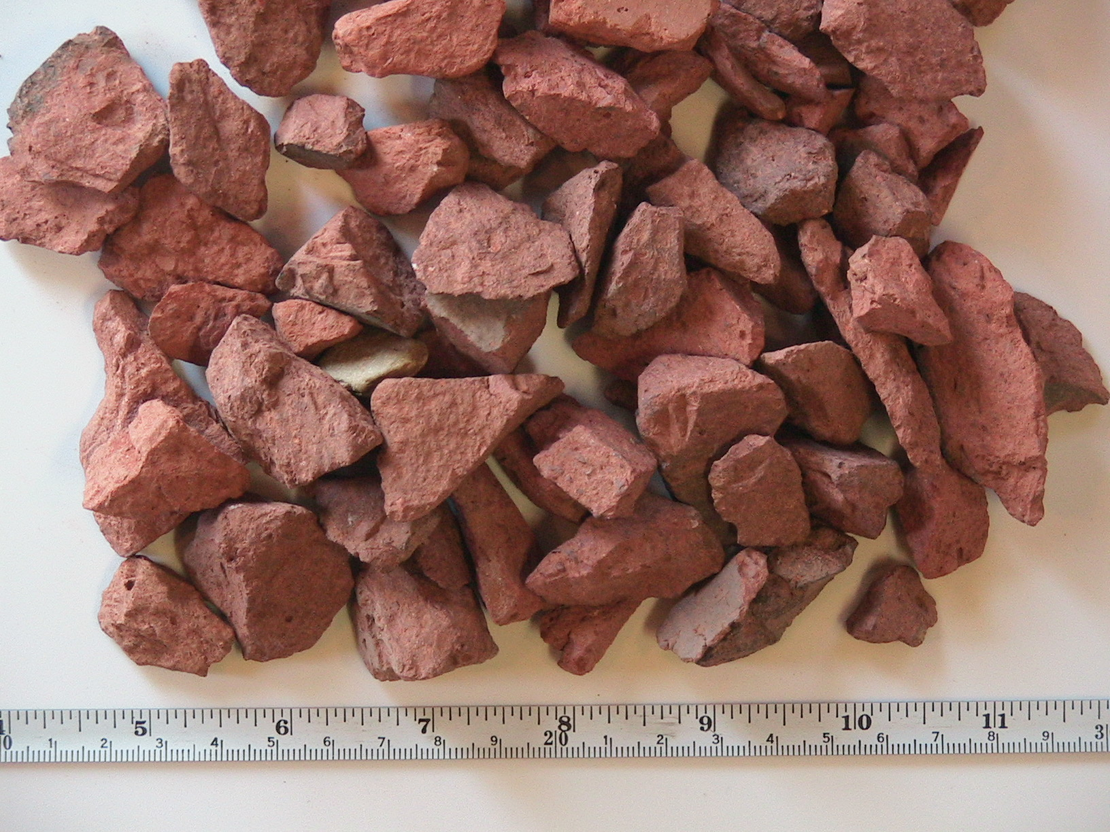  R_{s} (cm) | 1.81
M_{s} (kg) | 4.440
ρ_{s} | 2.22
ρ_{bulk} (kg/m³) | 0.80
I_{v} (liters) | 3.556
V/V_{s} | 0.36
n/kg | 57
k (W/m/K) | 19-17
c (J/kg/K) | 1200
α_{bulk} (m²/s) | 6.7

B0.8: Crushed Brick 3/4”
R_{s} (cm) | 1.12
M_{s} (kg) | 4.445
ρ_{s} | 2.14
ρ_{bulk} (kg/m³) | 0.80
I_{v} (liters) | 3.480
V/V_{s} | 0.37
n/kg | 258
k (W/m/K) | 6
c (J/kg/K) | 1500
α_{bulk} (m²/s) | 2.5

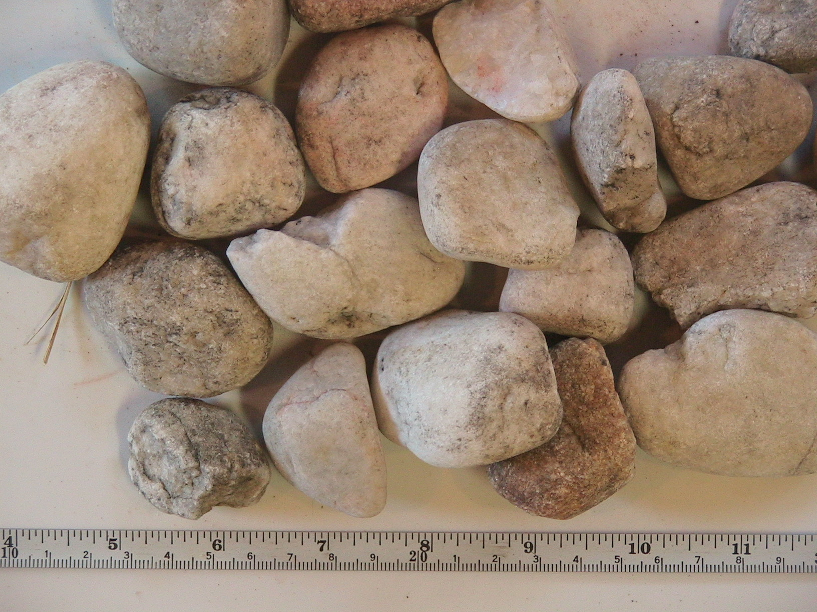
C1: Granite Stream Cobble 1.5”
R_{s} (cm) | 2.62
M_{s} (kg) | 6.245
ρ_{s} | 2.08
ρ_{bulk} (kg/m³) | 1.12
I_{v} (liters) | 2.556
V/V_{s} | 0.54
n/kg | 20
k (W/m/K) | 28-26
c (J/kg/K) | 870
α_{bulk} (m²/s) | 13

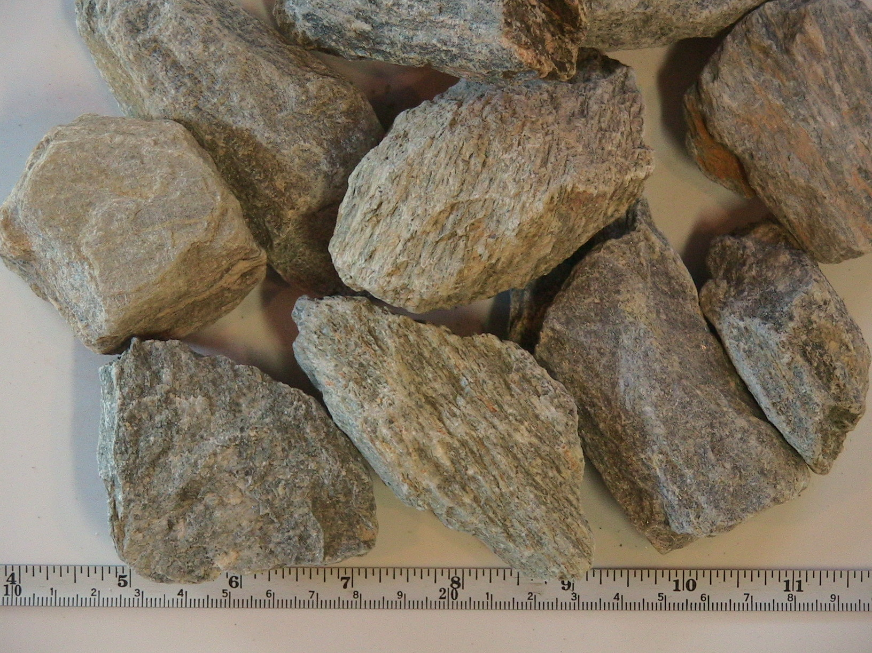

S2: Siltstone 3”
R_{s} (cm) | 3.77
M_{s} (kg) | 4.690
ρ_{s} | 1.98
ρ_{bulk} (kg/m³) | 0.844
I_{v} (liters) | 3.191
V/V_{s} | 0.43
n/kg | 7
k (W/m/K) | 47-57
c (J/kg/K) | 920
α_{bulk} (m²/s) | 26

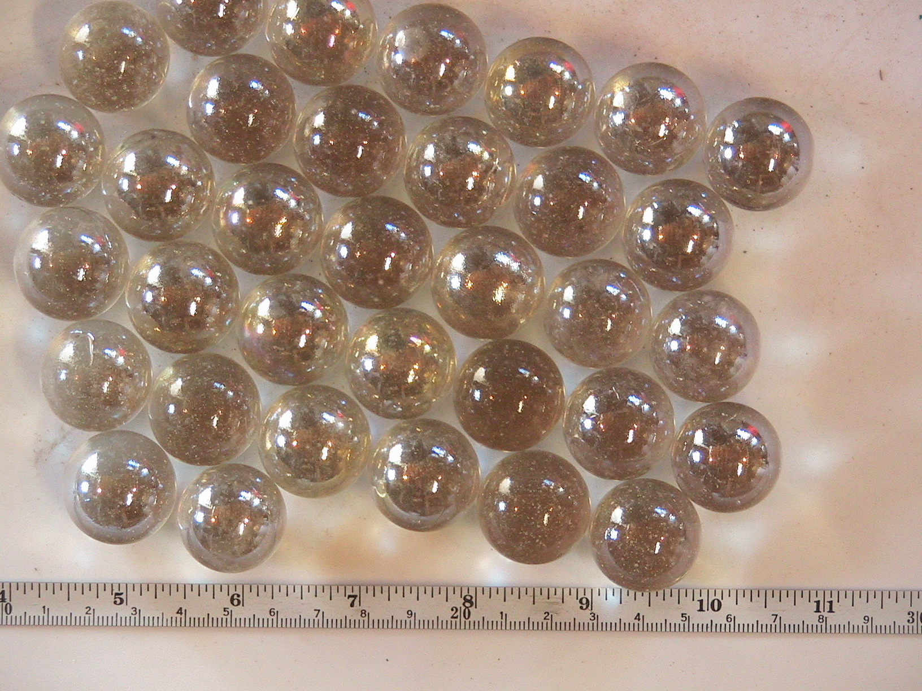
GB1: Glass Marbles 1”
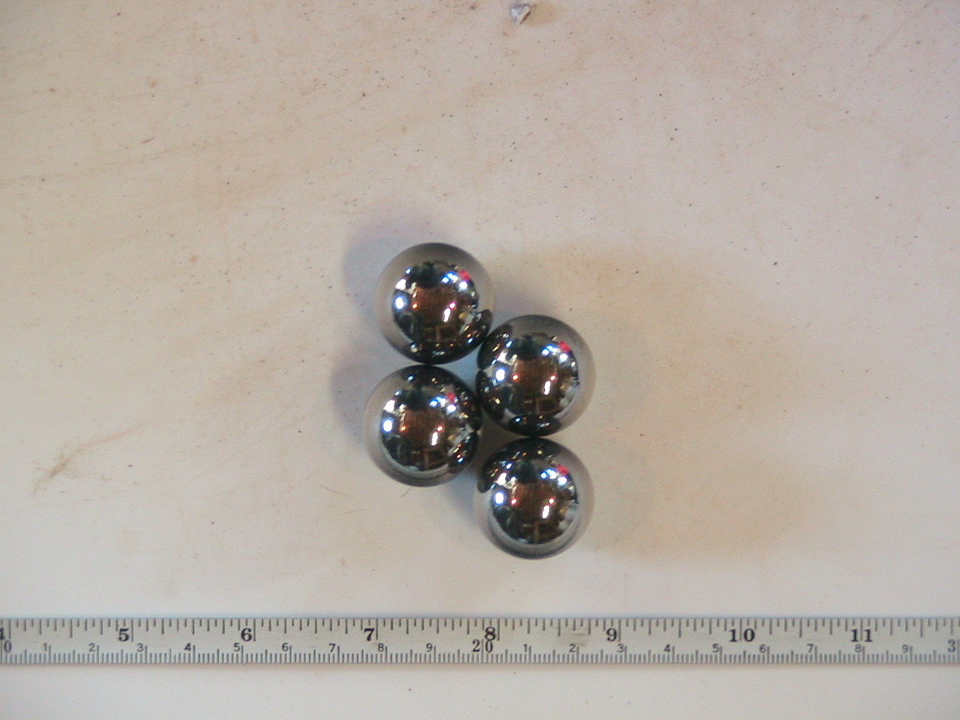  R_{s} (cm) | 1.77
M_{s} (kg) | 5.845
ρ_{s} | 2.58
ρ_{bulk} (kg/m³) | 1.05
I_{v} (liters) | 3.290
V/V_{s} | 0.41
n/kg | 52
k (W/m/K) | 15
c (J/kg/K) | 110
α_{bulk} (m²/s) | 5.1

SB1: 1018 Alloy Mild Steel Balls 1”
R_{s} (cm) | 1.75
M_{s} (kg) | 20.660
ρ_{s} | 8.81
ρ_{bulk} (kg/m³) | 3.72
I_{v} (liters) | 3.210
V/V_{s} | 0.42
n/kg | 15
k (W/m/K) | 35-26
c (J/kg/K) | 53.4
α_{bulk} (m²/s) | 6.2

