Fork-Join Pattern

1. Fork is called by a parent thread to create a new child thread of concurrency which allows the parent continues computation after the fork operation and lets the child begin operation separate from the parent; and hence creates concurrency.

Join is a call by both the parent and the child, the children join after it finishes computation and parent waits for all children to joins before continuing computation; and hence remove concurrency when children exit.

1. Flood Fill

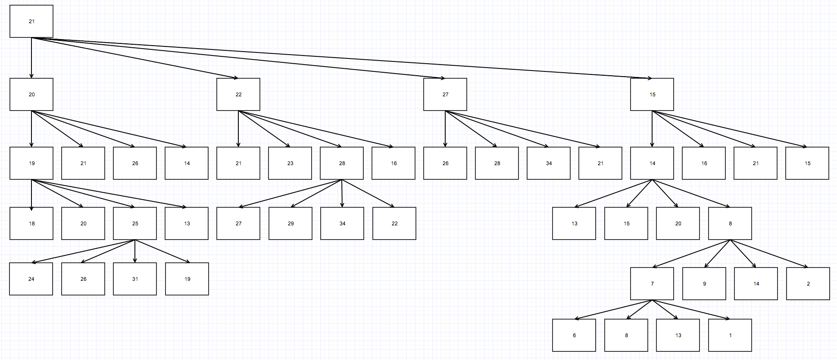

* 1. The level of concurrency is related to the size of the problem. It can achieve 4 ^ (log4N - 1) – way parallelism because each fork create 4 new children.
  2. Yes, since there can be different threads accessing the same cell and they might try to change the color of the cell at the same time. For instance, FloodFill(27) and FloodFill(22) would call FloodFill(28) and there is no guarantee which thread might be modifying the 28 cell first

1. Parallel slack is the amount of extra parallelism available above the minimum necessary to use the parallel hardware resources. When we use fork-join, it is a good to over-decompose a problem that in turns creates parallel slack for more flexible load balancing such as work stealing.

Pipelline Pattern

1. Since the number of tasks limits the parallelism with serial tasks,

|  |  |
| --- | --- |
| 4 itmes | Macintosh HD:Users:liam:Desktop:Screen Shot 2014-05-13 at 12.03.29 AM.png |
| 5 items | Macintosh HD:Users:liam:Desktop:Screen Shot 2014-05-13 at 12.05.33 AM.png |

When the number of data item exceeds the number of processors (P), the processor(1) can start the I(any integer) * P + 1 th task when the P th processor finish the prerequisites for the I*P + 1 th task.

|  |  |  |
| --- | --- | --- |
|  | Benefits | Negatives |
| Stage-bound | Simple | Workers have to wait for the waiting items from the previous stage to finish before performing work to the item (wasted clock cycles);  No data locality for each item |
| Item-bound | Better data locality for items (than stage-bound); | Workers can get stuck waiting at serial stages |
| Hybrid | Retains good data locality without blocking at serial stages |  |