Thank you very much for buying Fantasy Mushroom Flower from Experience Lab Art on
Unity!

Fantasy_Plant_DoubleSided shader Details:
Shader made using Amplify Shader Editor.
5 material texture slots for Albedo, Specular, Normal, Ambient Occlusion, and Emission.
Albedo and Emission color can be adjusted in the color boxes below their texture slots.
There is also a slider for adjusting Smoothness values.
Image Example:
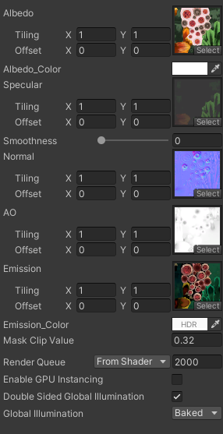
Have fun adjusting!

