CONSOLE-BASED GRADE MONITORING SYSTEM

---------------------------------------------------------------------

Introduction To Computing Project
Presented to the
Faculty of the College of Information Technology
Cagayan de Oro College
Cagayan de Oro City

-------------------------------------------------------------------------------

In Partial Fulfillment
of the Requirements for the Degree
Bachelor of Science in Information Technology

-------------------------------------------------------------------------------

NAME OF RESEARCHER

BACARRISAS, IVAN CRISTER T.
DIGAL, GYM JANE G.
GABIN, WINDELL C.
JAYME, CHRISTIAN REEVE T.
LUMANTAS, SEBASTIAN O.
MAGDUGO, JIMMY B.

OCTOBER 7, 2026

  - Introduction

1.1 Introduction
Technology has become an important part of education, especially in managing student records and academic performance. Instead of relying only on paper records and manual calculations, schools can use digital systems to organize academic information and make it easier to monitor students’ progress. Digital technology can support education system management through the use of assessment data and other educational information (UNESCO, 2023). Similarly, Domingo, Lardizabal, and Toledo (2021) developed an academic performance monitoring system for Senior High School students, showing how computerized systems can help organize and monitor student grades. Krongpol, Vlademir, and Miguel (2024) also presented a periodical performance monitoring system that focuses on recording and monitoring students’ academic performance. These studies show the importance of using organized digital systems to support academic monitoring.

For this project, the setting is based on the academic environment of PHINMA Cagayan de Oro College, where students need to keep track of their grades and academic performance throughout the school year. Teachers also need an organized way to manage student records, subjects, and grades across different periods. Without a computerized system, three main problems may occur: difficulty in organizing student and subject records, repetitive manual calculation of period and final grades, and difficulty in monitoring students’ overall academic performance and Dean’s List status. These problems can make grade monitoring more time-consuming for teachers and make it more difficult for students to keep track of their academic standing. For students at PHINMA Cagayan de Oro College, having organized and accessible grade information can help them better understand their academic progress and know whether they are meeting the requirements for academic recognition.

The proposed Console-Based Grade Monitoring System aims to make grade monitoring more organized and convenient for students and teachers at PHINMA Cagayan de Oro College through a simple Python console-based application. Teachers can add and remove student records, manage subjects, input P1, P2, and P3 grades, view students’ grades, and check Dean’s List qualifiers. Students can log in using their Student ID to view their grades and check their Dean’s List status. The system also automatically calculates period grades, determines the final percentage from the three periods, converts the result into the corresponding college grade, and provides a grade description. These features directly address the difficulty of organizing student and subject records, the repetitive process of manually calculating grades, and the difficulty of monitoring students’ overall academic performance and Dean’s List status. By replacing a less organized manual process with a computerized system, the project can help teachers manage academic records more efficiently while allowing students to have an easier way to monitor their academic progress and standing.

1.2 Statement of the Problem

General Problem
The lack of an organized grade monitoring system can cause problems in managing student and subject records, calculating grades, and checking students’ academic performance and Dean’s List status. These problems can make grade management more difficult and time-consuming for teachers and can make it harder for students at PHINMA Cagayan de Oro College to keep track of their grades and academic standing.

Specific Problems

Difficulty in Organizing Student and Subject Records

The lack of an organized way to manage student and subject records can make academic information difficult to arrange and find. Teachers may spend more time managing student information and subject records, which can make the grade monitoring process less organized.
- Repetitive Manual Calculation of Period and Final Grades
Manually calculating grades for each period and the final grade requires repeated calculations for every student and subject. This can take a lot of time, especially when handling grades for P1, P2, and P3.
- Difficulty in Monitoring Academic Performance and Dean’s List Status
Without an organized grade monitoring system, it can be difficult for students and teachers to check overall academic performance and Dean’s List status. Students may have difficulty knowing their current academic standing, while teachers may need to spend more time checking which students qualify for the Dean’s List.

1.3 Objectives of the Study

General Objective
The main objective of this study is to develop a Console-Based Grade Monitoring System, a Python console-based application that enables teachers to manage student and subject records, calculate grades, and monitor students’ academic performance and Dean’s List status.

Specific Objectives
● To develop a student and subject record management feature that allows teachers to add, remove, and view student and subject records in an organized way.
● To create an automatic grade calculation feature that calculates P1, P2, and P3 grades, final percentages, and college grades accurately.
● To provide a grade monitoring feature that allows teachers and students to view academic performance and check Dean’s List status.

1.4 Scope

The proposed Console-Based Grade Monitoring System is a Python console-based program designed to organize and manage student records, subject records, and academic grades. It is intended for the academic setting of PHINMA Cagayan de Oro College and can be used by teachers and students through a text-based interface. The system stores student, subject, and grade information within the program and provides functions for managing and viewing academic records.

Allow teachers to access the system and manage student and subject records.

Allow teachers to add, remove, and view student records and subject records.

Allow teachers to input P1, P2, and P3 grades for students.

Automatically calculate period grades based on the assigned Computer Science and PE percentages.

Calculate the final percentage from the three grading periods and convert it into the corresponding college grade and grade description.

Allow teachers to view students’ grades and check the students who qualify for the Dean’s List.

Allow students to log in using their Student ID and view their own grades.

Allow students to check their Dean’s List status through the system.

Handle student information, subject information, grading period scores, final grades, and Dean’s List status within the program session.

1.5 Limitations

The proposed Console-Based Grade Monitoring System is a simple Python console-based application intended for basic grade monitoring and record management. The system has two types of users, teachers and students. Teachers have access to student and subject management, grade entry, grade viewing, and Dean’s List checking, while students can only view their own grades and check their Dean’s List status. Students cannot add, remove, or change student records, subjects, or grades. Grade entry is also limited to P1, P2, and P3 scores, with the system calculating the period and final grades based on the set grading percentages. The system does not allow students to enter or edit their own grades.

The system does not use databases or file storage, so student records, subject records, and grades are only available while the program is running and will be lost when the program is closed. It is designed for single-user use and does not support multiple users accessing the system at the same time. It does not provide online access, notifications, email or SMS reminders, or connection to other school systems. Security is limited to basic login credentials without advanced security features such as encryption. The system is intended for basic academic record management and does not include advanced reporting or data analysis features.

1.6 System Requirements

Hardware Requirements
- Processor: Intel Core i3 or equivalent
- RAM: Minimum 4 GB
- Storage: At least 100 MB of free storage space
- Display: Monitor with 1024 × 768 resolution or higher
- Input Devices: Keyboard and mouse
- Network: None required
Software Requirements
- Operating System: Windows 11
- Programming Language: Python
- Development Environment: Visual Studio Code

Functional Requirements
Teacher Requirements:
- Log in using the teacher account.
- Add, remove, and view student records.
- Add, remove, and view subject records.
- Enter P1, P2, and P3 grades for students.
- View students’ grades and calculated final grades.
- Check the students who qualify for the Dean’s List.
Student Requirements:
- Log in using their Student ID.
- View their own grades.
- Check their Dean’s List status.
System Requirements:
- Automatically calculate period grades based on the assigned grading percentages.
- Calculate the final percentage from P1, P2, and P3 grades.
- Convert the final percentage into the corresponding college grade and grade description.
- Prevent students from entering or changing their own grades.
- Require valid login credentials before allowing access to the assigned user functions.
1.7 Code Snippet of Scheduling System for Claiming School Uniform
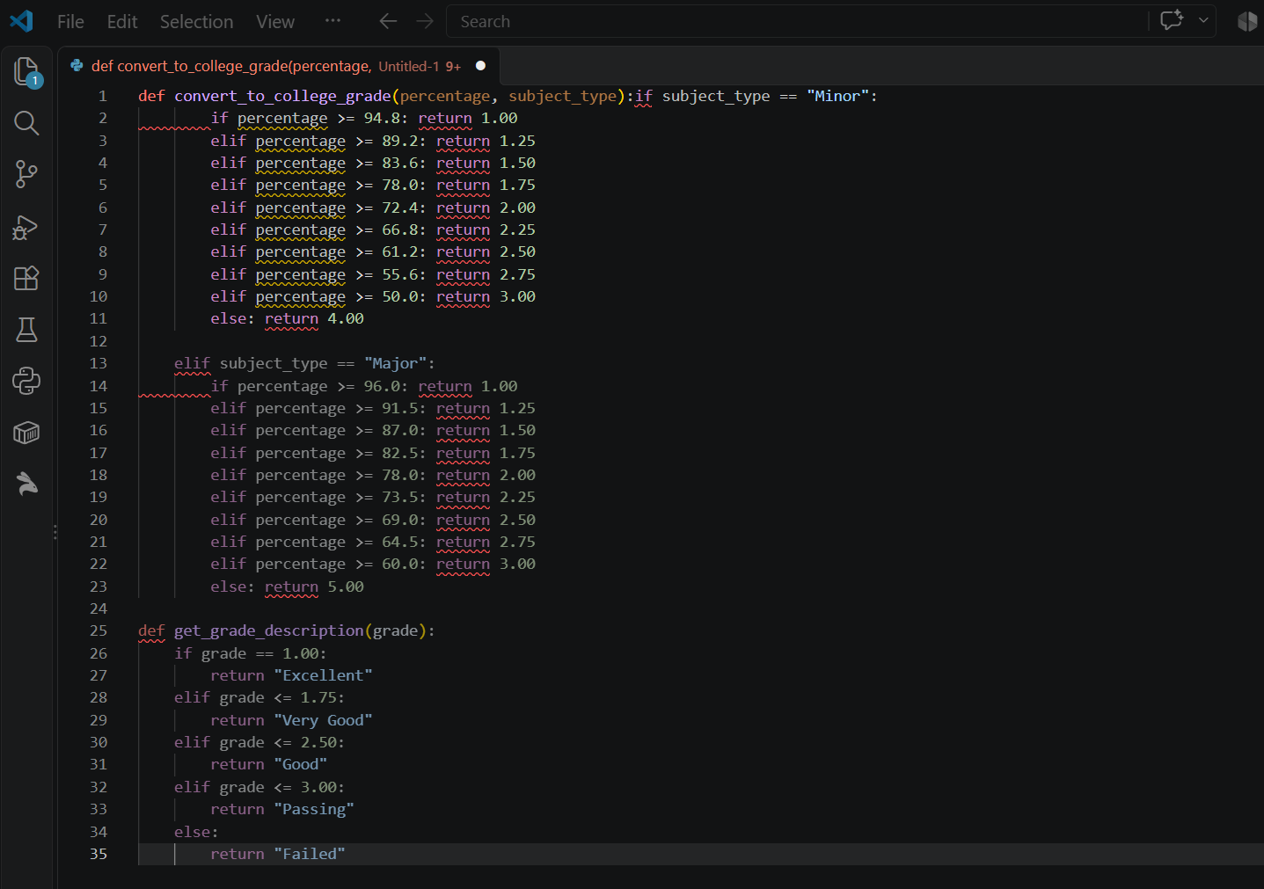

def convert_to_college_grade(percentage, subject_type):

if subject_type == "Minor":

if percentage >= 94.8: return 1.00

elif percentage >= 89.2: return 1.25 elif percentage >= 83.6: return 1.50

elif percentage >= 78.0: return 1.75 elif percentage >= 72.4: return 2.00

elif percentage >= 66.8: return 2.25 elif percentage >= 61.2: return 2.50

elif percentage >= 55.6: return 2.75 elif percentage >= 50.0: return 3.00

else: return 4.00

elif subject_type == "Major":

if percentage >= 96.0: return 1.00

elif percentage >= 91.5: return 1.25 elif percentage >= 87.0: return 1.50

elif percentage >= 82.5: return 1.75 elif percentage >= 78.0: return 2.00

elif percentage >= 73.5: return 2.25 elif percentage >= 69.0: return 2.50

elif percentage >= 64.5: return 2.75 elif percentage >= 60.0: return 3.00

else: return 5.00
Receives overall percentage and subject classification (Minor/Major). Evaluates score thresholds using conditional branching. Returns numerical grade mark (1.00–5.00). Fulfills Objective 1 by automating course-specific grading logic.

Snippet 1 Descriptive function title
Related objective: Objective 1 – To automatically convert overall percentage scores into standardized college numerical marks based on course classification (Minor vs. Major)
def convert_to_college_grade(percentage, subject_type):
if subject_type == "Minor":
if percentage >= 94.8: return 1.00
elif percentage >= 89.2: return 1.25 elif percentage >= 83.6: return 1.50
elif percentage >= 78.0: return 1.75 elif percentage >= 72.4: return 2.00
elif percentage >= 66.8: return 2.25 elif percentage >= 61.2: return 2.50
elif percentage >= 55.6: return 2.75 elif percentage >= 50.0: return 3.00
else: return 4.00
elif subject_type == "Major":
if percentage >= 96.0: return 1.00
elif percentage >= 91.5: return 1.25 elif percentage >= 87.0: return 1.50
elif percentage >= 82.5: return 1.75 elif percentage >= 78.0: return 2.00
elif percentage >= 73.5: return 2.25 elif percentage >= 69.0: return 2.50
elif percentage >= 64.5: return 2.75 elif percentage >= 60.0: return 3.00
else: return 5.00

The function receives a numerical overall score percentage (percentage) and a subject classification string (subject_type set as "Minor" or "Major"). It processes the input using conditional branching (if-elif-else) to check the score against designated percentage thresholds, applying a 50.0% passing benchmark for Minor subjects and a 60.0% passing benchmark for Major subjects. It returns a standardized college numerical mark ranging from 1.00 to 5.00. This directly supports Objective 1 by automating score conversions according to course-specific evaluation criteria.Snippet 2 Descriptive function title

Snippet 2 Descriptive function title
Related objective: Objective 2 – To evaluate numerical college marks and automatically generate standardized qualitative performance descriptionsde get_grade_description(grade):
if grade == 1.00: return "Excellent"
elif grade <= 1.75: return "Very Good"
elif grade <= 2.50: return "Good"
elif grade <= 3.00: return "Passing"
else: return "Failed"
A numerical college grade mark (grade as a float).
Processing: Compares the numerical mark against defined performance ranges using structured if-elif-else evaluation steps.
Output: Returns a standardized qualitative rating string ("Excellent", "Very Good", "Good", "Passing", or "Failed")

Snippet 3 Descriptive function title
Related objective: Objective 3 – To compute the weighted final percentage using term grades across all three evaluation periods while handling missing data.

def calculate_subject_grade(p1, p2, p3):
if p1 is None or p2 is None or p3 is None: return None
return round((p1 * 0.33) + (p2 * 0.33) + (p3 * 0.34), 2) Input: Three numerical period scores (p1, p2, p3 as float or None representing Prelim, Midterm, and Final grades).
Processing: Checks if any grading period is missing or incomplete, then applies designated weighting factors (33% for Period 1, 33% for Period 2, and 34% for Period 3) and rounds the sum to two decimal places.
Output: Returns the calculated weighted total percentage (float), or None if any required period score is missing.
Link to Objective: Fulfills Objective 3 by ensuring accurate multi-term percentage calculations while gracefully handling incomplete student records.

References
- Domingo, W. G., Lardizabal, E. N., & Toledo, S. M. V. (2021). K12 Senior High School Students Academic Performance Monitoring System for Private Institutions with Decision Support System. https://doi.org/10.5121/csit.2021.112011
- Krongpol, K. B., Vlademir, J., & Miguel, L. (2024). Periodical Performance Monitoring System. https://ejournals.ph/articles.php?id=30686

