# Install dependencies

Be sure to install visual studio. You can follow this site for instructions: <https://yugdamor.medium.com/microsoft-visual-c-14-0-724d91d00590>

* Doing so will allow me to download things like pandas or psycopg2 (a package that contains the PostgreSQL driver for the web)

# Set up flask

How to set up flask

1. Cmd > pip install flask
2. Go to folder where flask.py is located
3. Type: set FLASK_APP=myProject.py (no space)

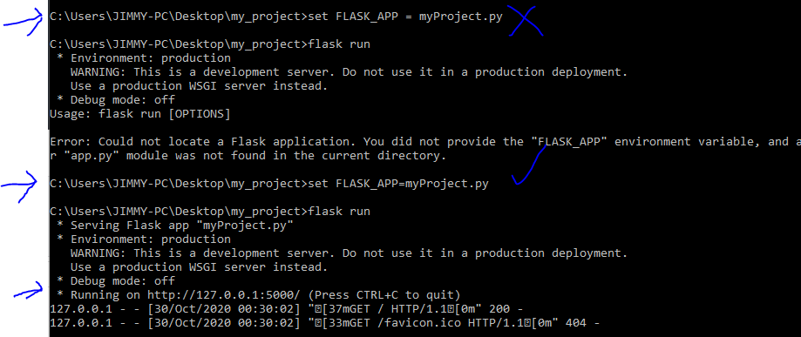

Do note that by doing the above my debug mode will remain off. If I want to run with debug mode on do the below…

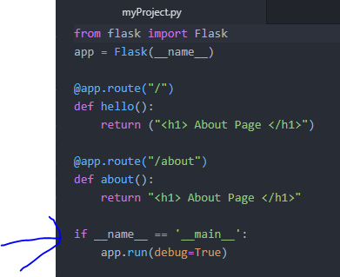

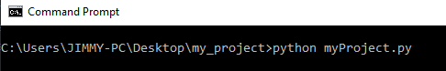

# Inheritance

Summary:

The layout.html is the parent. The home and about.html is the child.

Ex: in home.html I am inheriting layout.html template

* This means I am copying EVERYTHING from the layout.html.
* I am using home.html to hold values to plug into {%block content%}
  + Note: ‘block’ is a syntax (I think). the variable ‘content’ can be anything. Can be apple_pie if I wanted to…

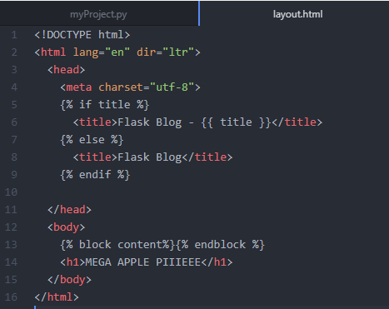

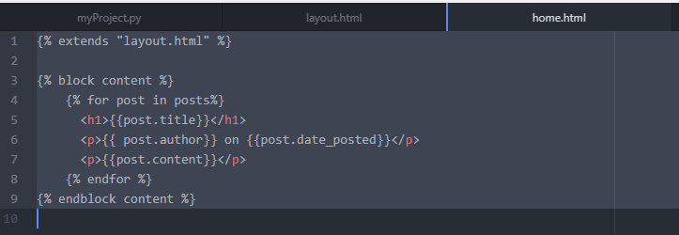

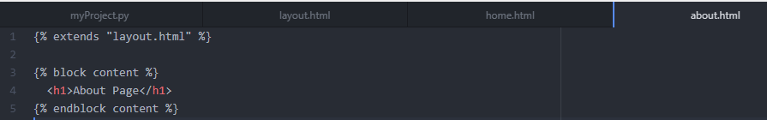

Output:

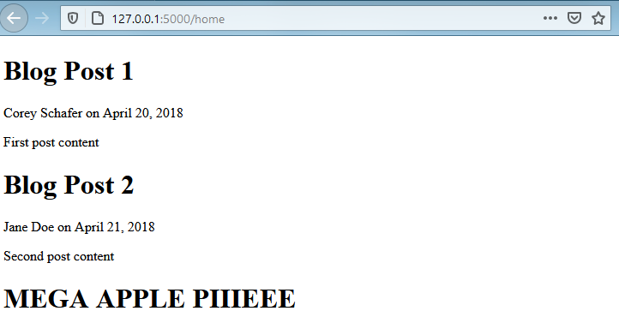

## Bootstrap

Go to this website: <https://getbootstrap.com/docs/4.5/getting-started/introduction/#quick-start>

* Then copy the cdn and paste under the head
* Copy paste the jquery (aka the java script) in the body below
* Doing this allows me to use bootstrap classes
* Note: the class “container” is calling a class from bootstrap

Summary of this chapter:

* We learn how to copy paste cdn and jquery stuff
* We also learn how to copy paste a bunch of bootstrap formatting and .css formatting
  + Should consider using the .css and bootstrap as refernce when creating my own personal project.

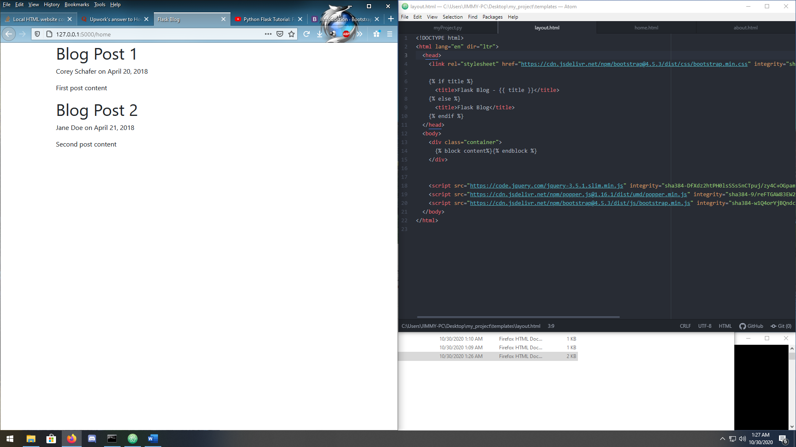

Another example of bootstrap. This time we add more stuff under the container

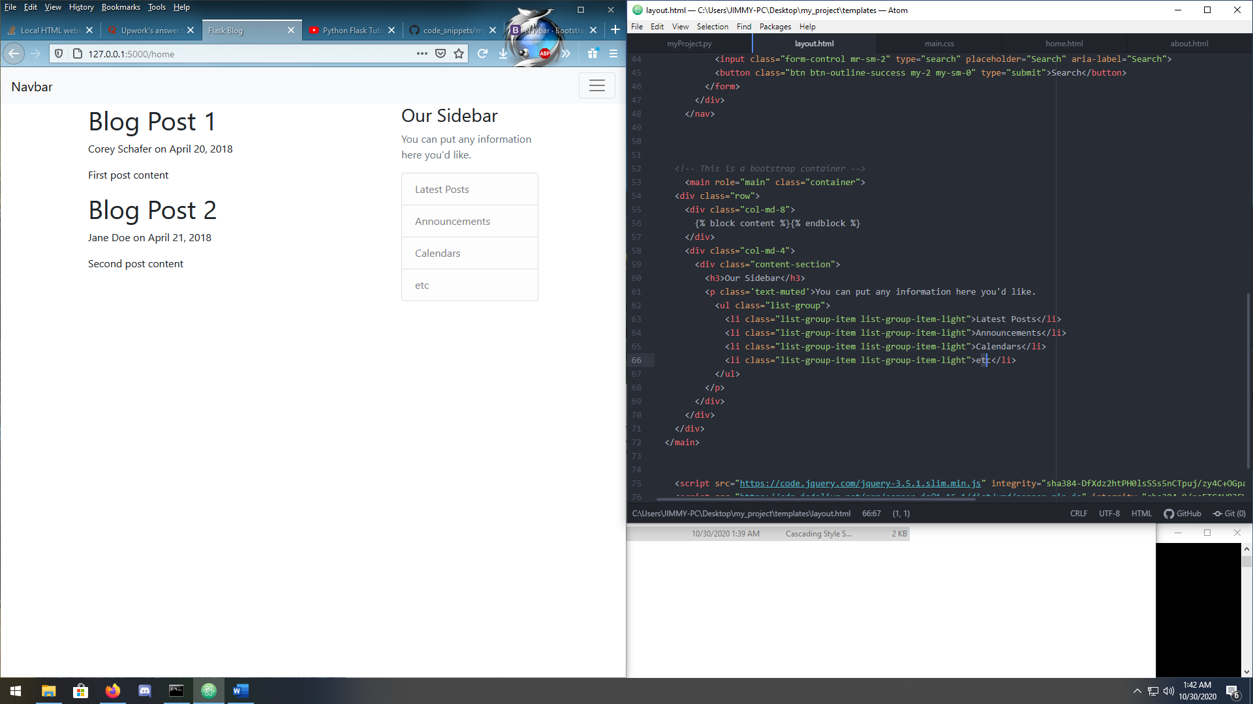

Lastly is implementing css for additional styling

Make sure you include a css reference

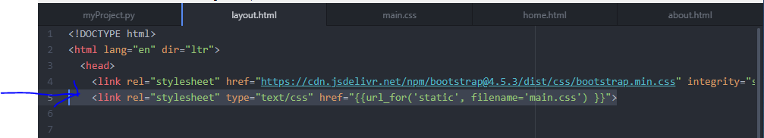

Folder directory so far:

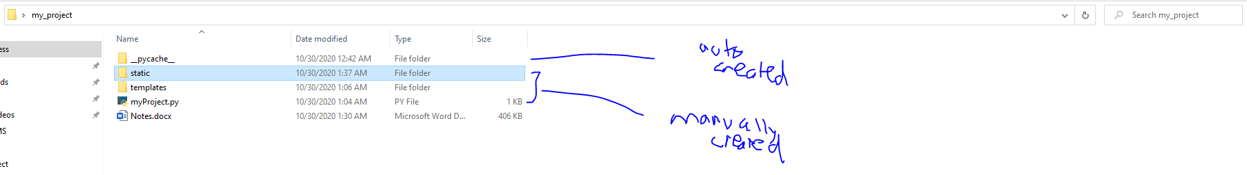

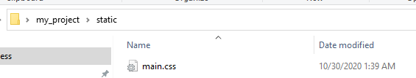

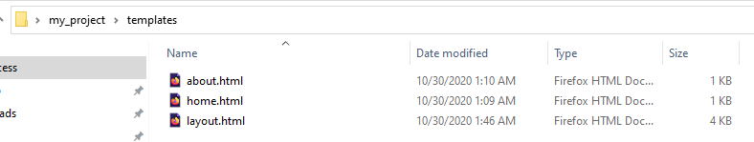

Css code:

body {

background: #fafafa;

color: #333333;

margin-top: 5rem;

}

h1, h2, h3, h4, h5, h6 {

color: #444444;

}

.bg-steel {

background-color: #5f788a;

}

.site-header .navbar-nav .nav-link {

color: #cbd5db;

}

.site-header .navbar-nav .nav-link:hover {

color: #ffffff;

}

.site-header .navbar-nav .nav-link.active {

font-weight: 500;

}

.content-section {

background: #ffffff;

padding: 10px 20px;

border: 1px solid #dddddd;

border-radius: 3px;

margin-bottom: 20px;

}

.article-title {

color: #444444;

}

a.article-title:hover {

color: #428bca;

text-decoration: none;

}

.article-content {

white-space: pre-line;

}

.article-img {

height: 65px;

width: 65px;

margin-right: 16px;

}

.article-metadata {

padding-bottom: 1px;

margin-bottom: 4px;

border-bottom: 1px solid #e3e3e3

}

.article-metadata a:hover {

color: #333;

text-decoration: none;

}

.article-svg {

width: 25px;

height: 25px;

vertical-align: middle;

}

.account-img {

height: 125px;

width: 125px;

margin-right: 20px;

margin-bottom: 16px;

}

.account-heading {

font-size: 2.5rem;

}

One last tweak to make this nicer…

You could also revise the home.html to loop and make it more spacious. Of course it’s only applied at the home page

