SPRINGBOOT DYNAMODB

Create Dynamo DB: create 1st a simple dynamo DB .

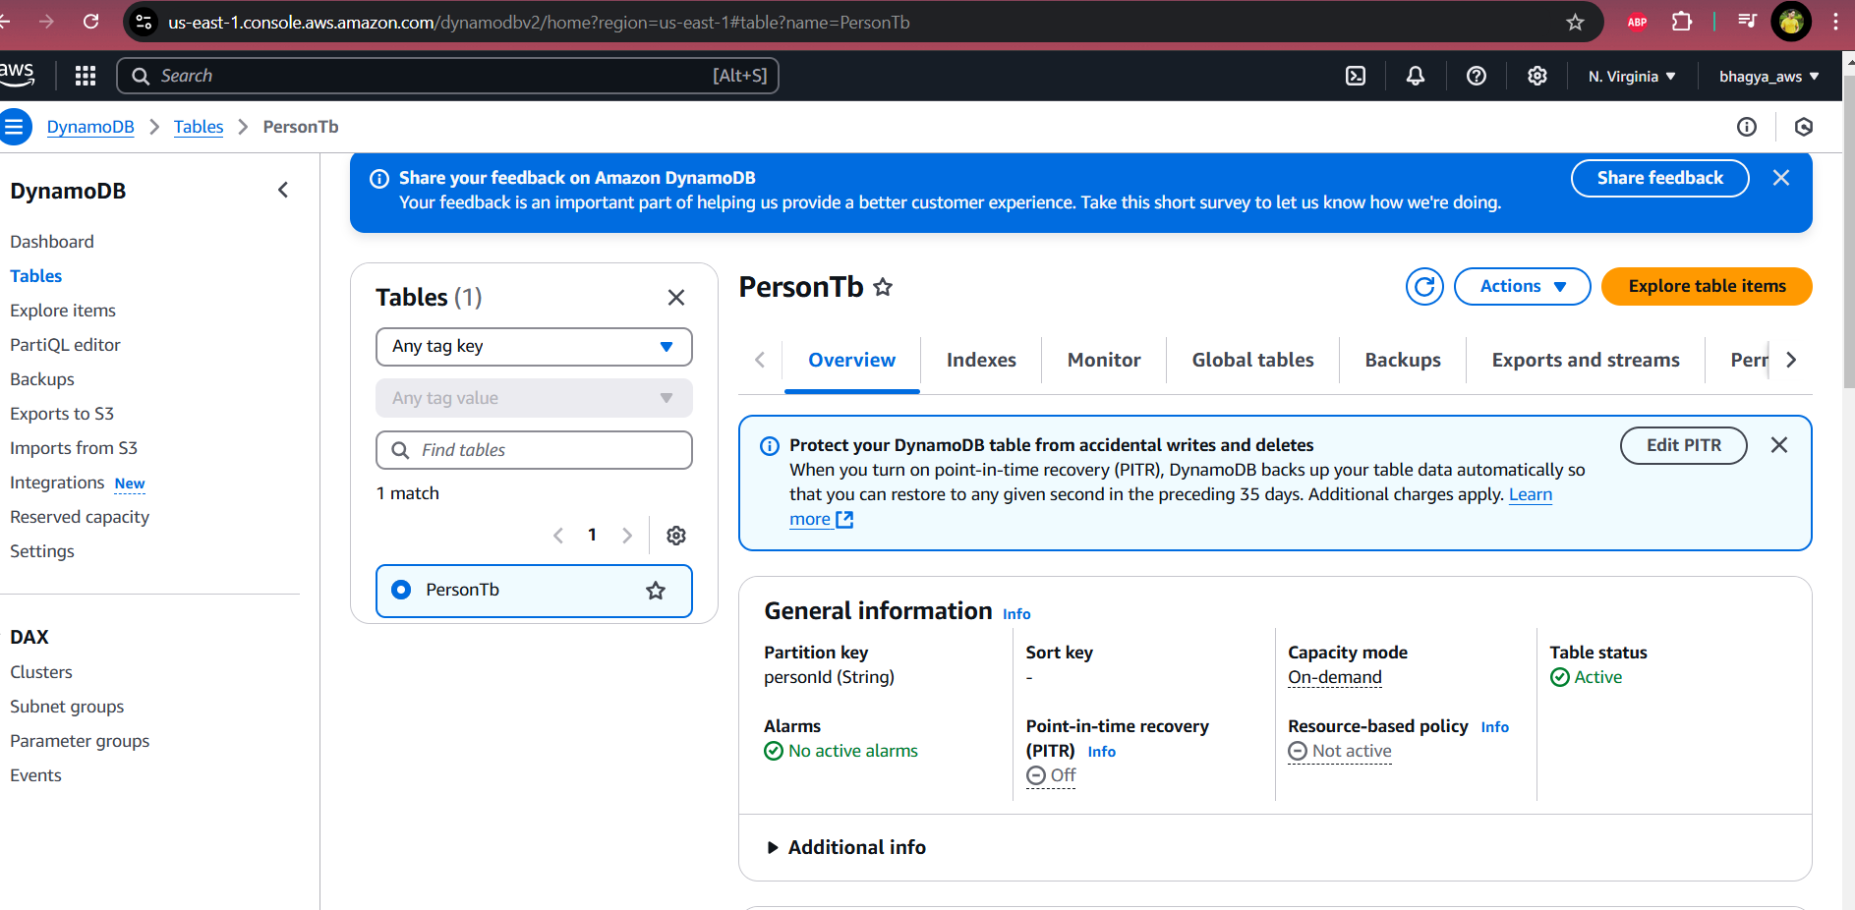

Now to access the table from java application we need certain key.

We need to set the IAM access and need to generate a key

1. Under the IAM we need to 1st create a group and we need to add user to the group and also to that user need to add some policy, then only java application can interact with cloud AWS Dynamo DB.

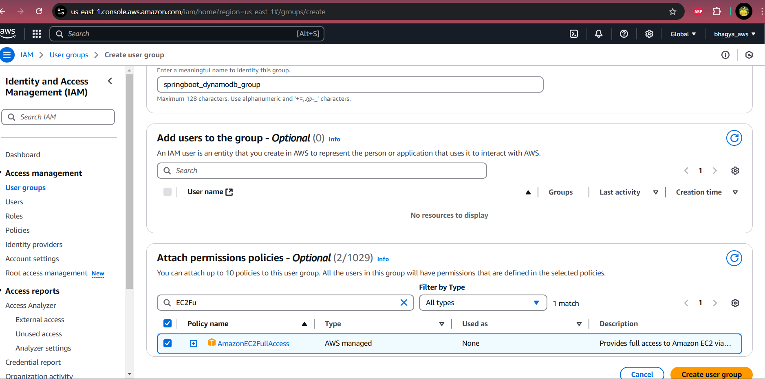

As we can see there is a group we have to create the spring boot to interact with dynamo DB. When creating group we need to add the policies to the group as we can see I have checked

AmazonEC2FullAccess

AdminstratorAccess

Then create group.

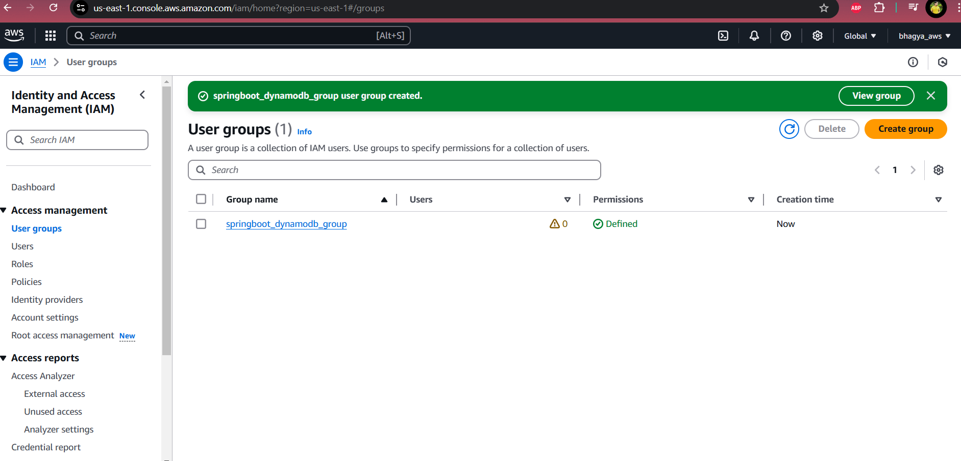

Now to the above created group we need to add a user

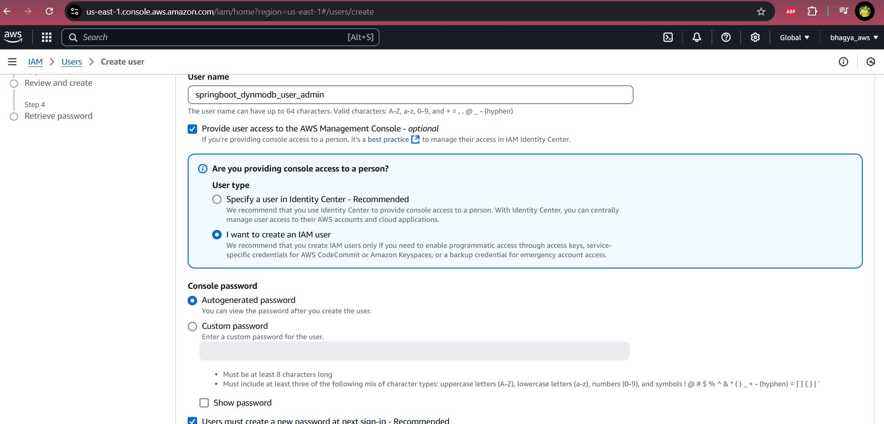

As per above screenshot attached, you can Select the I want to create a I am User and it will create a new user with password then you can choose auto generate password or your on custom password

Now click next add the group to this user follow the below screenshot

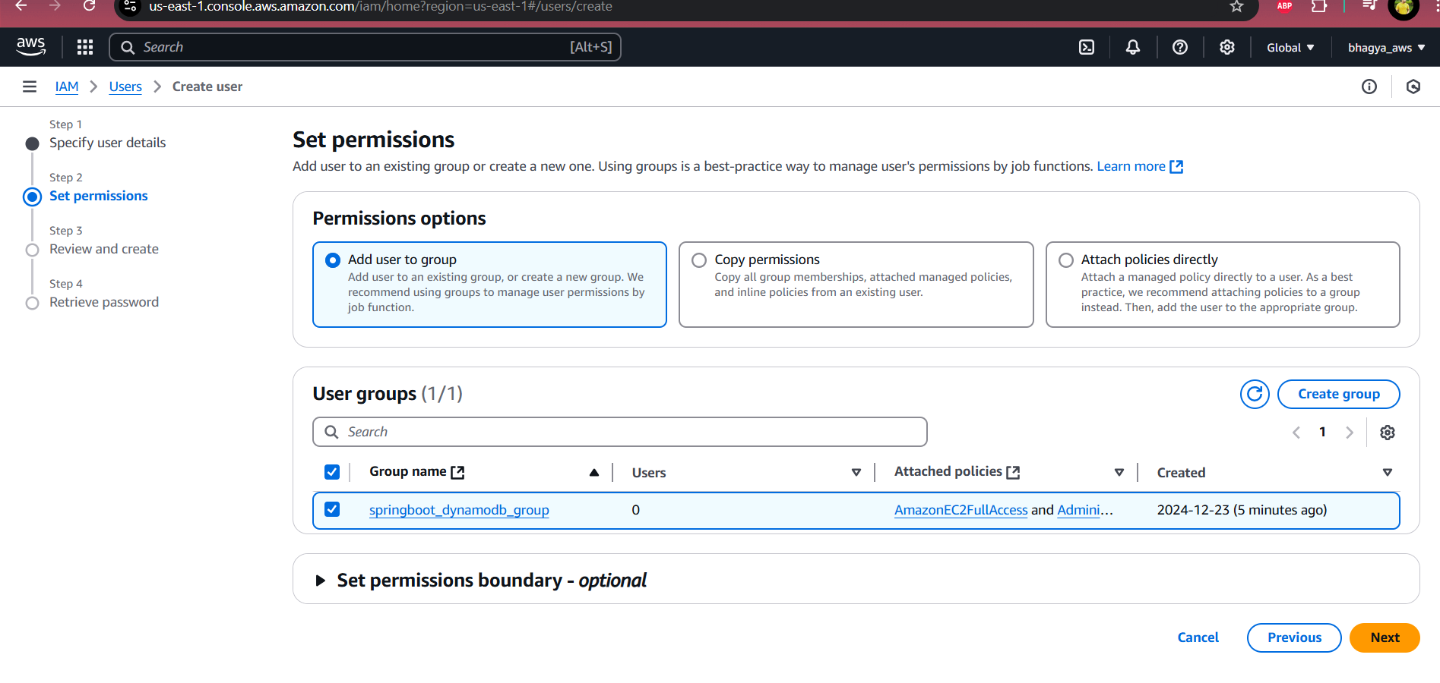

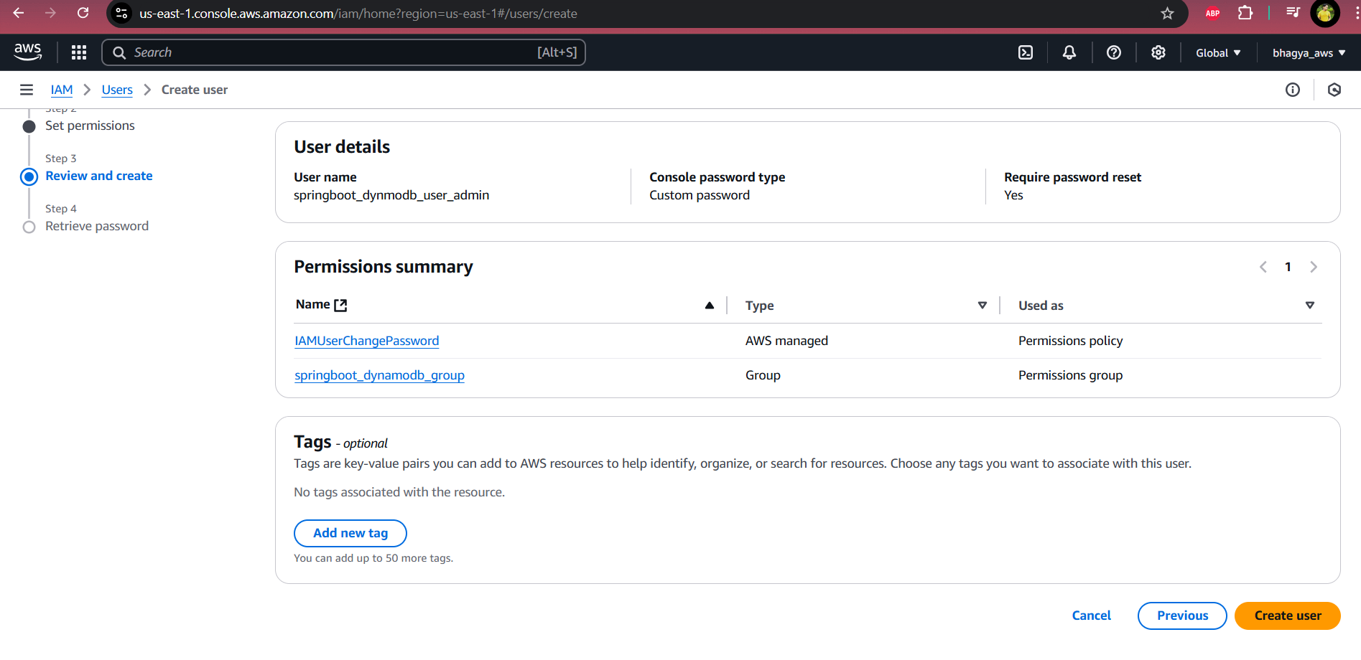

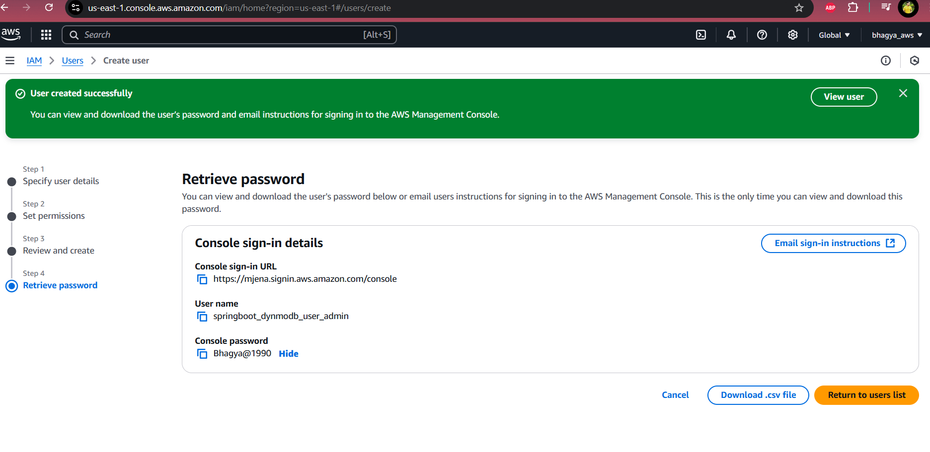

We have created a group and attached a user and now lets add a custom policy to that group .

Now add the policy custom policy for the new policy at JSON postion adding custom policy for Dynamodba and sns

{

"Version": "2012-10-17",

"Statement": [

{

"Effect":"Allow",

"Action": ["dynamodb:PutItem"],

"Resource": ["\*"]

},

{

"Effect":"Allow",

"Action": ["sns:Publish"],

"Resource": ["\*"]

}

]

}

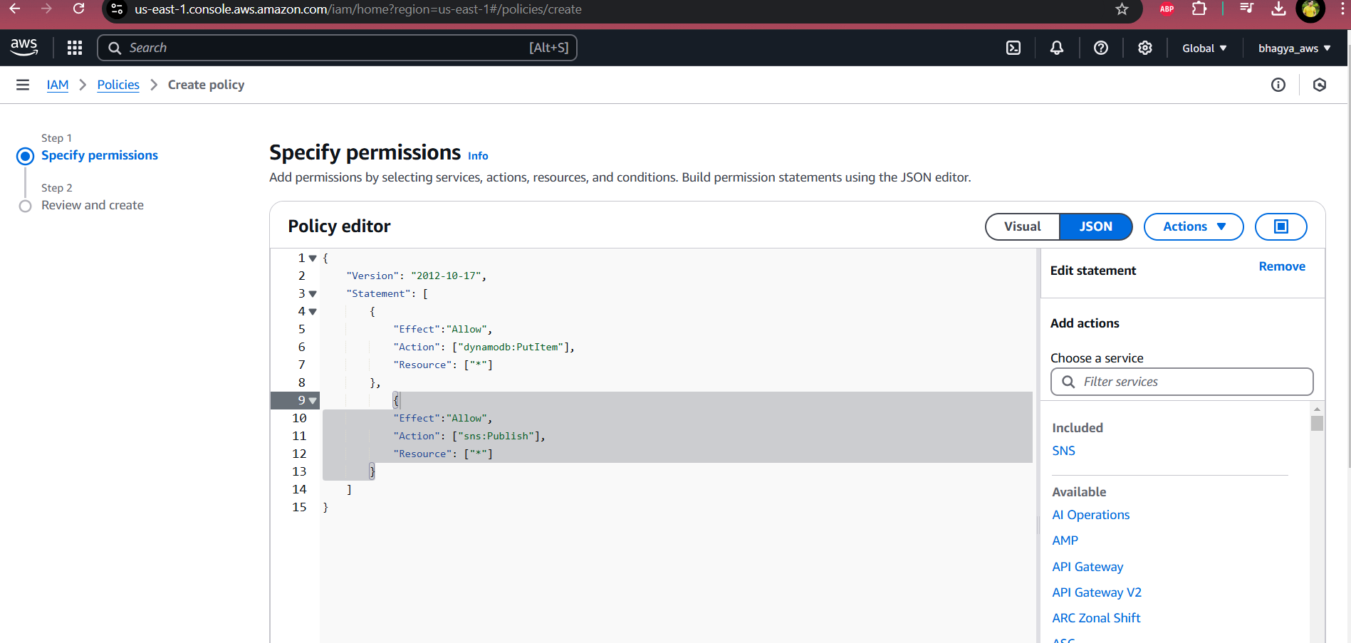

As we can notice at below screenshot the two policies has added simply we need to add the new policy name and create the policy

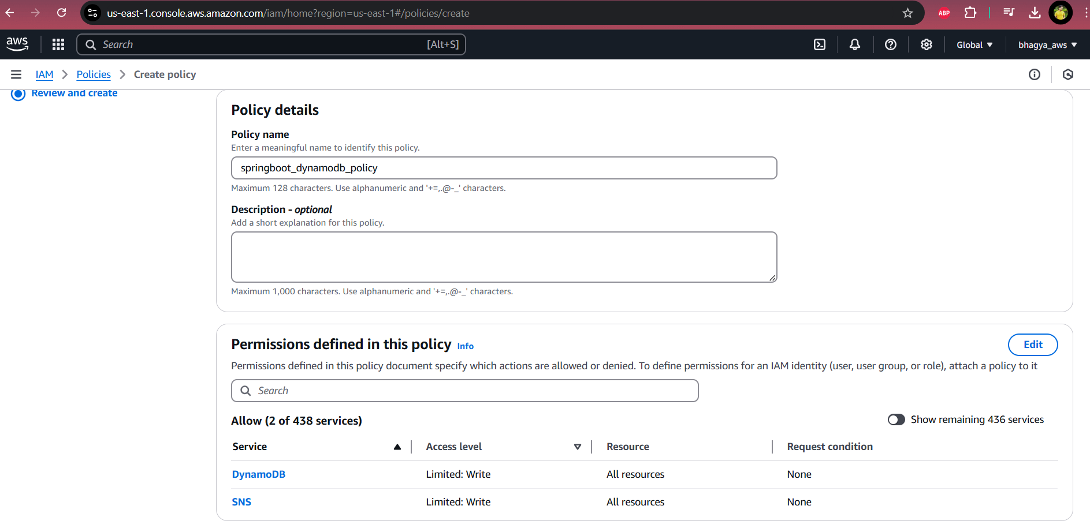

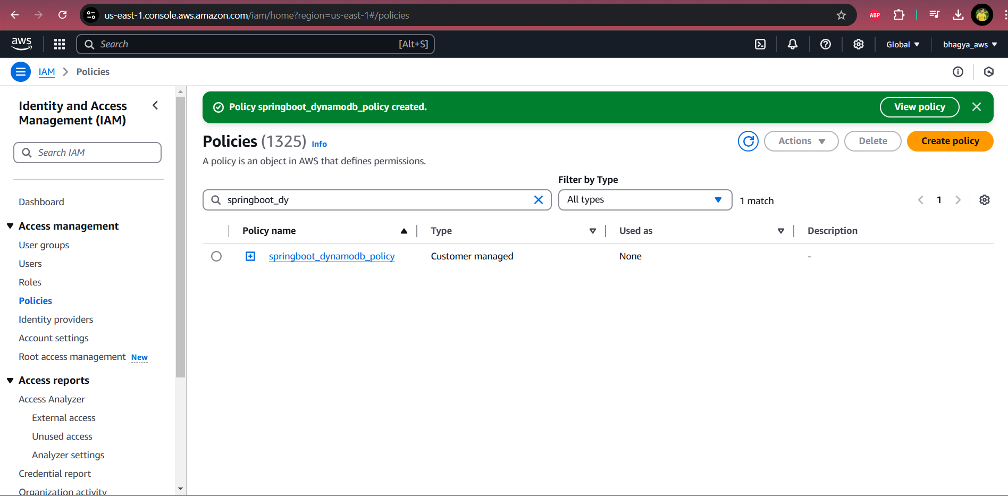

Now lets attach the policy to the group we need to check the policy radio button and click on action

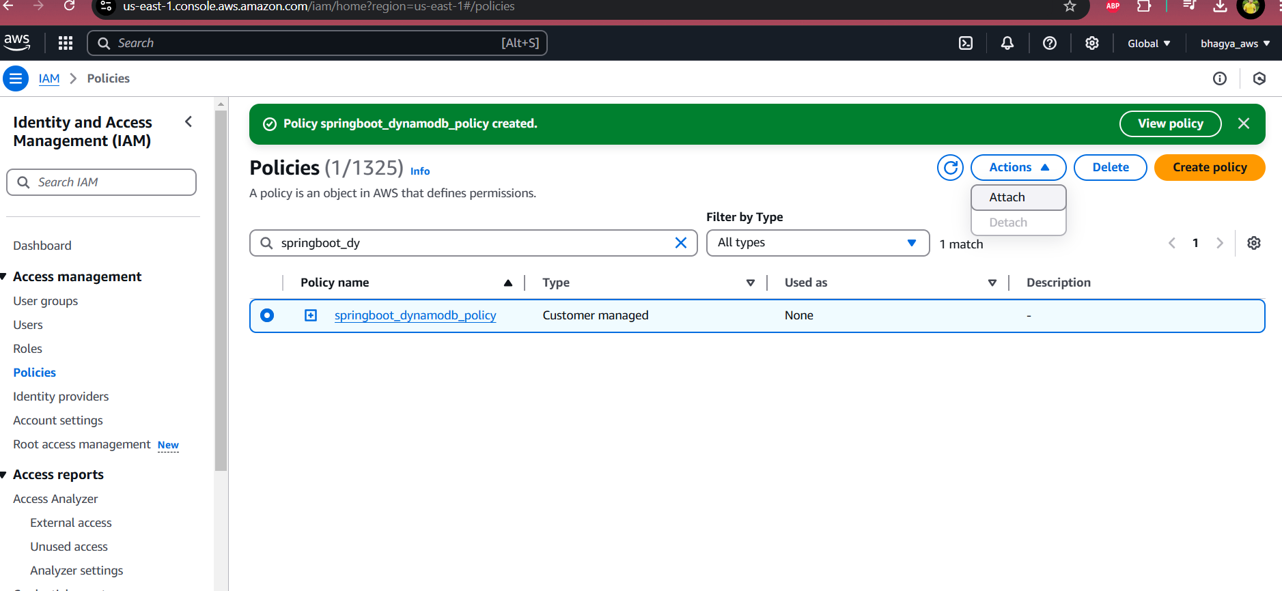

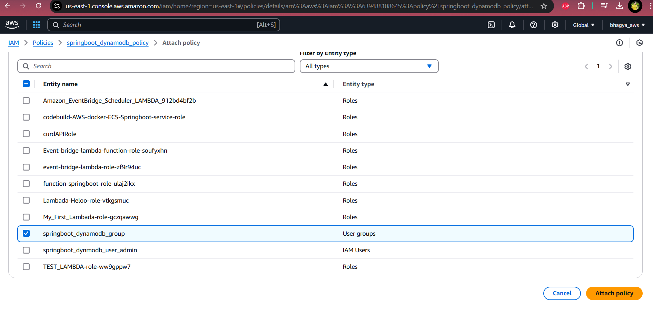

Now we are done with the configuration lets go to the IntelliJ and create spring boot application