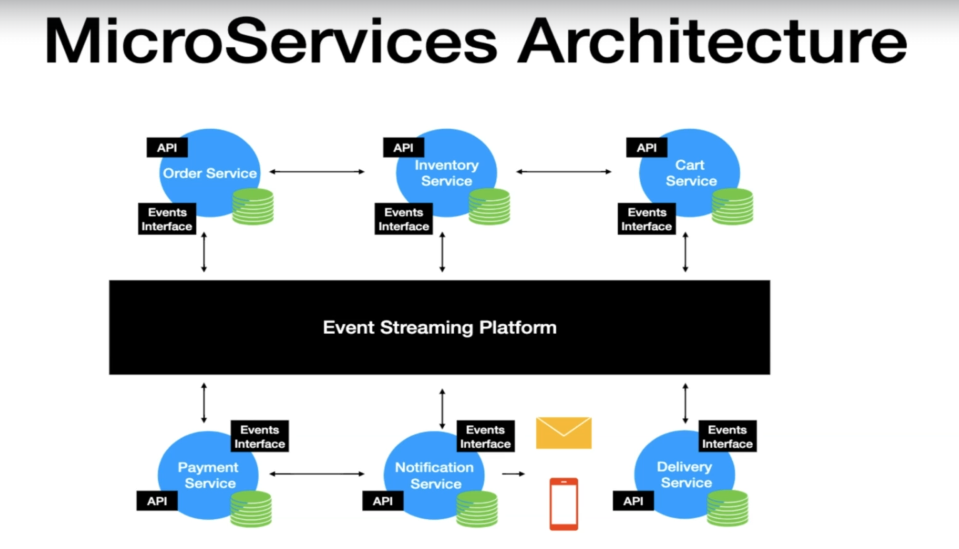

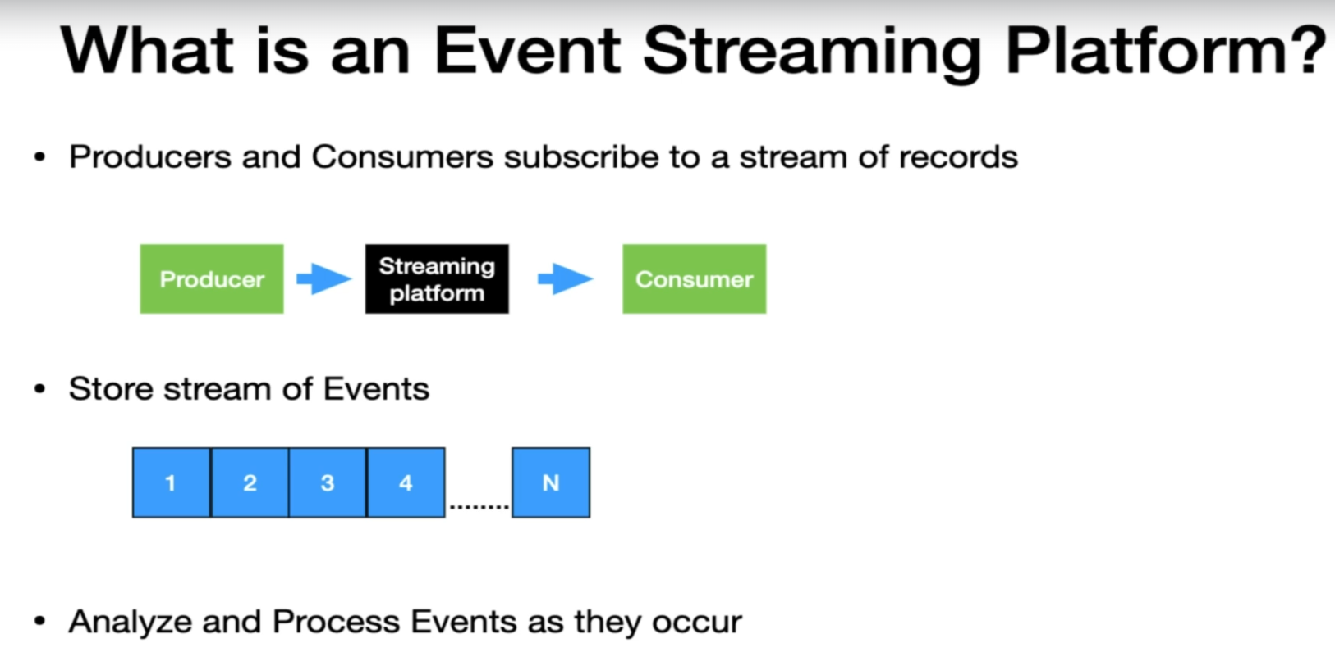

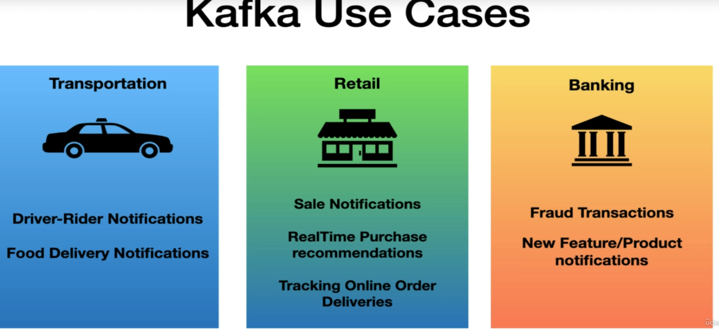

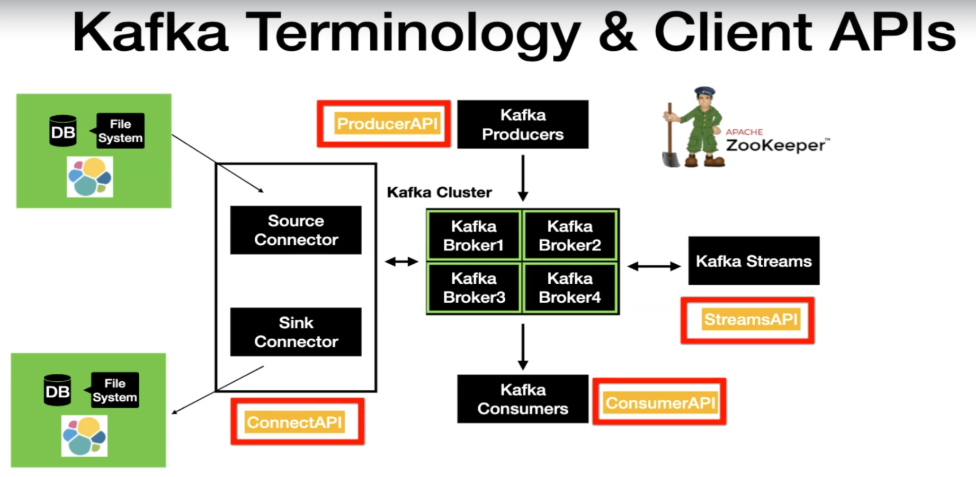

**Partitions:**

* Each partition is an ordered, immutable sequence record.
* Each record assigned a sequential number called **offset.**
* Each partition is independent of each other.
* Ordering is guaranteed only at partition level.
* Partition has continuously grown as new records are produced.

KAFKA Setup GIT REPO :

<https://github.com/dilipsundarraj1/kafka-for-developers-using-spring-boot-v2/tree/main>

In above just extract the repo and run docker compose file from docker desktop.

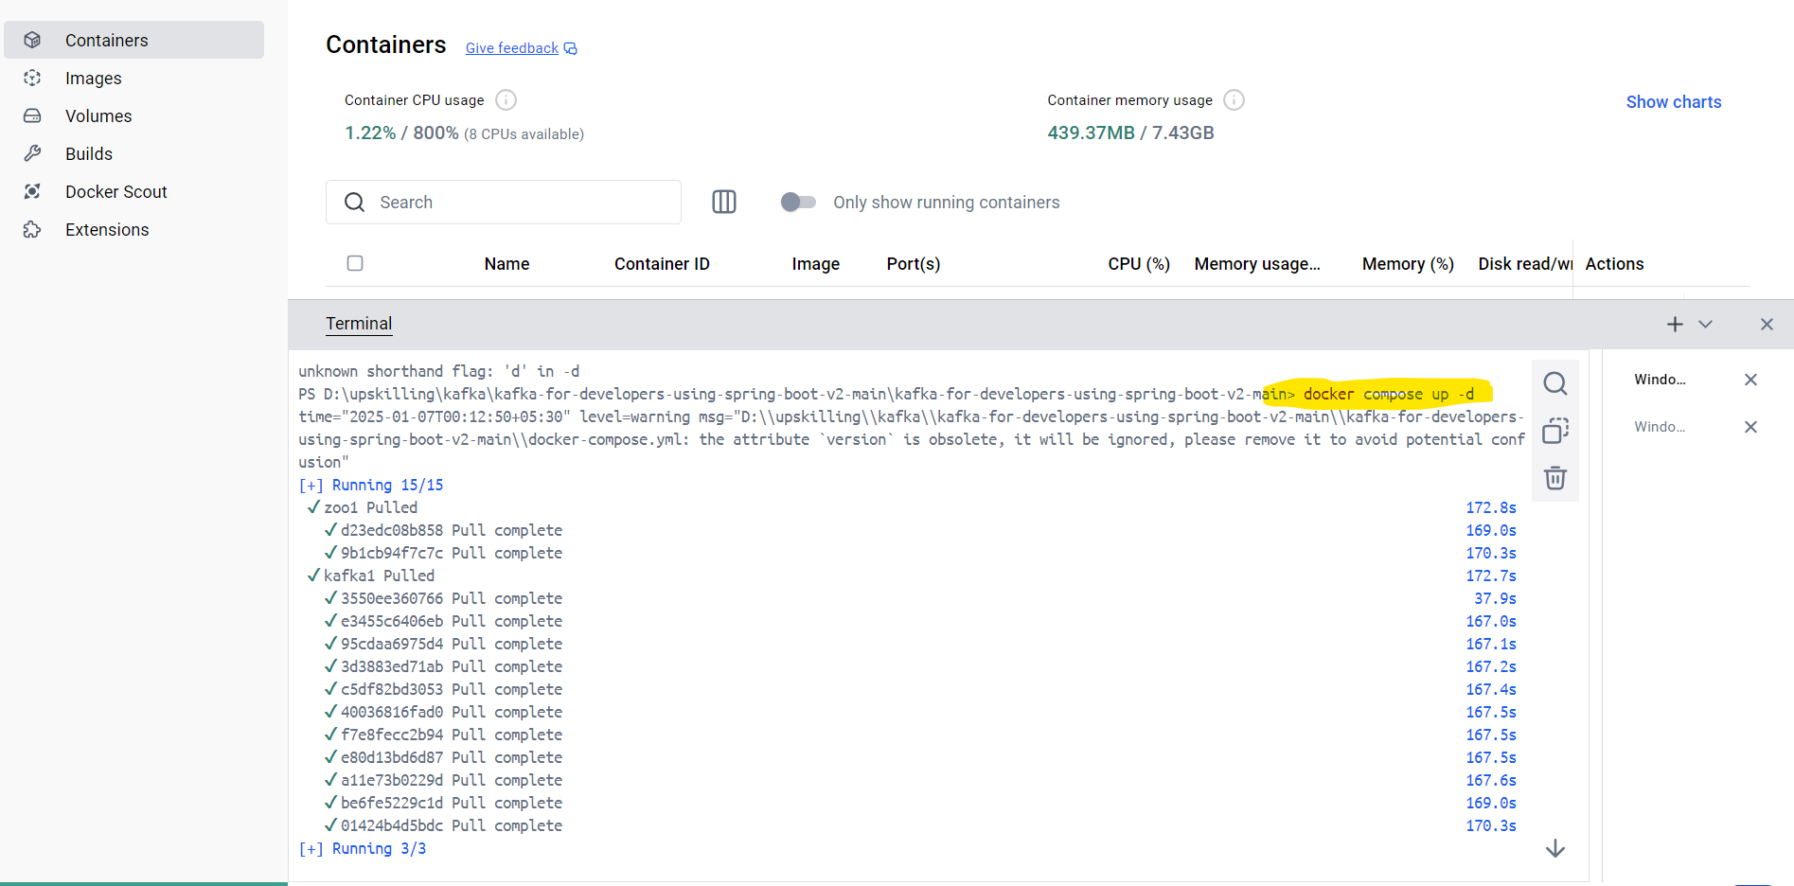

Then check the docker able to pull the image of kafka server and zookeeper .

docker ps

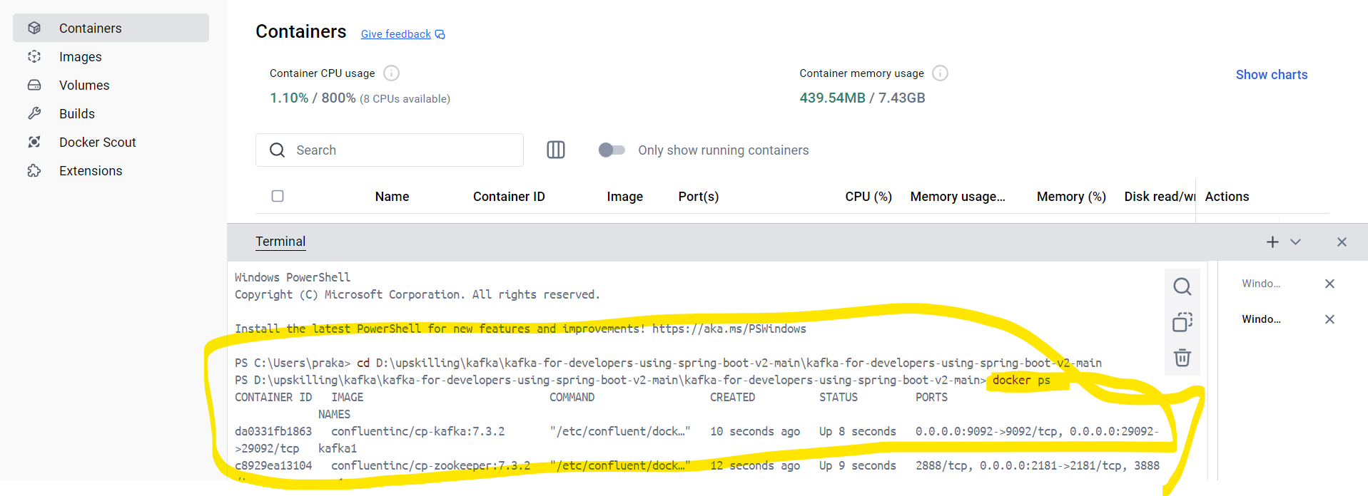

Now its time to create a topic at the Kafka server or Kafka broker. Follow the below git steps

<https://github.com/dilipsundarraj1/kafka-for-developers-using-spring-boot-v2/blob/main/SetUpKafkaDocker.md>



Create topic :

