Producer consumer flow :

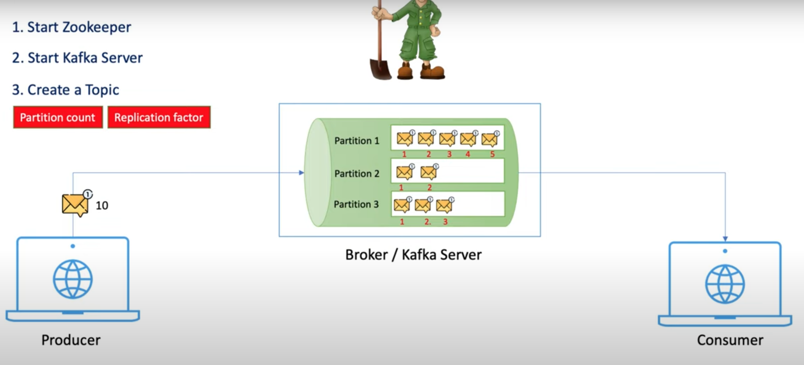

1st we need to start the Zookeeper which is inside the bin folder of the kafka installation folder .

We can run the zookerper-start.sh from command propmpt by giving the zooker properties as path

