Producer consumer flow :

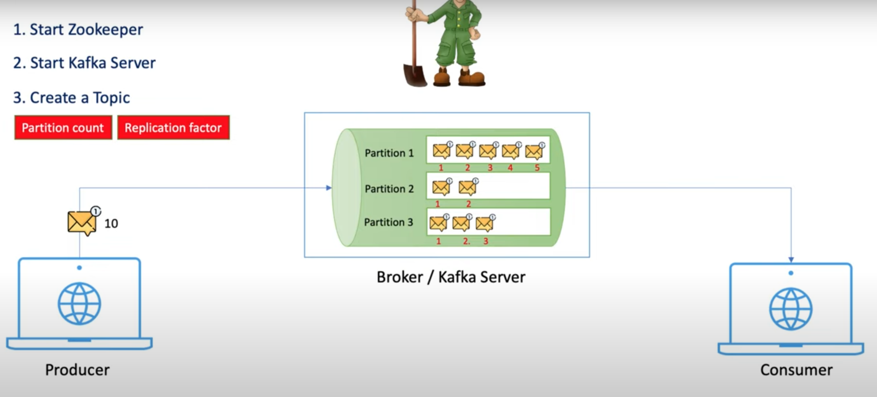

1st we need to start the Zookeeper which is inside the bin folder of the kafka installation folder .

We can run the zookerper-start.bat from command propmpt by giving the zookeeper properties as path

I*** If you want to run the sh file from windows you have to do below steps

Install WSL if you are using windows and run the zookeeper from linux command prompt

zookeeper-server-start.sh /mnt/d/Softwares/kafka_2.12-3.8.0/kafka_2.12-3.8.0/config/zookeeper.properties

For Windows : zookeeper-server-start.bat C:\kafka\config\zookeeper.properties

after the installation of wsl if you want to access the unix terminal type simple below in powe shell.

PS C:\Users\praka> wsl

Now start the Kafka Server :

kafka-server-start.sh /mnt/d/Softwares/kafka_2.12-3.8.0/kafka_2.12-3.8.0/config/server.properties

For windows: kafka-server-start.bat C:\kafka\config\server.properties

** The default port of zookeeper 2181

** The default port iof Kafka server is 9092

Now our zookeeper and Kafka server both are running . We need to communicate the producer and consumer with the TOPIC .

Run the Topic:

kafka-topics.sh --bootstrap-server localhost:9092 --create --topic javatest --partitions 3 --replication-factor 1

list of Topics:

kafka-topics.sh --bootstrap-server localhost:9092 –list

**kafka-topics.bat --bootstrap-server localhost:9092 --describe --topic javademo**

[2024-09-24 16:51:06,995] WARN [AdminClient clientId=adminclient-1] The DescribeTopicPartitions API is not supported, using Metadata API to describe topics. (org.apache.kafka.clients.admin.KafkaAdminClient)

Topic: javademo TopicId: dCAFDylyS06ggZHYy1RBIA PartitionCount: 3 ReplicationFactor: 1 Configs:

Topic: javademo Partition: 0 Leader: 0 Replicas: 0 Isr: 0 Elr: N/A LastKnownElr: N/A

Topic: javademo Partition: 1 Leader: 0 Replicas: 0 Isr: 0 Elr: N/A LastKnownElr: N/A

Topic: javademo Partition: 2 Leader: 0 Replicas: 0 Isr: 0 Elr: N/A LastKnownElr: N/A

From Command pompt we can communicate to producer and consumer

Activate the producer :

C:\kafka\bin\windows>kafka-console-producer.bat --broker-list localhost:9092 --topic javademo-topic

>hi java demo

>

Activate the consumer :

C:\kafka\bin\windows>kafka-console-consumer.bat --bootstrap-server localhost:9092 --topic javademo-topic --from-beginning

Look below digram how they communicate

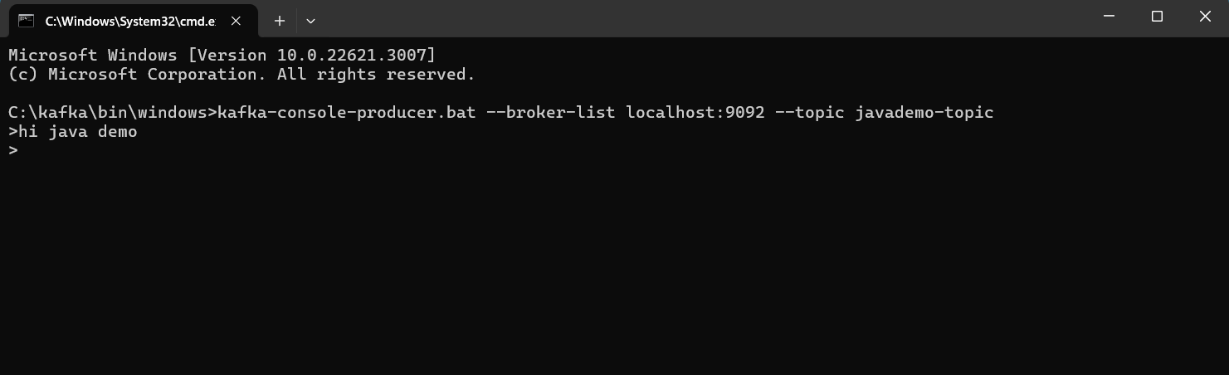

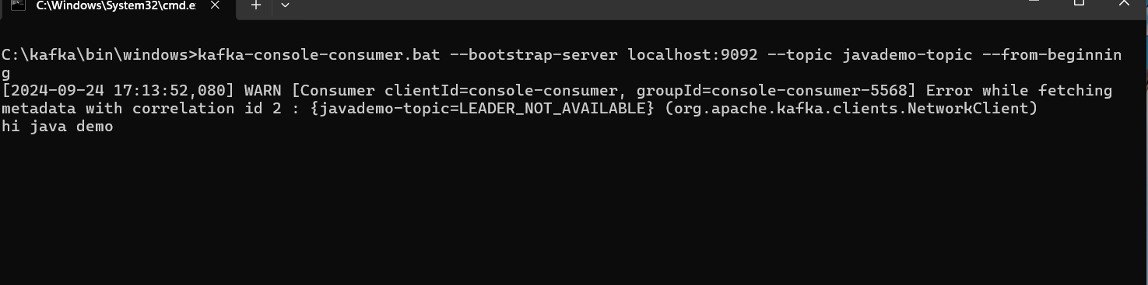

Check the same javademo-topic topics listening the message from the producer in offset explorer as well.

