# CHIAKI SATO

CREATIVE DESIGNER

I am a professional creative designer with 8 years of experience project management, advertisement, and computer aided design. Proven ability to transform client ideas into beautiful, functional design solutions.

## WORK EXPERIENCE

Thynk Unlimited / July 2015 - Oct 2016

### Senior Designer

Incorporated integrated sustainable design solutions into projects, preparing 2D and 3D design drawings

## CONTACT

+123-456-7890

[hello@reallygreatsite.com](mailto:hello@reallygreatsite.com) reallygreatsite.com

Wardiere Inc. / Oct 2016 - present

### Creative Designer

Incorporated integrated sustainable design solutions into projects, preparing 2D and 3D design drawings

## EDUCATION

Borcelle Institute Master of Graphic Design

Borcelle Institute Master of Graphic Design

## SKILLS

 Creativity Leader

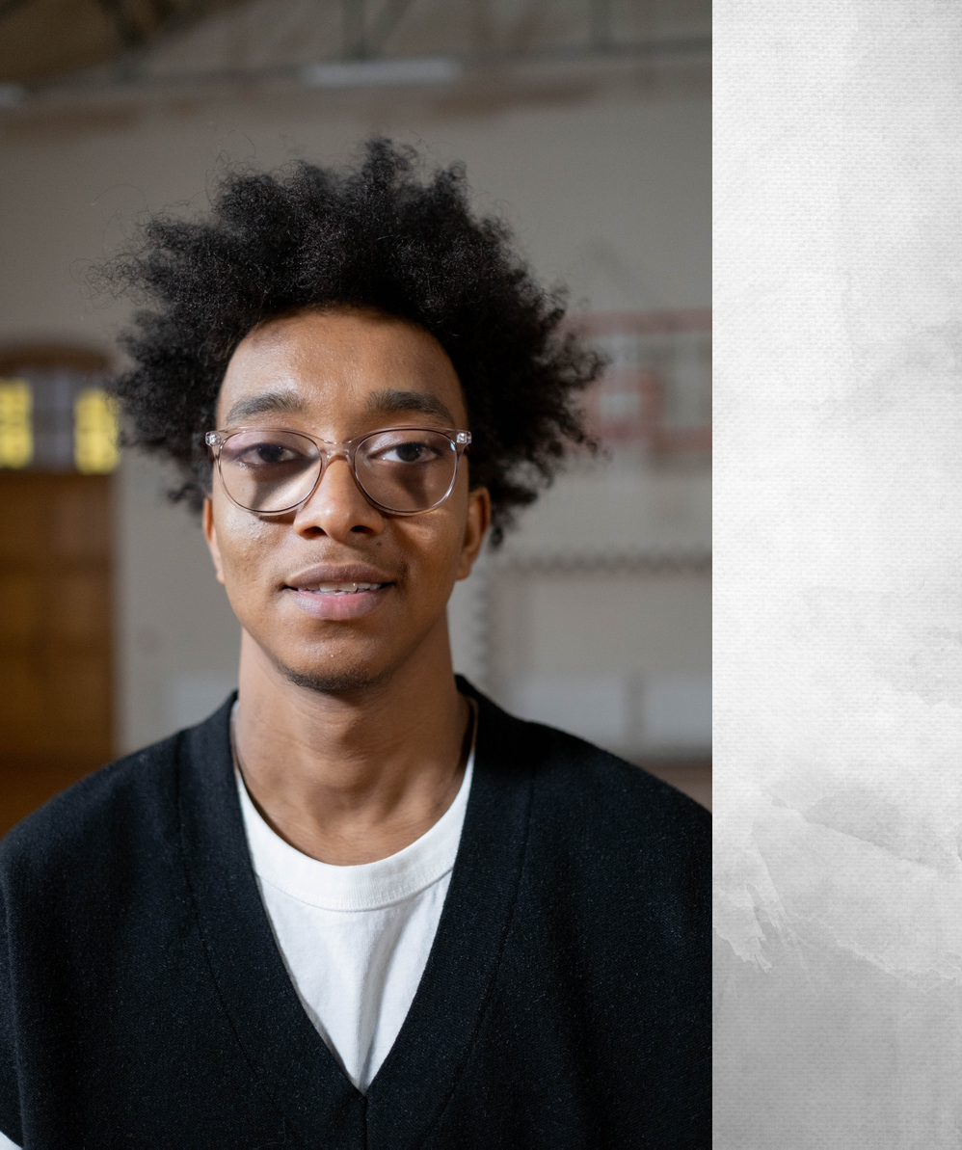

 Computer Communication

 Unique Drawing

COVER LETTER BY

# CHIAKI SATO

CREATIVE DESIGNER

#### DEAR MR. ANDREW

I am writing a letter of interest in regards to the position in your company. Your company is known for its innovation, professionalism, and results-driven marketing strategy, which is why I am certain I would make a valuable addition to your team. I would be interested in learning more about the company and available opportunities, so I have enclosed my resume for your consideration.

I am confident that my experience in this field will be an asset to your company. As you will see on my resume, I have a proven record of achievements, which will allow me to make major contributions to your company.

I look forward to speaking with you to discuss how my experience and abilities match your needs. I will call you on the day of the week to see what day and time fit your busy schedule. Don’t hesitate to contact me at your phone number or contact me by email at your email address should you have any questions. I look forward to speaking with you.

Sato

#### chiaki sato