What is this software about?

Understanding the organization of the healthy human brain, both structurally and functionally, is necessary in order to quantify the relationship between anatomy and function and to elucidate the effect of damage from disease and injury on dysfunction. There are many methods to assess pathologic brain changes in structural or diffusion MRI; however, the Network Modification (NeMo) tool is the first that associates localized white matter (WM) lesions with disruptions in gray matter connectivity as a step toward understanding the lesions’ functional implications. A Tractogram Reference Set (TRS), i.e. collections of white matter fibers, is constructed from 73 normal healthy individuals and coregistered to a common space (MNI). The LoCo Tool uses the TRS to assess structural network disruption due to a particular WM lesion mask on a region and network-wise level. This tool is an easy way for researchers and clinicians to investigate changes in the structural brain network without having to perform tractography on their own normal data or on diseased/injured brains where the results may not represent the underlying physiology. In addition to reporting connectivity changes for an individual GM region in a standard atlas, the LoCo Tool also reports changes to overall brain network metrics like efficiency, path length, average clustering coefficient, etc. Because the LoCo is based on many different normal tractograms, the variation of the scores over a population can be analyzed. Please note this is a light version of NeMo tool with only part of the tractgrams. If you need all 73 tractgrams, please feel free to contact Amy Kuceyeski (amk2012@med.cornell.edu).

How to setup the software?

I assume you have already have our software package if you are seeing this manual now :)

User could then download the two fiber tracts files named FiberTracts86_MNI_sub7.tar.gz
FiberTracts116_MNI_sub7.tar.gz,
decompress them, change the folder name into
FiberTracts86_MNI_BIN and FiberTracts116_MNI_BIN correspondingly, and finally put those two folders into the folder Tractgrams under the software package.

How to use the software?

With Matlab: the software can be used within Matlab. User needs to run NeMo_GUI.m to display the main graphical user interface.

Without Matlab: the software can be used without Matlab (currently only support distribution for Windows operating system). User needs to run NeMo_GUI.exe to display the main graphical user interface.

Once open the main GUI, User can provide a 3-dimensional white matter alteration mask of WM injury. If the mask is not in MNI space, user can alternatively provide a structural MRI file for co-registration. The structural MRI file can be T1, T2 and EPI. User can view the selected files by clicking view button.

User can choose atlas either AAL 116 regions or FreeSurfer 86 regions.

User can customize the output by selecting the corresponding options from Output section.

Once the input and output options has been setup, user can click the Run button to run the program. After finishing, the results will be saved in default_output folder (this folder is located under the same folder of the provided alteration mask). User can also change the save location by click the save icon on the tool bar. The results is also displayed after run. If user would like to view the results again, user can click the view button at the bottom.

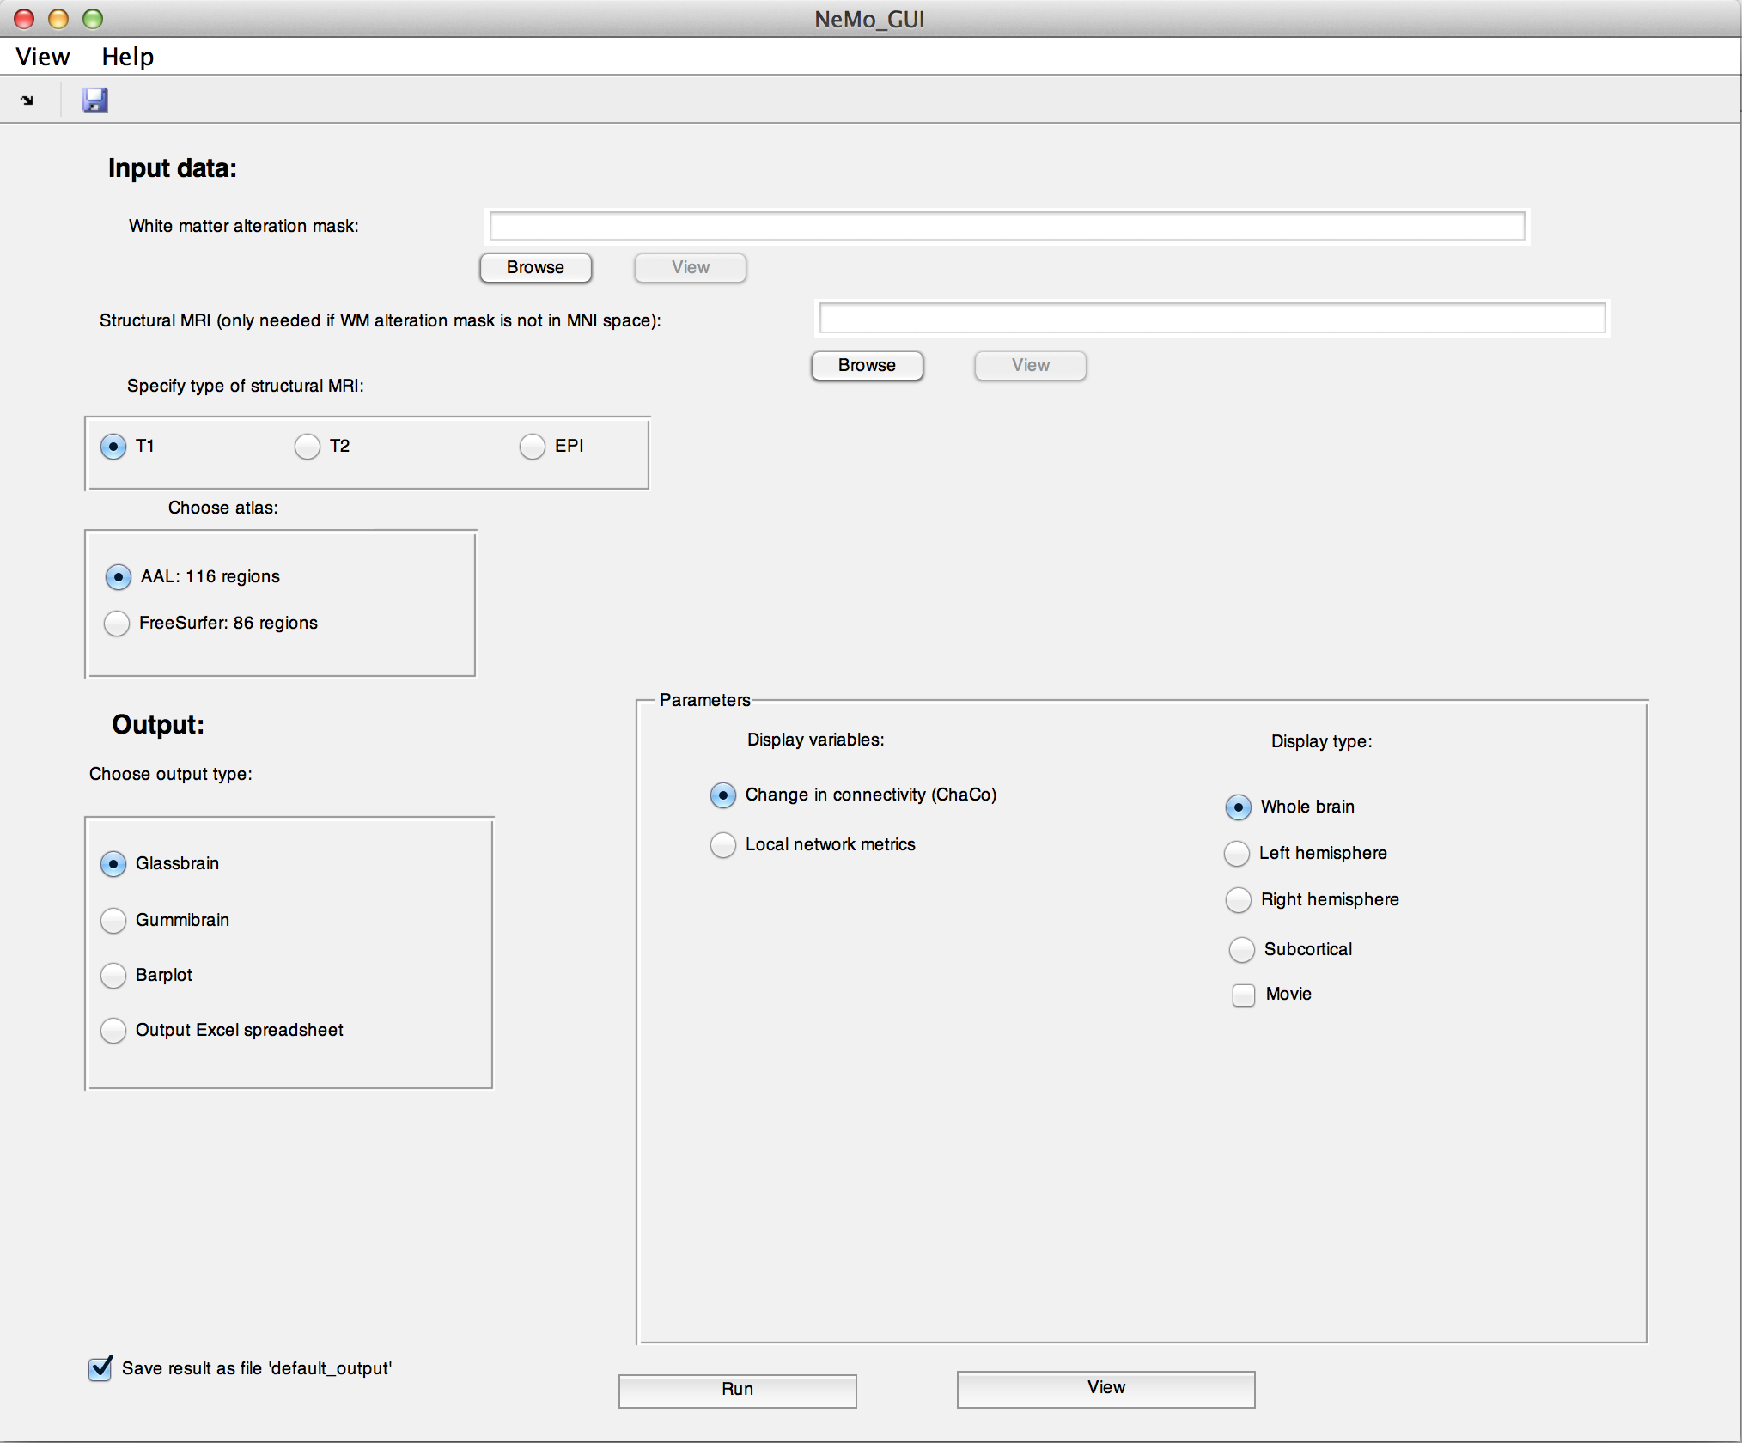
Figure 1. Main GUI
Reference
Amy Kuceyeski, Jun Maruta, Norman Relkin and Ashish Raj. The Network Modification (NeMo) Tool: elucidating the effect of white matter integrity changes on cortical and subcortical structural connectivity. (submitted)

