Novelty Analysis of the Plasma Immunome
in Cardiovascular Disease
A genetics-anchored assessment of which plasma immune proteins are causally implicated in cardiovascular disease, how much of that signal is genuinely new, and what should be done about it.
Human Plasma Immune Atlas · layer 7 (novelty & therapeutic-direction engine) · FinnGen R12 cardiovascular chapter
Open resource: https://huggingface.co/spaces/jianlizhao/Human-Plasma-Immune-Atlas

Headline result
Across the cardiovascular chapter of FinnGen R12, 61 plasma immune proteins are causally implicated in 38 cardiovascular endpoints, giving 191 causal protein–disease pairs at FDR < 5 %. This is the single largest disease system in the atlas: 18.8 % of all 1,016 whole-phenome causal pairs are cardiovascular, more than respiratory (137) or musculoskeletal (132) disease.
78 of the 191 pairs colocalise with the disease signal (PP.H4 ≥ 0.8), meaning the protein and the disease share the same causal variant rather than two variants in linkage disequilibrium. 32 additionally replicate in an independent Finland → England two-population test.
Only 1 of the 191 pairs is a previously established immune–cardiovascular drug axis. 78 pairs (41 %) are classified NOVEL with colocalisation support, of which 5 are additionally confirmed at the circulating-protein level using INTERVAL plasma pQTL. In other words, the cardiovascular immunome is almost entirely unexploited therapeutic territory.
115 of the 191 pairs involve a protein with an existing tractability route (small molecule, antibody or an approved drug class), and 43 sit on proteins that are already the target of an approved drug for some other indication — i.e. immediate repurposing candidates.
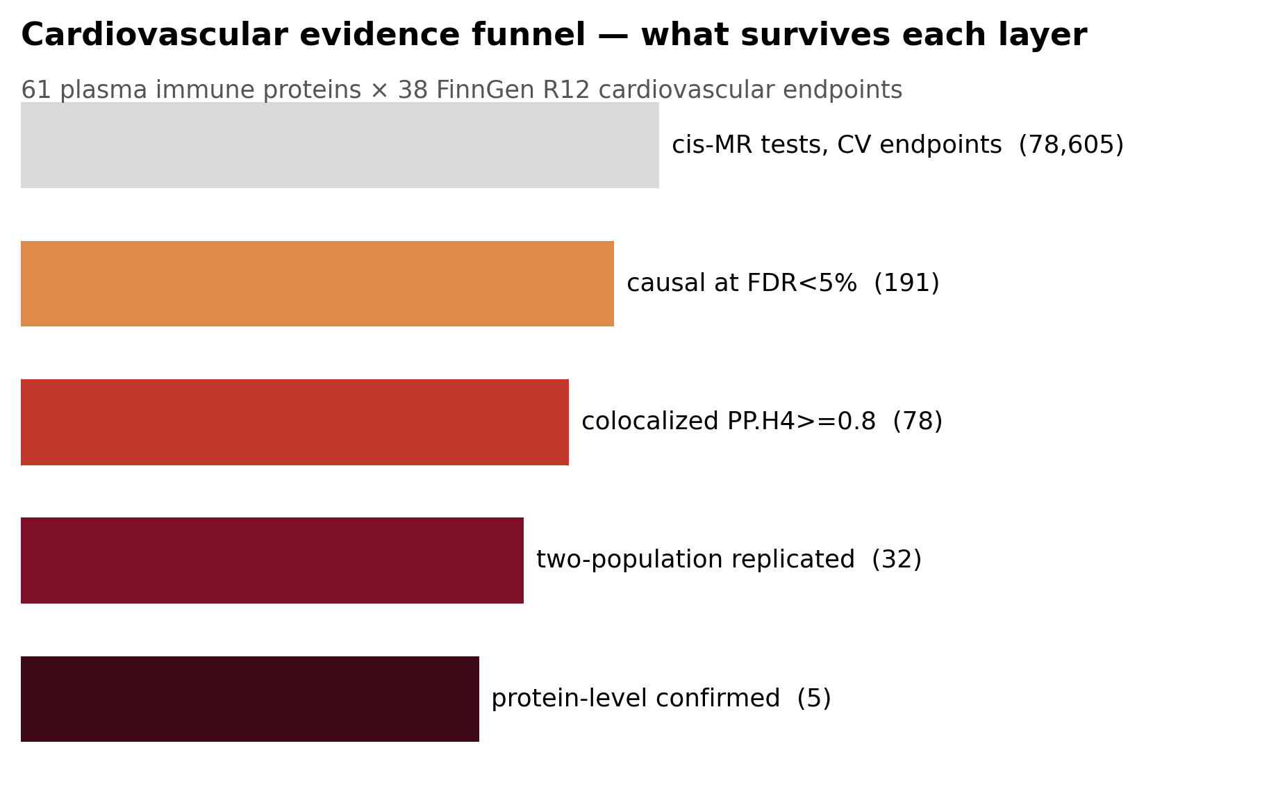
Figure 1 · Cardiovascular evidence funnel. Each layer of the atlas is an independent filter; the surviving set is the therapeutically actionable core.

How novelty is defined
The novelty engine does not ask whether a protein has ever been mentioned alongside heart disease. It asks whether the specific causal claim — this protein, this direction, this endpoint — is already exploited. Each pair receives a score built from seven components and two penalties:
Component | Meaning | CV mean
s_causal | strength of the cis-eQTL MR effect (FDR) | 0.81
s_coloc | colocalisation posterior PP.H4 | 0.44
s_pleio | specificity — penalised if the protein hits many unrelated chapters | 0.76
s_drug | druggability / tractability class | 0.52
s_cell | does the protein also move immune cell counts or CRP | 0.49
s_protein | confirmed at the circulating-protein level (INTERVAL pQTL MR) | 0.07
s_repl | independent two-population replication (UK Biobank) | 0.08
p_known | PENALTY — already an approved drug axis | 0.01
p_mhc | PENALTY — MHC region, long-range LD defeats colocalisation | 0.21

The cardiovascular set scores high on causal strength (mean 0.81) and specificity (mean 0.76) but low on protein confirmation (mean 0.07) — the honest reading is that the transcript-level evidence is strong and the plasma-protein arbitration is still thin, because public login-free pQTL coverage of these proteins is incomplete rather than because the signals failed.
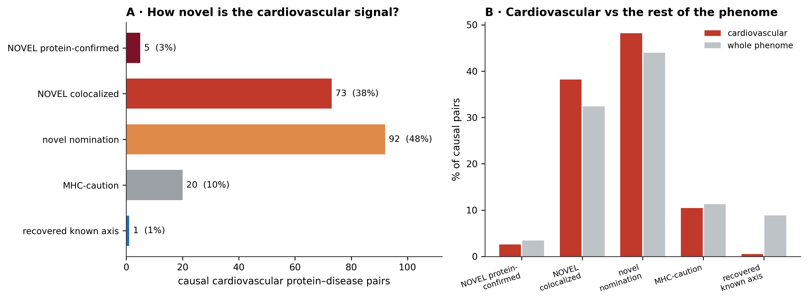
Figure 2 · Novelty class composition. (A) The cardiovascular chapter split by engine class. (B) Cardiovascular disease is enriched for novel colocalized signal relative to the rest of the phenome, and almost devoid of recovered known axes.

The top novel cardiovascular targets
Ranked by novelty priority. Every row is a live claim: a direction of effect, a colocalisation posterior, and where available an independent-population test.
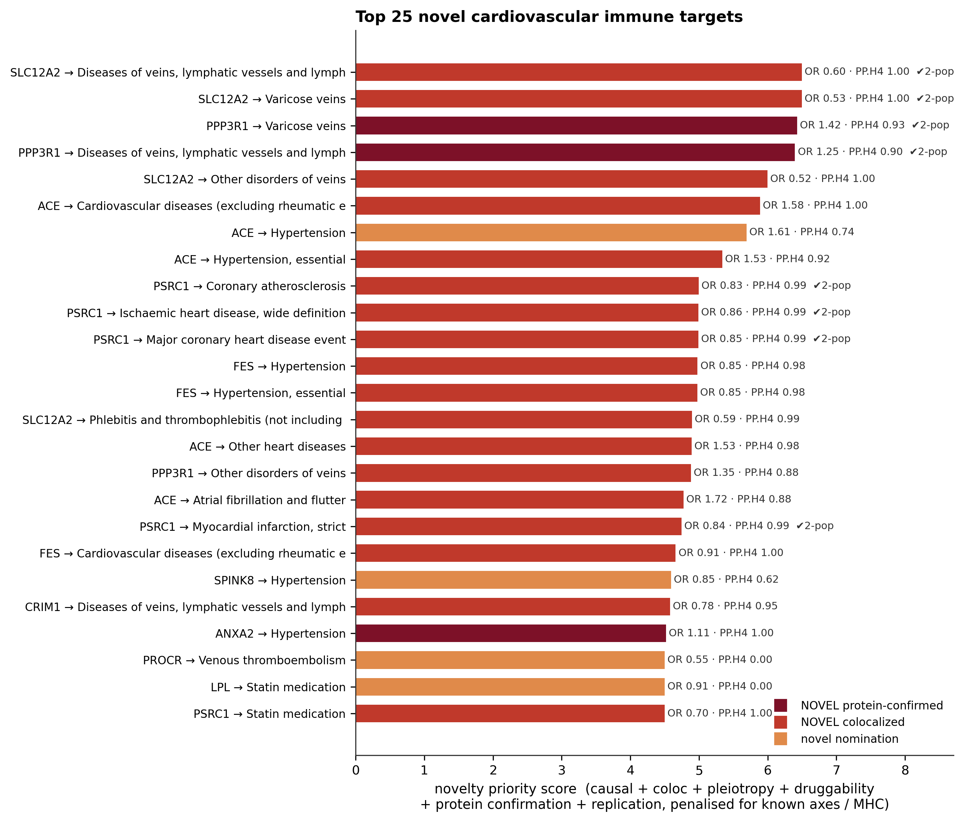
Figure 3 · Top 25 novel cardiovascular immune targets, coloured by engine class. OR is per 1-SD genetically-proxied increase in the plasma protein; ✔2-pop marks pairs that also replicate in UK Biobank.
Gene | Cardiovascular endpoint | Immune class | OR | FDR | PP.H4 | 2-pop | Novelty class | Tier | Implied action
SLC12A2 | Diseases of veins, lymphatic vessels and lym | Immune-cell-enriched | 0.603 | 2.77e-35 | 0.997 | True | NOVEL colocalized | 2 | agonise / replace
SLC12A2 | Varicose veins | Immune-cell-enriched | 0.530 | 2.46e-32 | 0.997 | True | NOVEL colocalized | 2 | agonise / replace
PPP3R1 | Varicose veins | Immune-cell-enriched | 1.415 | 3.27e-36 | 0.929 | True | NOVEL protein-confirmed | 2 | block / antagonise
PPP3R1 | Diseases of veins, lymphatic vessels and lym | Immune-cell-enriched | 1.246 | 1.68e-24 | 0.896 | True | NOVEL protein-confirmed | 2 | block / antagonise
SLC12A2 | Other disorders of veins | Immune-cell-enriched | 0.517 | 5.09e-18 | 0.997 | False | NOVEL colocalized | 3 | agonise / replace
ACE | Cardiovascular diseases (excluding rheumatic | Immune-cell-enriched | 1.584 | 1.1e-07 | 0.997 | False | NOVEL colocalized | 3 | block / antagonise
ACE | Hypertension | Immune-cell-enriched | 1.611 | 5.32e-08 | 0.735 | False | novel nomination | 4 | block / antagonise
ACE | Hypertension, essential | Immune-cell-enriched | 1.534 | 2.42e-05 | 0.917 | False | NOVEL colocalized | 3 | block / antagonise
PSRC1 | Coronary atherosclerosis | Immune-cell-enriched | 0.827 | 9.23e-23 | 0.994 | True | NOVEL colocalized | 2 | agonise / replace
PSRC1 | Ischaemic heart disease, wide definition | Immune-cell-enriched | 0.856 | 2.33e-19 | 0.991 | True | NOVEL colocalized | 2 | agonise / replace
PSRC1 | Major coronary heart disease event | Immune-cell-enriched | 0.850 | 1.89e-15 | 0.988 | True | NOVEL colocalized | 2 | agonise / replace
FES | Hypertension | Immune-cell-enriched | 0.847 | 1.3e-28 | 0.978 | False | NOVEL colocalized | 3 | agonise / replace
FES | Hypertension, essential | Immune-cell-enriched | 0.846 | 5.51e-26 | 0.977 | False | NOVEL colocalized | 3 | agonise / replace
SLC12A2 | Phlebitis and thrombophlebitis (not includin | Immune-cell-enriched | 0.588 | 3.08e-05 | 0.995 | False | NOVEL colocalized | 3 | agonise / replace
ACE | Other heart diseases | Immune-cell-enriched | 1.528 | 0.009 | 0.982 | False | NOVEL colocalized | 3 | block / antagonise
PPP3R1 | Other disorders of veins | Immune-cell-enriched | 1.346 | 6.41e-13 | 0.882 | False | NOVEL colocalized | 3 | block / antagonise
ACE | Atrial fibrillation and flutter | Immune-cell-enriched | 1.724 | 0.011 | 0.878 | False | NOVEL colocalized | 3 | block / antagonise
PSRC1 | Myocardial infarction, strict | Immune-cell-enriched | 0.842 | 1.77e-09 | 0.994 | True | NOVEL colocalized | 2 | agonise / replace
FES | Cardiovascular diseases (excluding rheumatic | Immune-cell-enriched | 0.906 | 4.89e-09 | 0.996 | False | NOVEL colocalized | 3 | agonise / replace
SPINK8 | Hypertension | Immune-cell-enriched | 0.848 | 1.39e-05 | 0.620 | False | novel nomination | 4 | agonise / replace
Table 1 · The 20 highest-priority novel cardiovascular immune targets. Full table: 09_tables/T8_cv_novelty_all_pairs.tsv
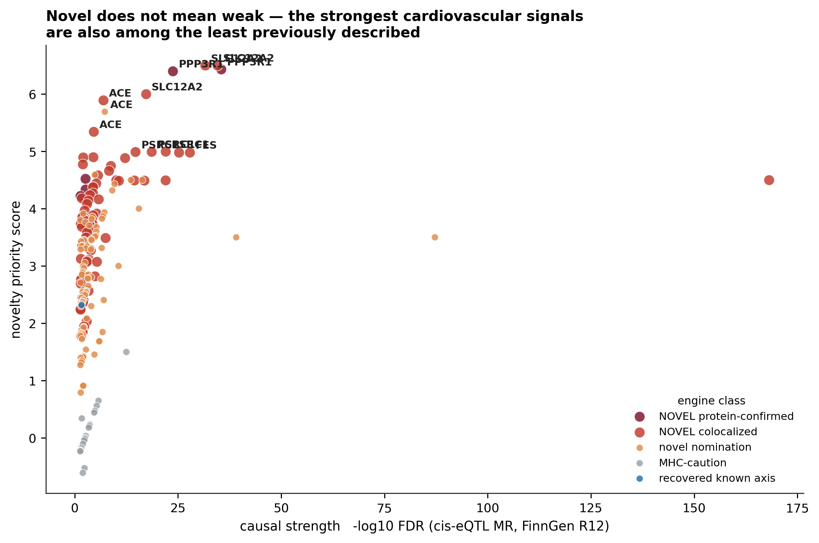
Figure 4 · Novelty against causal strength. Novelty here is not a consolation prize for weak signal — several of the least-described proteins carry the strongest cardiovascular MR evidence in the atlas.

Worked case studies

SLC12A2 → Diseases of veins, lymphatic vessels and lymph nodes, not el
Class: Immune-cell-enriched · engine verdict: NOVEL colocalized · tier 2 · novelty priority 6.50
A genetically-proxied 1-SD increase in plasma SLC12A2 reduces the odds of diseases of veins, lymphatic vessels and lymph nodes, not elsewhere classified (OR 0.60, FDR 2.8e-35). The protein and the disease share a causal variant with posterior PP.H4 = 1.00. It replicates in the independent Finland → England two-population test. Across the cardiovascular chapter SLC12A2 is causal for 4 endpoint(s), 4 of them colocalised and 2 two-population replicated. Therapeutic reading: agonise, supplement or replace it.

PPP3R1 → Varicose veins
Class: Immune-cell-enriched · engine verdict: NOVEL protein-confirmed · tier 2 · novelty priority 6.43
A genetically-proxied 1-SD increase in plasma PPP3R1 increases the odds of varicose veins (OR 1.42, FDR 3.3e-36). The protein and the disease share a causal variant with posterior PP.H4 = 0.93. It replicates in the independent Finland → England two-population test. The claim is confirmed at the circulating-protein level using INTERVAL plasma pQTL (protein-level OR 1.27, P = 0.049), so the signal is not a transcript-only artefact. Across the cardiovascular chapter PPP3R1 is causal for 4 endpoint(s), 4 of them colocalised and 2 two-population replicated. Therapeutic reading: block or antagonise it.

ACE → Cardiovascular diseases (excluding rheumatic etc)
Class: Immune-cell-enriched · engine verdict: NOVEL colocalized · tier 3 · novelty priority 5.89
A genetically-proxied 1-SD increase in plasma ACE increases the odds of cardiovascular diseases (excluding rheumatic etc) (OR 1.58, FDR 1.1e-07). The protein and the disease share a causal variant with posterior PP.H4 = 1.00. It does not yet have an independent-population test, because no matching single-cohort UK Biobank GWAS of this endpoint exists. Across the cardiovascular chapter ACE is causal for 6 endpoint(s), 4 of them colocalised and 0 two-population replicated. Therapeutic reading: block or antagonise it.

PSRC1 → Coronary atherosclerosis
Class: Immune-cell-enriched · engine verdict: NOVEL colocalized · tier 2 · novelty priority 4.99
A genetically-proxied 1-SD increase in plasma PSRC1 reduces the odds of coronary atherosclerosis (OR 0.83, FDR 9.2e-23). The protein and the disease share a causal variant with posterior PP.H4 = 0.99. It replicates in the independent Finland → England two-population test. Across the cardiovascular chapter PSRC1 is causal for 14 endpoint(s), 14 of them colocalised and 5 two-population replicated. Therapeutic reading: agonise, supplement or replace it.

FES → Hypertension
Class: Immune-cell-enriched · engine verdict: NOVEL colocalized · tier 3 · novelty priority 4.98
A genetically-proxied 1-SD increase in plasma FES reduces the odds of hypertension (OR 0.85, FDR 1.3e-28). The protein and the disease share a causal variant with posterior PP.H4 = 0.98. It does not yet have an independent-population test, because no matching single-cohort UK Biobank GWAS of this endpoint exists. Across the cardiovascular chapter FES is causal for 18 endpoint(s), 8 of them colocalised and 4 two-population replicated. Therapeutic reading: agonise, supplement or replace it.

SPINK8 → Hypertension
Class: Immune-cell-enriched · engine verdict: novel nomination · tier 4 · novelty priority 4.59
A genetically-proxied 1-SD increase in plasma SPINK8 reduces the odds of hypertension (OR 0.85, FDR 1.4e-05). The protein and the disease share a causal variant with posterior PP.H4 = 0.62. It does not yet have an independent-population test, because no matching single-cohort UK Biobank GWAS of this endpoint exists. The claim is confirmed at the circulating-protein level using INTERVAL plasma pQTL (protein-level OR 0.80, P = 0.00053), so the signal is not a transcript-only artefact. Across the cardiovascular chapter SPINK8 is causal for 2 endpoint(s), 1 of them colocalised and 0 two-population replicated. Therapeutic reading: agonise, supplement or replace it.
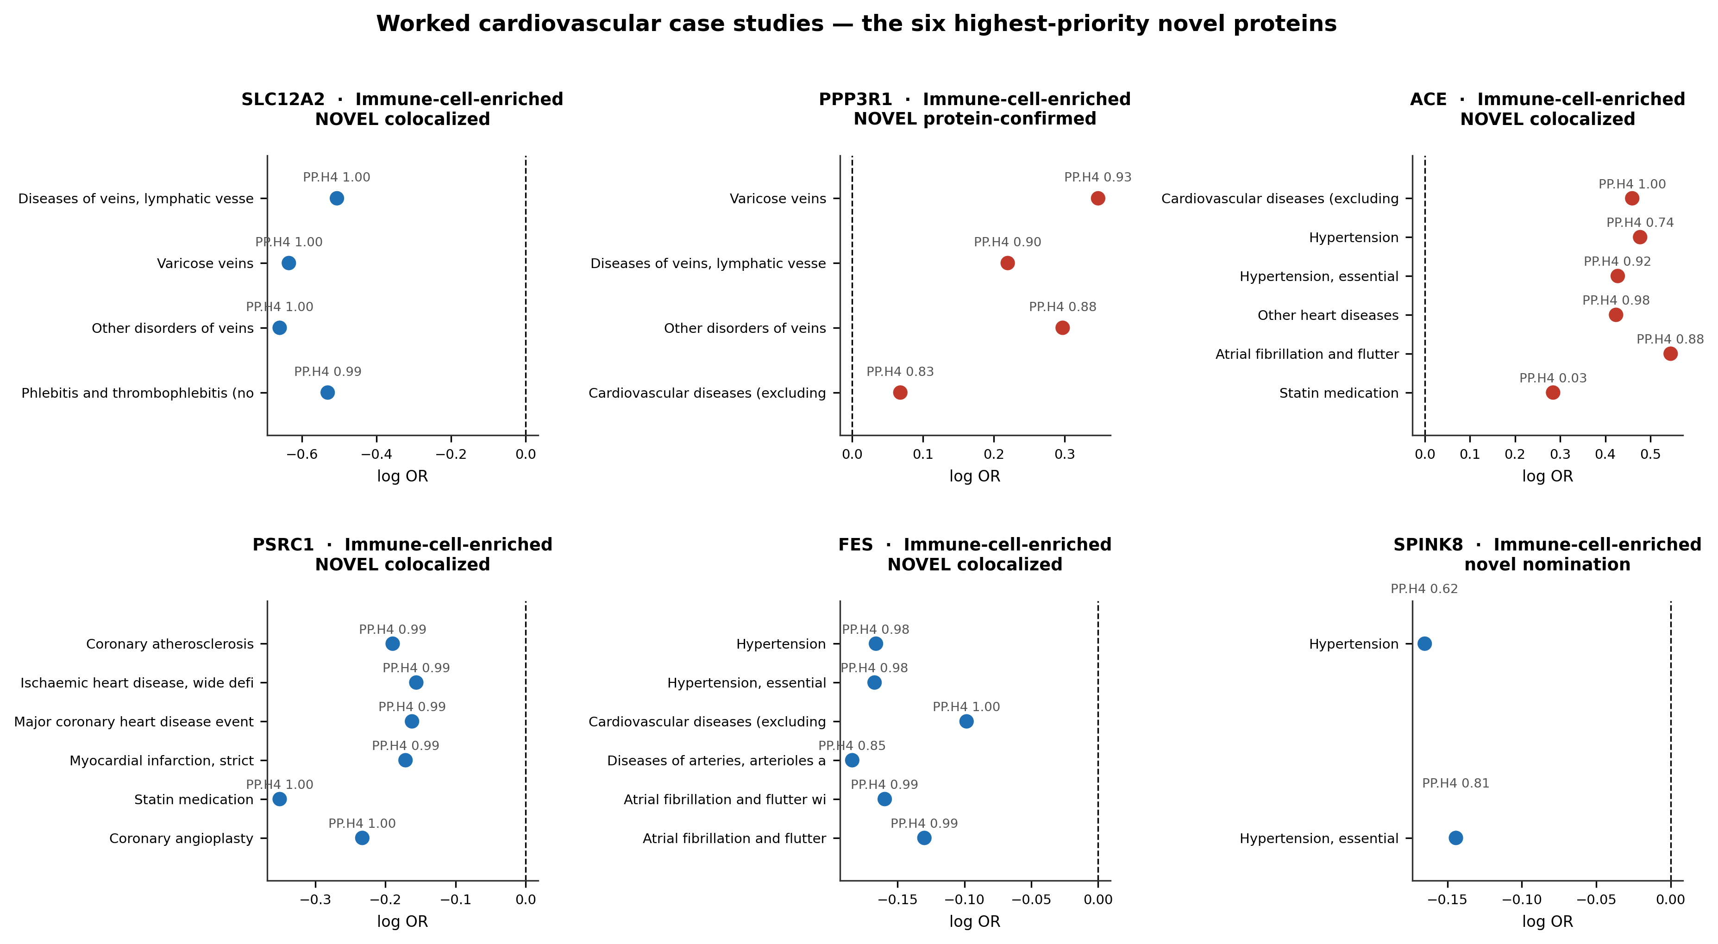
Figure 5 · Worked case studies. For each of the six highest-priority novel proteins, every cardiovascular endpoint it causes, with the colocalisation posterior above each point. Red = risk-increasing, blue = protective.

Which cardiovascular diseases the immunome reaches
The signal is not confined to atherosclerosis. Hypertension, venous disease, atrial fibrillation and revascularisation endpoints all carry independent plasma-immune causal architecture, and the venous endpoints in particular are dominated by novel colocalised proteins with essentially no prior immune-therapeutic literature.
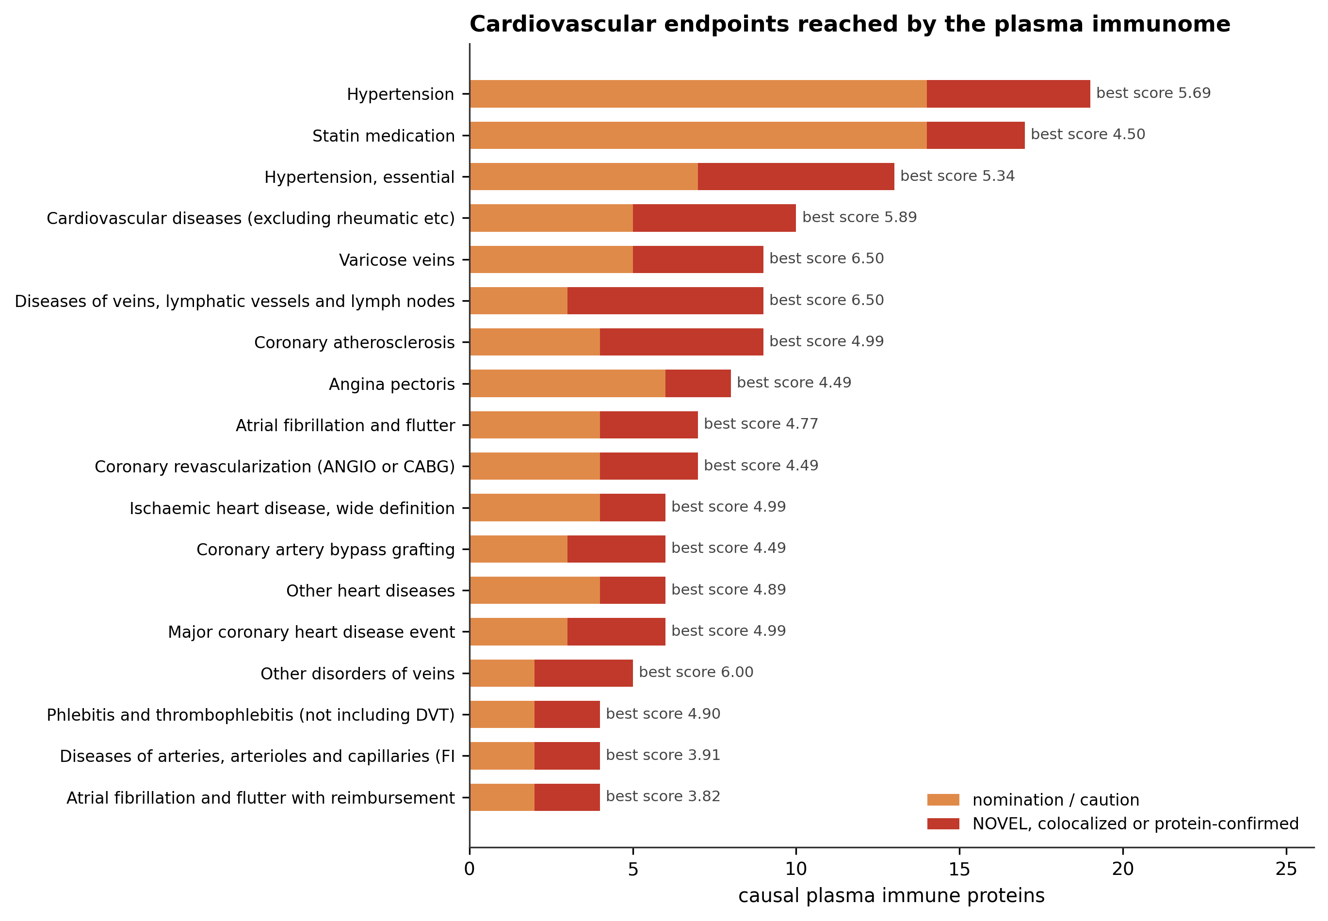
Figure 6 · Cardiovascular endpoints ranked by the number of causal plasma immune proteins; the dark segment is the NOVEL colocalised / protein-confirmed fraction.
Cardiovascular endpoint | Causal proteins | of which NOVEL | Best score
Hypertension | 19 | 5 | 5.690
Statin medication | 17 | 3 | 4.500
Hypertension, essential | 13 | 6 | 5.340
Cardiovascular diseases (excluding rheumatic etc) | 10 | 5 | 5.889
Varicose veins | 9 | 4 | 6.497
Diseases of veins, lymphatic vessels and lymph nodes, no | 9 | 6 | 6.497
Coronary atherosclerosis | 9 | 5 | 4.994
Angina pectoris | 8 | 2 | 4.491
Atrial fibrillation and flutter | 7 | 3 | 4.773
Coronary revascularization (ANGIO or CABG) | 7 | 3 | 4.493
Ischaemic heart disease, wide definition | 6 | 2 | 4.991
Coronary artery bypass grafting | 6 | 3 | 4.489
Other heart diseases | 6 | 2 | 4.893
Major coronary heart disease event | 6 | 3 | 4.988
Other disorders of veins | 5 | 3 | 5.997
Phlebitis and thrombophlebitis (not including DVT) | 4 | 2 | 4.897
Diseases of arteries, arterioles and capillaries (FINNGE | 4 | 2 | 3.914
Atrial fibrillation and flutter with reimbursement | 4 | 2 | 3.820
Table 2 · Cardiovascular endpoints with the most causal plasma immune proteins.

Therapeutic direction and tractability
Of the 191 causal pairs, 75 are risk-increasing (implied action: block the protein) and 116 are protective (implied action: agonise, supplement or replace it). The protective majority is important: it means a large part of the cardiovascular immunome would be damaged, not helped, by broad immunosuppression — the direction has to be read protein by protein.
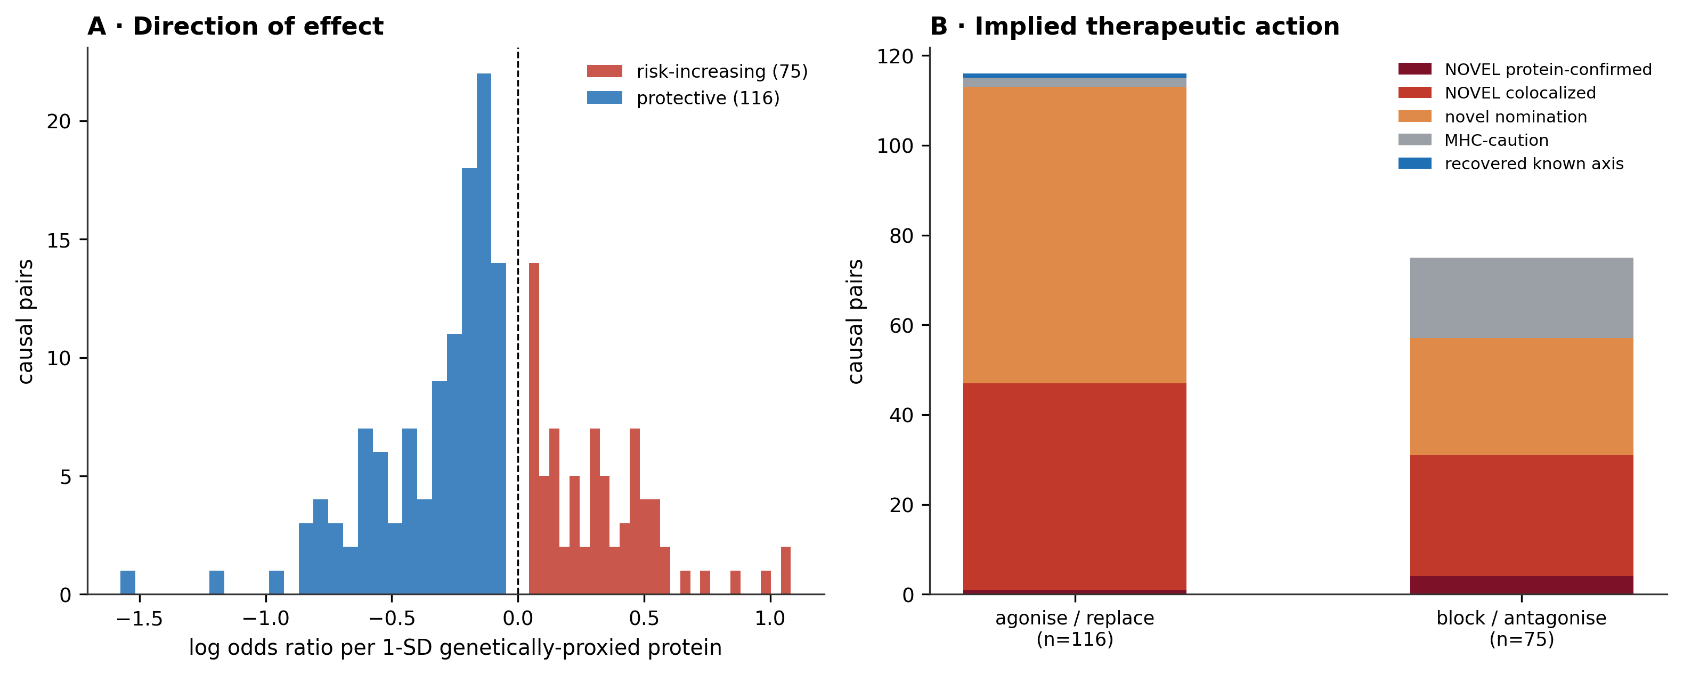
Figure 7 · (A) Distribution of causal effect direction. (B) Implied therapeutic action split by novelty class.
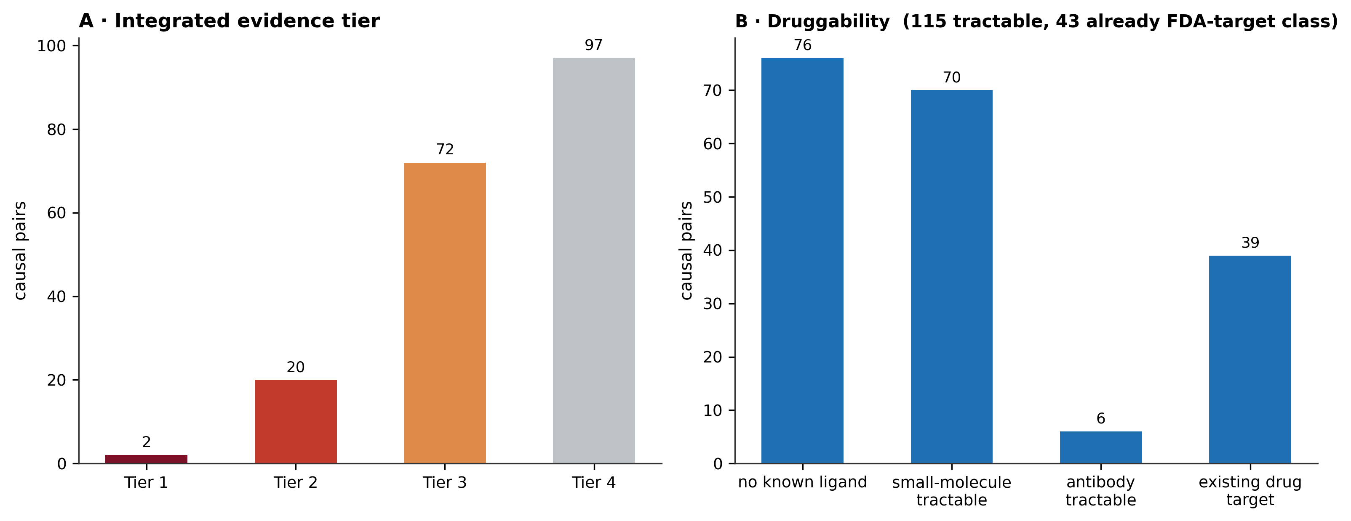
Figure 8 · (A) Integrated evidence tier — tier 1–2 pairs carry protein-level or replicated colocalised support. (B) Druggability of the underlying proteins.
Gene | Immune class | CV endpoints | Best score | Best endpoint | Colocalised | 2-pop replicated | Druggability
SLC12A2 | Immune-cell-enriched | 4 | 6.497 | Diseases of veins, lymphatic vessels and | 4 | 2 | 3
PPP3R1 | Immune-cell-enriched | 4 | 6.429 | Varicose veins | 4 | 2 | 2
ACE | Immune-cell-enriched | 6 | 5.889 | Cardiovascular diseases (excluding rheum | 4 | 0 | 3
PSRC1 | Immune-cell-enriched | 14 | 4.994 | Coronary atherosclerosis | 14 | 5 | 0
FES | Immune-cell-enriched | 18 | 4.978 | Hypertension | 8 | 4 | 0
SPINK8 | Immune-cell-enriched | 2 | 4.591 | Hypertension | 1 | 0 | 1
CRIM1 | Immune-cell-enriched | 4 | 4.580 | Diseases of veins, lymphatic vessels and | 4 | 0 | 1
ANXA2 | Immune-cell-enriched | 2 | 4.520 | Hypertension | 2 | 0 | 3
PROCR | Immune-cell-enriched | 6 | 4.500 | Venous thromboembolism | 0 | 0 | 3
LPL | Immune-cell-enriched | 4 | 4.500 | Statin medication | 0 | 3 | 3
PLAUR | Immune-cell-enriched | 10 | 4.439 | Major coronary heart disease event | 9 | 4 | 3
IFNGR2 | Interferon axis | 3 | 4.375 | Hypertension | 3 | 0 | 3
LYPD3 | Immune-cell-enriched | 1 | 4.318 | Statin medication | 0 | 0 | 1
PILRA | Immune-cell-enriched | 1 | 4.180 | Statin medication | 1 | 0 | 2
PLAU | Immune-cell-enriched | 2 | 4.139 | Atherosclerosis, excluding cerebral and | 2 | 0 | 1
HAVCR1 | Immune-cell-enriched | 1 | 4.000 | Statin medication | 0 | 0 | 1
MAPT | Immune-cell-enriched | 1 | 3.915 | Hypertension | 0 | 0 | 3
PVR | Immune-cell-enriched | 1 | 3.868 | Statin medication | 0 | 0 | 2
SWAP70 | Immune-cell-enriched | 4 | 3.863 | Hypertension | 0 | 0 | 0
MERTK | Immune-cell-enriched | 2 | 3.734 | Hypertension | 2 | 0 | 1
Table 3 · The 20 highest-priority cardiovascular immune proteins, collapsed across endpoints. Full table: 09_tables/T8_cv_novelty_by_protein.tsv

What this analysis does not claim
- MR estimates are lifelong genetically-proxied effects. They identify a causal direction; they do not predict the effect size of a drug given to an adult patient.
- 20 cardiovascular pairs sit in or near the MHC region and are held at nomination only — long-range linkage disequilibrium there defeats colocalisation, so a shared-variant posterior cannot be trusted.
- cis-eQTL instruments proxy transcript abundance, which is not always circulating protein. The plasma pQTL layer is the arbiter, and it currently covers only part of this protein set because public login-free SomaScan/Olink aptamer coverage is incomplete.
- The two-population layer uses only single-cohort UK Biobank GWAS. Several large public meta-analyses of the same endpoints silently include FinnGen, which would make 'replication' circular; those were deliberately excluded, which is why only 32 of 191 pairs carry a replication flag.
- 'Novel' is a statement about therapeutic exploitation, not about the literature. A protein may have been described in cardiovascular biology and still be scored novel if no approved drug acts on that axis for that indication.
- Research resource only — not clinical advice and not a validated diagnostic.

Methods, in brief
Instruments: strongest cis-eQTL per plasma immune protein from eQTLGen (n ≈ 31,684). Outcomes: FinnGen release R12, every endpoint in the cardiovascular chapter. Causal estimation: Wald ratio / Zhu approximation, Benjamini–Hochberg FDR across the whole phenome (not within-chapter, so the cardiovascular results are not preferentially significant). Colocalisation: coloc.abf with Wakefield approximate Bayes factors, PP.H4 ≥ 0.8. Protein-level confirmation: INTERVAL plasma pQTL (Sun et al. 2018, public via the EBI GWAS Catalog) MR + colocalisation. Two-population replication: independent single-cohort UK Biobank GWAS of the matched endpoint. Immune-cell layer: the same instruments against blood cell counts, fractions and CRP. Novelty engine: the seven components and two penalties tabulated above, combined into the novelty priority score.
Source tables: 06_genetic_causality/novelty_engine_ranked_ALL.tsv (1,016 whole-phenome causal pairs), uk_panphenome_concordance_ALL.tsv, pqtl_MR_ALL_finngen_results.tsv, extended_cell_crp_MR_results.tsv. Derived tables written by this script: 09_tables/T8_cv_novelty_all_pairs.tsv, T8_cv_novelty_novel_only.tsv, T8_cv_novelty_by_protein.tsv. Figures: 08_figures/cv_novelty/CVN1–CVN8.
Every figure and number in this report is regenerated from those tables by src/53_cv_novelty_report.py. Nothing is hand-entered.

